**CLEAN@SILVER LAKE WATER QUALITY REPORT 9/12/25**

**Board of Directors:**

**Rob Ritz, President Kelly Paganelli, Vice President/Secretary**

**Michelle Hess, Social Media/Treasurer Todd Shuskey, Board Member**

**Lee Loomis, Board Member Nate Wallis, Board Member**

**Ron Norton, Consultant Frank Bright, Consultant**

**Harmful Algae Blooms (HABs).**

There was a mixing event on August 30 bringing nutrients to the top of the surface causing the current algae bloom situation. The Temperature Array indicated the lake turnover.

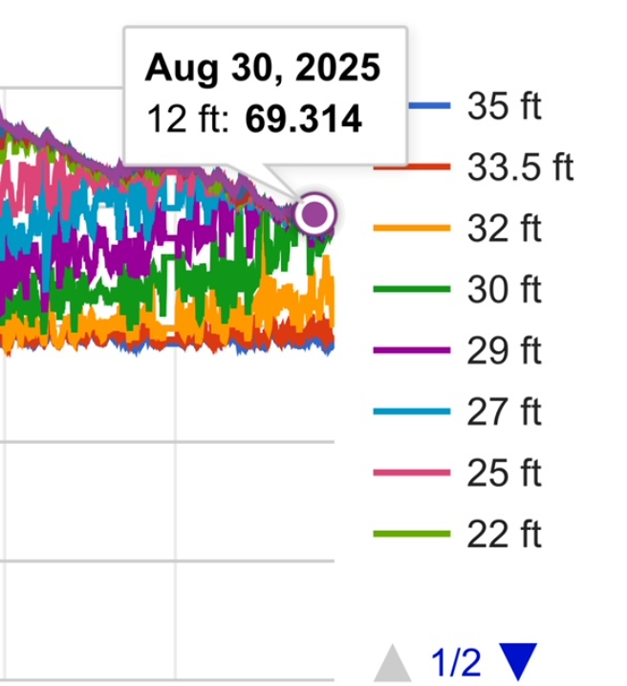

Report HABs on the NYHABS web site:[**https://experience.arcgis.com/experience/e5dec19912454731a308bbb7af605fb3/**](https://experience.arcgis.com/experience/e5dec19912454731a308bbb7af605fb3/)

**WEED HARVESTING**  –

*See website for weed mapping. Focusing on the most problematic areas North and South ends (near Macs) and Eberstein/Sherman area. Approximately 4 acres.

Bob Michalski is working diligently on this.

* Cost - $12,000 for one weed harvesting cycle. TO DO: Need to find someplace to take the weeds. UNKNOWN FUNDING: FLOPA funding through Wyoming County could support some of that, grant funding and property owners/fundraising needed to help fund.

DEC has grants relating to water quality. Also grants for invasive weed control. Opportunity for grant writer

*CLEAN will be applying for DEC permits for both weed harvesting and chemical treatment. Permit is good for 2 years.

**MPC Buoy for HAB’s**

Sonic float system is also being investigated with a proposal to have a test site at the north end near the drinking water intakes. Proposal will be sent to Drinking Water Source Protection Program (DWSP2) for consideration.

**DREDGING UPDATE**

Wyoming County has been provided a list of at least 6 farms around the lake interested in using the dredged material.

Wyoming County has reached out to the engineering firm leading the north end dredging project (Clarke Patterson Lee (CPL)) and they have compiled the sediment chemical composition and quantity**.** Next step is to have the Western New York Crop Management group work with the farmers to determine nutrient requirements and application processes.

**LWRP REVIEW** – Drafts have been received for editing/review. CLEAN has 5 members on the WAC and they are carefully reviewing to make sure the water quality aspects are complete.

**JAPENESE KNOTWEED RESULTS** –ATIP has done a second spraying on Luther Road/Private Drive #1.. An infestation on Fairview has been noted.

**STATE PARK RAMP IMPROVEMENTS – Delayed until 2026.** CLEAN has sent a letter to the state for launch improvements beyond the current 4 foot extension and urging this project be completed by end of 2026.

**2026 CLEAN Golf Tournament:  Reserved for 7/18/2026 9:00 am shotgun start – Opportunity** New Tournament Directors will be Heidi and Chad Ruchala. They will be meeting with volunteers. Look for registration information to be sent out by April 1, 2026.

**LED FLARES –** 750 LED Flares sold in 2025. 2026 – plan to purchase 400 LED Flares and offer promotional pricing to lakeside residents

**Silver Lake Nutrient Extractor:** CLEAN team members have reached out to leadership within the WCSWCD to relaunch this project at a new site in 2026.

**NYSFOLA**  meeting will be Saturday, October 25th. Lee Loomis and Rob Ritz will be attending.

**CSLAP** – Team continues to test and submit. Reports come out at the end of the year.

ONGOING CLEAN TEAM Partnerships:

**Wyoming County Water Resource Agency (WCWRA**). Frank Bright. Headed by Scott Schrader, Wyoming County Administrator, and they oversee large-scale “projects”, including the North end dredging at Silver Lake.

**Drinking Water Source Protection Program (DWSP2).** Frank Bright

**Silver Lake Watershed Commission (SLWC**). Lee Loomis -This committee has membership from each municipality drawing water from Silver Lake plus an CLEAN representative. Next meeting 10/16/25

**Wyoming County Water Resources / Resource Conservation and Development Committee (WCWR / RCDC).** Lee Loomis. This committee operates through the Wyoming County Soil and Water Conservation District (WCSWCD) and it has representation from every waterbody within 1 Wyoming County and DEC. Next meeting 10/16/25

\