All Equitation O/F Classes
18 in., 2 ft., 2’3”, 2’6”, 2’9”, 3’

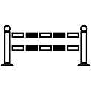  4 |  | 5 |  | 3 | 6
 | 1
 |  |  |  | 2 | 7
Gate

