Crossrails Hunter
2 x around

7 3
8 4
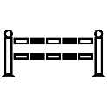 |  |  |  |  | 2 6
 |  |  |  |  | 1 5
Gate

