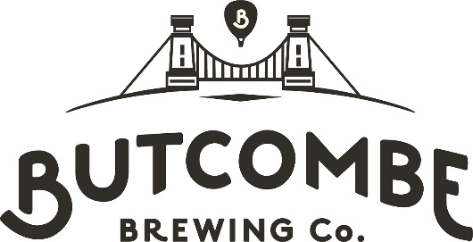

Bristol & District Combination
Cup Competitions Entry Form
Season 2025/26
Club name:
We wish to enter the Competition: YES / NO
Bond payment made? YES / NO
Club contact for communications pertaining to the Cup Competitions:
Name:
Tel:
Email:
Please return your completed form to: cupsec@bristolrugbycombination.co.uk before Sunday 9th November.
We envisage Cup Dates to be between 31/7/26, 7/2/26, 21/2/26 & 14/3/26 with Semi Finals 2/5/26 & Finals 7th & 9th May 2026
Bond payment (£99.00) is to be made to:
Bristol Combination
Account name: Treasurers Account
Sort Code: 30-92-13
Account no: 01566751
Payment Ref ButcombeCup

