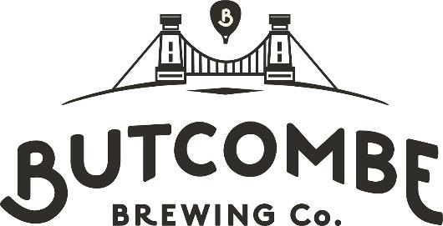

Bristol & District Combination
Cup Competitions Entry Form
Season 2024/25

Club name:
We wish to enter the Competition: YES / NO
Bond payment made? YES / NO
Club contact for communications pertaining to the Cup Competitions:
Name:
Tel:
Email:

Please return your completed form to: ian92116@gmail.com before 23:59 on Sunday 1st September 2024
(As per accompanying email, please ensure a reply (entering or not) is sent to the above address by this date)
Bond payment (£99.00) is to be made to:
Account name: Treasurers Account
Sort Code: 30-92-13
Account no: 01566751
Payment ref: ButcombeCup

