

Atypical Education Business Continuity Plan

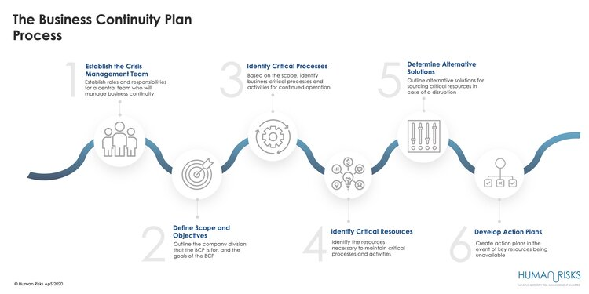

1. Crisis Management Team

-If I, Emma Oxnam, am unwell, work may need to stop, be postponed or reorganised for another time or day, or Sharon Ungless, who is sub-contracted for 3 days, may be able to cover

- If the sub-contractor is unwell, the same applies, and I can cover.

1. Scope and Objectives

-Teaching the pupils who have an LA contract so that they have a consistent timetable

- Planning suitable lessons and activities

- Organising additional sessions

1. Critical Processes

* Access to the internet
* Access to pupils
* Transportation

1. Critical Resources

- Car or transportation

- Food and lesson resources

- Internet for online learning

1. Alternative Solutions

* Online work
* Face-to-face work
* Working outside or renting an appropriate learning space, e.g., library

1. Action Plans

* Increase my capacity to cover and support if required.