Environmental Policy and Action Plan

Atypical Education

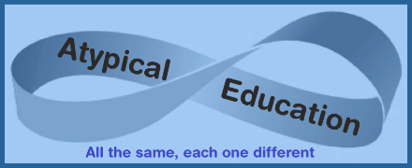

Approved by: | Emma Oxnam | Date: 1st September 2022
Last reviewed on: | 1st September 2026
The following review is due by: | 1st September 2027

Contents
1. Aims 2
2. Legislation and guidance 2
3. Suffolk County Council’s Ask- Supply Chain 2
4. Minimising Environmental Impact 3
5. Environmental Impacts 3
6. Environmental Commitments 5
7. Environmental Targets 5

1. Aims
An environmental policy should summarise the organisation’s key environmental impacts and its commitment to minimising them. This can include compliance with existing environmental legislation and measures that have been and will be taken voluntarily. This should be made available internally and externally to demonstrate commitment and ensure compliance.

2. Legislation and guidance
On 21 March 2019, councillors at Suffolk County Council voted to declare a climate emergency. In July 2020, the Cabinet agreed on a set of recommended actions arising from the work of a Policy Development Panel. Suffolk County Council aims to achieve net-zero emissions by 2030. Through practical action, it seeks to save money, generate income and reduce carbon emissions to net zero for its operations and services. We aim to minimise the environmental impact of the Council’s procurement of goods, services, and work in line with our response to the climate emergency.

3. Suffolk County Council’s Ask- Supply Chain
Our ask of our contractors is to:
- Know the impact that your organisation has on the environment.
- Have an Environmental Policy that embeds a culture of reducing negative environmental impacts within your organisation.
- Ensure your environmental impact is measured regularly, reported and overseen at the highest level.
- Reduce negative environmental impacts with a clear action plan outlining the work to be undertaken, focusing on the most significant impacts, with key targets and timelines for the actions to be undertaken, for example.
  - If you travel, you reduce your mileage. For the miles that you cannot reduce, consider travelling in more environmentally friendly ways.
  - If you use buildings, ensure that you have had Environmental Building Surveys 2024 undertaken and mitigated the negative environmental impact.
- Work with your supply chain to know the environmental impact of the goods/services you purchase and mitigate/reduce the negative impact; where the negative impact cannot be reduced, offset the effects.
- Work towards your organisation also being Carbon Net Zero by 2030.

4. Minimising Environmental Impact
As an Educational establishment, Atypical Education promotes environmental awareness, encouraging students to help protect the environment and reduce energy consumption. Our approach must be to promote and support the behavioural changes needed to think and act differently. We hope sustainability becomes a more prominent consideration in everyone’s day-to-day thoughts, that increased awareness leads to more action, and that a ripple effect is felt beyond the educational community.
The values they develop now will carry them through life and inform their personal and professional decisions. We are responsible for teaching our students to be engaged citizens, which we achieve by raising their awareness of important issues and equipping them with the skills and confidence to effect change. Without these skills, knowledge, and facts, one can be unsettled and disempowered. The climate crisis and ecological collapse pose an existential threat to life on Earth, and we must act now to reduce our impact and educate and empower the next generation to make sustainability a core part of their values.
The Intergovernmental Panel on Climate Change stated that humanity must keep the global temperature rise below 1.5°C by drastically reducing greenhouse gas emissions by 45% from 2010.

5. Environmental Impacts
We aim to be carbon neutral by 2030 by following UN guidelines
In this strategy, we establish quantitative targets against a baseline to track progress and hold ourselves accountable. We will monitor these targets to celebrate our successes and focus on areas that need greater attention.

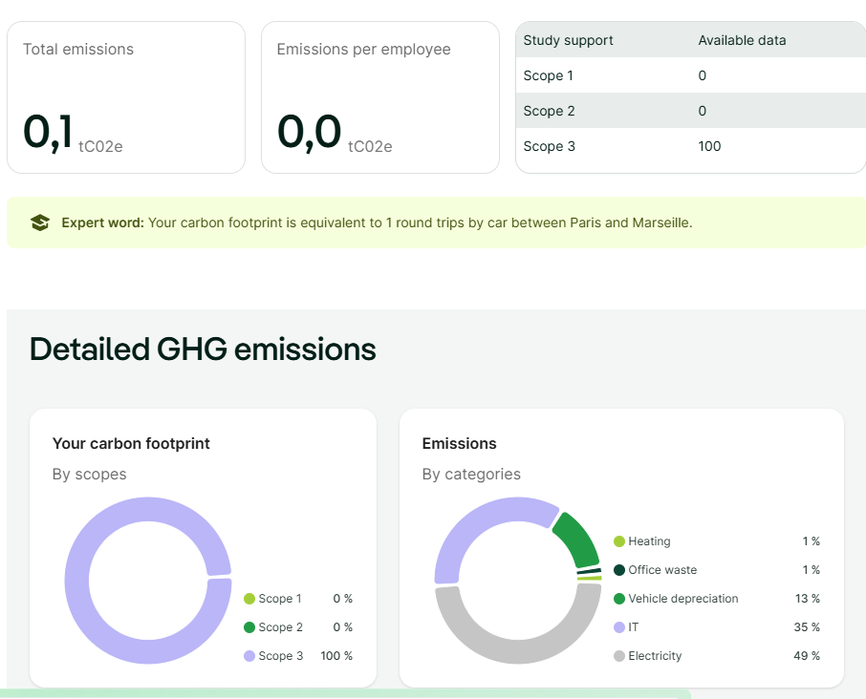
2026

2025
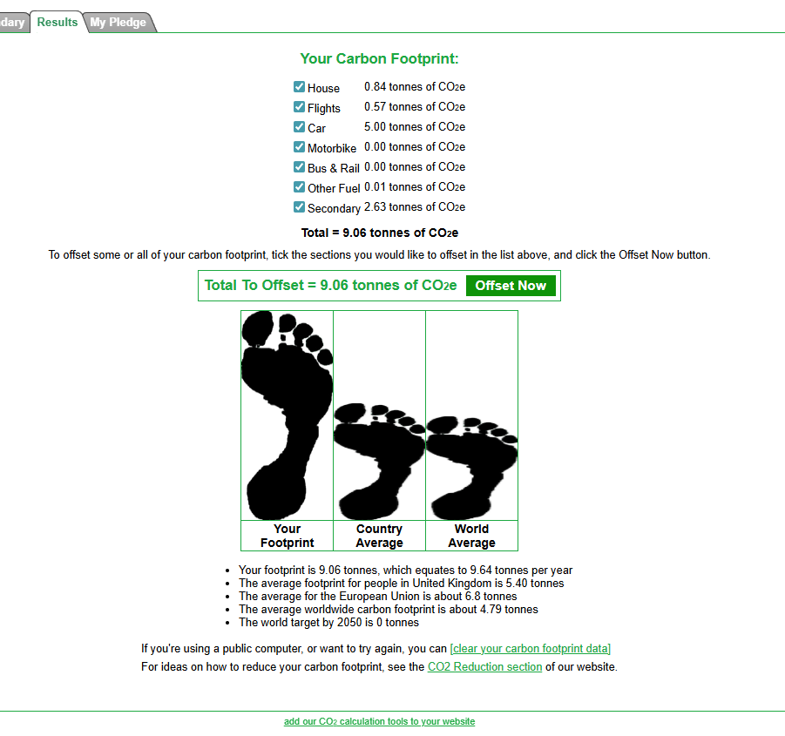
2024
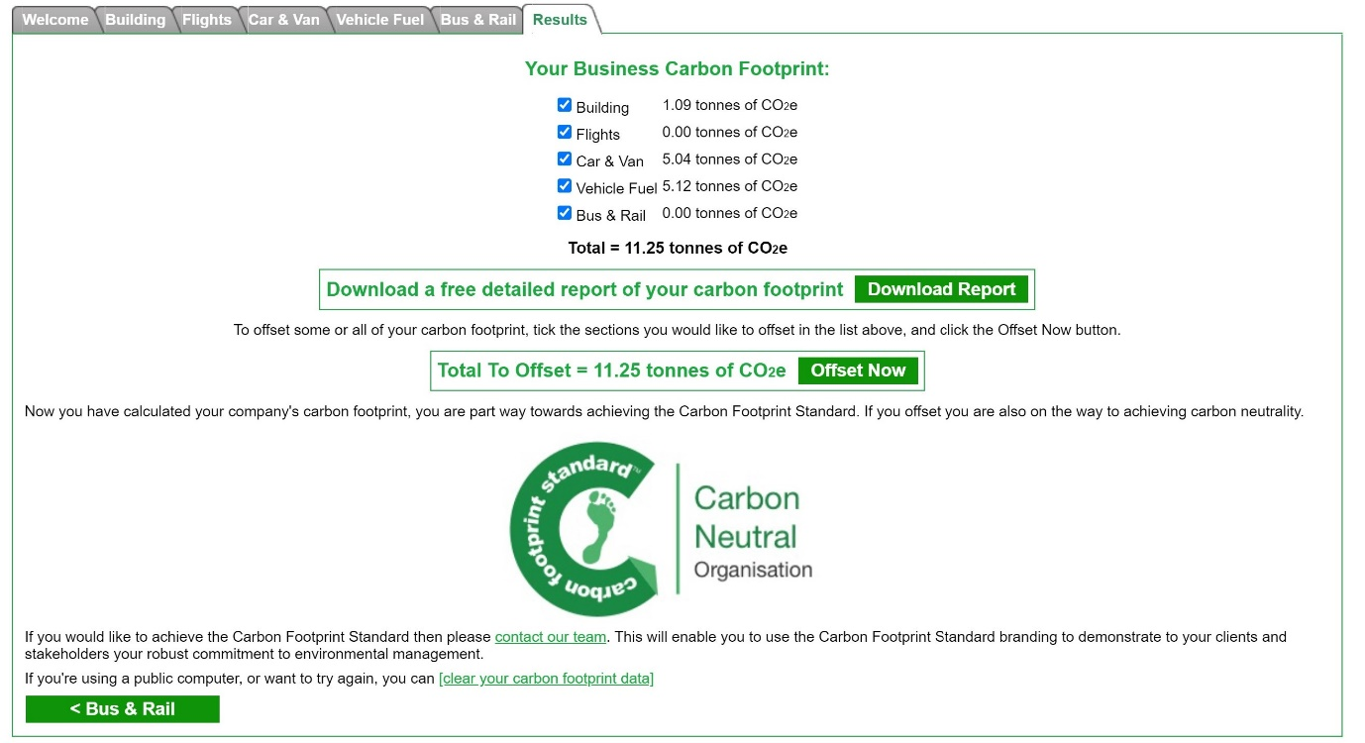

6. Environmental Commitments
Atypical Education is a small home business. The recent replacement of heating systems, LED lighting, double-glazed windows, and solar energy has reduced the family and business's energy impact. We grow food for our cookery lessons on our allotment. Students live in the same village, so transportation is reduced.
Firstly, we will reduce our emissions as much as possible, and secondly, we will offset the remaining emissions. Offsetting involves investing in projects that remove greenhouse gases from the atmosphere by planting trees or supporting renewable energy initiatives.

7. Environmental Targets
- To update this strategy each academic year and publish our progress against the targets
- To regularly update the school community with news of our sustainability projects
- To complete the UN Climate Change teacher training

