Child Protection and Safeguarding Policy

Atypical Education



Policy Consultation & Review

The policy is provided to all staff at induction alongside our Staff Code of Conduct and behaviour policy. In addition, all staff are provided with Part One of the statutory guidance ‘Keeping Children Safe in Education’.

All staff receive training on safeguarding procedures at Atypical Education on joining the company, with an annual update provided. In addition, all staff are provided with Keeping children safe in education - GOV.UK (www.gov.uk)staff are required to read Part One following the updates every September, and sign to say that they have read and understood the document.

Approved by: | Emma Oxnam | Date: 1st September 2022
Last reviewed on: | 1st September 2025
Next review due by: | 1st September 2026

Contents

- Key contacts
- Purpose and aims
- Company ethos
- Roles and responsibilities
- Training and induction
- Procedures for managing concerns
- Specific safeguarding issues
- Recording and information sharing
- Working with commissioners
- Child Protection conferences
- Safer recruitment
- Safer working practice
- Managing allegations and concerns
- Relevant policies and guidance
- Appendix 1 Recording form for reporting concerns
- Appendix 2 Induction checklist for staff and volunteers
- Appendix 3 Local safeguarding procedures [CADS]
- Appendix 4 Advice for providers where there are concerns about an adult who works within the setting
- Appendix 5 Confirmation of staff safeguarding checks for commissioners

Key contacts

Role | Name | Contact Details
Designated Safeguarding Lead | Emma Oxnam | 07471 344408  emma.atypicaleducation@gmail.com
Alternative Safeguarding Lead | Sharon Ungless | 07359771710  sharon.atypicaleducation@gmail.com
Customer First (Suffolk) |  | 0808 800 4005
SCC Child Missing Education |  | 01473 265224
Children's Advice and Duty Service (CADS)  Norfolk | Single point of contact for raising concerns about a child. | Children's Advice and Duty Service (CADS) NCC  0344 800 8021  03448008020 (24 hrs)
Local Authority Education Duty Desk (Norfolk) | Advice where there is a concern about an adult working with a child | n/a  01603 307797
LADO | Making Norfolk referrals about an adult who may have caused harm to a child, using LADO referral form | LADO@norfolk.gov.uk  01603 307797  Call the Duty Desk above for advice before making a LADO referral
 | Simon Hope (Suffolk) | LADOCentral@suffolk.gov.uk  0300 123 2044

Unregulated alternative provision settings must have due regard to the safeguarding of the children attending the placement. As noted in Working together to safeguard children - GOV.UK (www.gov.uk), Rapid reviews and child safeguarding practice reviews have highlighted that missed opportunities to record, understand the significance of, and share information on time can have severe consequences for children.

Within this policy, where the guidance is clear that the commissioner should be informed, the following applies in all cases, where the child:

- is on a school roll, contact the DSL at the home school
- is under the remit of the Alternative Education Service (Section 19 team) - Schools (norfolk.gov.uk), contact the relevant adviser/key contact
- is in care, and the placement has been commissioned by the Virtual School for Children in Care and Previously in Care - Schools (norfolk.gov.uk), contact the relevant adviser/key contact
- is electively home-educated, contact an adviser within Home Education - Schools (norfolk.gov.uk)

Purpose and aims

2.1 The purpose of Atypical Education’s safeguarding policy is to ensure every child who attends the setting is safe and protected from harm. This means we will always aim to be:
- providing help and support to meet the needs of children as soon as problems emerge
- protecting children from maltreatment, whether that is within or outside the home, including online
- preventing impairment of children’s mental and physical health or development
- ensuring that children grow up in circumstances consistent with the provision of safe and effective care
- promoting the upbringing of children with their birth parents, or otherwise, their family network
- taking action to enable all children to have the best outcomes in line with the outcomes set out in the Children’s Social Care National Framework.

2.2 This policy will give clear direction to all staff, visitors, commissioners, parents and carers and children about expected behaviour and our legal responsibility to safeguard and promote the welfare of all children at our setting.
2.3 Atypical Education fully recognises the contribution it can make to protect children from harm and supports and promotes the welfare of all children who attend our setting. The elements of our policy are prevention, protection and support. This policy applies to all children, staff, commissioners, parents and carers, and visitors.

Ethos

3.1 The child’s welfare is of paramount importance at Atypical Education. Our setting will establish and maintain an ethos where young people feel secure, are encouraged to talk, are listened to and are safe. Young people at our setting will be able to talk freely to any member of staff if they are worried or concerned about something. All staff will reassure victims that they are being taken seriously and that they will be supported and kept safe. Victims will never be given the impression that they are creating a problem by reporting abuse, sexual violence or sexual harassment.

3.2 We recognise that staff at our setting play an important role as they can identify concerns and provide help for children to prevent concerns from escalating. All staff are advised to maintain an attitude of ‘it could happen here’ when it comes to safeguarding. When concerned about the welfare of a child, staff must always act in the best interests of the child.

3.3 At Atypical Education, we ensure that safeguarding and child protection are at the forefront and underpin all relevant aspects of process and policy development. We operate with the best interests of the child at heart.

3.4 Where there is a safeguarding concern, the child’s wishes and feelings are considered when determining what action to take and what services to provide. The systems we have in place are well-promoted, easily understood and easily accessible for children to confidently report abuse, knowing their concerns will be treated seriously, and knowing they can safely express their views and give feedback. Our systems are designed to ensure that schools and other commissioners, such as the local authority, are informed without delay where there is a safeguarding concern.

3.5 All staff and regular visitors will, through training and induction, know how to recognise indicators of concern, how to respond to a child’s disclosure and how to record and report the information. We will not make promises to any child, and we will not keep secrets. Every child will understand what the adult will do with any information they disclose. All staff will be trained to recognise that children may not feel ready or know how to tell someone that they are being abused, exploited, or neglected, and/or they may not recognise their experiences as harmful. At all times, we will work in partnership and endeavour to establish effective working relationships with schools, other commissioners, parents, carers and colleagues from other agencies in line with Working Together to Safeguard Children and the Norfolk and Suffolk Multi-Agency Safeguarding Partnership arrangements.

3.6 Atypical Education recognises that pupils who may benefit from unregulated AP are often the most vulnerable children. They may have special needs (with or without an Education Health and Care Plan [EHCP]), medical needs, attendance difficulties, challenging behaviour, experienced adverse child experiences and trauma, a social worker, be suspended (after day 6), at risk of permanent exclusion, in care and/or known to supporting agencies such as the Youth Justice Service for example. We understand that children attending AP may feel more at ease (than at school, for example) and therefore make disclosures more readily than in school.

3.7 Atypical Education will ensure that, before placement, the following information is recorded:
- If a school is the commissioner, the name and contact details for the home school’s Designated Safeguarding Lead
- If the local authority is the commissioner, the name, telephone number and email for the local authority officer commissioning the placement and/or key contact at the Virtual School for Children in Care or Previously in Care, as appropriate
- A clear service level agreement on how safeguarding concerns will be communicated, followed up and by whom, and how regular communication between the home school/commissioner and Atypical Education will be assured
- Pupil-specific risk assessment
- Emergency contact details for the pupil
- Key medical information

3.8 We understand the importance of working in a way that adheres to the following legislation:
- The Human Rights Act 1998
- Equality Act 2010
- Public Sector Equality Duty
This means we do not unlawfully discriminate against children because of their sex, race, disability, religion or belief, gender reassignment, pregnancy and maternity, or sexual orientation (protected characteristics).

Roles and responsibilities

4.1 The proprietor Emma Oxnam of Atypical Education is responsible for ensuring that:
- All staff carry out all the requirements of this policy
- All staff work in a way that will safeguard and promote the welfare of all children attending the setting
- All staff receive appropriate safeguarding induction on appointment
- all staff are adequately trained to carry out safeguarding duties
- All staff maintain timely and detailed records of safeguarding
- The safeguarding lead has sufficient time to carry out their duties
- This policy is reviewed and updated annually
- All staff read and sign annually to say they have read and understood Part One of Keeping Children Safe in Education on GOV.UK (www.gov.uk) procedures are in place for dealing with allegations against members of staff
- Procedures are in place for promptly informing schools and commissioners of safeguarding concerns
- Safeguarding records are maintained confidentially and securely
- Safer recruitment practices are followed
- Placement procedures include details on when and how safeguarding concerns are reported back to schools and other commissioners
- Placement paperwork includes contact details for the commissioning schools’ Designated Safeguarding Lead
- sufficient information is provided to visitors on how to report a safeguarding concern (e.g., by providing a leaflet on arrival, or having a poster in reception)

4.2 The safeguarding lead, Emma Oxnam, is responsible for:
- informing schools and commissioners of safeguarding concerns without delay
- maintaining accurate safeguarding records
- ensuring that safeguarding records are maintained confidentially and securely
- maintaining an accurate central log of home school Designated Safeguarding Lead and/or other commissioner contact details

4.3 The proprietor and safeguarding lead(s) are advised to sign up to Norfolk Schools Ecourier to receive weekly Management Information [MI] sheets. These often contain safeguarding updates for schools and may be of value to unregistered AP settings.

Training and induction

5.1 When new staff join Atypical Education they will be informed of the safeguarding arrangements in place. All staff will annually be given a copy of this safeguarding policy, the Staff Code of Conduct, behaviour policy and Part One of Keeping children safe in education - GOV.UK (www.gov.uk). All staff are expected to read these key documents and sign a log to record that they have been read and understood. They will also be provided with contact details for the safeguarding lead(s) and information about how to record and report safeguarding concerns.
5.2 Every new member of staff will receive safeguarding training during their induction period. This programme will include information relating to signs and symptoms of abuse, how to manage a disclosure from a child (including reassuring victims that they are being taken seriously and that they will be supported and kept safe), how to record concerns, the processes for referral to Children’s Services and the remit of the safeguarding lead. The induction will also include information about whistleblowing in respect of concerns about another adult’s behaviour and suitability to work with children. Staff will also receive online safety training, including understanding the expectations, applicable roles, and responsibilities concerning filtering and monitoring, as this is part of the overarching safeguarding approach of our setting.

5.3 In addition to the safeguarding induction, we will ensure that mechanisms are in place to assist staff to understand and discharge their role and responsibilities as set out in Part One of Keeping children safe in education - GOV.UK (www.gov.uk). To achieve this, we will ensure that:
- All staff undertake appropriate annual safeguarding training, and the proprietor and safeguarding lead(s) will evaluate the impact of this training
- all staff receive regular safeguarding and child protection updates (for example, via email, e-bulletins, staff meetings), as required, but at least annually, to provide them with relevant skills and knowledge to safeguard children

5.4 All staff, volunteers and commissioners will be informed of our safeguarding procedures, including how to contact the safeguarding lead(s), how to record a concern and pass it on. Parent carers will be signposted to the policy on our website.

Procedures for managing concerns

6.1 Atypical Education adheres to child protection procedures that have been agreed locally through the Norfolk Safeguarding Children Partnership and Suffolk Safeguarding Partnership. Where we identify children and families in need of support, we will notify the commissioner without delay and work in partnership with them and other agencies which may subsequently become involved.

6.2 All staff are encouraged to report any concerns that they have and not see these as insignificant. On occasion, a referral is justified by a single incident such as an injury or disclosure of abuse. More often, however, concerns accumulate over a period of time and are evidenced by building up a picture of harm over time; this is particularly true in cases of emotional abuse and neglect. In these circumstances, it is crucial that staff record and pass on concerns in accordance with this policy immediately to allow the safeguarding lead to pass this information on to the home school or other commissioner.

6.3 It is not the responsibility of Atypical Education staff to investigate welfare concerns or determine the truth of any disclosure or allegation. All staff, however, have a duty to recognise concerns and pass the information on to commissioners in accordance with the procedures outlined in this policy.

6.4 The safeguarding lead should be used as a first point of contact for concerns and queries regarding safeguarding. Any member of staff or visitor who receives a disclosure of abuse or suspects that a child is at risk of harm must report it immediately to the safeguarding lead, or if unavailable, to the alternate designated person. In the absence of either of the above, the matter should be brought to the attention of the most senior member of staff on site.

6.5 All concerns about a child or young person should be reported without delay and recorded in writing using the agreed system in the setting (see Appendix 1). Records should include:
- a clear and comprehensive summary of the concern
- the time and date that the concern was communicated to the home school/commissioner
- details of how the concern was followed up and resolved
- a note of any action taken, decisions reached and the outcome

6.6 Following receipt of any information raising concern, the safeguarding lead will pass this on without delay to:
- The home school Designated Safeguarding Lead, or
- Other commissioner, or
- Services to Home Educators Team if the child is electively home educated by their parent, or
- The relevant Norfolk County Council officer if the child is not on the roll of a school, but has been placed by the local authority, for example on an EOTAS package.

6.7 If, at any point, there is a risk of immediate serious harm to a child a referral should be made to Children's Advice and Duty Service (CADS) immediately on 0344 800 8021 . Or Customer First in Suffolk (0808 800 4005).
Anyone can make a referral in these circumstances. If the child’s situation does not appear to be improving, the staff member with concerns should press for reconsideration by raising concerns again with the safeguarding lead. Concerns should always lead to help for the child at some point.

6.8 Staff should always follow the reporting procedures outlined in this policy in the first instance. However, they may also share information directly with Norfolk Children’s Advice & Duty Service, Suffolk Customer First or the police if:
- The situation is an emergency, and the safeguarding lead, their deputy and the proprietor are unavailable
- They are convinced that a direct report is the only way to ensure the child’s safety.

6.9 Any staff member who does not feel that concerns about a child have been responded to appropriately and in accordance with the procedures outlined in this policy should raise their concerns with the proprietor. If any staff member does not feel the situation has been addressed appropriately at this point should contact Children's Advice and Duty Service (CADS) or Customer First directly with their concerns.

Specific Safeguarding Issues

Contextual safeguarding

7.1 We recognise that safeguarding incidents and/or behaviours can be associated with factors outside of the setting’s environment and/or can occur between children outside of the setting. This is known as contextual safeguarding. It is key that all school staff understand the definition of contextual safeguarding and consider whether children are at risk of abuse or exploitation in situations outside their families. Through training, we will ensure that staff and volunteers are aware that extra-familial harms take a variety of different forms and children can be vulnerable to multiple harms, including (but not limited to) sexual exploitation, criminal exploitation, and serious youth violence. When reporting concerns, staff should include as much information and background detail as possible for the safeguarding lead to report to the home school Designated Safeguarding Lead or other commissioner to provide a holistic view of the child. This will allow any assessment to consider all the available evidence and the full context of any abuse.

7.2 We recognise that children with special educational needs or disabilities (SEND) or certain health conditions can face additional safeguarding challenges, such as
- assumptions that indicators of possible abuse, such as behaviour, mood and injury, relate to the child’s condition without further exploration
- children with SEN and disabilities can be disproportionately impacted by things like bullying, without outwardly showing any signs; and
- communication barriers and difficulties in overcoming these barriers.

7.3 We recognise that a previously looked after child potentially remains vulnerable and all staff should have the skills, knowledge and understanding to keep previously looked after children safe. During pre-placement arrangements, we will ensure that key contacts for the Virtual School are named, and agreement is reached on how and when the Virtual School should be informed of a safeguarding concern.

Child Sexual Exploitation [CSE], Child Criminal Exploitation [CCE]: County Lines and serious violence

7.4 We train staff to recognise that both CSE and CCE are forms of abuse and both occur where an individual or group takes advantage of an imbalance in power to coerce, manipulate or deceive a child into sexual or criminal activity. Whilst age may be the most obvious, this power imbalance can also be due to a range of other factors, including gender, sexual identity, cognitive ability, physical strength, status, and access to economic or other resources. Victims can be exploited even when activity appears consensual, and it should be noted that exploitation, as well as being physical, can be facilitated and/or take place online.

7.5 We recognise that CSE is a form of child sexual abuse, and this imbalance of power coerces, manipulates or deceives a child or young person into sexual activity (a) in exchange for something the victim needs or wants, and/or (b) for the financial advantage or increased status of the perpetrator. CSE does not always include physical contact; it can also occur using technology. We understand that some children may not realise they are being exploited, e.g., they may believe they are in a genuine romantic relationship.

7.6 We understand that CCE is a geographically widespread form of harm that is a typical feature of county lines criminal activity. Drug networks or gangs groom and exploit children and young people to carry drugs and money from urban areas to suburban and rural areas, market and seaside towns. The key to identifying potential involvement in county lines is missing episodes when the victim may have been trafficked to transport drugs.

7.7 We understand that children can become trapped by this type of exploitation as perpetrators can threaten victims (and their families) with violence or entrap and coerce them into debt. They may be coerced into carrying weapons such as knives or begin to carry a knife for a sense of protection from harm from others. We will treat these children as victims, understanding that they have been criminally exploited, even if the activity appears to be something they have agreed to or consented to. We recognise the experience of girls who are criminally exploited can be very different to that of boys and that both boys and girls being criminally exploited may be at higher risk of sexual exploitation.

7.8 At Atypical Education, staff are aware of the indicators and risk factors which may signal a child is vulnerable to or involved with serious violent crime. We refer to the Home Office’s Preventing youth violence and gang involvement and Criminal exploitation of children and vulnerable adults: county lines guidance for more information.

7.9 If a child is suspected to be at risk of or involved in county lines, the home school or other commissioner will be informed immediately.

So-called ‘honour-based violence (including Female Genital Mutilation [FGM] and Forced Marriage)

7.10 We recognise that our staff are well placed to identify concerns and take action to prevent children from becoming victims of FGM and other forms of so-called ‘honour-based’ violence [HBV] and provide guidance on these issues through our safeguarding training. If staff have a concern regarding a child that might be at risk of HBV, they should inform the safeguarding lead, who will inform the home school or other commissioner immediately.

7.11 Where FGM has taken place, since 31 October 2015, there has been a mandatory reporting duty placed on teachers. Section 5B of the Female Genital Mutilation Act 2003 (as inserted by section 74 of the Serious Crime Act 2015) places a statutory duty upon teachers in England and Wales, to report to the police where they discover (either through disclosure by the victim or visual evidence) that FGM appears to have been carried out on a girl under 18. Those failing to report such cases will face disciplinary sanctions. Further information on when and how to make a report can be found at: Mandatory Reporting of Female Genital Mutilation- procedural information, Home Office (January 2020).

7.12 We recognise that forcing a person into a marriage is a crime in England and Wales. A forced marriage is one entered into without the full and free consent of one or both parties, where violence, threats or any other form of coercion is used to cause a person to enter a marriage. Threats can be physical, emotional, or psychological. The Forced Marriage Unit has statutory guidance and Multi-agency guidelines and can be contacted for advice or more information: Contact 020 7008 0151 or email fmu@fco.gov.uk

Preventing radicalisation and extremism

7.13 We recognise that safeguarding against radicalisation and extremism is no different to safeguarding against any other vulnerability in today’s society. We will ensure that:
- Through training, staff understand what radicalisation and extremism are, why we need to be vigilant and how to respond when concerns arise
- The safeguarding lead will notify the home school or commissioner of any concerns in this area without delay
- There are systems in place for keeping children safe from extremist material when accessing the internet in our setting by using effective filtering and usage policies
- The safeguarding lead has received Prevent training and will act as the point of contact for any concerns relating to radicalisation and extremism
- The safeguarding lead may make referrals in accordance with Prevent duty - Norfolk Schools and Learning Providers - Norfolk County Council and Suffolk Prevent Referral may represent our setting at Channel meetings as required

Child-on-child sexual violence and sexual harassment

7.14 All staff are trained so that they are aware that safeguarding issues can manifest themselves via child-on-child abuse. This is most likely to include, but may not be limited to:
- bullying (including cyberbullying)
- physical abuse such as hitting, kicking, shaking, biting, hair pulling, or otherwise causing physical harm
- sexual violence and sexual harassment
- upskirting
- sexting (also known as youth-produced sexual imagery)
- initiation/hazing type violence and rituals

7.15 We recognise that children are vulnerable to physical, sexual and emotional abuse by other children or siblings. Abuse perpetrated by children can be just as harmful as that perpetrated by an adult, so it is essential that all staff and volunteers remember the impact on both the victim of the abuse and focus on the support for the child or young person exhibiting the harmful behaviour. We understand that abuse can occur in intimate personal relationships between children, and that consensual and non-consensual sharing of nudes and semi-nude images and or videos (also known as sexting or youth-produced sexual imagery) It is a form of child-on-child abuse.

7.16 We understand that even if there are no reports in our setting, it does not mean it is not happening; it may be the case that it is just not being reported. We recognise that children may not find it easy to tell staff about their abuse and can show signs or act in ways that they hope adults will notice and react to. In some cases, the victim may not make a direct report, and this may come from a friend or a conversation that is overheard. Such abuse will always be taken as seriously as abuse perpetrated by an adult, and the same safeguarding children’s procedures will apply in respect of any child who is suffering or likely to suffer significant harm. Staff must never tolerate or dismiss concerns relating to child-on-child abuse, and they will constantly challenge this. It must never be tolerated or passed off as ‘banter’, ‘just having a laugh’ or ‘part of growing up’. Doing this can lead to a culture of unacceptable behaviours, an unsafe environment for children and in worst-case scenarios, a culture that normalises abuse, leading to children accepting it as normal and not coming forward to report it.

7.17 We regularly review decisions and actions, and relevant policies are updated to reflect any lessons learnt. We look out for potential patterns of concerning, problematic or inappropriate behaviour. Where a pattern is identified, we decide upon an appropriate course of action.

7.18 At Atypical Education, all staff will reassure victims that they are being taken seriously and that they will be supported and kept safe. Victims will never be given the impression that they are creating a problem by reporting abuse, sexual violence or sexual harassment. Nor will a victim ever be made to feel ashamed for making a report. We will also offer appropriate support to the perpetrator and any other children involved.

7.19 All staff will understand that they should follow our safeguarding procedures for reporting a concern if they are worried about child-on-child abuse. The safeguarding lead will notify the home school or other commissioner of any safeguarding concerns in this area without delay.

7.20 In liaison and with the agreement of the home school Designated Safeguarding Lead or other commissioner, we will work with other agencies, including the police and Children’s Services, as required to respond to concerns about sexual violence and harassment. Where agreed with the home school Designated Safeguarding Lead or other commissioner, we will seek consultations where there are concerns or worries about developmentally inappropriate or harmful sexual behaviour from the Harmful Sexual Behaviour (HSB) Team as required, so that we ensure we are offering the right support to the child(ren). Where appropriate, we will share risk assessments and/or advice from the HSB team with the commissioner.

7.21 Support will depend on the circumstances of each case and the needs of the child, it may include completion of risk assessments to support children to remain in the setting whilst safeguarding other children and the victim, delivery of early intervention in respect of HSB and/or referral to The Harbour Centre Sexual Assault Referral Centre (SARC) where a pupil discloses a rape, an attempted rape or a serious sexual assault whether this has happened recently or in the past. The assault does not have to have taken place in Norfolk, but the victim must live in Norfolk to access support. The SARC also has a 24/7 helpline 01603 276381 if pupils or staff need to speak to a Crisis Worker for help & advice. Referral forms can be found on The Harbour Centre website. Any actions should be agreed with the home school Designated Safeguarding Lead or other commissioner.

Modern Slavery

7.22 We understand that modern slavery encompasses human trafficking and slavery, servitude and forced or compulsory labour. Exploitation can take many forms, including sexual exploitation, forced labour, slavery, servitude, forced criminality and the removal of organs. We refer to the DfE guidance Modern slavery: how to identify and support victims for concerns of this nature.

The safeguarding lead will notify the home school or other commissioner of any safeguarding concerns in this area without delay.

Safeguarding responses to children who go missing

7.23 At Atypical Education, all staff should be aware of the safeguarding responsibilities for children who are absent or go missing from the setting, particularly on repeat occasions, to help identify the risk of abuse and neglect, including sexual abuse or exploitation, and to help prevent the risks of their going missing in future.

We adhere to the following procedures and processes to ensure there is an appropriate safeguarding response to children who are missing:
- An attendance register is taken at the start of the first session of each day
- Attendance (positive attendance, lateness and absences) is reported to the home school/commissioner within 30 minutes of the child’s planned arrival or as per the expectations within the contract
- We hold at least two emergency contact numbers for each of the children who attend our setting, wherever possible
- If a child absconds, the home school/commissioner and parent/carer will be informed immediately.
- Staff will alert the safeguarding lead to any concerns raised regarding absent children
- Children will not be permitted to leave the AP site during the session, unless, for example, it is for a pre-arranged appointment or trip
- Any absence concerns will be discussed with the commissioner without delay

Mental Health

7.24 At Atypical Education, all staff are made aware, through training, that mental health problems can, in some cases, be an indicator that a child has suffered or is at risk of suffering abuse, neglect or exploitation. Our staff are well placed to observe children day-to-day and identify those whose behaviour suggests that they may be experiencing a mental health problem or be at risk of developing one.

7.25 We understand that where children have suffered abuse and neglect, or other potentially traumatic adverse childhood experiences, this can have a lasting impact throughout childhood, adolescence and into adulthood. Therefore, through training, staff are aware of how children’s experiences can impact their mental health, behaviour and education. All staff are aware that if they have a mental health concern about a child, that is also a safeguarding concern, they should take immediate action by passing the information on to the safeguarding lead. The safeguarding lead will notify the home school or other commissioner of any safeguarding concerns in this area without delay.

Online Safety

7.26 At Atypical Education, all staff are aware that technology is a significant component in many safeguarding and wellbeing issues. Children are at risk of abuse online as well as face-to-face. We understand that in many cases, abuse will take place concurrently online and in daily life. We know that children can also abuse other children online; this can take the form of abusive, harassing, and misogynistic messages, the non-consensual sharing of indecent images, especially around chat groups, and the sharing of abusive images and pornography.

7.27 As part of the requirement for staff to undergo regular updated safeguarding training, online safety training is also delivered. We will ensure that online safety is a running and interrelated theme, reflected in relevant policies, staff training, the role and responsibilities of the safeguarding lead, and any parental engagement

7.28 We recognise that technology, and risks and harms related to the internet, evolve and change rapidly. Therefore, we carry out an annual review of our approach to online safety, supported by a risk assessment (on at least an annual basis) that considers and reflects the risks that children face in our setting (even if the use of technology does not feature in their programme). For example, as a setting, we commit to ensuring that:

- Colleagues using the internet to carry out work tasks must do so in accordance with our online safety policy
- Colleagues will not use personal mobile and/or smart watch devices in front of children, nor use them to record any images or videos of children accessing our setting
- Colleagues will respect the rules regarding social media, as outlined in our online safety policy
- Parent carer consent will be sought regarding photo consent
- If photographs are taken of children to record progress, these will be stored securely

The safeguarding lead will notify the home school or other commissioner of any safeguarding concerns in this area without delay.

Cybercrime

7.29 We understand that cybercrime is criminal activity committed using computers and/or the internet. It is broadly categorised as either ‘cyber-enabled’ (crimes that can happen offline but are enabled at scale and at speed online) or ‘cyber-dependent’ (crimes that can be committed only by using a computer).

If there are concerns about a child in this area, the safeguarding lead must notify the home school or other commissioner without delay.

Domestic Abuse

7.30 At Atypical Education, all staff are aware that domestic abuse can encompass a wide range of behaviours and may be a single incident or a pattern of incidents. That abuse can be, but is not limited to, psychological, physical, sexual, financial or emotional. We understand that children can be victims of domestic abuse. Where they see, hear or experience the effects, this can have a detrimental and long-term impact on their health, well-being, development, and ability to learn. We are aware of the Norfolk Integrated Domestic Abuse Service (NIDAS) and signpost victims to the service. Norfolk and Suffolk Victim Care are available to offer support where the threshold for NIDAS support has not been met. Lighthouse offer support with Suffolk - Lighthouse | From a brighter future, free from domestic abuse

If there are concerns about a child in this area, the safeguarding lead will notify the home school or other commissioner without delay.

Children with special educational needs and disabilities or physical health issues

7.31 We recognise that children with special educational needs or disabilities (SEND) or certain health conditions can face additional safeguarding challenges, such as
  - assumptions that indicators of possible abuse, such as behaviour, mood and injury, relate to the child’s condition without further exploration
  - These children are more prone to peer group isolation or bullying (including prejudice-based bullying) than other children
  - the potential for children with SEND or certain medical conditions being disproportionately impacted by behaviours such as bullying, without outwardly showing any signs; and
  - communication barriers and difficulties in managing or reporting these challenges.
7.32 We work to address these additional challenges and consider extra pastoral support and attention for these children, along with ensuring any appropriate support for communication is in place.
7.33 We also recognise that pupils who attend Alternative Provision will often have complex needs, and due to this, we are aware of the additional risk of harm these children may be vulnerable to.

Children who are lesbian, gay, bisexual or transgender [LGBT]

7.34 The fact that a child or a young person may be lesbian, gay, bisexual or questioning their gender is not in itself an inherent risk factor for harm. However, in line with ‘Keeping Children Safe in Education’, we recognise that these children and in some cases children who other children perceive to be lesbian, gay or bisexual can be just as vulnerable as children who are. Therefore, we work to reduce any additional barriers faced and provide a safe space for these children to speak out or share their concerns with members of staff. Through our curriculum, we counter homophobic, biphobic and transphobic bullying and abuse.

If there are concerns about a child in this area, the safeguarding lead will notify the home school or other commissioner without delay.

Recording and information sharing

8.1 If staff are concerned about the welfare or safety of any child at Atypical Education, they will record their concern either on the agreed reporting form (Appendix 1) or through the setting’s electronic system. Any concerns should be passed to the safeguarding lead without delay.

8.2 Any information recorded will be kept in a separate named file, in a secure cabinet if a paper system is used and not with the child’s progress file. These files will be the responsibility of the safeguarding lead. Child protection information will only be shared within the setting based on ‘need to know in the child’s interests’ and on the understanding that it remains strictly confidential.

8.3 Child protection information will be kept up to date. Each concern logged will include:
  - a clear and comprehensive summary of the concern and when it was logged
  - details of how and when the home school/commissioner was informed
  - a note of any action taken, decisions reached and the outcome
  - We will keep detailed, accurate, secure written records of all concerns, discussions and decisions made, including the rationale for those decisions.

8.4 Records of concern, copies of referrals, invitations to child protection conferences, core groups and reports will be stored on the child’s file, whether an electronic or paper system is used.

8.5 When a child leaves our setting, the safeguarding lead will contact the Designated Safeguarding Lead at the home school and will ensure that the child protection file is forwarded to the school. This will be within 5 days of a placement ending.

8.6 If the child is not on a school roll, Atypical Education will follow its GDPR/Data policy and confidentially destroy the file after 5 years.

8.7 We will retain evidence to demonstrate how the file has been transferred; this may be in the form of a written confirmation of receipt from the receiving school and/or evidence of recorded delivery.

Working with commissioners

9.1 Atypical Education communicates primarily with the home school or commissioner where there are safeguarding concerns.

9.2 We are committed to working in partnership with home schools, commissioners and parents and/or carers to safeguard and promote the welfare of children and to support them to understand our statutory responsibilities in this area.

9.3 When new children join our setting, home schools, commissioners and parents and/or carers (if the child is home-educated) will be informed that we have a safeguarding policy. A copy will be provided on request and is available on our website at www.atypicaleducation.co.uk. Parents and/or carers will be informed of our legal duty to assist colleagues in other agencies with child protection enquiries, and the process should we need to contact the Children's Advice and Duty Service (CADS) or Customer First.

9.4 We are committed to working with parents and/or carers positively, openly and honestly. We ensure that all parent carers are treated with respect, dignity and courtesy. We respect parents ' and carers’ rights to privacy and confidentiality and will not share sensitive information unless we have permission or it is necessary to do so to safeguard a child from harm.

9.5 To keep children safe and provide appropriate care for them, Atypical Education requires commissioners and parents and/or carers to submit accurate and up-to-date information regarding:
- full names and contact details of all adults with whom the child normally lives
- full names and contact details of all persons with parental responsibility (if different from above)
- emergency contact details (if different from above)
- full details of any other adult authorised by the parent/carer to collect the child from the setting (if different from the above)

9.6 We will retain this information in the child’s file. The setting will only share information about children with adults who have parental responsibility or where a parent carer has given permission, and we have been supplied with the adult’s full details in writing.

Child Protection conferences

10.1 Children’s Services will convene a Child Protection conference once a child protection enquiry under Section 47 of the Children Act 1989 has been undertaken and the child is judged to be at continuing risk of significant harm. A review conference will take place once a child has been made the subject of a Child Protection Plan to monitor the safety of the child and the required reduction in risk.

10.2 The home school/commissioner would normally be the education representative at such meetings. However, our staff members may be asked to attend a child protection conference or core group meetings in respect of individual children. Usually, the person representing Atypical Education at these meetings will be the safeguarding lead. The person attending will need to have as much relevant, up-to-date information about the child as possible; any member of staff may be required to contribute to this process.

10.3 All reports for child protection conferences will be prepared in advance using the information and templates available at NSCP. The information contained in the report will be shared with parents/carers before the conference as appropriate. It will include information relating to the child’s physical, emotional and intellectual development and the child’s presentation at Atypical Education. In order to complete such reports, all relevant information will be sought from staff working with the child.

Safer recruitment

11.1 We will ensure that the proprietor and at least one other senior leader have completed appropriate safer recruitment training. At all times, the proprietor will ensure that safer recruitment practices are followed, broadly in line with those detailed in Part 3 of Keeping children safe in education. At least one person involved in conducting an interview will have received safer recruitment training.

11.2 We will use the recruitment and selection process to deter and prevent people who are unsuitable to work with children from applying for or securing employment or volunteering opportunities.

11.3 We require details of a candidate’s present (or last) employment and reason for leaving; full employment history (since leaving school, including education, employment and voluntary work), including reasons for any gaps in employment and evidence of original academic certificates. We do not accept testimonials and insist on taking up references prior to the interview. We will question the contents of application forms if we are unclear about them, and shortlisted candidates will be asked to complete a self-declaration of their criminal record or information that would make them unsuitable to work with children.

11.4 We use a range of selection techniques to identify the most suitable person for the post. The interview panel agrees on structured questions, and any potential areas of concern are explored to determine the applicant’s suitability to work with children. We will undertake Disclosure and Barring Service (DBS) checks on all staff, volunteers and trustees to ensure we are recruiting and selecting the most suitable people to work with children.

11.5 We will maintain a Single Central Record [SCR] of all safer recruitment checks carried out in line with recommendations from Keeping children safe in education. A senior member of staff will check the SCR regularly to ensure that it meets statutory requirements.

11.6 We recognise that safer recruitment is not just about carrying out the right DBS checks and is not limited to recruitment procedures. Therefore, we understand the importance of continuous vigilance, maintaining an environment that deters and prevents abuse and challenges inappropriate behaviour.

11.7 As per paragraph 334 of Keeping children safe in education we will ensure that written confirmation is provided to all home schools and commissioners that appropriate safeguarding checks have been carried out on our staff, i.e., those checks that the school would otherwise perform in respect of its own staff. Appendix 4 provides a sample form for this purpose. Appendix 4 also provides a checklist for the suggested organisation of staff files.

Safer Working Practice

12.1 All adults who come into contact with our children have a duty of care to safeguard and promote their welfare. There is a legal duty placed upon us to ensure that all adults who work with or on behalf of our children are competent, confident and safe to do so.

12.2 All staff and volunteers will be provided with a copy of the Staff Code of Conduct at induction. They will be expected to know our Code of Conduct and carry out their duties in accordance with this advice.

12.3 If staff or volunteers are working with children alone, they will be expected to inform another member of staff of their whereabouts, who they are with and for how long.

  - Guidance about acceptable conduct and safe practice will be given to all staff and volunteers during induction. These are sensible steps that every adult should take in their daily professional conduct with children.

  - Please refer to our organisation’s lone-working policy and/or safeguarding procedure for carrying out home visits and/or sessions in community spaces as applicable.

Managing allegations against staff and volunteers

13.1 Allegations that may meet the harms threshold
We aim to provide a safe and supportive environment which secures the well-being and very best outcomes for the children. We do recognise that sometimes the behaviour of adults may lead to an allegation of abuse being made.

13.2 Allegations sometimes arise from a differing understanding of the same event, but when they occur, they are distressing and challenging for all concerned. We also recognise that many allegations are genuine and some adults deliberately seek to harm or abuse children. We work to the thresholds for harm as set out in Working together to safeguard children (2023) and Keeping Children Safe in Education. An allegation may relate to a person who works/volunteers with children who has:
- behaved in a way that has harmed a child, or may have harmed a child and/or
- possibly committed a criminal offence against or related to a child and/or
- behaved towards a child or children in a way that indicates they may pose a risk of harm to children; and/or
- behaved or may have behaved in a way that indicates they may not be suitable to work with children

13.3 The 4th bullet point above recognises circumstances where a member of staff is involved in an incident outside of Atypical Education which did not involve children but could have an impact on their suitability to work with children; this is known as transferrable risk.

13.4 We recognise our responsibility to report/refer allegations or behaviours of concern and/or harm to children by adults in positions of trust who are not employed by us to the LADO service directly. These are adults such as those in the voluntary sector, taxi drivers, escorts, and foster carers.

13.5 We will take all possible steps to safeguard our children and to ensure that the adults in our setting are safe to work with children. When concerns arise, we will always ensure that the procedures outlined in the local protocol Allegations Against Persons who Work with Children and Part 4 of Keeping Children Safe in Education are adhered to and will seek appropriate advice. The first point of contact for settings regarding concerns and/or allegations is via the Local Authority Education Duty Desk. A Duty Advisor (not a LADO) will give advice and guidance on next steps.

13.6 If an allegation is made or information is received about any adult who works/volunteers in our setting, which indicates that they may be unsuitable to work/volunteer with children, the member of staff receiving the information should inform the proprietor immediately. Should an allegation be made against the proprietor, this will be reported to the LADO.

13.7 The proprietor will seek advice from the LADO within one working day. No member of staff will undertake further investigations before receiving advice from the LADO.

13.8 Any member of staff who does not feel confident to raise their concerns with the proprietor should contact the LADO directly.

13.9 Further national guidance can be found at: Advice on whistleblowing. The NSPCC whistleblowing helpline is also available for staff who do not feel able to raise concerns regarding child protection failures internally. Staff can call: 0800 028 0285 – line is available from 8:00am to 8:00pm, Monday to Friday or via e-mail: help@nspcc.org.uk.

13.10 Atypical Education has a legal duty to refer to the Disclosure and Barring Service anyone who has harmed, or poses a risk of harm, to a child, or if there is reason to believe the member of staff has committed one of a number of listed offences, and who has been removed from working (paid or unpaid) in regulated activity or would have been removed had they not left. The DBS will consider whether to bar the person. If these circumstances arise in relation to a member of staff at our setting, a referral will be made as soon as possible after the resignation or removal of the individual in accordance with advice from the LADO and/or HR. If we need guidance on making a Barring Referral, we will contact the East of England DBS Outreach Advisor for support.

In the case of a teacher, we will also consider whether to refer the case to the Secretary of State (via the Teaching Regulation Agency) if the teacher is dismissed or the setting ceases to use the services of a teacher because of serious misconduct or might have dismissed them or ceased to use their services had they not left first.

13.11 Concerns that do not meet the harm threshold

The term ‘low-level’ concern does not mean that it is insignificant; it means that the behaviour towards a child does not meet the thresholds as stated above. In the ‘low-level’ concern process, the consultation is with the Local Authority Education Duty Desk. We recognise a low-level concern to be something which is
- inconsistent with the staff code of conduct, including inappropriate conduct outside of work; and
- does not meet the allegations threshold or is otherwise not considered serious enough to consider a referral to the LADO.

13.12 We promote an open and transparent culture in which all concerns about all adults working in or on behalf of the setting (including volunteers) are dealt with promptly and appropriately. Through training, staff are made aware of what low-level concerns are and understand the importance of reporting these concerns in writing.

13.13 Atypical Education staff report all low-level concerns to the safeguarding lead. If reported to the safeguarding lead, they will inform the proprietor, who will always be the ultimate decision maker in respect of all low-level concerns.

13.14 Through training and induction, we ensure that all staff understand the importance of self-referring, where, for example, they have found themselves in a situation which could be misinterpreted, might appear compromising to others, and/or on reflection, they believe they have behaved in such a way that they consider falls below expected professional standards.

13.15 We understand the importance of recording low-level concerns and the actions taken, considering these are being reported. The records are kept confidential and stored securely. We will review the records we hold to identify potential patterns and take action when needed. This could be through a disciplinary process, but also by referring to the Local Authority Education Duty Desk. Please note that where a child, parent, carer or staff member makes an allegation of harm, this will not be considered as a ‘low level’ concern without consultation with the Local Authority Education Duty Desk or the LADO service directly.

13.16 We recognise that low-level concerns should not be included in references unless they relate to issues which would normally be included in a reference, for example, misconduct or poor performance. However, where a low-level concern (or group of concerns) has met the threshold for referral to the LADO and has been found to be substantiated, it should be referred to in a reference.

Relevant policies and guidance

14.1 To underpin the values and ethos of our setting and our intent to ensure that children are appropriately safeguarded, the following policies are also included under our safeguarding umbrella:

- Staff Code of Conduct
- Behaviour which includes measures to prevent bullying (including cyberbullying, prejudice-based and discriminatory bullying)
- Recruitment & Selection which adheres to Part 3 of Keeping Children Safe in Education’.
- Online safety
- Whistleblowing

14.2 This policy makes reference to the following publications
8.3 Allegations Against Persons who Work/Volunteer with Children - Norfolk Safeguarding Children Partnership (norfolklscb.org)
Alternative provision - GOV.UK (www.gov.uk)
Independent school registration - GOV.UK (www.gov.uk)
Keeping children safe in education - GOV.UK (www.gov.uk)
Keeping children safe in out-of-school settings: code of practice - GOV.UK (www.gov.uk)
Mandatory reporting of female genital mutilation: procedural information - GOV.UK (www.gov.uk)
Policies and Procedures - Norfolk Safeguarding Children Partnership
Working together to improve school attendance - GOV.UK (www.gov.uk)
Working together to safeguard children - GOV.UK (www.gov.uk)

Appendix 1

Draft Recording Form for Safeguarding Concerns
Staff, volunteers and regular visitors are required to complete this form and pass it to the safeguarding lead if they have a safeguarding concern about a child in our setting.

Complete a Safeguarding concern online - Safeguarding Concern

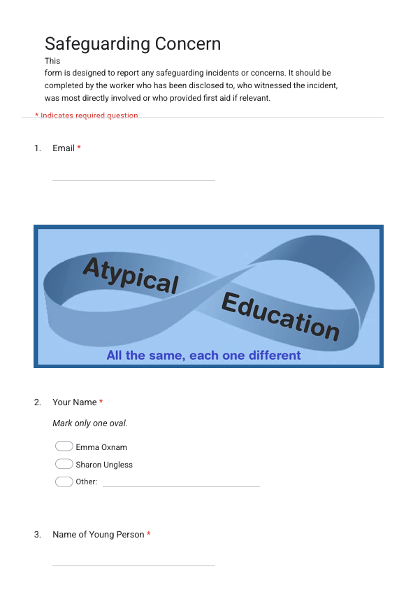
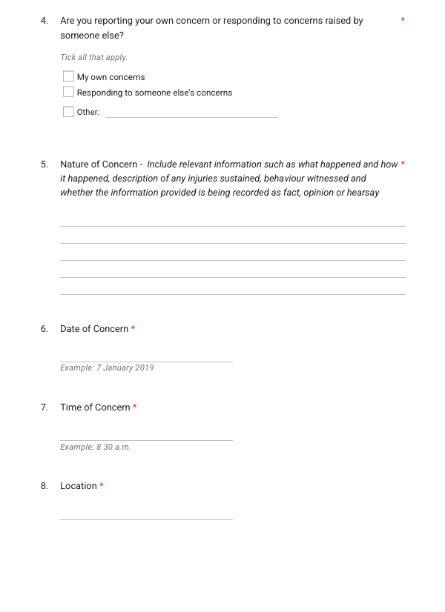
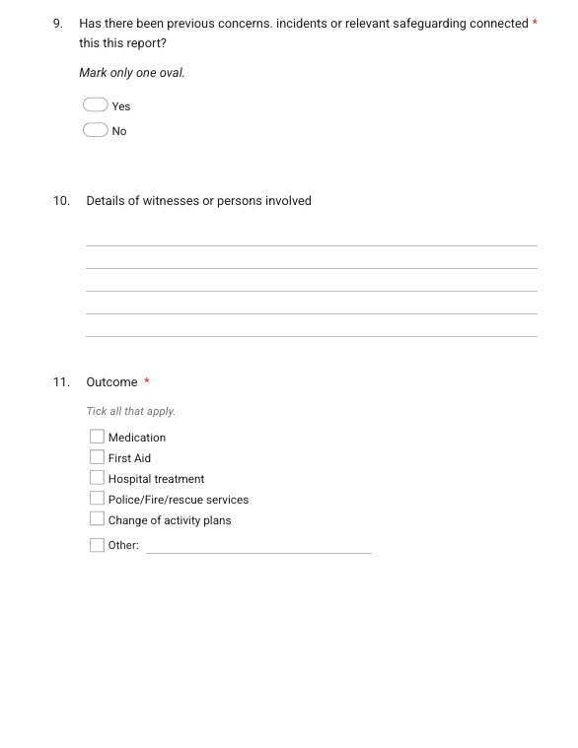
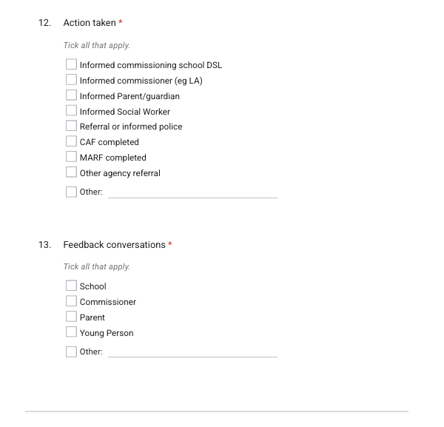

Body Map
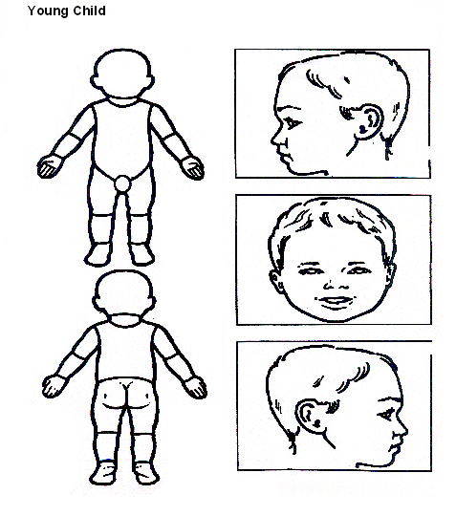

Indicate clearly where the injury was seen and attach this to the referral form

Body Map
Older Child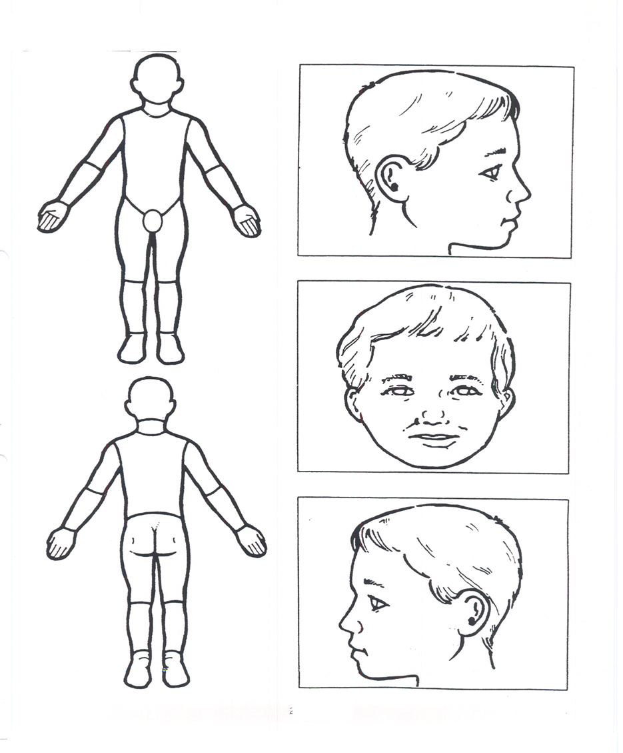
Indicate clearly where the injury was seen and attach this to the referral form.

Appendix 2

Safeguarding Induction Sheet for new staff, regular visitors, or volunteers.

We all have a statutory duty to safeguard and promote the welfare of children, and at Atypical Education, we take this responsibility seriously.

If you have any concerns about a child in our setting, you must share this information immediately with our Safeguarding Lead or one of the alternate postholders.
Do not think that your worry is insignificant if it is about hygiene, appearance or behaviour – we would rather you told us, as we would rather know about something that appears small than miss a worrying situation.

If you think the matter is very serious and may be related to child protection, for example, physical, emotional, sexual abuse or neglect, you must find one of the designated professionals detailed below and provide them with a written record of your concern.
If you are unable to locate them, ask a member of staff to find them and to ask them to speak with you immediately about a confidential and urgent matter.

Any allegation or low-level concern about a member of staff, a child’s foster carer or a volunteer should be reported immediately to the safeguarding lead. If an allegation is made about the proprietor, you should contact the Local Authority Duty Desk or LADO.

NSPCC whistleblowing helpline is also available for staff who do not feel able to raise concerns regarding child protection failures internally. Staff can call: 0800 028 0285 – line is available from 8:00am to 8:00pm, Monday to Friday or via e-mail: help@nspcc.org.uk.

The people you should talk to at Atypical Education are:

Safeguarding Lead: Emma Oxnam
Email: emma.atypicaleducation@gmail.com
Contact Number: 07471344408

Deputy Safeguarding Lead: Sharon Ungless
Email: sharon@atypicaleducation@gmail.com
Contact Number: 07359 771710

Appendix 3

Local safeguarding procedures

Children’s Advice and Duty Service [CADS] or Customer First (0808 800 4005)

Children's Advice and Duty Service (CADS) Norfolk County Council | Norfolk Community Directory or Child Safeguarding Concern (MARF)
Before contacting CADS or Customer First, please answer the following questions and follow the advice provided.

- Can you evidence that the child is experiencing or likely to suffer significant harm?
  - Yes
    - Do you have the consent of the parent/carer/young person to make contact, or have you informed them of your intention to do so?
      - Yes
        - Gather all the family’s details, including dates of birth, current address, current and working contact details and family composition, along with the history and current worries. Ensure that you have to hand details of any support already provided to the child or family.
      - No
        - Inform the parent/carer and/or gain their consent for you to make this contact unless doing so would put the child at risk
  - No
    - Have you discussed the child’s needs with your safeguarding lead or your line manager?
    - Discuss the child with your safeguarding lead or line manager if available and follow their advice when providing support to the family
- Call CADS on the professionals-only phone line 0344 800 8021 or Customer First (0808 800 4005).
- Make a record of the discussion.
- Follow the advice given by the consultant social worker.
- Keep a record of your own setting’s recording process
- The contact number for parents, carers and members of the public is 0344 800 8020.

Appendix 4

Appendix 5

Unregulated alternative provider safer recruitment checks

As per Keeping children safe in education - GOV.UK (www.gov.uk)

333. Where a school places a pupil with an alternative provision provider, the school continues to be responsible for the safeguarding of that pupil. It should be satisfied that the provider meets the needs of the pupil.

334. Schools should obtain written confirmation from the alternative provision provider that appropriate safeguarding checks have been carried out on individuals working at the establishment, i.e., those checks that the school would otherwise perform in respect of its staff.

Therefore, [name of school] is obliged to obtain written confirmation of the following (according to Part 3 of Keeping children safe in education - GOV.UK (www.gov.uk)
Prior to any placement being agreed, the following must be completed by the AP centre lead or proprietor, signed and returned to the school. Failure to complete this form may result in placements being paused or ceased and funding withdrawn.

Name of provision

Address of provision

Proprietor/centre lead name/role

Proprietor/centre lead contact telephone and email

Name and role(s) of colleagues who are safer recruitment trained
Date of safer recruitment training

I, the undersigned, confirm that in respect of all employees and volunteers at the above named unregulated alternative provision, the following checks and procedures are in place and affirm that all staff are suitable to work with children. I understand that the school may request sight of relevant documents during a pre or mid-placement visit.

- Staff files are in place and contain evidence of
  - Application forms containing
    - personal details (current and former names, current address and national insurance number)
    - details of their present (or last) employment and reason for leaving
    - full employment history
    - qualifications
    - details of at least 2 referees
    - a statement of personal qualities and experience
  - A self-declaration of any criminal record or information which may make them unsuitable to work with children
  - Evidence of right to work in the UK
  - Photocopies of 2 identity checks (with a photograph)
  - At least 2 references, including 1 from the applicant’s current or most recent employer
  - A risk assessment as required
  - Copies of interview notes which determine the applicant’s suitability to work with children
  - Photocopies of qualifications
- Staff tracker or single central record which includes:
  - Name and address of employee/volunteer
  - Date employment started
  - Date identity checks carried out and by whom
  - Date DBS checked and by whom
  - Risk assessment in place yes/no
  - Right to work in the UK checks – when and by whom
  - Qualifications check – when and by whom
  - Prohibition order checks- when and by whom (for those in ‘teaching activity’)

Signed

Date

Received by school (name/date)

Education other than at school
Note: this telephone number is only for professionals working with children. 0344 800 8020 should be used by members of the public.
UKCIS guidance: Sharing nudes and semi-nudes advice for education settings
See Safeguarding forms and templates for a template

