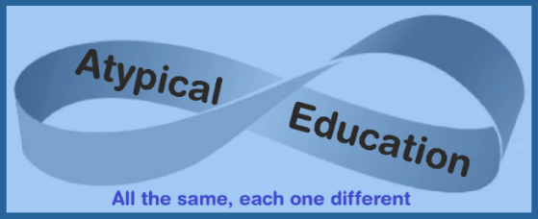

The Rectory, Church Road, Honington, Bury St Edmunds Suffolk IP31 1RG

emma.atypicaleducation@gmail.com 07471 344 408 www.atypicaleducation.co.uk

Transportation and Visits Permission Form

While your child is in the care of Atypical Education, we will be transporting them in private vehicles for various purposes, including visits. To ensure everyone’s safety, please observe the following rules:

- Everyone must wear their seatbelt at all times.

- Speak with respect—no swearing or shouting.

- Smoking is not permitted.

- Eating and drinking must be done responsibly.

- Windows should be used carefully, and there should be no leaning out.

- Music may be played at a sensible volume.

Please indicate your consent for the following:

* Atypical Education can transport my child to and from any provision, visit, and home.
* My child can participate in all educational visits, and if necessary, Atypical Education can sign in loco parentis.
* I am comfortable with paracetamol being administered to my child if required.

Alternatively, please indicate if you **do not wish** for your child to:

* to be transported
* participate in educational visits
* have paracetamol administered if required

Name of pupil

Signature Date

Name of parent

Signature Date