SAFEGUARDING POLICY FOR NON-SCHOOL ALTERNATIVE PROVISION INCORPORATING CHILD PROTECTION

Atypical Education
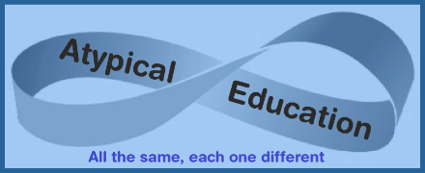

Policy Consultation & Review

This policy is on our website and is available on request from emma.atypicaleducation@gmail.com. We provide commissioners with this policy during pre-placement planning, and we also inform parents and carers about this policy when their children join our setting.

We recognise the expertise our staff build by undertaking safeguarding training and managing safeguarding concerns daily, and we therefore invite staff to contribute to and shape this policy and associated safeguarding arrangements.

We provide the policy to all staff at induction, alongside our Staff Code of Conduct and behaviour policy. In addition, all staff are provided with Part One of the statutory guidance ‘Keeping Children Safe in Education’.

All staff receive training on safeguarding procedures at Atypical Education on joining the company. An annual update is provided in September. In addition, all staff are provided with Keeping children safe in education - GOV.(www.gov.uk). Staff are required to read Part One following the updates every September and sign to confirm they have read and understood the document.

Approved by: | Emma Oxnam | Date: 1st September 2022
Last reviewed on: | 20th August 2026
Next review due by: | 20th August 2027

Contents
- Key contacts
- Purpose and aims
- Company ethos
- Roles and responsibilities
- Training and induction
- Procedures for managing concerns
- Specific safeguarding issues
- Recording and information sharing
- Working with commissioners
- Child Protection conferences
- Safer recruitment
- Safer working practice
- Managing allegations and concerns
- Relevant policies and guidance
- Appendix 1 Recording form for reporting concerns
- Appendix 2 Induction checklist for staff and volunteers
- Appendix 3 Children’s Advice and Duty Service [CADS] Safeguarding Process
- Appendix 4 Advice for providers where there are concerns about an adult who works within the setting
- Appendix 5 Confirmation of staff safeguarding checks for commissioners
- Appendix 6 Indicators of abuse and neglect

Key contacts
Name | Role | Email | Telephone
Emma Oxnam | Proprietor | emma.atypicaleducation@gmail.com | 07471 344408
Emma Oxnam | Safeguarding lead | emma.atypicaleducation@gmail.com | 07471 344408
Sharon Ungless | Safeguarding lead | sharon.atypicaleducation@gmail.com | 07359771710
Customer First (Suffolk) | Customer First (Suffolk) |  | 0808 800 4005
SCC Child Missing Education (Suffolk) | SCC Child Missing Education |  | 01473 265224
CADS | Single point of contact for raising concerns about a child. | Children's Advice and Duty Service (CADS) Norfolk County Council | Norfolk Community  Directory | 0344 800 8021
Local Authority Education Duty Desk | Advice where there is a concern about an adult working with a child. | n/a | 01603 307797
LADO (NCC) | Making referrals about an adult who may have caused harm to a child, using LADO referral form | LADO@norfolk.gov.uk | Call the Duty Desk above for advice before making a LADO referral
LADO (SCC) | Simon Hope (Suffolk) | LADOCentral@suffolk.gov.uk | 0300 123 2044

Non-school alternative provision settings must have due regard to the safeguarding of the children attending the placement. As noted in Working together to safeguard children - GOV.UK (www.gov.uk) (2026) Rapid reviews and child safeguarding practice reviews have highlighted that missed opportunities to record, understand the significance of, and share information in a timely manner can have severe consequences for children.

Within this policy, where the guidance is clear that the commissioner should be informed the following applies in all cases, where the child:
- is on a school roll, contact the DSL at the home school
- is under the remit of the Transitional Education Service - Norfolk Schools and Learning Providers - Norfolk County Council, contact the relevant adviser/key contact
- is in care, and the placement has been commissioned by the Virtual School for Children in Care and Previously in Care - Schools (norfolk.gov.uk), contact the relevant adviser/key contact
- is electively home-educated, contact an adviser within Home Education - Schools (norfolk.gov.uk)

Purpose and aims
  - The purpose of Atypical Education’s safeguarding policy is to ensure every child who attends the setting is safe and protected from harm. This means we will always aim to be:
- Provide help and support to meet the needs of children and young people as soon as problems emerge.
- Protect children from maltreatment, whether that is within or outside the home, including online.
- Prevent impairment of our children’s and young people’s mental and physical health or development.
- Ensure that children and young people at our setting grow up in circumstances consistent with the provision of safe and effective care.
- Take action to enable children and young people at our setting to have the best outcomes.

  - This policy will give clear direction to all staff, visitors, commissioners, parents and carers and children about expected behaviour and our legal responsibility to safeguard and promote the welfare of all children at our setting.

  - Atypical Education fully recognises the contribution it can make to protect children from harm and support and promote the welfare of all children who attend our setting. The elements of our policy are prevention, protection and support.

  - This policy applies to all children, staff, commissioners, parents and carers, and visitors.

Company ethos
  - The child’s welfare is of paramount importance at Atypical Education. Our setting will establish and maintain an ethos where young people feel secure, are encouraged to talk, are listened to and are safe. Young people at our setting will be able to talk freely to any member of staff if they are worried or concerned about something. All staff will reassure victims that they are being taken seriously and that they will be supported and kept safe. Victims will never be given the impression that they are creating a problem by reporting abuse, sexual violence or sexual harassment.

  - We recognise that staff at our setting play an important role as they are able to identify concerns and provide help for children to prevent concerns from escalating. All staff are advised to maintain an attitude of ‘it could happen here’ where safeguarding is concerned. When concerned about a child's welfare, staff must always act in the child's best interests.

  - At Atypical Education we ensure that safeguarding and child protection are at the forefront and underpin all relevant aspects of process and policy development. We operate with the best interests of the child at the heart of everything we do.

  - Where there is a safeguarding concern, the child’s wishes and feelings are considered when determining what action to take and what services to provide. The systems we have in place are well promoted, easily understood, and easily accessible, so children can confidently report abuse, knowing their concerns will be treated seriously and that they can safely express their views and give feedback. Our systems are designed to ensure that schools and other commissioners, such as the local authority, are informed without delay where there is a safeguarding concern.

3.5 All staff and regular visitors will, through training and induction, know how to recognise indicators of concern, how to respond to a child’s disclosure and how to record and report the information. We will not make promises to any child, and we will not keep secrets. Every child will know what the adult will have to do with any information they have disclosed. All staff will be trained to recognise that children may not feel ready or know how to tell someone that they are being abused, exploited, neglected, at risk of exploitation, serious violence or modern slavery, and/or they may not recognise their experiences as harmful.

3.6 At all times we will work in partnership and endeavour to establish effective working relationships with schools, other commissioners, parents, carers and colleagues from other agencies in line with Working Together to Safeguard Children (2026) and the Norfolk Multi Agency Safeguarding Partnership arrangements and Suffolk Multiagency working partnership.

3.7 Atypical Education recognises that pupils who may benefit from non-school AP are often the most vulnerable children. They may have special needs (with or without an Education, Health and Care Plan [EHCP]), medical needs, attendance difficulties, challenging behaviour, experienced adverse childhood experiences and trauma, a social worker, be suspended (after day 6), at risk of permanent exclusion, in care and/or known to supporting agencies such as the Youth Justice Service, for example. Atypical Education understands that children attending AP may feel more at ease (than at school, for example) and therefore make disclosures more readily than in school.

3.8 Atypical Education will ensure that, pre-placement, the following information is recorded:
    - If a school is the commissioner, the name and contact details for the home school’s Designated Safeguarding Lead.
    - If the local authority is the commissioner, the name, telephone number and email for the local authority officer commissioning the placement and/or key contact at the Virtual School for Children in Care or Previously in Care, as appropriate.
    - A clear service level agreement on how safeguarding concerns will be communicated, followed up and by whom, and how regular communication between the home school/commissioner and Atypical Education will be assured.
    - Pupil-specific risk assessment.
    - Emergency contact details for the pupil.
    - Key medical information.

Additional guidance on pre-placement procedures is available at
Non-school alternative provision templates - Norfolk Schools and Learning Providers - Norfolk County Council

3.9 At Atypical Education, we understand the importance of working in a way that adheres to the following legislation:
    - The Human Rights Act 1998
    - Equality Act 2010
    - Public Sector Equality Duty
    - Data Protection Act 2018, UK GDPR and the Data (Use and Access) Act 2025
This means we do not unlawfully discriminate against children because of their sex, race, disability, religion or belief, gender reassignment, pregnancy and maternity, or sexual orientation (protected characteristics).

Roles and responsibilities
  - The proprietor Emma Oxnam of Atypical Education is responsible for ensuring that:
    - all staff carry out all the requirements of this policy
    - all staff work in a way that will safeguard and promote the welfare of all children attending the setting
    - all staff receive appropriate safeguarding induction on appointment
    - all staff are adequately trained to carry out safeguarding duties
    - all staff maintain timely and detailed records of safeguarding
    - the safeguarding lead has sufficient time to carry out their duties
    - this policy is reviewed and updated annually
    - all staff read and sign annually to say they have read and understood Part One of Keeping children safe in education - GOV.UK (www.gov.uk) procedures are in place for dealing with allegations against members of staff
    - procedures are in place for promptly informing schools and commissioners of safeguarding concerns without delay
    - safeguarding records are maintained confidentially and securely
    - safer recruitment practices are followed
    - placement procedures to Atypical Education include detail on when and how safeguarding concerns are reported back to schools and other commissioners
    - placement paperwork includes contact details for the commissioning schools’ Designated Safeguarding Lead
    - sufficient information is provided to visitors on how to report a safeguarding concern (e.g., by providing a leaflet on arrival, or having a poster in reception)

  - The safeguarding lead, Emma Oxnam is responsible for:
    - informing schools and commissioners of safeguarding concerns without delay
    - maintaining accurate safeguarding records
    - ensuring that safeguarding records are maintained confidentially and securely
    - maintaining an accurate central log of home school Designated Safeguarding Lead and/or other commissioner contact details
    - providing advice and support to other staff on child welfare and child protection matters
    - representing our setting at child protection conferences and core group meetings.
    - liaising with Children’s Services and other agencies where necessary, and making referrals of suspected abuse to Children’s Services, taking part in strategy discussions and other interagency meetings and contributing to the assessment of children.
    - following the Norfolk Continuum of Needs Guidance produced by the Norfolk Safeguarding Children Partnership (NSCP)

  - The proprietor and safeguarding lead(s) are advised to sign up to Together e-Courier to receive the weekly newsletter which goes to all schools. These often contain safeguarding updates for schools and may be of value to non-school AP settings.

Training and induction
5.1 When new staff join Atypical Education, they will be informed of the safeguarding arrangements in place. All staff will annually be given a copy of this safeguarding policy, the Staff Code of Conduct, behaviour policy and Part One of Keeping children safe in education - GOV.UK (www.gov.uk). All staff are expected to read these key documents and sign a log to record that all have been read and understood. They will also be provided with contact details for the safeguarding lead(s) and information about how to record and report safeguarding concerns. Online Safeguarding Forms and SSSCPD Training.

5.2 Every new member of staff will receive safeguarding training during their induction period within 4 weeks of joining Atypical Education. This programme will include information relating to signs and symptoms of abuse, how to manage a disclosure from a child (including reassuring victims that they are being taken seriously and that they will be supported and kept safe), how to record concerns, the processes for referral to Children’s Services and the remit of the safeguarding lead. The induction will also include information about whistleblowing regarding concerns about another adult’s behaviour and suitability to work with children. Staff will also receive online safety training, including understanding the expectations, roles, and responsibilities related to filtering and monitoring, as this is part of our setting's overarching safeguarding approach.

5.3 In addition to the safeguarding induction, we will ensure that mechanisms are in place to assist staff to understand and discharge their role and responsibilities as set out in Part One of Keeping children safe in education - GOV.UK (www.gov.uk). In order to achieve this, we will ensure that:
    - all staff undertake appropriate annual safeguarding training, and the proprietor and safeguarding lead(s) will evaluate the impact of this training
    - all staff receive regular safeguarding and child protection updates (for example, via email, e-bulletins, staff meetings), as required, but at least annually, to provide them with relevant skills and knowledge to safeguard children
SSSCPD Update emails.

5.4 All staff, volunteers and commissioners will be informed of our safeguarding procedures, including how to contact the safeguarding lead(s), how to record a concern and pass it on. Parent carers will be signposted to the policy on our website.

5.5 We actively encourage all our staff to keep up to date with the most recent local and national safeguarding advice and guidance. Annex A of ‘Keeping Children Safe in Education’ (2026) provides links to guidance on specific safeguarding issues such as Child Exploitation and Female Genital Mutilation. In addition, local guidance is available on the Norfolk Safeguarding Children Partnership website. Or the Suffolk Portal

Procedures for managing concerns

6.1 Atypical Education adheres to child protection procedures that have been agreed locally through the Norfolk Safeguarding Children Partnership and Suffolk Safeguarding Partnership. We will carry out our responsibilities in accordance with the Norfolk Continuum of Need Guidance. Where we identify children and families in need of support, we will notify the commissioner without delay and work in partnership with them and other agencies which may subsequently become involved.

Key points to consider when dealing with a disclosure:
    - Listen and be supportive.
    - Do not ask any leading questions, interrogate the child, or put ideas in the child’s head, or jump to conclusions.
    - Do not stop or interrupt a child who is recalling significant events.
    - Never promise the child confidentiality– it must be explained that information will need to be passed on to help keep them safe.
    - Record what was said immediately, as close to what was said as possible. Also record what was happening immediately before the child disclosed.
    - Name, sign and date the record in ink/electronically
    - Contact the designated safeguarding person immediately, who will decide on what action to take.

  - All staff are encouraged to report any concerns that they have and not see these as insignificant. On occasion, a referral is justified by a single incident such as an injury or disclosure of abuse. More often, however, concerns accumulate over a period of time and are evidenced by building up a picture of harm over time; this is particularly true in cases of emotional abuse and neglect. In these circumstances, staff must record and pass on concerns in accordance with this policy immediately, so the safeguarding lead can pass this information on to the home school or other commissioner.

  - It is not the responsibility of Atypical Education staff to investigate welfare concerns or determine the truth of any disclosure or allegation. All staff, however, have a duty to recognise concerns and pass the information on to commissioners in accordance with the procedures outlined in this policy.

  - The safeguarding lead should be used as a first point of contact for concerns and queries regarding any safeguarding concern at Atypical Education. Any member of staff or visitor to the setting who receives a disclosure of abuse or suspects that a child is at risk of harm must report it immediately to the safeguarding lead, or if unavailable, to the alternate designated person. In the absence of either of the above, the matter should be brought to the attention of the most senior member of staff on site.

  - All concerns about a child or young person should be reported without delay and recorded in writing using the agreed system in the setting (see Appendix 1).

Records should include:
    - a clear and comprehensive summary of the concern
    - the time and date that the concern was communicated to the home school/commissioner
    - details of how the concern was followed up and resolved
    - a note of any action taken, decisions reached and the outcome

  - Following receipt of any information raising concern, the safeguarding lead will pass this on without delay to:
    - The home school Designated Safeguarding Lead, or
    - Other commissioner, or
    - Services to Home Educators Team if the child is electively home educated by their parent, or
    - The relevant Norfolk County Council or Suffolk County Council officer if the child is not on the roll of a school, but has been placed by the local authority, for example on an EOTAS1 package.
  - If it is an emergency or a child is in immediate danger, call the Police on 999.
If, at any point, there are child protection or immediate safeguarding concerns, call the Children's Advice and Duty Service (CADS) immediately on 0344 800 80212.

Choose from the following options:
Option 1-the child or young person is currently being supported by a Social Worker or Family Practitioner.
Option 2-your call relates to Child Exploitation.
Option 3-your call relates to Domestic Abuse.
Option 0 – for Child Protection and immediate Safeguarding Concerns
(Please note: during busy periods, if your call is not answered within 40 minutes, a call-back option will be offered
Ensure you seek consent for the referrals unless the concerns being raised suggest that the child/children or someone else (including the referrer) would be placed at risk of significant harm, or it might undermine a criminal investigation if the parents/carers are informed. Reasons for not seeking consent should be clearly stated when speaking with CADS and recorded on internal systems for your records.
Anyone can make a referral in these circumstances. If the child’s situation does not appear to be improving, the staff member with concerns should press for reconsideration by raising concerns again with the safeguarding lead. Concerns should always lead to help for the child at some point

Have the following information ready before calling CADS:
- all of the details known to your organisation about the child (including DOB, current address, contact details for the family, the family composition including siblings, and where possible extended family members and anyone important in the child’s life)
- the nature of the concern and worries
- history of the family (including significant events)
- any work/support you have provided to the child or family to date.
- where the child is now
- whether you have informed parents/carers of your concern

When to complete a request for support form
If there are not child protection or immediate safeguarding concerns, but you feel a family would benefit from additional support then professionals can submit a Request for Support form.

An initial conversation should take place with the Safeguarding Lead prior to completing the form.
Inform parents/carers of the concerns and gain consent for support from Early Help services before a call or completing a Request for Support, unless doing so places the child at further risk.
When submitting a Request for Support form, professionals must include:
- A clear, up-to-date chronology of involvement with the child and family, outlining key events, concerns, and interventions.
- Relevant assessments and plans, including Early Help Assessments, Family Plans, and any other supporting documentation.

This information is essential to support informed and timely decision-making.
The form can be accessed here: Request for support - Norfolk County Council
After you submit a request, a team member will contact you to discuss it. The information you provide, along with any supporting documents, will be reviewed before this discussion takes place.
You can access community-based support and targeted early help through the Request for support form.
Early Help supports children, young people, and families experiencing difficulties that may affect their wellbeing, development, or ability to flourish.

Further details on the CADS safeguarding process can be found in Appendix 3.

  - Staff should always follow the reporting procedures outlined in this policy in the first instance. However, they may also share information directly with Norfolk Children’s Advice & Duty Service, SCC or the police if:

    - the situation is an emergency and the safeguarding lead, their deputy and the proprietor are unavailable
    - they are convinced that a direct report is the only way to ensure the child’s safety.
  - Any staff member who does not feel that concerns about a child have been responded to appropriately and in accordance with the procedures outlined in this policy should raise their concerns with the proprietor. If any staff member does not feel the situation has been addressed appropriately at this point should contact Children's Advice and Duty Service (CADS) directly with their concerns.

Specific Safeguarding Issues

Contextual safeguarding
  - At Atypical Education we recognise that safeguarding incidents and/or behaviours can be associated with factors outside of the setting’s environment and/or can occur between children outside of the setting. This is known as contextual safeguarding. It is key that all staff understand the definition of contextual safeguarding and consider whether children are at risk of abuse or exploitation in situations outside their families. Through training, we will ensure that staff and volunteers are aware that extra-familial harms take a variety of different forms and children can be vulnerable to multiple harms including (but not limited to) sexual exploitation, criminal exploitation, and serious youth violence. When reporting concerns, staff should include as much information and background detail as possible for the safeguarding lead to report to the home school Designated Safeguarding Lead or other commissioner to provide a holistic view of the child. This will allow any assessment to consider all the available evidence and the full context of any abuse.
  - At Atypical Education we recognise that children with special educational needs or disabilities (SEND) or certain health conditions can face additional safeguarding challenges such as
    - assumptions that indicators of possible abuse such as behaviour, mood and injury relate to the child’s condition without further exploration.
    - children with SEN and disabilities can be disproportionally impacted by things like bullying- without outwardly showing any signs.
    - communication barriers and difficulties in overcoming these barriers.
    - the need for intimate care and being more likely to be dependent on adults for care
    - cognitive understanding – being unable to understand the difference between fact and fiction in online content and then repeating the content/behaviours in the setting or the consequences of doing so.
At Atypical Education we recognise that a previously looked after child potentially remains vulnerable and all staff should have the skills, knowledge and understanding to keep previously looked after children safe. During pre-placement arrangements, we will ensure that key contacts for the Virtual School are named, and agreement is reached on how and when the Virtual School should be informed of a safeguarding concern.

Child Sexual Exploitation [CSE], Child Criminal Exploitation [CCE]: County Lines and serious violence

  - At Atypical Education we train staff to recognise that both CSE and CCE are forms of abuse and both occur where an individual or group takes advantage of an imbalance in power to coerce, manipulate or deceive a child into sexual or criminal activity. Whilst age may be the most obvious, this power imbalance can also be due to a range of other factors including gender, sexual identity, cognitive ability, physical strength, status, and access to economic or other resources. Victims can be exploited even when activity appears consensual, and it should be noted that exploitation as well as physical abuse can be facilitated and/or take place online.

  - We recognise that CSE is a form of child sexual abuse, and this imbalance of power coerces, manipulates or deceives a child or young person into sexual activity (a) in exchange for something the victim needs or wants, and/or (b) for the financial advantage or increased status of the perpetrator. CSE does not always include physical contact; it can also occur through the use of technology. We understand that some children may not realise they are being exploited, e.g., they may believe they are in a genuine romantic relationship.

  - We understand that CCE is a geographically widespread form of harm that is a typical feature of county lines criminal activity. Drug networks or gangs groom and exploit children and young people to carry drugs and money from urban areas to suburban and rural areas, and market and seaside towns. Key to identifying potential involvement in county lines are missing episodes when the victim may have been trafficked for the purpose of transporting drugs.

  - We understand that children can become trapped by this type of exploitation as perpetrators can threaten victims (and their families) with violence or entrap and coerce them into debt. They may be coerced into carrying weapons such as knives or begin to carry a knife for a sense of protection from harm from others. We will treat these children as victims, understanding that they have been criminally exploited even if the activity appears to be something they have agreed or consented to. We recognise the experience of girls who are criminally exploited can be very different to that of boys and that both boys and girls being criminally exploited may be at higher risk of sexual exploitation.

7.7 At Atypical Education, staff are aware of the indicators and risk factors which may signal a child is vulnerable to or involved with serious violent crime. We make reference to the Home Office’s Preventing youth violence and gang involvement, and the Children’s Society Preventing Child Sexual Exploitation guidance for more information.

7.8 We understand that serious violence is seen as a continuing safeguarding concern, Staff are trained and alert to the signs a child may be at risk or involved in serious violence. We are aware there are times of the day when children may be at higher risk and respond accordingly. Where staff report concerns, the safeguarding lead will gather contextual information, provide early support for those considered at risk and dependent on the risk, implement a safety and support plan.

7.9 If a child is suspected to be at risk of or involved in county lines, exploitation, serious violence, or modern slavery, the home school or other commissioner will be informed immediately.

Honour or faith-based abuse (including female genital mutilation and forced marriage)

7.10 Honour or faith-based abuse (HBA) encompasses incidents or crimes which have been committed to protect or defend the honour of the family and/or the community, including (FGM), forced marriage, and practices such as breast ironing. Abuse committed in the context of preserving honour often involves a wider network of family or community pressure and can include multiple perpetrators. All forms of HBA are abuse.
7.11 At Atypical Education we recognise that our staff are well placed to identify concerns and take action to prevent children from becoming victims of FGM and other forms of honour-based abuse and provide guidance on these issues through our safeguarding training. If staff have a concern regarding a child that might be at risk of HBA, they should inform the safeguarding lead, who will inform the home school or other commissioner immediately (see p3).

7.12 Where FGM has taken place, since 31 October 2015 there has been a mandatory reporting duty placed on teachers. Section 5B of the Female Genital Mutilation Act 2003 (as inserted by section 74 of the Serious Crime Act 2015) places a statutory duty upon teachers in England and Wales, to report to the police where they discover (either through disclosure by the victim or visual evidence) that FGM appears to have been carried out on a girl under 18. Those failing to report such cases will face disciplinary sanctions. Further information on when and how to make a report can be found at: Mandatory Reporting of Female Genital Mutilation- procedural information Home Office (January 2020).

7.13 At Atypical Education we recognise that forcing a person into a marriage is a crime in England and Wales. A forced marriage is one entered into without the full and free consent of one or both parties where violence, threats or any other form of coercion is used to cause a person to enter into a marriage. Threats can be physical or emotional and psychological. Since February 2023 it has also been a crime to carry out any conduct whose purpose is to cause a child to marry before their eighteenth birthday, even if violence, threats or another form of coercion are not used. The Forced Marriage Unit has statutory guidance and Multi-agency guidelines and can be contacted for advice or more information: Contact 020 7008 0151 or email fmu@fco.gov.uk

Preventing radicalisation and extremism
7.14 We recognise that safeguarding against radicalisation and extremism is no different to safeguarding against any other vulnerability in today’s society. At Atypical Education we will ensure that:
    - through training, staff understand what radicalisation and extremism is, why we need to be vigilant and how to respond when concerns arise
    - the safeguarding lead will notify the home school or commissioner of any concerns in this area without delay (see p3)
    - there are systems in place for keeping children safe from extremist material when accessing the internet in our setting by using effective filtering and monitoring policies
    - the safeguarding lead has received Prevent training and will act as the point of contact for any concerns relating to radicalisation and extremism
    - the safeguarding lead may make referrals in accordance with Prevent duty - Norfolk Schools and Learning Providers - Norfolk County Council and may represent our setting at Channel meetings as required

Child-on-child abuse (including harassment and violence)

7.15 At Atypical Education all staff are trained so that they know that child-on-child abuse is a safeguarding issue for both the victim and alleged perpetrator. These forms of harm may include an online element which facilitates, threatens and/or encourages abuse. This is most likely to include, but may not be limited to:
- bullying (including cyberbullying, prejudice-based and discriminatory bullying),
- abuse in intimate personal relationships between children,
- physical abuse such as hitting, kicking, shaking, biting, hair pulling, or otherwise causing physical harm,
- serious physical assault and harm, or the threat of harm with a weapon,
- sexual violence such as rape, assault by penetration and sexual assault,
- sexual harassment such as sexual comments, remarks, jokes and online sexual harassment, which may be standalone or part of a broader pattern of abuse,
- causing someone to engage in sexual activity without consent, such as forcing someone to strip, touch themselves sexually, or to engage in sexual activity with a third party,
- consensual and non-consensual making or sharing of nudes and semi nudes,
- upskirting which typically involves taking a picture under a person’s clothing without their permission, with the intention of viewing their genitals or buttocks to obtain sexual gratification, or cause the victim humiliation, distress, or alarm,
- initiation/hazing type violence and rituals (this could include activities involving harassment, abuse or humiliation used as a way of initiating a person into a group).

7.16 We recognise that children are vulnerable to physical, sexual and emotional abuse by other children or siblings. Abuse perpetrated by children can be just as harmful as that perpetrated by an adult, so it is important that all staff and volunteers remember the impact on both the victim of the abuse as well as focus on the support for the child or young person exhibiting the harmful behaviour. We understand that abuse can occur in intimate personal relationships between children, and that consensual and non-consensual sharing of nude and semi-nude images and/or videos³ is a form of child-on-child abuse.

7.17 We understand that even if there are no reports in our setting, it does not mean it is not happening; it may be the case that it is just not being reported. We recognise that children may not find it easy to tell staff about their abuse and can show signs or act in ways that they hope adults will notice and react to. In some cases, the victim may not make a direct report, and it may come from a friend or an overheard conversation. Such abuse will always be taken as seriously as abuse perpetrated by an adult, and the same safeguarding children’s procedures will apply in respect of any child who is suffering or likely to suffer significant harm. Staff must never tolerate or dismiss concerns relating to child-on-child abuse, and they will always challenge this.
It must never be tolerated or passed off as ‘banter’, ‘just having a laugh’ or ‘part of growing up’. Doing this can lead to a culture of unacceptable behaviours, an unsafe environment for children and, in worst-case scenarios, a culture that normalises abuse, leading to children accepting it as normal and not coming forward to report it.

7.18 At Atypical Education we regularly review decisions and actions, and relevant policies are updated to reflect any lessons learnt. We look out for potential patterns of concerning, problematic or inappropriate behaviour. Where a pattern is identified, we decide upon an appropriate course of action.

7.19 At Atypical Education, all staff will reassure victims that they are being taken seriously and that they will be supported and kept safe. Victims will never be given the impression that they are creating a problem by reporting abuse, sexual violence or sexual harassment. Nor will a victim ever be made to feel ashamed for making a report. We will also offer appropriate support to the perpetrator and any other children involved.

7.20 All staff will understand that they should follow our safeguarding procedures for reporting a concern if they are worried about child-on-child abuse. The safeguarding lead will notify the home school or other commissioner of any safeguarding concerns in this area without delay.

3 UKCIS guidance: Sharing nudes and semi-nudes advice for education settings

7.21 In liaison and with the agreement of the home school Designated Safeguarding Lead or other commissioner, we will work with other agencies including the police and Children’s Services, as required to respond to concerns about sexual violence and harassment. Where agreed with the home school Designated Safeguarding Lead or other commissioner, we will seek consultations where there are concerns or worries about developmentally inappropriate or harmful sexual behaviour from the Harmful Sexual Behaviour (HSB) Team as required so that we ensure we are offering the right support to the child(ren). Where appropriate, we will share risk assessments and/or advice from the HSB team with the commissioner.

7.22 Support will depend on the circumstances of each case and the needs of the child, it may include completion of risk assessments to support children to remain in the setting whilst safeguarding other children and the victim, delivery of early intervention in respect of HSB and/or referral to The Harbour Centre Sexual Assault Referral Centre (SARC) where a pupil discloses a rape, an attempted rape or a serious sexual assault whether this has happened recently or in the past. The assault does not have to have taken place in Norfolk, but the victim must live in Norfolk to access support; similarly for Suffolk. The SARC also has a helpline 01603 276381 if pupils or staff need to speak to a Crisis Worker for help & advice. You can call Monday-Friday 9am-5pm. Referral forms can be found on The Harbour Centre website. Any actions should be agreed with the home school Designated Safeguarding Lead or other commissioner.

Modern Slavery
7.23 At Atypical Education, we understand that modern slavery encompasses human trafficking and slavery, servitude and forced or compulsory labour. Exploitation can take many forms, including sexual exploitation, forced labour, slavery, servitude, forced criminality and the removal of organs. We refer to the DfE guidance Modern slavery: how to identify and support victims for concerns of this nature.

The safeguarding lead will notify the home school or other commissioner of any safeguarding concerns in this area without delay.

Safeguarding responses to children who are absent from education
7.24 At Atypical Education all staff should be aware of the safeguarding
responsibilities for children who are absent or go missing from the setting,
particularly on repeat occasions, or for prolonged periods, to help identify the risk
of abuse and neglect, including sexual abuse or exploitation, and to help prevent the
risks of them going missing in future.
7.25 At Atypical Education we adhere to the following procedures and processes to ensure there is an appropriate safeguarding response to children who are absent or missing:
    - an attendance register is taken at the start of the first session of each day
    - attendance (positive attendance, lateness and absences) is reported to the home school/commissioner within 30 minutes of the child’s planned arrival
    - we hold at least two emergency contact numbers for each of the children who attend our setting wherever possible
    - if a child absconds from Atypical Education, the home school/commissioner and parent/carer will be informed immediately.
    - staff will alert the safeguarding lead to any concerns raised regarding children who are absent
    - children will not be given permission to leave the NSAP site during the session, unless, for example, it is for a pre-arranged appointment or trip
    - any absence concerns will be discussed with the commissioner without delay

Mental Health
7.26 At Atypical Education, all staff are made aware, through training, that mental health problems can, in some cases, be an indicator that a child has suffered or is at risk of suffering abuse, neglect or exploitation. Our staff are well placed to observe children day-to-day and identify those whose behaviour suggests that they may be experiencing a mental health problem or be at risk of developing one.

7.27 We understand that where children have suffered abuse, neglect or exploitation, or other potentially traumatic adverse childhood experiences, this can have a lasting impact throughout childhood, adolescence and into adulthood. Therefore, through training, staff are aware of how children’s experiences can impact on their mental health, behaviour and education. All staff are aware that if they have a mental health concern about a child that is also a safeguarding concern (which could include self-harm, signs of an eating disorder or contemplating suicide), they should take immediate action by passing the information on to the safeguarding lead. The safeguarding lead will notify the home school or other commissioner of any safeguarding concerns in this area without delay (see p3).

Online Safety
7.28 Online Safety includes the use of photography and video, the internet and social media sites, mobile phones and smart watches. At Atypical Education, all staff are aware that technology is a significant component in many safeguarding and wellbeing issues. Children are at risk of abuse online as well as face to face. We understand that in many cases abuse will take place concurrently online and in daily life. We know that children can also abuse other children online, this can take the form of abusive, harassing, and misogynistic messages, the non-consensual sharing of indecent images, especially around chat groups, and the sharing of abusive images and pornography.
Commissioned non-school alternative provision providers are expected, where appropriate, to follow mobile phone approaches that reflect the principles used in registered schools, as per the DfE Statutory guidance.
7.29 As part of the requirement for staff to undergo regular updated safeguarding training, online safety training is also delivered. We will ensure online safety is a running and interrelated theme and is reflected in relevant policies, staff training, the role and responsibilities of the safeguarding lead and any parental engagement.
Please see Online Safety Policy

7.30 At Atypical Education we recognise that technology, and risks and harms related to the internet evolve and change rapidly. Therefore, we carry out an annual review of our approach to online safety, supported by a risk assessment (at least annually) that considers and reflects the risks children face in our setting (even if the use of technology does not feature in their programme). As a setting, we commit to ensuring that:

    - colleagues using the internet to carry out work tasks must do so with regard to our online safety policy
    - colleagues will not use personal mobile and/or smart watch devices in front of children, nor use them to record any images or videos of children accessing our setting
    - colleagues will respect the rules regarding social media, as outlined in our online safety policy
    - parent carer consent will be sought regarding photo consent
    - if photographs are taken of children for the purposes of recording progress, these will be stored securely
The safeguarding lead will notify the home school or other commissioner of any safeguarding concerns in this area without delay.

Cybercrime
7.31 We understand that cybercrime is criminal activity committed using computers and/or the internet. It is broadly categorised as either ‘cyber-enabled’ (crimes that can happen off-line but are enabled at scale and at speed on-line) or ‘cyber dependent’ (crimes that can be committed only by using a computer).

If there are concerns about a child in this area, the safeguarding lead must notify the home school or other commissioner without delay.

Domestic Abuse
7.32 At Atypical Education all staff are aware that domestic abuse can encompass a wide range of behaviours and may be a single incident or a pattern of incidents. That abuse can be, but is not limited to, psychological, physical, sexual, financial or emotional. We understand that children can be victims of domestic abuse. Where they see, hear or experience the effects, this can have a detrimental and long-term impact on their health, well-being, development, and ability to learn. We are aware of the Norfolk Integrated Domestic Abuse Service (NIDAS) and signpost victims to the service. Norfolk and Suffolk Victim Care are available to offer support where the threshold for NIDAS support has not been met. Suffolk DA Support

If there are concerns about a child in this area, the safeguarding lead will notify the home school or other commissioner without delay.

Children with special educational needs and disabilities or physical health issues

7.33 At Atypical Education we recognise that children with special educational needs or disabilities (SEND) or certain health conditions can face additional safeguarding challenges such as
    - assumptions that indicators of possible abuse such as behaviour, mood and injury relate to the child’s condition without further exploration
    - these children being more prone to peer group isolation or bullying (including prejudice-based bullying) than other children
    - the potential for children with SEND or certain medical conditions being disproportionally impacted by behaviours such as bullying, without outwardly showing any signs; and
    - communication barriers and difficulties in managing or reporting these challenges.
7.34 We work to address these additional challenges and consider extra pastoral support and attention for these children, along with ensuring any appropriate support for communication is in place.
7.35 At Atypical Education we also recognise that pupils who attend non-school alternative provision will often have complex needs and due to this we are aware of the additional risk of harm these children may be vulnerable to.

Children who are lesbian, gay, bisexual or questioning their gender

7.36 The fact that a child or a young person may be lesbian, gay, bisexual or questioning their gender is not in itself an inherent risk factor for harm. However, in line with ‘Keeping Children Safe in Education’, we recognise that these children and, in some cases, children who are perceived by other children to be lesbian, gay or bisexual can be just as vulnerable as children who are. Therefore, we work to reduce any additional barriers faced and provide a safe space for these children to speak out or share their concerns with members of staff. Through our curriculum and behaviour policy, we are clear that bullying and disrespectful language or behaviour is never appropriate.

If there are concerns about a child in this area, the safeguarding lead will notify the home school or other commissioner without delay.

Recording and information sharing
  - If staff are concerned about the welfare or safety of any child at Atypical Education, they will record their concern either on the agreed reporting form (Appendix 1) or through the setting’s electronic system. Any concerns should be passed to the safeguarding lead without delay.

Our organisation will adhere to the following principles of information sharing:
    - Information sharing must be necessary and proportionate to the circumstances of the child or young person.
    - The information must be shared quickly and securely.
    - Use clear and precise language.
    - Identify how the information is to be shared.
    - Record exactly what has been shared.
    - If information is withheld, then that should also be recorded.
When sharing information with any organisation, we will first consider the principles outlined by Government Guidance. We will consult the 7 golden rules for information sharing from ‘Information Sharing Advice for Safeguarding Practitioners’

  - Any information recorded will be kept in a separate named file, in a secure cabinet if a paper system is used and not with the child’s progress file. These files will be the responsibility of the safeguarding lead. Child protection information will only be shared within the setting based on ‘need to know in the child’s interests’ and on the understanding that it remains strictly confidential.

  - Child protection information will be kept up to date. Each concern logged will include:
    - a clear and comprehensive summary of the concern and when it was logged
    - details of how and when the home school/commissioner was informed
    - a note of any action taken, decisions reached and the outcome

8.4 At Atypical Education we will keep detailed, accurate, secure written records of all concerns, discussions and decisions made including the rationale for those decisions. This includes instances where referrals were or were not made to another agency such as the Children’s Advice and Duty Service or the Prevent programme. Invitations to child protection conferences, core groups, and all other multi-agency meetings, and the minutes taken at these, will be stored on the child’s file, whether an electronic or paper system is used. All our safeguarding records will include a chronology, a contents front cover and will record significant events in the child’s life.

8.5 When a child leaves our setting, the safeguarding lead will make contact with the Designated Safeguarding Lead at the home school and will ensure that the child protection file is forwarded to the school. This will be within 5 days of a placement ending. The safeguarding lead will include a clear, structured summary identifying current safeguarding concerns, relevant context and any ongoing support needs.

8.6 If the child is not on a school roll, Atypical Education will follow its GDPR/Data policy and confidentially destroy the file after 12 months

8.7 We will retain evidence to demonstrate how the file has been transferred; this may be in the form of a written confirmation of receipt from the receiving school and/or evidence of recorded delivery.

Working with commissioners
  - Atypical Education communicates primarily with the home school or commissioner where there are safeguarding concerns.
  - Atypical Education will share all safeguarding concerns, accidents or injuries to the home school or commissioner without delay.

  - Atypical Education is committed to working in partnership with home schools, commissioners and parent and/or carers to safeguard and promote the welfare of children and to support them to understand our statutory responsibilities in this area.

  - When new children join our setting, home schools, commissioners and parent and/or carers (if the child is home-educated) will be informed that we have a safeguarding policy. A copy will be provided on request and is available on our website at www.atypicaleducation.co.uk. Parents and/or carers will be informed of our legal duty to assist colleagues in other agencies with child protection enquiries, and what happens if we have cause to contact the Children's Advice and Duty Service (CADS). Parents and/or carers will be made aware that we will need to share information with the relevant authorities if we have concerns about the welfare of their child, and that we do not have to seek their consent if there are serious concerns about harm or likely harm to their child.

  - We are committed to working with parents and/or carers positively, openly and honestly. We ensure that all parent carers are treated with respect, dignity and courtesy. We respect parent and carer rights to privacy and confidentiality and will not share sensitive information unless we have permission or it is necessary to safeguard a child from harm.

  - To keep children safe and provide appropriate care for them, Atypical Education requires commissioners and parent and/or carers to submit accurate and up-to-date information regarding:
    - full names and contact details of all adults with whom the child normally lives
    - full names and contact details of all persons with parental responsibility
(if different from above)
    - emergency contact details (if different from above)
    - full details of any other adult authorised by the parent/carer to collect the child from the setting (if different from the above)

  - Atypical Education will retain this information on the child’s file. The setting will only share information about children with adults who have parental responsibility or where a parent/carer has given permission, and we have been supplied with the adult’s full details in writing.

Child Protection conferences
  - Children’s Services will convene a Child Protection conference once a child protection enquiry under Section 47 of the Children Act 1989 has been undertaken, and the child is judged to be at continuing risk of significant harm. A review conference will take place once a child has been made the subject of a Child Protection Plan to monitor the child's safety and the required reduction in risk.

  - The home school/commissioner would normally be the education representative at such meetings. However, our staff members may be asked to attend a child protection conference or core group meetings for individual children. Usually, the person representing Atypical Education at these meetings will be the safeguarding lead. The person attending will need to have as much relevant up to date information about the child as possible; any member of staff may be required to contribute to this process.

  - All reports for child protection conferences will be prepared in advance using the information and templates available at How to Raise a Concern | Norfolk Safeguarding Children Partnership | PWWC (norfolklscp.org.uk) under the tab labelled ‘Child Protection Conferences and Contextual Safeguarding Conferences’ and SCC. When completing a chronology, we will refer to the Multi Agency Chronologies-Practice Guidance and the completed chronology examples, all of which can be accessed at Norfolk Guidance to Understanding Continuum of Needs | NSCP | PWWC (norfolklscp.org.uk) under the ‘Genogram & Chronologies Resources and Guidance’ tab. The information in the report will be shared with parents/carers before the conference, as appropriate, and will include information relating to the child’s physical, emotional, and intellectual development and the child’s presentation at Atypical Education. To complete these reports, we will seek all relevant information from staff working with the child.

  - Clearly, child protection conferences can be upsetting for parents. We will work in an open and honest way with any parent whose child has been referred to Children’s Services or whose child is subject to a child protection plan. Our responsibility is to promote the protection and welfare of all children, and our aim is to achieve this in partnership with our parents.

11. Safer recruitment
11.1 We will ensure that the proprietor and at least one other senior leader (trustee etc. – adapt as appropriate) have completed appropriate safer recruitment training. At all times the proprietor will ensure that safer recruitment practices are followed, broadly in line with those detailed in Part 3 of Keeping children safe in education - GOV.UK. At least one person involved in conducting an interview will have received safer recruitment training.
11.2 At Atypical Education we will use the recruitment and selection process to deter and prevent people who are unsuitable to work with children from applying for or securing employment, or volunteering opportunities.

11.3 We require details of a candidate’s present (or last) employment and reason for leaving; full employment history (since leaving school, including education, employment and voluntary work), including reasons for any gaps in employment and evidence of original academic certificates. We do not accept testimonials and require references before the interview. We will question the contents of application forms if we are unclear about them, and shortlisted candidates will be asked to complete a self-declaration of their criminal record or information that would make them unsuitable to work with children.

11.4 At Atypical Education we use a range of selection techniques to identify the most suitable person for the post. The interview panel agrees on structured questions, and any potential areas of concern are explored to determine the applicant’s suitability to work with children. We will undertake Disclosure and Barring Service (DBS) checks on all staff, volunteers, and trustees to ensure we recruit and select the most suitable people to work with children. We will renew these checks every3 years. If the DBS Update Service is used, we will carry out an annual online status check. We understand that we need the individual’s consent to carry out a check using the Update Service. We will carry out online searches for all shortlisted candidates.
11.5 We will maintain a Single Central Record [SCR]4 of all safer recruitment checks carried out in line with recommendations from Keeping children safe in education. A senior member of staff will check the SCR regularly to ensure that it meets statutory requirements.

- See Safeguarding forms and templates - Schools (norfolk.gov.uk) for a template

11.6 At Atypical Education we recognise that safer recruitment is not just about carrying out the right DBS checks and is not limited to recruitment procedures. Therefore, we understand the importance of continuous vigilance, maintaining an environment that deters and prevents abuse and challenges inappropriate behaviour.

11.7 As per paragraph 402 of Keeping children safe in education we will ensure that written confirmation is provided to all home schools and commissioners that appropriate safeguarding checks have been carried out on our staff, i.e., those checks that the school would otherwise perform in respect of its own staff. Appendix 5 provides a sample form for this purpose. Appendix 5 also provides a checklist for the suggested organisation of staff files.

Safer Working Practice
12.1 All adults who encounter our children have a duty of care to safeguard and promote their welfare. We have a legal duty to ensure that all adults who work with or on behalf of our children are competent, confident, and safe to do so.

12.2 All staff and volunteers will be provided with a copy of the Staff Code of Conduct at induction. They will be expected to know our Code of Conduct and carry out their duties in accordance with this advice. There will be occasions when some form of physical contact is inevitable, for example if a child has an accident or is hurt or is in a situation of danger to themselves or others around them. However, our policies and procedures must be followed at all times.

12.3 If staff or volunteers are working with children alone, they will, wherever possible, be visible to other members of staff. They will be expected to inform another member of staff of their whereabouts, who they are with and for how long. Doors should have a clear visual panel in them and be left open.

12.4 Guidance about acceptable conduct and safe practice will be given to all staff and volunteers during induction. These are sensible steps that every adult should take in their daily professional conduct with children. This advice can be found in Safer Recruitment Consortium training information (February 2022). All staff and volunteers are expected to carry out their work in accordance with this guidance and will be made aware that failure to do so could lead to disciplinary action.

12.5 Please refer to our organisation’s lone-working policy and/or safeguarding procedure for carrying out home visits and/or sessions in community spaces as applicable.

Managing allegations against staff and volunteers
  - Allegations that may meet the harms threshold
Our aim is to provide a safe and supportive environment which secures the wellbeing and very best outcomes for the children. We do recognise that sometimes the behaviour of adults may lead to an allegation of abuse being made.

  - Allegations sometimes arise from a differing understanding of the same event, but when they occur, they are distressing and difficult for all concerned. We also recognise that many allegations are genuine and there are some adults who deliberately seek to harm or abuse children. We work to the thresholds for harm as set out in Working Together to Safeguard Children (2026) and Keeping Children Safe in Education. An allegation may relate to a person who works/volunteers with children who has:

    - behaved in a way that has harmed a child, or may have harmed a child and/or
    - possibly committed a criminal offence against or related to a child and/or
    - behaved towards a child or children in a way that indicates they may pose a risk of harm to children; and/or
    - behaved or may have behaved in a way that indicates they may not be suitable to work with children

The 4th bullet point above recognises circumstances where a member of staff is involved in an incident outside of Atypical Education which did not involve children but could have an impact on their suitability to work with children; this is known as transferable risk.

  - At Atypical Education we recognise our responsibility to report/refer allegations or behaviours of concern and/or harm to children by adults in positions of trust who are not employed by us to the LADO service directly at or SCC LADO. These include adults in the voluntary sector, taxi drivers, escorts, and foster carers.

We will take all possible steps to safeguard our children and to ensure that the adults in our setting are safe to work with children. When concerns arise, we will always ensure that the procedures outlined in the local protocol Allegations Against Persons who Work/Volunteer with Children Policy | NSCP and Part 4 of Keeping Children Safe in Education are adhered to and will seek appropriate advice. The first point of contact for settings regarding concerns and/or allegation issues is via the Local Authority Education Duty Desk on 01603 307797; refer to Appendix 4. A Duty Advisor (not a LADO) will give advice and guidance on next steps. If the advice is to refer to the LADO service, the LADO referral form should be completed. The completed LADO referral form is then sent via email to: LADO@norfolk.gov.uk. Or Suffolk LADO LADOCentral@suffolk.gov.uk

13.5 If an allegation is made or information is received about any adult who works/volunteers in our setting which indicates that they may be unsuitable to work/volunteer with children, the member of staff receiving the information should inform the proprietor immediately. Should an allegation be made against the proprietor, this will be reported to the LADO

13.6 The proprietor will seek advice from the LADO within one working day. No member of staff will undertake further investigations before receiving advice from the LADO.

13.7 Any member of staff who does not feel confident to raise their concerns with the proprietor should contact the LADO directly via email to lado@norfolk.gov.uk. Suffolk LADO LADOCentral@suffolk.gov.uk

13.8 Where we have concerns around any adult who is working or volunteering
with a child, we will contact the Duty Desk (01603 307797) for advice and
submit a LADO referral if required.

13.9 Further information and guidance documents in relation to the LADO process, forms, leaflets and the Allegations against Persons who Work/Volunteer with Children Procedures are found on the Norfolk or Suffolk Safeguarding Children Partnership website. Further national guidance can be found at: Advice on whistleblowing. The NSPCC Whistleblowing Helpline is also available for staff who do not feel able to raise concerns regarding child protection failures internally. Staff can call: 0800 028 0285 – line is available from 8:00am to 8:00pm, Monday to Friday or via e-mail: help@nspcc.org.uk.
13.10 Atypical Education has a legal duty to refer to the Disclosure and Barring Service anyone who has harmed, or poses a risk of harm, to a child, or if there is reason to believe the member of staff has committed one of a number of listed offences, and who has been removed from working (paid or unpaid) in regulated activity or would have been removed had they not left. The DBS will consider whether to bar the person. If these circumstances arise in relation to a member of staff at our setting, we will make a referral as soon as possible after the individual's resignation or removal, in accordance with advice from the LADO and/or HR. If we need guidance on making a Barring Referral, we will contact the East of England DBS Outreach Advisor for support.

13.11 In the case of a teacher employed by Atypical Education, we will also consider whether to refer the case to the Secretary of State (via the Teaching Regulation Agency) if the teacher is dismissed or the setting ceases to use the services of a teacher because of serious misconduct or might have dismissed them or ceased to use their services had they not left first.

13.12 Concerns that do not meet the harm threshold

The term ‘low-level’ concern does not mean it is insignificant; it means the behaviour towards a child does not meet the thresholds stated above. In Norfolk, the ‘low-level’ concern process is to consult with the Local Authority Education Duty Desk on 01603 307797.

At Atypical Education we recognise a low-level concern to be something which is
inconsistent with the staff code of conduct, including inappropriate conduct outside of work; and does not meet the allegations threshold or is otherwise not considered serious enough to consider a referral to the LADO.

Examples of such behaviour could include:
      - Being over friendly with children
      - Excessive 1-1 attention beyond what is required for their role
      - Having favourites
      - Adults taking photographs of children on their mobile phone
      - Unmonitored engagement with a child on a one-to-one basis in a secluded area
      - Using inappropriate sexualised, intimidating or offensive language
      - Inappropriate sharing of images
      - Humiliating children
      - This list of examples is not exhaustive, and low-level concerns can arise from various forms of behaviour.

13.13 At Atypical Education we promote an open and transparent culture in which all concerns about all adults working in or on behalf of the setting (including volunteers) are dealt with promptly and appropriately. Through training, staff are made aware of what low-level concerns are and understand the importance of reporting these concerns in writing.

13.14 At Atypical Education, staff report all low-level concerns to the safeguarding lead or to the proprietor. If reported to the safeguarding lead, they will inform the proprietor, who will always be the ultimate decision maker for all low-level concerns.
13.15 Through training and induction, we ensure that all staff understand the importance of self-referring, where, for example, they have found themselves in a situation which could be misinterpreted, might appear compromising to others, and/or on reflection they believe they have behaved in such a way that they consider falls below expected professional standards.

13.16 At Atypical Education we understand the importance of recording low-level concerns and the actions taken in light of these being reported. We keep the records confidential and store them securely. We will review the records we hold to identify potential patterns and act when needed. This could be through a disciplinary process, or by referring to the Local Authority Education Duty Desk on 01603 307797. Please note, where a child, parent carer or staff member makes an allegation of harm, this will not be considered as a ‘low level’ concern without consultation with the Local Authority Education Duty Desk or the LADO service directly.

13.17 We recognise that low-level concerns should not be included in references unless they relate to issues which would normally be included in a reference, for example, misconduct or poor performance. However, where a low-level concern (or group of concerns) has met the threshold for referral to the LADO and found to be substantiated, it should be referred to in a reference.

14. Relevant policies and guidance
14.1 To underpin the values and ethos of our setting and our intent to ensure that children are appropriately safeguarded, the following policies are also included under our safeguarding umbrella:

    - Staff Code of Conduct
    - Anti-Bullying and Behaviour, which includes measures to prevent bullying
(including cyberbullying, prejudice-based and discriminatory bullying)
    - Recruitment & Selection which adheres to Part 3 of
Keeping Children Safe in Education’.
    - Health and Safety
    - Risk Assessment
    - Online safety
    - Whistleblowing
    - Data Protection and GDPR

  - This policy makes reference to the following publications and websites

- Working Together to Safeguard Children
- Keeping Children Safe in Education
- Norfolk Multi-Agency Safeguarding Arrangements (MASA) | NSCP
- Non-school alternative provision templates - Norfolk Schools and Learning Providers - Norfolk County Council
- Norfolk Guidance to Understanding Continuum of Needs | NSCP | PWWC
- Request for support - Norfolk County Council
- Advice to schools and colleges on gangs and youth violence - GOV.UK
- Child Sexual Exploitation | The Children's Society
- Female Genital Mutilation Act 2003
- Mandatory reporting of female genital mutilation: procedural information - GOV.UK
- Prevent duty - Norfolk Schools and Learning Providers - Norfolk County Council
- Sharing nudes and semi-nudes: advice for education settings working with children and young people - GOV.UK
- https://www.theharbourcentre.co.uk/professionals
- Modern slavery: how to identify and support victims - GOV.UK
- Home - NIDAS
- Norfolk & Suffolk Victim Care
- The Prevent duty: Departmental advice for schools and childcare providers
- The Prevent duty: safeguarding learners vulnerable to radicalisation (September 2023)
- Information sharing advice for safeguarding practitioners - GOV.UK
- How to Raise a Concern | Norfolk Safeguarding Children Partnership | PWWC
- The DBS Regional Outreach service - GOV.UK
- Safer Recruitment Consortium training information
- Safeguarding forms and templates - Norfolk Schools and Learning Providers - Norfolk County Council
- Whistleblowing Advice Line | NSPCC
- Out-of-school settings: safeguarding guidance for providers - GOV.UK
- Norfolk Safeguarding Children Partnership procedures
- Norfolk Safeguarding Children Partnership Protocol: Allegations Against Persons Who Work with Children
- Mobile phones in schools - GOV.UK

Appendix 1 - Form for Safeguarding Concerns
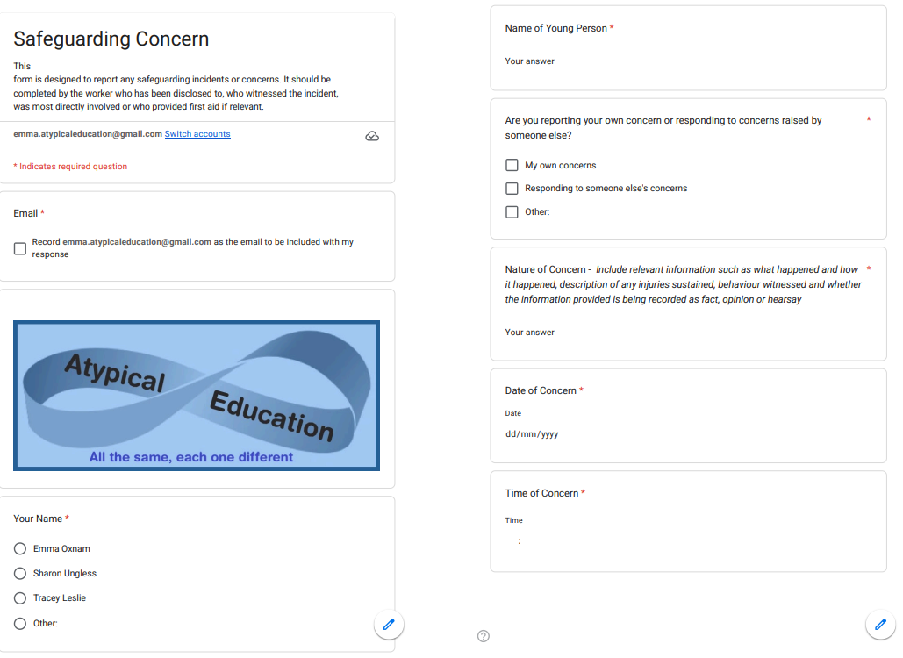
Staff, volunteers, and regular visitors must complete this form and pass it to the safeguarding lead if they have a safeguarding concern about a child in our setting.

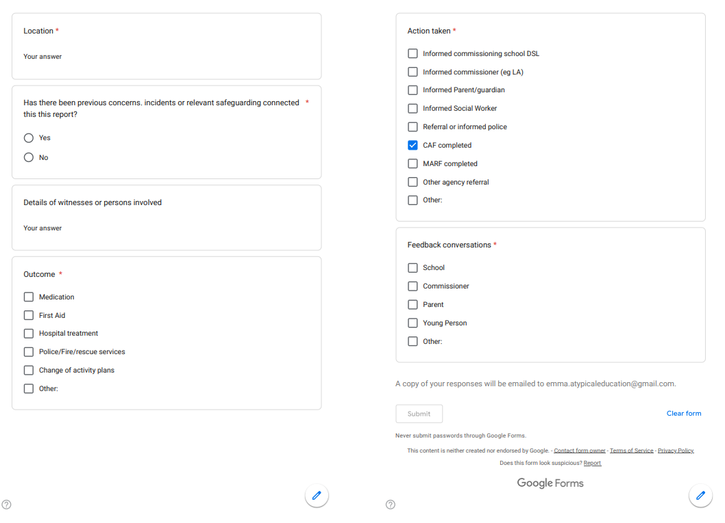

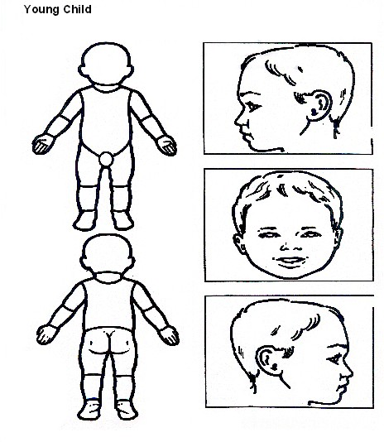
Body Map

Indicate clearly where the injury was seen and attach this to the referral form Body Map

Older Child
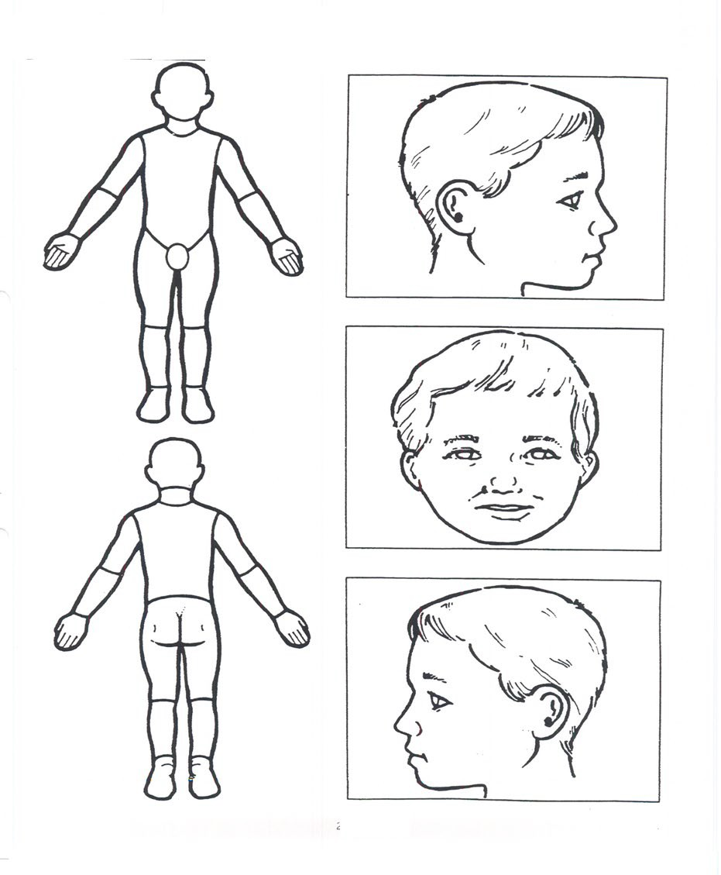
Indicate clearly where the injury was seen and attach this to the referral form.

Safeguarding Induction Sheet for new staff and regular visitors or volunteers.
We all have a statutory duty to safeguard and promote the welfare of children, and at
Atypical Education, we take this responsibility seriously.

If you have any concerns about a child in our setting, you must share this information immediately with our Safeguarding Lead or one of the alternate post holders.

Do not think that your worry is insignificant if it is about hygiene, appearance or behaviour – we would rather you told us as we would rather know about something that appears small than miss a worrying situation.

If you think the matter is very serious and may be related to child protection, for example, physical, emotional, sexual abuse or neglect, you must find one of the designated professionals detailed below and provide them with a written record of your concern. A copy of the form to complete is attached to this and others can be obtained from Emma Oxnam
Please ensure you complete all sections as described.

If you are unable to locate them, ask a member of staff to find them and speak with you immediately about a confidential and urgent matter.

Report any allegation or low-level concern about a member of staff, a child’s foster carer, or a volunteer immediately to the safeguarding lead. If an allegation is made about the proprietor, you should contact the Local Authority Duty Desk on 01603 307797.

NSPCC whistleblowing helpline is also available for staff who do not feel able to raise concerns regarding child protection failures internally. Staff can call: 0800 028 0285 – line is available from 8:00am to 8:00pm, Monday to Friday or via e-mail: help@nspcc.org.uk.

The people you should talk to at Atypical Education are:

Safeguarding Lead: Emma Oxnam Email: emma.atypicaleducation@gmail.com
Contact Number: 07471344408

Deputy Safeguarding Lead: Sharon Ungless Email: sharon@atypicaleducation@gmail.com Contact Number: 07359 771710

At Atypical Education, we strive to safeguard and promote the welfare of all our children.

Children’s Advice and Duty Service [CADS] Safeguarding Process

- Identify & Assess Risk: Identify child at potential or actual risk.

- Consult Safeguarding Lead: Report concerns to your organisation's Safeguarding Lead and document them (e.g. CPOMS) and follow advice regarding contacting CADS or completing a Request for Support.’

- Immediate Protection: If the child is in immediate danger, call 999.

- Contact CADS if child protection or immediate safeguarding concerns.

- Professionals call 0344 800 8021 and choose from the following options:
Press 1 – if the child or young person is currently being supported by a Social Worker or Family Practitioner.
Press 2 – if your call relates to Child Exploitation.
Press 3 – if your call relates to Domestic Abuse.
Press 0 – for Child Protection and immediate safeguarding concerns.
(If the lines are busy and your call is not answered within 40 minutes, a call back option will be offered).
To use the service, members of the public can call the Customer Service Centre number 0344 800 8020.

- Request Support for Universal, Community based Early Help and Family Help
Complete a Request for Support form:
be accessed via Request for support - Norfolk County Council. Early Help is designed to support children, young people, and families experiencing difficulties that may affect their wellbeing, development, or ability to flourish.
Consent: Inform parents/carers of the concerns and gain consent for support from Early Help services, prior to a call or completing a Request for Support unless doing so places the child at further risk.

Universal services and community-based early help
Universal outcomes and community based early help provide preventative support for children and families of all ages, strengthening resilience, improving outcomes, and reducing the risk of needs escalating. Delivered as a coordinated local system rather than a single service, this support is offered through universal provision such as education, health, and wider community services.

It includes services like Best Start Family Hubs, youth, and housing support, and after school provision.

Best Start Family Hubs offer a clear pathway from pregnancy to age 19 (or 25 for young people with SEND), bringing together multi agency partners to provide accessible, ongoing community support and to safeguard families, including those transferring from targeted or specialist services.

Family Help – targeted early help, safeguarding, and promoting the welfare of children.

Family Help is offered where universal services and community based early help have not achieved sufficient or sustained improvement, or where a child and family present with multiple, complex, or escalating needs. Delivered through a coordinated, multi-agency approach led by Children’s Services and its partners, Family Help provides structured support to address identified risks and concerns. Family Help will only be initiated where there is an agreed Family Plan, or a Graded Care Profile (GCP) in cases of neglect, which has been shared with CADS.

Family Help is a voluntary, consent based approach that supports families to build capacity, improve outcomes, and reduce risks, including families in kinship arrangements and those requiring additional support during pregnancy, with the aim of preventing the need for statutory child protection intervention.

Consent: Inform parents/carers of the concerns and gain consent for support from Early Help services, prior to a call or completing a Request for Support unless doing so places the child at further risk.

- CADS: A member of the team responds to the call or Request for Support and decides on next steps.

- Information Gathering: MASH partners (police, health, social care) share information if required.

- Outcome & Action:
Information, advice, and guidance
Community based Early Help
Family Help

- Feedback: Following a call CADS provides feedback to the referrer regarding the outcome.

CADS FAQS and further information on making a referral can be accessed here:
How to Raise a Concern | Norfolk Safeguarding Children Partnership | PWWC

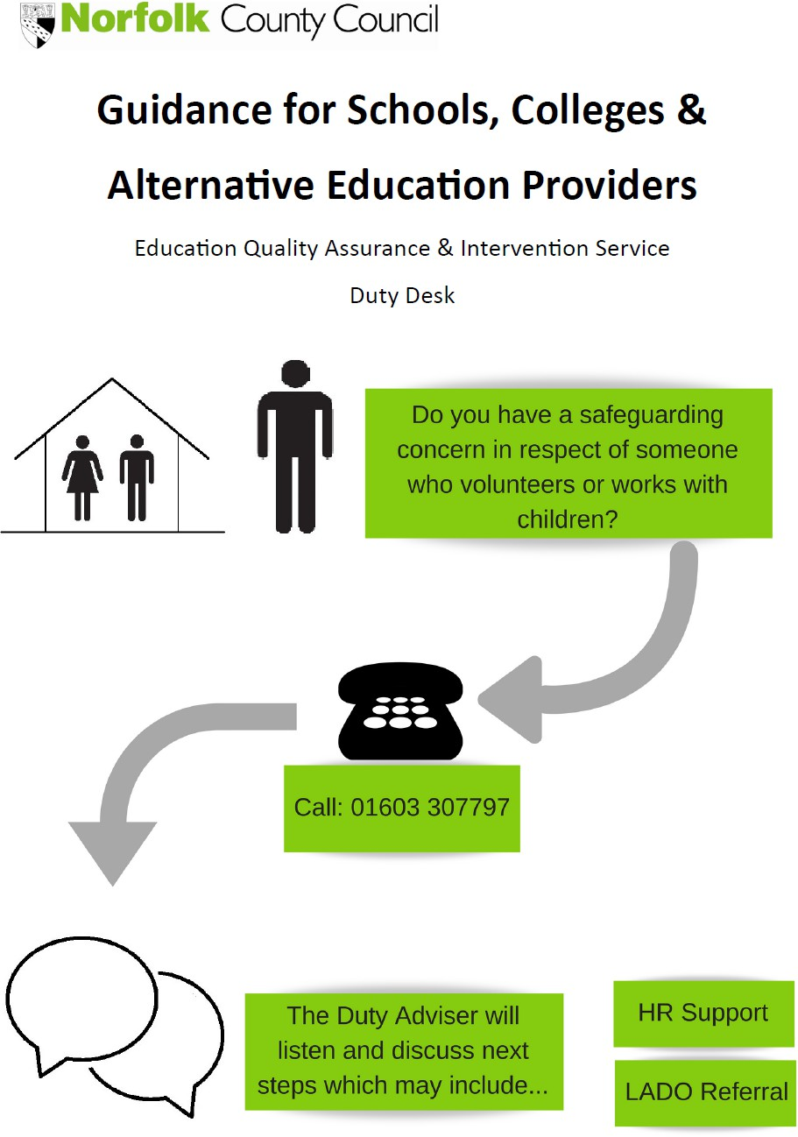

Appendix 5 Non-school alternative provider safer recruitment checks
As per Keeping children safe in education - GOV.UK (www.gov.uk)

208. Where a school places a pupil with an alternative provision provider, it continues to be responsible for the safeguarding of that pupil and should therefore be satisfied that the placement meets the pupils’ needs.
209. The cohort of pupils in Alternative Provision often have complex needs; it is important that governing bodies and proprietors of these settings are aware of the additional risk of harm that their pupils may be vulnerable to. Schools should obtain written information from the alternative provider that appropriate safeguarding checks have been carried out on individuals working at their establishment (i.e. those checks that schools would otherwise perform on their own staff). This includes written confirmation that the alternative provider will inform the commissioning school of any arrangements that may put the child at risk (i.e. staff changes), so that the commissioning school can assure itself that appropriate safeguarding checks have been carried out on new staff.

Therefore [name of school] is obliged to obtain written confirmation of the following (according to Part 3 of Keeping children safe in education - GOV.UK (www.gov.uk) Prior to any placement being agreed, the following must be completed by the non- school AP centre lead or proprietor, signed and returned to the school. Failure to complete this form may result in placements being paused or ceased and funding withdrawn.

Name of provision
Address of provision
Proprietor/centre lead name/role
Proprietor/centre lead contact telephone and email
Name and role(s) of colleagues who are safer recruitment trained
Date(s) of safer recruitment training
I, the undersigned, confirm that in respect of all employees and volunteers at the above named non-school alternative provision, the following checks and procedures are in place and affirm that all staff are suitable to work with children. I understand that the school may request sight of relevant documents during a pre or mid-placement visit.

  - Staff files are in place and contain evidence of
    - Application forms containing
      - personal details (current and former names, current address and national insurance number)
      - details of their present (or last) employment and reason for leaving
      - full employment history
      - qualifications
      - details of at least 2 referees
      - a statement of personal qualities and experience
    - A self-declaration of any criminal record or information which may make them unsuitable to work with children
    - Evidence of right to work in the UK
    - Photocopies of 2 identity checks (with a photograph)
    - At least 2 references, including 1 from the applicant’s current or most recent employer
    - A risk assessment as required
    - Copies of interview notes which determine the applicant’s suitability to work with children
    - Photocopies of qualifications
  - Staff tracker or single central record which includes:
    - Name and address of employee/volunteer
    - Date employment started
    - Date identity checks carried out and by whom
    - Date DBS checked and by whom
    - Risk assessment in place yes/no
    - Right to work in the UK checks – when and by whom
    - Qualifications check – when and by whom
    - Prohibition order checks- when and by whom (for those in ‘teaching activity’)
    - Online search (ref KCSIE 225)

Signed
Date
Received by school (name/date)

Appendix 6 Indicators of abuse and neglect from KCSIE 2026 (paragraph 24-28)

Abuse: a form of maltreatment of a child. Somebody may abuse or neglect a child by inflicting harm or by failing to act to prevent harm. Harm can include ill treatment that is not physical as well as the impact of witnessing ill treatment of others. This can be particularly relevant, for example, in relation to the impact on children of all forms of domestic abuse, including where they see, hear or experience its effects. Children may be abused in a family or in an institutional or community setting by those known to them or, more rarely, by others. Abuse can take place wholly online, or technology may be used to facilitate offline abuse. Children may be abused by an adult or adults or by another child or children. Children may also cause harm to other family members, often referred to as child to parent or care giver abuse.

Physical abuse: a form of abuse which may involve hitting, shaking, throwing, poisoning, burning or scalding, drowning, suffocating or otherwise causing physical harm to a child. Physical harm may also be caused when a parent or carer fabricates the symptoms of, or deliberately induces, illness in a child.

Emotional abuse: the persistent emotional maltreatment of a child such as to cause severe and adverse effects on the child’s emotional development. It may involve conveying to a child that they are worthless or unloved, inadequate, or valued only insofar as they meet the needs of another person. It may include verbal abuse, such as persistent criticism, belittling, or name-calling, as well as not giving the child opportunities to express their views, deliberately silencing them or ‘making fun’ of what they say or how they communicate. It may feature age or developmentally inappropriate expectations being imposed on children. These may include interactions that are beyond a child’s developmental capability as well as overprotection and limitation of exploration and learning or preventing the child from participating in normal social interaction. It may involve seeing or hearing the ill-treatment of another. It may involve serious bullying (including cyberbullying), causing children frequently to feel frightened or in danger, or the exploitation or corruption of children. Some level of emotional abuse is involved in all types of maltreatment of a child, although it may occur alone.

Sexual abuse: involves forcing or enticing a child or young person to take part in sexual activities, not necessarily involving violence, whether or not the child is aware of what is happening. The activities may involve physical contact, including assault by penetration (for example rape or penetration with an object) or non-penetrative acts such as masturbation, kissing, rubbing, and touching outside of clothing. They may also include non-contact activities, such as involving children in looking at, or in the production of, sexual images, watching sexual activities, encouraging children to behave in sexually inappropriate ways, or grooming a child in preparation for abuse. Sexual abuse can take place online, and technology can be used to facilitate offline abuse. Sexual abuse is not solely perpetrated by adult males. Women can also commit acts of sexual abuse, as can other children. The sexual abuse of children by other children is a specific safeguarding issue in education and all staff should be aware of it and of their school or college’s policy and procedures for dealing with it.

Neglect: the persistent failure to meet a child’s basic physical and/or psychological needs, likely to result in the serious impairment of the child’s health or development. Neglect may occur during pregnancy, for example, as a result of maternal substance abuse. Once a child is born, neglect may involve a parent or carer failing to: provide adequate food, clothing and shelter (including exclusion from home or abandonment); protect a child from physical and emotional harm or danger; ensure adequate supervision (including the use of inadequate caregivers); or ensure access to appropriate medical care or treatment. It may also include neglect of, or unresponsiveness to, a child’s basic emotional needs.

