Environmental Policy and Action Plan

Atypical Education

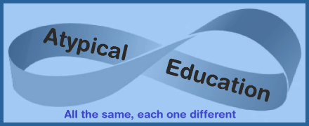

|  |  |  |
| --- | --- | --- |
| **Approved by:** | Emma Oxnam | **Date:** 1st September 2022 |
| **Last reviewed on:** | 1st July 2024 | |
| **The following review is due by:** | 1st September 2025 | |

**Contents**

1. Aims 2

2. Legislation and guidance 2

3. Suffolk County Council’s Ask- Supply Chain 3

4. Minimising Environmental Impact 3

5. Environmental Impacts 3

6. Environmental Commitments 4

7. Environmental Targets 4

# 1. Aims

An environmental policy should summarise the organisation’s key environmental impacts and its commitment to minimising them. This can include compliance with existing environmental legislation and measures that have been and will be taken voluntarily. This should be made available internally and externally to demonstrate commitment and ensure compliance.

# 2. Legislation and guidance

On 21 March 2019, councillors at Suffolk County Council voted to declare a climate emergency. In July 2020, the Cabinet agreed on a set of recommended actions arising from the work of a Policy Development Panel. Suffolk County Council aims to achieve net zero emissions by 2030. Through practical action, it seeks to save money, generate income and reduce carbon emissions to net zero for its operations and services. We want to ensure the environmental impact of the Council’s procurement of goods, services and works is minimised in line with our response to the climate emergency.

# 3. Suffolk County Council’s Ask- Supply Chain

Our ask of our contractors is to:

* know the impact that your organisation has on the environment;
* have an Environmental Policy that embeds a culture of reducing negative environmental impacts within your organisation;
* ensure your environmental impact is measured regularly, reported and overseen at the highest level;
* reduce negative environmental impacts with a clear action plan outlining the work to be undertaken, focusing on the biggest impacts, with key targets and timelines for the actions to be undertaken, for example;
  + if you use travel, reduce your mileage. For the miles that you are not able to reduce, travel in more environmentally friendly ways;
  + if you use building/s ensure that you have had Environmental building survey/s undertaken and mitigated the negative environmental impact;
* work with your supply chain to know the environmental impact of the goods/services you purchase and mitigate/reduce the negative impact; where the negative impact is not able to be reduced, offset the effects;
* work towards your organisation also being Carbon Net Zero by 2030.

# 4. Minimising Environmental Impact

As an Educational establishment, Atypical Education promotes awareness of the environment, encouraging students to help protect the environment and reduce energy use. Our approach must be to promote and support the behavioural changes needed to think and act differently. We hope that sustainability will become more of everyone’s day-to-day thoughts, that more awareness will translate into more action, and that a ripple effect will be felt outside the educational community.

The values they develop now will carry them through life and inform their personal and professional decisions. We are responsible for teaching our students to be engaged citizens, which we do by raising their awareness of important issues and giving them the skills and confidence to enact change. Without these skills, knowledge and facts alone can be unsettling and disempowering. The climate crisis and ecological collapse pose an existential threat to life on Earth, and we must act now to reduce our impact and educate and empower the next generation to hold sustainability at the core of their values.

The Intergovernmental Panel on Climate Change stated that humanity must keep global temperature rise below 1.5°C by drastically reducing greenhouse gas emissions by 45% from 2010.

# 5. Environmental Impacts

**We aim to be carbon neutral by 2030 by following UN guidelines**

In this strategy, we set quantitative targets against a baseline to track progress and be accountable. We will monitor these targets to celebrate our successes and focus on areas that need greater attention.

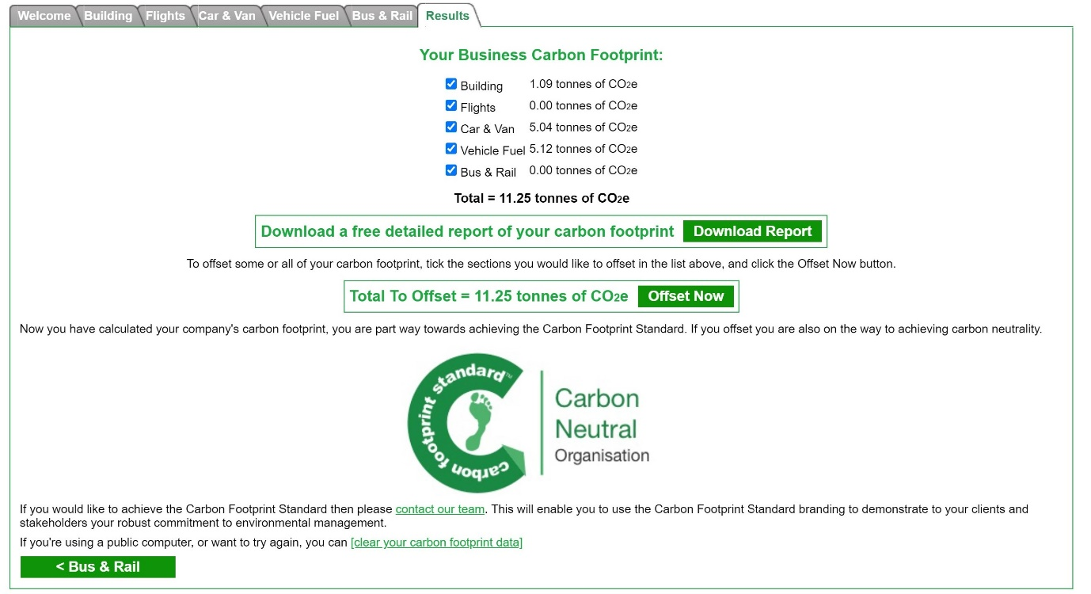

# 6. Environmental Commitments

Atypical Education is a small home business. The recent replacement of heating systems, LED lighting, double-glazed windows, and solar energy has reduced the family and business's energy impact. We grow food for our cookery lessons on our allotment. Students live in the same village, so transportation is reduced.

Firstly, we will reduce our emissions as much as possible, and secondly, we will offset what we emit. Offsetting involves investing in projects that remove greenhouse gasses from our atmosphere by planting trees or investing in renewable energy projects.

# 7. Environmental Targets

* To update this strategy each academic year and publish our progress against the targets
* To regularly update the school community with news of our sustainability projects
* To complete UN Climate Change teacher training