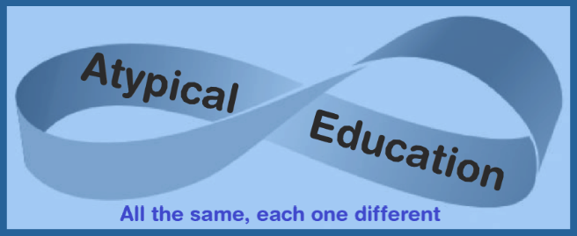

The Rectory, Church Road, Honington, Bury St Edmunds Suffolk IP31 1RG
emma.atypicaleducation@gmail.com 07471 344408 www.atypicaleducation.co.uk

Photograph Permission Form

Whilst your child is in the care of Atypical Education we will be taking photographs for a variety of different purposes.
Please complete the form in order that we fully comply with your wishes.
Please indicate which of the following you give your consent to:

- Pupil’s personal file
- Parental emails and messages
- School/Alternative Provision emails
- Atypical Education website and or Social Media (pupils will be asked permission and anonymised)
- Atypical Education promotional documentation (pupils will be asked permission and anonymised)

- All of the above

- None of the above

Name of pupil
Name of parent
Signature Date

