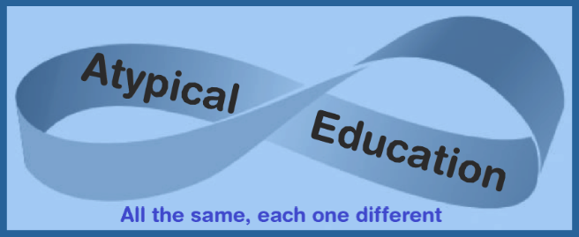

The Rectory, Church Road, Honington, Bury St Edmunds Suffolk IP31 1RG

emma.atypicaleducation@gmail.com 07471 344 408 www.atypicaleducation.co.uk

Transportation and Visits Permission Form

Whilst your child is in the care of Atypical Education we will be transporting your child in private vehicles for a variety of different purposes and visits.

To keep everyone safe:

* Everyone must wear their seatbelt at all times
* Speak with respect – no swearing or shouting
* Smoking is not permitted
* Eating and drinking must be done responsibly
* Windows must be used responsibly – no leaning out
* Music can be used responsibly and at a sensible volume

Please indicate which of the following you give your consent to:

* Atypical Education can transport my child to and from any provision, visit and home
* I give consent for my child to take part in all educational visits and if required Atypical Education can sign in loco parentis
* I do not wish for my child to be transported
* I do not wish for my child to take part in educational visits

Name of pupil

Signature Date

Name of parent

Signature Date