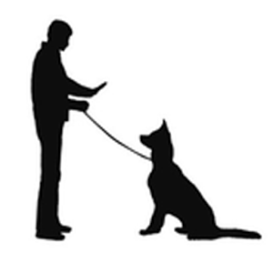
HAVE A DOG?
NEED TO FURTHER ITS EDUCATION?
At Quad Cities Dog Obedience Club, we offer a variety of dog classes to choose from. All dogs are welcome, and classes are FUN!
PUPPY CLASS / AKC STAR PUPPY CLASS
This is a 6-week course that includes socialization, grooming tips, health care, and introductory training on walking on a leash, sitting, staying, lying down, and coming when called. For puppies from 11 w. up to 6 m. old.

FAMILY DOG CLASS
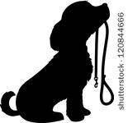
This course is for all family dogs 6 months and older. This class will focus on basic manners and obedience to help your dog be a well-mannered family companion, generally following the AKC Canine Good Citizen requirements. The course lasts 6 weeks then culminates in the CGC test and certification, if desired. 7-week class.
About our club:
The QCDOC celebrated our 50th anniversary in 2017. Our goal is to further the sport of training and showing dogs. To further this goal, we have established a full range of training classes open to the public as well as to our members.

QCDOC activities include training and showing our dogs in obedience trials, conformation shows, rally and other competitions. All our instructors and staff are all volunteers, dedicated to helping you train your dog.

The QCDOC membership holds monthly meetings as well as various social activities. We own a large, heated and air-conditioned facility which is supported primarily by offering training classes to the public. You are eligible to join the QCDOC after taking a 6-week session of any training class. Annual family membership fees are $35. Members can then pay a yearly training fee of only $145. This fee pays for most classes.

BEGINNER
This course is offered for dogs 6 months and older. Basic dog obedience including sit, down, stay, come when called, basic manners and heeling. 6-week class.

CONFORMATION
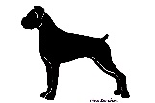
This course trains for the handling of your AKC registered dog in the Breed Ring for competition. It includes grooming tips, and is in cooperation with the Tri-City Kennel club. Drop-in class.

RALLY
This class is for dogs that have completed Beginner or Family Dog classes, and are competent in basic obedience. This course will provide instruction and practice for AKC Rally competitions. These are one-time classes.

ADVANCED BEGINNER
This 6-week class is offered as a continuation of Beginner or Family Dog classes. Classes continue to practice and perfect skills, and try new challenges.

RING PREP
The ring prep classes help to prepare the dog and handler for entry into AKC Novice or Open Obedience competitions, including heeling, heel free, sit-stay, down-stay, stand for exam, recall, figure 8, finish and attention. The prerequisite is either QCDOC Family Dog or Advanced Beginner. These are one-time classes.

$80 – Puppy Class (6 weeks)
$80 – Beginner Class (6 weeks)
$84 – Family Dog Class (7 weeks)
$80 – Advanced Beginner Class (6 weeks)

Rally Class - $12 per class
Ring Prep Class - $12 per class
Conformation Class - $5 per class
(Prices are subject to change)
Please visit us at
804 West 2nd Ave.
Milan, IL 61264
(309) 787-4700
Register online at:
www.qcdoc.com

You must pre-register and prepay for classes to enable us to keep class sizes reasonable. proof of current vaccinations* are required by the first class session. (*FOr all dogs over the age of 16 weeks, this includes rabies, combo distemper, parvo, and kennel cough.)

- Dangerous dogs may be dismissed / reassigned at the discretion of the instructor.
- Childcare facilities are NOT available. Children must be supervised at all times.

Quad Cities Dog Obedience Club, Inc.
PO Box 594
Milan, IL 61264

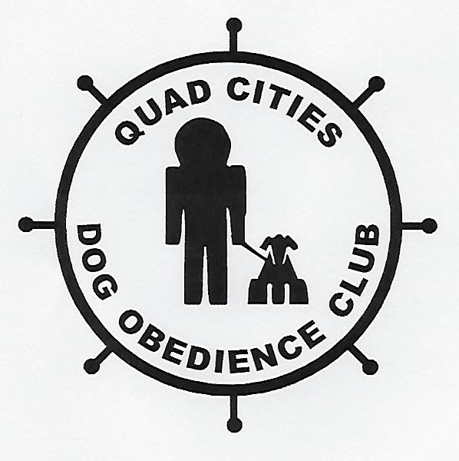

QUAD CITIES DOG OBEDIENCE CLUB, INC.
804 West 2nd Ave.
Milan, IL 61264
(309) 787-4700
www.qcdoc.com

