Quad Cities Dog Obedience Club Liability Waiver

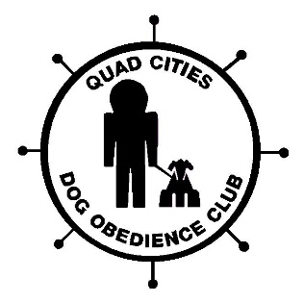

I understand that I will train my dog at my own risk. I agree to keep my dog under control at all times and to clean up after my dog.
I understand that should I fail to do so and especially if my dog is a threat, the instructor has the right to ask me to leave the premises for the safety of the other dogs and the people present.
I understand that I am responsible for the actions/behavior of my dog.
In case of an accident or incident I will not hold the Quad Cities Dog Obedience Club members, officers or board of directors responsible.

Signature of owner(s) present and training

Date

Class

Vaccination record: Yes No

