TRAIN AT YOUR OWN RISK

YOU ARE RESPONSIBLE FOR YOUR ACTIONS AND THE ACTIONS OF YOUR DOG.

WE RESERVE THE RIGHT TO DISMISS ANY HUMAN AND/OR CANINE FOR AGGRESSIVE BEHAVIORS.
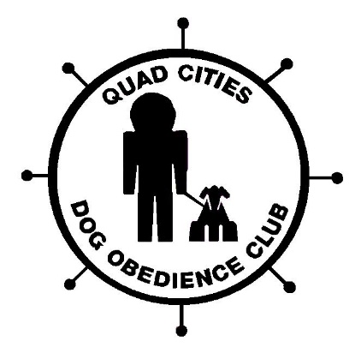
We are not responsible for accidents
Or your stupidity

