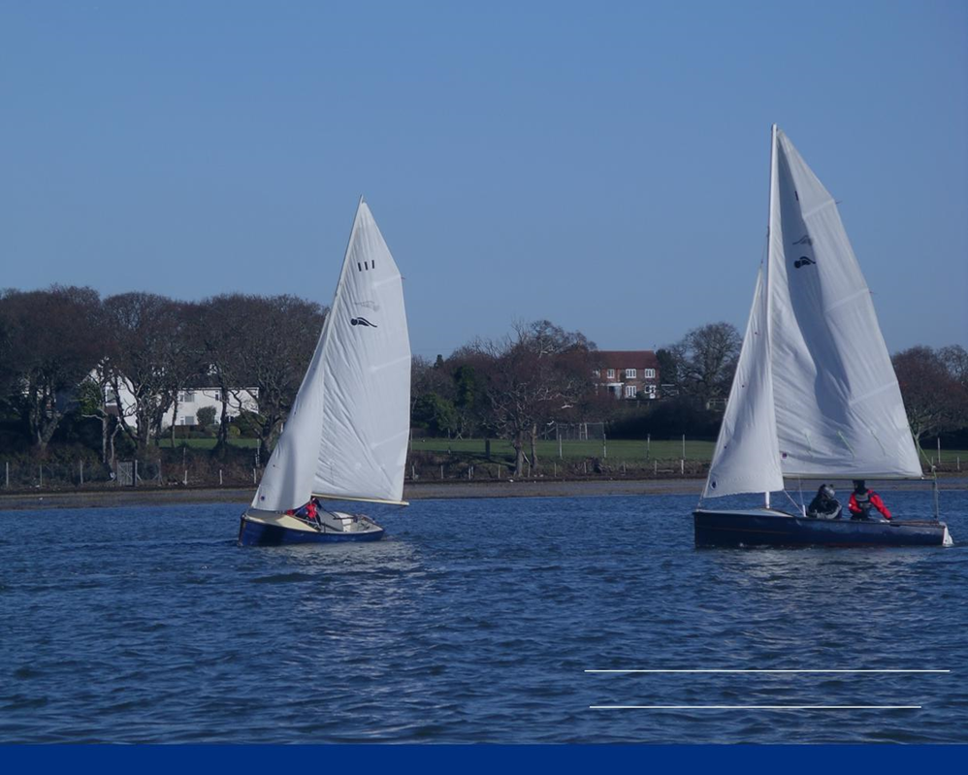

Saturday 13th March
09:30-12:00

Scout Hut
Kings Saltern Road
Lymington
SO41 3QD

- All pre-loved sailing gear welcome – from dinghies/canoes/kayaks to clothes, buoyancy aids, life jackets, kit bags and accessories. Fenders, rope, cleats, oars etc
- All profits go to the Sea Scouts and Honor Explorers
- Drop off your donations at the Yacht Haven, The Harbour Commissioner’s Office, Keyhaven Yacht club, The Royal Lymington Yacht Club, Lymington Town Sailing Club and the Scout Hut
- Scan the QR Code to visit the website for full details


Proudly sponsored by


e: contact.9thlym@gmail.com
w: 9thlymington.com/boat-jumble
Support your local Sea Scouts with a donation of something to sell.
Join us on the day for bargains and bacon butties.
The Lymington Sea Scouts Boat Jumble is back.

