* Welcome & introduction – Chair – Jill Byrne.
* Good morning everyone and thank you for taking the time to attend our Annual AGM. I would like to thank Taunton and Pickeridge Golf Club for welcoming us today and allowing use of their meeting room, providing our meal and offering the opportunity to play the course afterwards. Our thanks as a Committee go to each of the Clubs and Junior Organisers that have worked hard to help our Junior League to run as it does and afford the opportunity for so many young golfers at every level to come together to enjoy their golf. A personal thanks goes to Stuart, Mike, Tim, James and Eileen for the contributions they have all made in being your Committee elect for the year 2021-22. When we come to the election of officers in a moment, I gather that we are all prepared to stand again.
* Apologies – Enmore, Mendip Spring, Mendip, Oake, Long Sutton, Eileen, Wells, James W, Richard D.
* Absent – No apology – Yeovil, Farrington.
* Present – Jill B, Stewart J, Mike H, Tim B, Craig Y, Berni T, Jan H,
* Secretary's review – Thanks to all of the junior organisers, great to see club Captains presenting prizes, all of the juniors have been a real credit to their clubs. East and West leagues will continue in 2023, thanks again to Eileen for updating the website & Facebook.
* MH – Outlined the hosts for 2023 as follows, East = Mendip, Wells, Wheathill - 30th April 2023. West = B&B, Oake, T&P - 21st May 2023 = Clubs to provide dates ASAP.
* Treasurers review – New bank account = Nat-west, balance and accounts as noted on the day. 2023 – Fees agreed at £75 to include all events. Tim to email all the clubs with invoice details to be paid in full by Jan 31st 2023.  Accounts at end of this report.
* Election of Officers for 2023 – Will remain as 2022
* Stewart presented the League shield to Craig ( Worlebury) , cheques / Bacs prizes to the clubs sections, congratulations to Worlebury & Mendip £100 as league winners, to Worlebury as overall winners £100, Knock-out Winners - Mendip , golf balls & mementoes’, Jamboree winners – Worlebury golf balls & mementoes’.
* 3 League venues next year was recommended and agreed.
* A.O.B
* Maximum age of juniors taking part will be in-line with the rules of England golf, under 18 on Jan the 1st of the golfing year.
* Jamboree – Maximum handicap will be 36 for both boys & girls, however a player may take part off a higher handicap but play off 36, and the junior must be fully aware of the rules, able to play 18 holes, at the discretion of the player’s Junior Organiser’
* League days (change) – points to be awarded as follows – (1 player) = 2pts, (2 players) = 3pts & 1 point, (3 players) = 4pts, 2 & 1, (4 players) = 5points, 3,2,1. (5 or more players) = 6points,4,3,2,1. for each division.

 For each event – the JO will ask for medical issues, team details, image restrictions, cdh, handicaps, etc.

* Jamboree – Worlebury to host – Date to follow

* Div1 and 2: Parents walking the course = It is strongly recommended that parents stay in the clubhouse during the events. The League will update the guidance notes on the website and also encourage the hosts to print out a copy to distribute at the event and ask the starter to reinforce this message for the good of the juniors and for fairness to all. Please note that any parents interfering on the course will be asked to leave and also with the possibility of the junior’s disqualification - The clubs will ask other JO’s present and members of the host club to act as rules officers, ball spotters etc
* In Div 3 are parents allowed on the course due to the age and inexperience of the players in some cases.
* Funds in the bank – A discussion was had regarding the amount and how we could spend some of it. Ideas were made and these will be discussed and confirmed – TBA
* League officers uniform – MH – Black polo & top with yellow SJU – logo – TBA
* Chairman closed the meeting.

2023 AGM – Date - TBA.

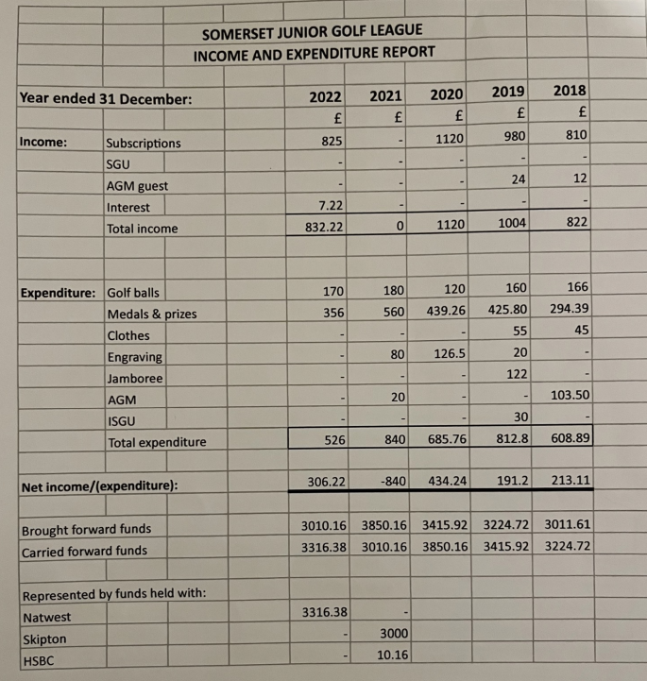

Items for further discussion and review for the 2023 AGM

* For 2024 consider 3 Areas playing a Round Robin
* Each club in each area hosts an Event
* Final played between the three winning clubs, one from each area - 5 x 3 balls
* Stableford format keeps motivation high to focus on individual contribution to the final points score.
* Clubs would need to sign up well before the AGM in order to decide Areas and book dates.
* Changing the leagues to 4 venues and alteration to the teams in the leagues- TBA, 2023
* Review East & West list of clubs to be discussed – TBA, 2023