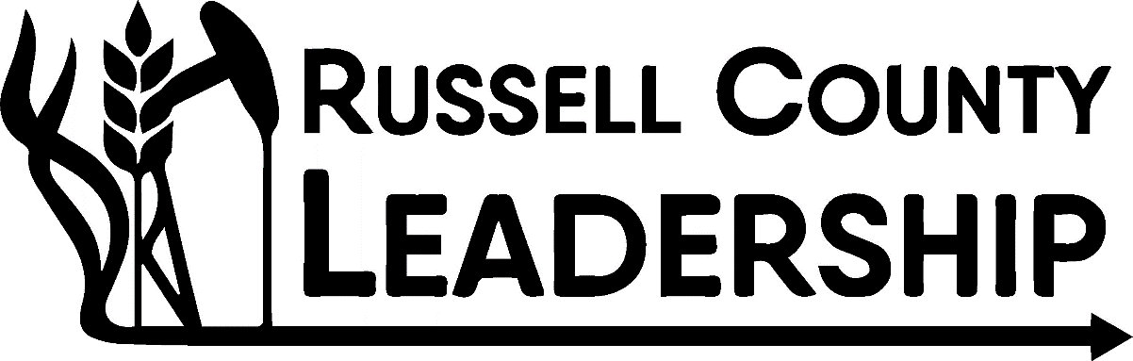
RUSSELL COUNTY LEADERSHIP NOMINATION FORM

The purpose of this form is to formally nominate an individual for Class II of the Russell County Leadership program beginning in August 2023 and ending in May 2024. Russell County Leadership is an intense leadership program aimed at developing emerging community and business leaders in the Russell County Area. A variety of challenges—environmental, economic, and political—are unfolding and will continue to test rural communities. Strong, progressive leaders, with a broad base of knowledge, will be necessary to help steward communities and industries as decisions are made. Russell County Leadership coaches and empowers the next generation of rising stars to lead within rural communities through a series of one-day seminars exploring a variety of topics including personal and professional skill development, economic development and impact in our region, local business, and industry, as well as community involvement.

Nominee Information Nominator Information:
Name: Name:
Phone Number: Phone Number:
Email (If possible): Email:

Please explain why you are choosing to nominate this individual to apply for Russell County Leadership:
_________________________________________________________________________________________________________________________________________________________________________________________________________________________________________________________________________________________________________________________________________________________________________________________________________________________________________

Interested in supporting Russell County Leadership: Yes_____ No ______
How so? Check all that apply
Seminar Host _________ Financial Contribution ____________
Seminar Speaker_______ I want RCL Class to visit my Business/Organization ______

