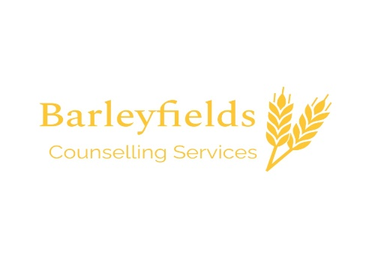
Privacy Policy
For us to work together, I will need to record personal information about you. It is your right to know how I use and store this information. Some of this information will be taken from the Contract, your name, address, phone number and GP details. If you have made contact via email, I will also have these contact details. The Contract is locked away in a secure location and only accessed by me.
In a separate locked location, your ‘client notes’ will be stored. I will allocate you an identifying code, allowing the notes to stay anonymous. These client notes are brief and factual summaries of our sessions together. This set of notes will include any agreements made with you e.g. cancelled sessions, holidays, changes to appointment times or location, appointments with other professionals e.g. your GP or hospital. If I have needed to speak and write to your GP this will also be noted and dated on these notes.
This personal information will be held securely for a period of 7 years from the date of your final attended counselling session with me. This is in agreement with my insurance provider.
I have Clinical Supervision once a month and only use your age and gender (if necessary) if discussing our work together. Supervision is an essential part of counselling work set out by the BACP to ensure ethical and safe work is carried out. Your contact details alone will be shared in exceptional circumstances with my supervisor if I am incapacitated so that they can contact you to explain the situation.

Information about counselling sessions and our work together
Your notes are for my records and reference only, unless there is a specific legal requirement for me share information.
Where there is a legal/ethical duty for me to do so, only necessary information will be shared, for example; to avoid serious harm to yourself or another person, including the safeguarding of children or vulnerable adults, or if you disclose you are going to/ or have committed a serious crime. Depending on the situation, I would endeavour to discuss this with you before any information sharing happened.

Links to external websites
This website; www.barleyfieldscounselling.co.uk may contain links to other websites of interest, blog posts etc. If you use/have used these links to leave www.barleyfieldscounselling.co.uk, you should note that I, Carly, do not have any control over that other website. Therefore, I cannot be responsible for the protection and privacy of any information which you provide whilst visiting such sites. This privacy policy only covers www.barleyfieldscounselling.co.uk. You should exercise caution and look at the privacy statement applicable to the website in question.

Your rights
You have the right to ask to see information held by me about you. To do this please either ask me or submit a request by email. You also have the right to ask for information which you believe to be incorrect and rectified. I will endeavour to provide you with the information requested within 4 weeks.
We can discuss any questions or concerns you may have about the way that your information is being held.

Agreement
A brief statement regarding this Privacy Policy is on the Counselling Contract. By signing the Contract, you are agreeing to this Privacy Statement.

