**GCC FEE POLICY**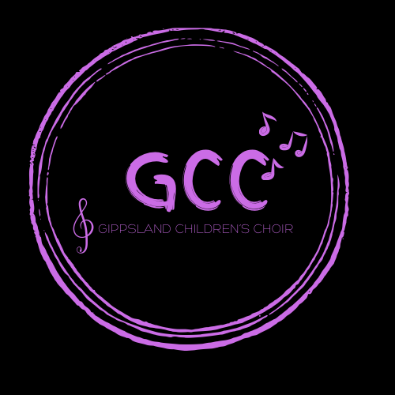

Gippsland Children’s Choir is committed to providing safe, fun and inclusive choir experiences for our members. Our fees are created to reflect the work and preparation that goes into the running of such a Choir, and our commitment to upholding a professional standard for our staff and members.

**Fees Payable**

Fees are payable at the beginning of each term, and will be invoiced directly to the email contact for each singer/guardian. Fees are payable within 15 days of date of invoice, and are to be paid into the GCC account as shown below:

**Account Name:** Gippsland Childrens Choir

**BSB:** 313-140

**Account Number:** 12430780

The fees are currently set at $12 per weekly rehearsal and are invoiced in correlation with Victorian school terms.

**Outstanding Fees**

Any outstanding fees will be sent an email reminder when overdue. If fees remain outstanding the following steps will be followed.

1. Email Reminder of Overdue Fees.
2. Second Email reminder and offer of payment plan.
3. Singers will not be permitted to rehearse or perform with the choir until fees are received: this will be communicated via email.
4. Recovery of overdue fees will be outsourced and legal fees will be payable by parent/guardian.

*Whereby no communication is received from the person responsible for Fees GCC reserves the right to implement step 4 immediately for recovery of outstanding fees.

**Fee Credit**

GCC will apply rehearsal credit to the following term where a rehearsal has been canceled by the Directors. Please note: credit does NOT apply for participant illness or non attendance.