2A Week 10 Drama Near the Top
Tumwater is Easy Choice for Top Spot but Murphy Situation Muddles Things
W

eek 10’s Round of 32 Matchups have some intriguing contests but also features several games which should not even be close.
The winners will be seeded into the 2A state tournament which will be announced around Noon on Sunday, Nov. 8. The losers will be out.
Teams will be reseeded from what appears to be projected this week, but you can bet the numbers on the left of each matchup (listed below) could be close to the seed expected next week. That could change depending on how close each team’s game is and if there is an upset as well. (Usually you can expect a few.)
Tumwater projects as the best team in the state, but the next three-four seeds are up for debate.
Arguments can be made for several different teams but, because of the strength and success of the Northwest Conference, number two will come from there.
That’s where Lynden fits in. Despite their 35-14 loss to Archbishop Murphy last weekend, (who could have easily wound up in a three-way tie for first), the Lions earned the loop’s top mark by virtue of their 41-26 victory over Anacortes earlier this fall. (Both teams tied for first with a 7-1 record.)
This week, Lynden is the projected number two behind the T-Birds.
Murphy, the defending 2A state champions, wound up fourth in the NWC despite only losing one game on the field because they forfeited
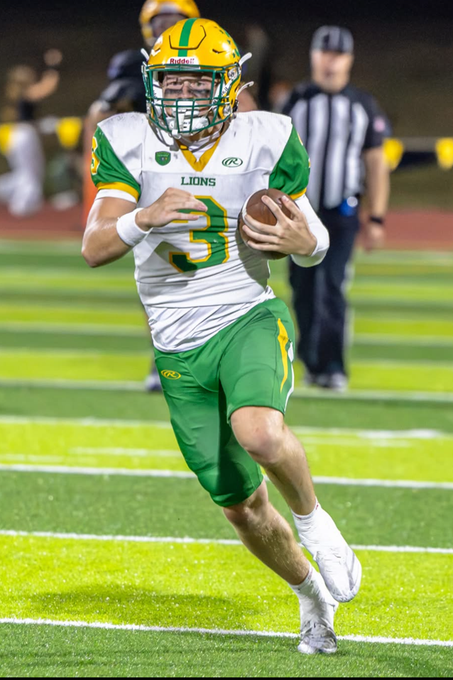
Lynden’s Gordy Bedlington is a senior quarterback who has completed 61% of his passes for a 10.28 completion rate.
____________________________________________________
their first three league wins for using, in what was ruled, an ineligible player.
Their final adjusted record of 4-4, 5-4 though, includes many twists and turns.
Murphy has a week five league victory over Squalicum (51-7), in which the ineligible athlete didn’t play and a non-league victory over 1A playoff-bound Lynden Christian (7-2) 21-14 the following week.
They also received two more league wins when Sultan and Lakewood opted out of scheduled contests. ATM capped the year last week with that impressive victory over Lynden.
With the controversy surrounding them, it was a bit confusing for the seeding committee as to where to put them. Do you ignore the fact of what happened and rate them high or punish them for the indiscretion?
Because of the impact of the forfeits, it would raise a lot of issues, (or problems) if the committee ignored the final ruling by the Wesco/NWC/WIAA of what happened and seeded them higher than the other two NWC teams. Then the forfeits would not have meant anything except for a league trophy.
That means (the projected fifth seed), Archbishop Murphy will be a very tough match-up in a couple of weeks for someone like Anacortes, Prosser or WF West. It will also skew the potential matchups by the committee who tries to pave a path for the four best teams in the state semifinals.
Another team that could easily be in the top four is Anacortes.
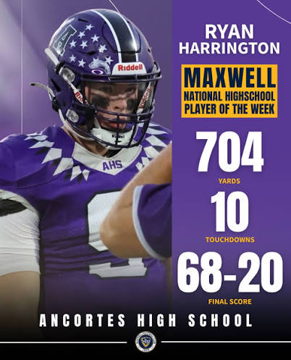
The Seahawks, back-to-back state champions two years ago, feature one of the best teams again this year. They also are the only school to beat Archbishop Murphy on the field this year, 48-47.
Led by senior quarterback, Ryan Harrington, they are a favorite to make it to the semi-finals once again. “He’s a cheat code who makes everyone around him better, including the coaches,” says Justin Portz of the Seahawks.
Through eight games, Harrington has completed 176 passes for 3,030 yards and 37 TDs.
Another couple teams that could sneak into the top four include Prosser and WF West.
The Mustangs are off to their best start since 2008 and feature a heavily junior-dominated squad. Loaded with several weapons, they have two of the most dynamic receivers/kick return men in juniors Brody Buxton and Xzander Espino.
An explosive player, Buxton is averaging nearly 75 yards per game, has 10 receiving Td’s, 2 interceptions and has scored on a kick return.
Espino has 7 touchdowns receiving and has scored three times on kick and punt returns.
WF West scored the most points on Tumwater than any team did this year (21) and their starting defense had only allowed ten touchdowns entering the game.
Their offense is led by a dual-threat quarterback, junior Wyatt Hoffman and they feature several skilled receivers.
There are several other teams who could surprise
A lot depends on how teams perform this week and how they are seeded in next week’s brackets. For example, if the brackets remain as they are potentially set up in the Round of 32, Murphy, Anacortes and Tumwater would be on the same side. Lynden, Prosser, WF West in the other bracket.
A dark horse could be Eatonville, who plays Squalicum this week but has won four-in-a-row including wins over Franklin Pierce (SPSL league champion) and Orting last week, 31-14.
NEWS AND NOTES:
Something that could be gathering steam for the Round of 32/24 play-in games is at-large berths. One factor is District 2 sending a team without a win (Chief Sealth) in and 1A Royal having their Week 10 matchup canceled when King’s Way Christian (2-7) of the Trico 1A (5 berths) elected to forfeit the game.
The reasoning is KW had only 16 players available for the contest to play against the defending state champions.
Nooksack Valley (6-3) of the 1A Northwest Conference could easily have slid into Northwest Christian’s spot since they were fourth in their league and missed the Round of 24 which the 1A plays. (Because of the smaller number of schools at the 1A level.)
The Pioneers’ three losses came against Lynden Christian, Mt. Baker and Meridian, league foes who are playing in the Week 10 games and the argument can be made that NV may be better than other teams that represent other districts.
Nooksack dealt the only losses suffered by two 1A playoff teams, King’s (8-1, 51-21) and Cascade Christian (7-1, 14-7), one 2B playoff team, Okanogan (8-1, 34-15) and beat 2A playoff bound, Squalicum (4-5, 19-12) the 5th seed from the 2A NWC.
You can bet this debate is to be continued.
• Also, Wing-T coaches across the state have to smile to know that offensive guru, Chip Kelly, is using the offense at Northwestern as their offensive coordinator.
“At first we were kinda like, man, what are we doing?” stated runningback Joseph Himon. “Because that’s not a system a lot of us have been in before.”
The Wildcats are currently 7-2 and have scored 283 points, averaging 31.4 ppg.
_____________________________________
This Week’s 2A Matchups
1. D2 Chief Sealth (0-9) at D4 Tumwater (9-0)
Fri., Nov. 6, Tumwater District Stadium, 6PM
The sole 2A team in District 2 Metro Mountain League, Chief Sealth played a tremendously difficult schedule, with O’Dea, Eastside Catholic and Rainier Beach as opponents. They lost last weekend to 2A Cedarcrest (7-2) of the Kingco 49-14.
“They are a pass-first offense who runs some RPOs and they have some explosive athletes on the perimeter,” states T-Bird coach, Willie Garrow.
Tumwater, meanwhile, capped another unbeaten season with a 51-21 victory over previously unbeaten EVCO foe, WF West (8-1). They are favorites to play for a state championship for the third year in a row. The T-Birds have also played in 7 of the last 10 state title games.
“We are going to approach this game exactly as it is,” Garrow explained. “A must-win to secure a berth in the state playoffs.”
2. D2 Renton (5-4) at D1 Lynden (7-2)
Fri., Nov. 6, Ferndale HS, 6PM
Coming off a difficult 35-14 loss to NWC foe, Archbishop Murphy, the Lions look to rebound against Renton of the Kingco Summit League.
Despite the loss, Lynden earned the league championship although both they and Anacortes finished 7-1. The Lions beat the Seahawks 41-26 back on October 9 to gain the advantage.
The Lions played the last four weeks against Anacortes, Burlington-Edison, Squalicum and Murphy who all advanced to the playoffs this week.
The senior duo of quarterback Gordy Bedlington to receiver Sam Arango had a sensational 52-yard pitch and catch in the first half last week into the Red Zone but Lynden didn’t score. Dawson VanDalen had the first Lions touchdown on a 62-yard run.
Renton, third in their league, beat Nathan Hale 38-6 last week. Their two league losses came against Cedarcrest and Foster, both in the Round of 32.
The Red Hawks are led by the passing combo of junior QB Gabriel A Rodriguez to fellow junior receivers, James Pattenaude and Osela Mitchell. Their leading rusher is sophomore Toa Lavatai.

3. D4 Ridgefield (4-5) at D5 Prosser (9-0)
Sat., Nov. 7, Art Fiker Stadium (Prosser), 2PM

Former Prosser QB, Kellen Moore, had a statue of himself unveiled last week at Boise State’s football game. (It will greet visitors outside the stadium.) The son of former Mustang coaching legend, Tom Moore, he is the head coach of the NFL’s New Orleans Saints. His younger brother Kirby is the head football coach at Washington State.
Prosser is off to their best start since they lost the 2008 state title game in double overtime to Lynden, 35-34. The six-time state champions host Ridgefield, who is much better than their record indicates.
One of the state’s better teams for the past few years, they played a tougher schedule this year to try and raise their program to an even better level.
One opponent they did face, Tumwater, beat them 41-0. Prosser, which features a balanced running attack led by junior Autry Hoefer (12 TD’s and 8.2 average) can also strike deadly through the air. Fellow junior, Daniel Diaz has 28 YD passes while surrendering only one interception.
The Spudders feature a shotgun Wing T which could cause Prosser some defensive challenges.
4. D3 North Mason (6-4) at D1 Anacortes (7-1)
Sat., Nov. 7, Anacortes High School, 3PM
An argument can be made for Anacortes as one of the top two teams in the state as well.
With victories over Archbishop Murphy and Burlington-Edison, they can match up with anyone. Their only loss was to league foe, Lynden, and they may have the most dynamic quarterback in the 2A ranks in senior * who threw for 700 yards and 10 TDs in a game this year. On the season, the WSU-bound signal-caller has 3,030 yards, 37 TD’s and just 3 INTs in just eight games. In addition, he has 550 yards rushing and 8 TDs.
Don’t be misled, the Seahawks are a complete team that could easily be playing in the semi-finals.
Their opponent, North Mason (Belfair), is a team on the rise. Earlier in the season, they dealt North Kitsap their only loss, 24-21 and had won five of their first seven games.
On Tuesday of this week, they beat Washington of the SPSL in a play-in game 18-15.
Senior receiver, Derek Dunham had two TD receptions from QB Reid Shumaker in the contest. Dunham is a record-setting receiver for the Bulldogs with 14 TD receptions on the year on 58 catches for 937 yards.
5. D4 Hockinson (5-4) at
D1 Archbishop Murphy (5-4)
Fri., Nov. 6, Terry Ennis Stadium (Everett), 6:30PM
One of the best teams in the state, Archbishop Murphy is a handful for any team and you could argue deserving of a number two seed in the Round of 16. They had a solid performance in their 35-14 victory over Lynden last week.
Murphy opened the game with an 85-yard drive, and their defense only allowed two yards on Lynden’s first possession.
Leading 21-0 at halftime, they controlled the ball on several drives and the younger brother of Seattle Seahawks offensive tackle, Abe Lucas, Andrew, (a senior running back) had a 19-yard run.
Hockinson, from the Greater St. Helen’s League, beat Washougal 21-14 last week for the GSHL South title. Heir defense was a key in the victory, stopping Washougal twice on fourth-down plays.

6. D3 Bremerton (5-4) at WF West (8-1)
Fri., Nov. 6, WF West HS (Chehalis), 7PM
Before last week, WF West was ranked in many polls as the second or third-best team in the 2A ranks.
But that changed after last week’s 51-21 loss to top-rated Tumwater.
Although both teams had their rough moments in the game, the T-Birds had too much overall fire power. But, don’t be deceived, the Bearcats are among the best 4-6 teams in the state.
Their opponent, Bremerton, beat North Mason 39-37 in a thriller earlier this year and was the third seed out of the Olympic Conference.
The Knights rushed for 2,157 yards this year and 5-foot-8 senior receiver, Kaliam Hunter is averaging 25 yards a reception and has scored 8 TDs.
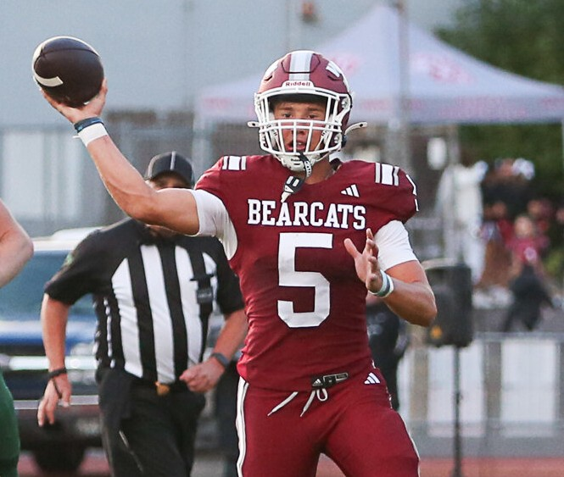
WF West quarterback, Wyatt Hoffman (Jr.), (above) has completed 70.4% of his passes for 25 TD’s. In addition, he has run for over 500 yards and 8 rushing touchdowns. Last week, against Tumwater, they forced him into his worst performance of the year with two picks and minus 17-yards rushing.
__________________________________________________
7. D4 Black Hills (4-4) at D5 Selah (8-1)
Fri., Nov. 6, Karl Graf Stadium, 7PM
The Selah Vikings are off to their best start since 2017 under third-year head coach, Greg Haste.
They feature a very tough defense and an offense powered by the running game. Senior Cale Wuitschick has been a workhorse but difficult to stop. In nine games, he has 1,568 yards on 163 carries (9.6). In the narrow 14-10 loss to Prosser, he was a workhorse with 28 carries for 132 yards.
Black Hills earned the seventh and final playoff spot in the fourth district by virtue of their regular season wins over Mark Morris (21-7) and Aberdeen (21-16).
Their four losses are to North Kitsap, Eatonville, WF West and Tumwater.
8. D5 Othello (5-4) at D6 West Valley (Sp.) (8-1)
Fri., Nov. 6, West Valley HS (Spokane), 6PM
An intriguing matchup, both schools have been among the best 2A teams in the state for quite some time.
West Valley, coached by Craig Whitney, has only one loss, to Selah, 29-24 on Oct. 3. They are led by two-way threat, senior Nathan Zettle (6-1, 172), who averages over ten yards a completion and also leads the team in rushing.
Othello has a new coach, Jerome Learman, who has taken over for Hall of Fame coach Roger Hoell. Originally from Michigan, he has coached several successful high school teams and had been working for the Tennessee Volunteers since 2022.
The Huskies feature a run-oriented attack and attacking defense.
9. D4 Washougal (4-5) at D3 Fr. Pierce (7-2)
Fri., Nov. 6, Franklin Pierce Stadium, 7PM
The champion of the SPSL, Franklin Pierce is among the best teams in the state. They lost in week one against 1A power, Lynden Christian 38-14, then reeled off five consecutive wins before losing to second-place Eatonville 34-26.
The Cardinals have a devastating rushing attack with over 3,000 yards on the season. Junior Forrest Dolan is their leading rusher with 1,014 yards (8.5 avg.) ad 11 TD’s. Three others have gained over 500 yards.
Washougal lost four of their last six games but enter as the second-place team from the GSHL South.
The Panthers play with a lot of pride and have been one of the better 2A programs over the past few years, winning nine games in 2025, 2023 and 2022.
Sophomore QB, Matteo DiGiacomo has passed for 1,899 yards and 17 TDs. His go-to receiver has been his brother, senior Luca DiGiacomo with 43 receptions for 533 yards and five scores.

10. D6 E. Valley (Sp.) (6-3) at D3 N. Kitsap (8-1)
Sat., Nov. 7, North Kitsap HS, 12PM
The Olympic league champion, North Kitsap has fared well under interim head coach, Chris Richardson.
Junior QB Teague Weible leads them with 1,018 passing yards averaging nearly ten yards per completion.
As a team, they’ve rushed for 1,650 yards, led by junior Trey Bell with 532 yards.
East Valley (Spokane) enters the game as the third seed out of their league. Monday, in a tie-breaker format, they beat Rogers 20-8 to secure one of the two playoff sports, then played their reserves against Pullman in a 28-0 loss.
Knights coach, Adam Fisher, defended the move saying the decision was made before the games began if they secured a playoff spot in the Round of 32.
Making a key point, East Valley wanted to make sure their starters didn’t take a bigger pounding than needed on a short week.
11. D6 Pullman (7-2) at D1 Burl.-Edison. (7-2)
Sat., Nov. 7, Sedro Woolley HS, 12PM
Pullman, tied for second in the 2A Greater Spokane League with Rogers and East Valley (S), and had a tie-breaker playoff on Monday to determine the second and third playoff seeds.
After a first-round bye, they beat East Valley 28-0 to earn the number two spot.
Burlington-Edison could be a surprise team in the post-season. Playing in the tough NWC, they had losses against Anacortes and Lynden. They received a forfeit against Archbishop Murphy.
This is one of Week 10’s contests that could go either way.
12. D4 Bainbridge (6-3) at D4 Woodland (7-2)
Fri., Nov. 6, Woodland HS, 6PM
Woodland is the top seed in the Greater St. Helen’s League, going 5-0. Their two loses came against 1A LaCenter (27-20) and Tumwater 47-7.
Sophomore Dayton Morris (5-10, 195) averages 115 yards rushing a game.
Bainbridge out of the Olympic League enters as the third seed, losing two close contests, 6-3 to first-place North Kitsap and a 34-41 loss to second-place Olympic.
Senior quarterback, Nate Putnam has been outstanding. Averaging over 10 yards a completion, he has 2,292 yards in the air and 30 TD passes.
His main target is junior Heath Voegtlin, (42 receptions for 802 yards and 14 TDs).
13. D2 Foster (8-1) at D3 Olympic (7-2)
Fri., Nov. 6, Olympic HS, 7PM
Foster High School of Tukwila is having a football season for the ages out of the Kingco Summitt Division in the Seattle area.
Their 8-1 record is the best since 1965 when they finished 9-1 and it is only the third time, they have won 8 games in a season (1965, 1980).
Senior runningback, Chrystian Cadogan (6-1, 165) is their leading rusher with 1,106 yards on the ground and is averaging 11.0 yards per carry while scoring 15 TDs. Junior Leroy Paselio (5-9, 160) averages nearly six yards a carry and has scored 9 times.
Their coach, Mark Cross, is in his third year coaching the Bulldogs and previously was the head coach at Highline and Renton. In 2023 and 2023, Cross was the Kingco Coach of the Year with the Red Hawks.
Olympic, (Bremerton) last year’s Olympic League champion, finished second this year to North Kitsap but has been among the best 2A football programs in the state over the past three seasons with a 24-7 record, (77%).
Offensively, senior runners Brycen Williams and Rashaun Webb have combined for 1,417 yards and 13 TDs. Junior Jayden Menchion has run for 357 yards and a 9.2-yard average.
14. D3 Fife (6-3 at D5 East Valley (Yak) 7-2)
Fri., Nov. 6, Earl Barden Stadium (Moxee), 6PM
Don’t be deceived by Fife’s 6-3 record. One of the steadiest football programs in the SPSL the past ten years, they feature a Wing T attack that will pose problems for East Valley (Yakima).
“I believe it will be a very physical game,” states Trojan head coach, Kent Nevin. “Both teams have good skill position kids, and it should be a good battle.”
Nevin also stated that he felt the Red Devils have a strong run game but one of the Trojans’ strengths has been stopping the run.
Fife senior QB, Ben Stevenson (5-8, 160) has been the catalyst for the offense, gaining over 1,000 yards.
Fife’s two league losses came against SPSL champion, Franklin Pierce (33-21) and Orting (42-56) who was unbeaten and ranked as among the best in the state at the time. The Trojans dealt Eatonville their last loss 28-7 on Thursday, Oct 1.
East Valley graduated nearly everyone off last year’s final four team but because of a strong sophomore class, they earned the CWAC’s #3 seed. Unbeaten their first seven games, they lost to both unbeaten Prosser and second place, Selah the final two weeks.
East Valley sophomore QB, Liam Peterson has 18 passing TDs while the two-pronged attack of senior Jacob Kerr and sophomore Zayden Wade has combined for 1,401 rushing yards and 15 TDs.

15. D1 Squalicum (4-5) at D3 Eatonville (7-2)
Fri., Nov. 6, Eatonville HS, 7PM
Eatonville has been on a roll the past four weeks with two signature wins over first-place Franklin Pierce (34-26) and Orting (31-14).
They feature a prolific passing attack with 6-5 senior, Cole Fowler, leading the way. He has thrown for 2,099 yards and averages over 18 yards a completion. He has 24 TD passes and only 4 interceptions.
Fowler’s main target is Amari Samuel (Sr., 6-0, 165) who has caught 42 passes for a 21.1 average and 8 scores. Senior Jacob Simons (6-1, 210) has ten TD catches on 25 receptions for a 21.8-yard average.
When they run the ball, 6-3, 250 Benjamin Smith (Jr.) does most of the work.
Squalicum (Bellingham) was the fifth and final representative from the Northwest Conference. They showed how dangerous they can be and how much they improved when they took Lynden to the limit in week eight, losing 35-32. The Storm had two extra points blocked and were stopped on a two-point attempt in the loss.
Junior Jayden Young (5-11, 170) is their main rushing threat.
16. D3 Orting (7-2) at D2 Cedarcrest (7-2)
Fri., Nov. 6, Cedarcrest HS, 7PM
Another intriguing matchup that could go either way is Orting at Cedarcrest.
Orting began the year as one of the top-ranked teams in the state among the 2A ranks and seemed to be rolling with back-to-back wins over Fife (42-6) and Steilacoom (52-25 in weeks six and seven. However, back-to-back losses to Franklin Pierce (48-21) and Eatonville (31-14) have slowed them down. But, they still remain quite capable of going far into the playoffs.
The Cardinals feature a balanced attack with 1,166 yards in the air and 1,201 yards on the ground.
Cedarcrest went unbeaten (5-0) in the Kingco Summit division, earning their top seed. Their only two losses were to 3A schools, Silas and Monroe.
6-foot-4 senior receiver, Ryder Pettit has 42 catches for 668 yards and seven scores. As a team, they have 1,703 yards in the air and 1,388 on the ground.

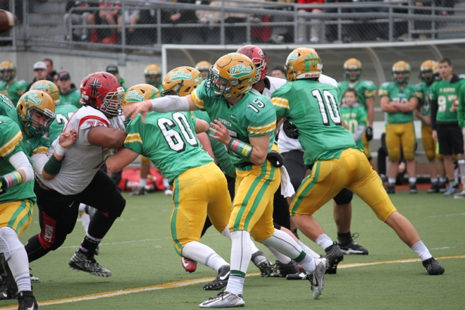
Tumwater is the most successful 2A football team over the past ten complete seasons, appearing in 7 state championship contests.
__________________________
2A STATE CHAMPIONSHIP HISTORY
(Since 2007)
2025 Archbishop Murphy 38, Tumwater 20
2024 Anacortes 20, Tumwater 10
2023 Anacortes 60, Tumwater 30
2022 Lynden 31, North Kitsap 24
2021 Lynden 21, Tumwater 7
2020 COVID – No State Playoffs
2019 Tumwater 48, Steilacoom 34
2018 Hockinson 42, Lynden 37
2017 Hockinson 35, Tumwater 22
2016 Archbishop Murphy 56, Liberty 14
2015 Prosser 22, Tumwater 15
2014 Sedro Woolley 42, Lynden 13
2013 Lynden 38, Tumwater 28
2012 Lynden 41, Tumwater 7
2011 Lynden 17, A. Murphy 16
2010 Tumwater 24, A. Murphy 14
2009 Lynden 16, West Valley (Sp.) 6
2008 Lynden 35, Prosser 34
2007 Prosser 42, Burl.-Edison 7

Week of 32 Playoff Berths
District 1 – 5 Berths
Northwest Conference: Lynden, Anacortes, Burlington-Edison, Archbishop Muphy, Squalicum.
District 2 – 4 Berths
Cedarcrest, Foster, Renton and Chief Sealth.
District 3 – 9 Berths
SPSL: Franklin Pierce, Fife, Eatonville, Orting, Olympic League: 4 Berths. North Kitsap, Olympic, Bainbridge, Bremerton. North Mason (Oly) beat Washington (SPSL) 18-15 this week for the 9th spot out of the district.
District 4 – 7 Berths
EVCO: Tumwater, WF West, with Black Hills earning the District’s seventh spot buy virtue of victories over Aberdeen and mark Morris.
GSHL: Woodland, Ridgefield, Washougal and Hockinson.
District 5 – 4 Berths
CWAC: Prosser, Selah, East Valley and Othello.
District 6 – 3 Berths
GSL 2A: West Valley of Spokane, Pullman, East Valley of Spokane.

