Jeff Place Sports Football Report
Saturday, Sept. 28, 2024
www.jeffplace.com - jeffplace@outlook.com

CWAC Standings Week 5

TEAM LG PF PA Season PF PA
1 Toppenish 4-0 89-47 4-0 89-47
2 Othello 3-0 79-12 4-0 121-29
3 Ephrata 3-1 64-60 3-1 64-60
4 East Valley 2-1 119-57 3-1 169-57
Selah 2-1 69- 13 2-2 76-41
6 Prosser 2-2 100-86 2-2 100-86
7 Quincy 0-3 17-134 1-3 41-146
8 Ellensburg 0-4 21-51 0-4 21-51
Grandview 0-4 33-131 0-4 33-131

THIS WEEK (Friday, 10-4-24)
East Valley (3-1) at Othello (4-0)
Grandview (0-4) at Ellensburg (0-4)
Selah (2-2) at Toppenish (4-0)
Quincy (1-3) at Prosser (2-2)
Davis at Ephrata (3-1) (NL)

LAST WEEK (10-27-24)
East Valley 40, Ephrata 7
Othello 10, Selah 3
Prosser 29, Grandview 13
Toppenish 7, Ellensburg 3
Quincy 24, Wapato 12 (NL)

NEXT WEEK (10-11-24)
Othello at Ephrata
Toppenish at East Valley
Ellensburg at Quincy
Grandview at Selah
Prosser at Royal (NL)

2 Weeks Ago (10-20-24)
Prosser 36, East Valley 35
Ephrata 9, Ellensburg 6
West Valley 28, Selah 7
Toppenish 42, Quincy 17
Othello 41, Grandview 0

3 Weeks Ago (10-13-24)
Othello 42, Connell 17
Selah 7, Ellensburg 3
East Valley 44, Grandview 14
Toppenish 23, Prosser 21
Ephrata 33, Quincy 0

+++++++++++++++++++++++++++++++
PROSSER FOOTBALL SCHEDULE
Fri Oct 11 at Royal 7PM
Fri Oct 18 at Othello 7PM
Fri Oct 25 Ellensburg 7PM
Fri Nov 1 Selah 7PM
+++++++++++++++++++++++++++

2A RPI RANKINGS
1 Tumwater (4-0) EVCO
2 Anacortes (4-0) NWC
3 Franklin Pierce (4-0) SPSL
4 *Clarkston (2-0) GSL (*See GSL)
5 Ridgefield (4-0) GSHL
6 Eatonville (4-0) SPSL
7 Chief Sealth (4-0) METRO
8 ATM (4-0) NWC
9 Bainbridge (3-1) OLYMPIC
10 WF West (4-0) EVCO
11 Toppenish (4-0) CWAC
Othello (4-0) CWAC
13 Orting (3-1) SPSL
14 Sehome (3-1) NWC
15 West Valley (S.) (3-0) GSL
16 Lynden (3-1) NWC
17 Olympic (3-1) OLYMPIC
18 Steilacoom (4-0) SPSL
19 Deer Park (3-1) GSL
Sequim (3-1) OLYMPIC
Fife (3-1) SPSL

MAJOR RESULTS LAST WEEK
Anacortes 35, Lynden 21
Franklin Pierce 36, Orting 8
Tumwater 49, Nooksack Valley 12
Clarkston 54, Omak 33
West Valley-S 39, Pullman 10
Ridgefield 49, Hudson’s Bay 0

STATE ALLOCATIONS – Round of 32
(Not Confirmed – Just a Guess)

D5 CWAC 9 Teams 4 Berths
D6 GSL 7 Teams
D1 NWC 9 Teams 5 Berths
D2 KINGCO 5 Teams
METRO 3 Teams
D3 OLYMPIC 8 Teams
SPSL 8 Teams
D4 EVCO 6 Teams
GSHL 8 Teams
2A LEAGUE LEADERS

D1 NORTHWEST CONF. (9 Teams)
1 Archbishop M 4-0 4-0
2 Anacortes 3-0 4-0
3 Sehome 3-1 3-1
4 Squalicum 2-1 2-1
5 Lynden 1-1 3-1

Last Week
Anacortes 35, Lynden 21
Archbishop Murphy 54, Bellingham 13
Sehome 28, Burl.-Edison 20
Lakewood at Squalicum (Sat)

This Week
Marysville-Pilchuck at Archbishop Murphy
Sehome at Lynden
Squalicum at Anacortes

D2 KINGCO (5 Teams)
1 Cedarcrest 1-0 1-3
2 Lindbergh 1-0 1-3
3 Evergreen 0-1 1-1
Renton 0-1 1-3

Last Week
Cedarcrest 47, Foster (SPSL) 7
Lindbergh 22, Sammamish (3A) 8
Newport (4A) 48, Renton 12

This Week
Evergreen at Cedarcrest
Foster at Lindbergh
Redmond (4A) at Renton

D2 METRO (3 Teams)
1 Chief Sealth 3-0 4-0
2 Nathan Hale 2-1 3-1

Last Week
Chief Sealth 33, Ingraham (3A) 7
Nathan Hale 14, Lakeside (Seattle 3A) 0

This Week
Lakeside (Seattle 3A) at Chief Sealth
Nathan Hale at Lincoln (4A Seattle)

D3 OLYMPIC (8 Teams)
1 Bainbridge 2-0 3-1
2 Sequim 1-0 3-1
3 No. Kitsap 1-1 1-3
No. Mason 1-1 3-1
Olympic 1-1 3-1

Last Week
Bainbridge 18, Olympic 14
North Kitsap 35, North Mason 14
Sequim 27, Port Angeles 7

This Week
Bainbridge at North Mason
Olympic at King’s (1A)
Port Angeles at North Kitsap

D3 SPSL. (8 Teams)
1 Eatonville 2-0 4-0
Franklin Pierce 2-0 4-0
Steilacoom 2-0 4-0
4 Fife 1-1 3-1
Orting 1-1 3-1

Last Week
Eatonville 45, Foss 20
Fife 46, Washington 7
Franklin Pierce 36, Orting 8
Steilacoom 35, Clover Park 6

This Week
Clover Park at Fife
Eatonville at Franklin Pierce
Orting at Steilacoom

D4 EVERGREEN CONF. (6 Teams)
1 Tumwater 0-0 4-0
WF West 0-0 4-0
3 Black Hills 0-0 1-3

Last Week
Rochester 28, Black Hills 13
Tumwater 49, Nooksack Valley 12
WF West 62, Shelton 0

This Week
Tumwater at Union
WF West at Aberdeen
Centralia at Black Hills

D4 GREATER ST. HELENS LG. (8 Teams)
1 RA Long 2-0 3-1
Ridgefield 2-0 4-0
Woodland 2-0 2-2
4 Mark Morris 1-1 1-3
Washougal 1-1 2-2

Last Week
RA Long 47, Hockinson 14
Ridgefield 49, Hudson’s Bay 0
Washougal 22, Mark Morris 0
Woodland 29, Columbia River 7

This Week
Hudson’s Bay at Mark Morris
RA Long at Columbia River
Washougal at Ridgefield
Woodland at Hockinson

D6 GREATER SPOKANE LG. (7 Teams)

1 Deer Park 2-0 3-1
2 Rogers 1-0 2-2
West Valley – Sp. 1-0 4-0
4 East Valley – Sp. 1-1 2-2
5 Clarkston 0-0 2-2
6 North Central 0-2 1-3
Pullman 0-2 0-3

Last Week
Clarkston 54, Omak (1A) 33 (NL)
Deer Park 17, East Valley (Spokane) 10
Rogers 23, North Central 0
West Valley (Spokane( 39, Pullman 10

This Week
Clarkston at Deer Park
East Valley (Spokane) at Pullman
Rogers at West Valley (Spokane)
++++++++++++++++++++++++++++++

1A FOOTBALL

D5 SCAC 1A (9 Teams)
1 Cashmere 4-0 4-0
Royal 4-0 4-0
3 Zillah 3-1 3-1
4 Ki-Be 2-2 2-2
5 Wahluke 2-2 2-2
6 Connell 1-2 1-3
7 College Place 0-3 1-3
Naches Valley 0-3 0-4
Wapato 0-3 0-4

Last Week
Royal 49, Zillah 21
Cashmere 45, Wahluke 0
Ki-Be 38, Naches 6
Connell 42, College Place 7
Quincy 24, Wapato 12 (NL)

This Week
Royal (4-0) at Cashmere (4-0)
Ki-Be (2-2) at Zillah (3-1)
Wahluke (2-2) at Granger (NL)
Naches Valley (0-4) at Connell (1-2)
College Place (1-3) at Wapato (0-4)

1A RPI RANKINGS
1 La Center (4-0) TRICO
2 Kalama (4-0) TRICO
3 Blaine (4-0) NWC
4 Seton Catholic (4-0) TRICO
5 Royal (4-0) SCAC
6 Nooksack Vly. (3-1) NWC
7 Castle Rock (3-1) TRICO
8 Life Christian (2-0) NISQUALLY
9 Meridian (3-1) NWC
10 Cashmere (4-0) SCAC
11 Tenino (3-1) EVERGREEN
12 Granite Falls (3-1) EMERALD S.
13 Mt. Baker (4-0) NWC
14 Lynden Chr. (1-2) NWC

+++++++++++++++++++++++++++++++++

OTHER FOOTBALL
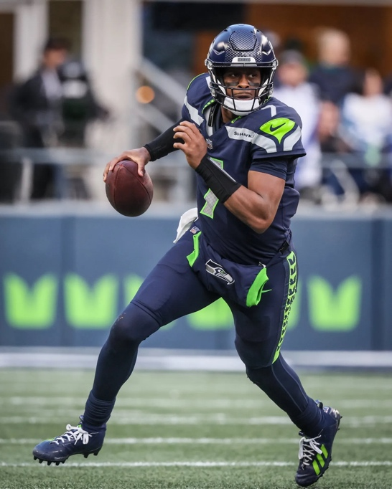

SEATTLE SEAHAWKS (3-0)
Monday, Sept 30: 5:15PM
Seahawks (3-0) at Detroit (2-1).

Last Week: Seattle 24-3 over Miam
Next Week: NY Giants at Seattle, 1:25PM

WASHINGTON STATE COUGARS (4-0)
Sat Sept 28 7pm at Boise State
Sat., Oct 12
WSU at Fresno State Time TBD

WASHINGTON HUSKIES (3-2)
Rutgers (4-0) 21, Washington 18
Sat., Oct 5
Michigan at U of Washington 4:30PM

