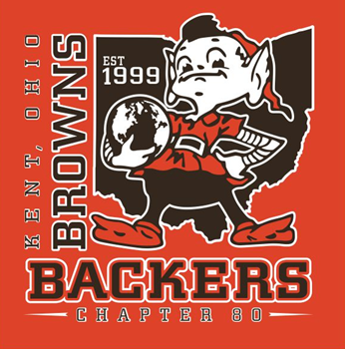

20th ANNUAL KENT BROWNS BACKERS
4-MAN CHARITY GOLF SCRAMBLE 2021

SPONSOR RECEIPT

Received from:

Amount:______________ Date:___________

Signed:______________________________________
(KBB Club Representative)

Kent Browns Backers is an IRS approved non-profit 501(c) corporation.

Proceeds fund donations to Hattie Larlham, Toys for Tots, Boys State, Stefanie Spielman Fund for Breast Cancer Research , American Cancer Society and many other charities.

THANK YOU! Your support is GREATLY APPRECIATED!

Save this receipt for your tax records. FID# 20-4852619

