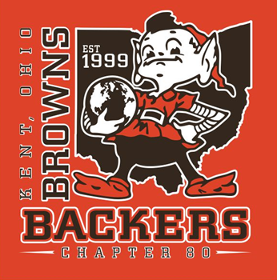

20th ANNUAL KENT BROWNS BACKERS
4-PERSON CHARITY GOLF SCRAMBLE

Where: Paradise Lake Golf Club, 1900 Randolph Rd. Mogadore

When: Sat. June 12, 2021. Scramble tee off 8:00 sharp. Be golf ready at 7:30.

18 holes of golf, cart, (2 per team), lunch at turn, rib & chicken dinner and beer.

Target Hole Contest, Cash Prizes for Longest Drive & Longest Putt, and Closest to the Pin. Special contest can win a $5,000 Dream Golf Giveaway, (new). Additional prizes include golf clubs, golf bag plus a Skins Contest and lots of other merchandise and Cleveland Browns prizes!

Cost: $100 per person until May 31, $105 after May 31. A $25 down payment, ($100 per foursome), is required to hold your position and lunch/dinner. Pay all at once or balance before tee off. This is required to be able to advise caterer on meal count. Rain or shine event.

Make your check payable to “Kent Browns Backers” and send to P.O. Box 3523, Kent, OH 44240, or pay via Pay Pal on our web site. Kent Browns Backers is an IRS approved 501(c) non-profit corporation. FID# 20-4852619

Call Mike, 330-328-6690, Marty, 330-283-9640, or Ron, 330-931-9527, for more details.

DON’T GET LEFT OUT! SIGN UP TODAY!
Golfer & Sponsor sign up form on reverse side

20th ANNUAL KENT BROWNS BACKERS 4-MAN CHARITY GOLF SCRAMBLE, June 12, 2021 – Golf and Sponsor sign up
________________________________________________________________

GOLFER SIGN-UP FORM

Player #1, (Captain):

Captain’s email address:
Player #2:
Player #3:

Player #4:
________________________________________________________________

SPONSOR SIGN-UP FORM

Business Name: _

Business Address:

Business Phone:

$100 Silver Level Sponsorship – Silver Level sponsors will have their business name and phone number printed on a large & distinctive sign. This sign will be displayed on the sponsor’s assigned tee.

$200 Gold Level Sponsorship—Gold Level sponsors include everything above plus their sign will be more distinctive multi-color tee sign.

$700 Platinum Level Sponsorship—Platinum Level sponsors include everything in the Silver & Gold levels plus this level includes a foursome from your business to our golf outing. Additionally, distinctive Kent Browns Backers apparel will be included for your foursome. Please give us the sizes you will need for your team players:

Small__ Med___ Large___ X Large___ 2X Large___

