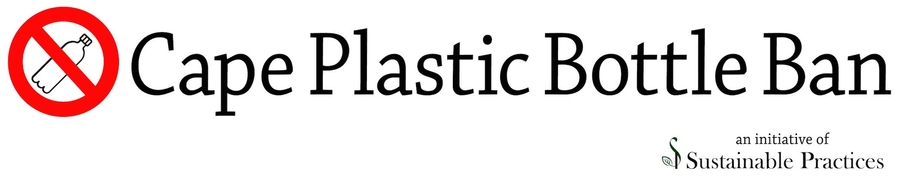
We live in a consumption-driven economy where the measurement of growth is dependent on a product’s lifecycle from production to waste. The more that is produced, consumed, and discarded, the higher the value of our gross domestic product (GDP), how we measure our economic strength. Unfortunately, non-market costs, such as pollution and disposal are not included in product prices. This means that we can overconsume resources because we are only looking at a fraction of the cost to the environment, society, and even our health. Awareness of the impact of our consumption decisions is a responsible use of the freedom of choice. Behavioral change that seeks to limit our environmental footprint, individually and collectively, reflects an understanding of and commitment to our common future.

The Cape Plastic Bottle Ban is an educational and citizen advocacy program that seeks to increase the awareness of the environmental and human impact of single-use plastic bottle consumption. Our current action, the Municipal Plastic Bottle Ban focuses on the elimination of single-use plastic bottled beverage purchase by town governments on Cape Cod and the sale of beverages in single-use plastic containers on town property. The rationale for our Municipal Plastic Bottle Ban rests on the assumption that government is established to protect the welfare of the people it governs. Plastic bottles are made from non-renewable fuels, leach chemicals into consumables, and never biodegrade. Plastic bottles impact environmental health and longevity of other species, who may ingest plastic as food. Ultimately, plastic re-enters the human food chain where adverse consequences are both known and emerging.

Plastic use is a U.S. issue:

There are 50 billion plastic bottles consumed every year, about 30 billion of them in the US. We consume roughly 60 percent of the world’s plastic bottles, even though we’re about 4.5 percent of the world population. The majority of plastic bottles are from the sale and distribution of water! There are 1,500 single-use plastic water bottles consumed per SECOND in the U.S.
Plastic use has a global impact:
- Plastic is non-renewable resource intensive and has a significant carbon footprint. We use 17 million barrels of oil each year just to produce water bottles. That’s enough oil to keep a million cars fueled for a whole year! The energy used to pump, process, transport, and refrigerate plastic bottled beverages requires more than 50 million barrels of oil every year. Estimates are that plastic will contribute to a minimum of 17% to the global greenhouse footprint based on present usage by 2050.
- Plastic is a human and environmental health hazard. Plastic contains and absorbs pollutants (BPA and phthalates) that are known to be human endocrine disruptors. Through plastic containers these chemicals and others can leach into the beverages we consume.
Plastic does not biodegrade. While it will break down into smaller parts based on sun exposure, it will never degrade into a natural substance. Plastic fragments absorb toxins that pollute our waterways, contaminate our soil, and sicken animals (which we then eat). Plastic has been found in the air we breathe, the water we drink and the food we eat.

- Recycling is not a solution to limiting plastic proliferation. Eighty percent of the water bottles we buy end up in landfills, the absolute worst place for them to be. That means roughly for every 10 bottles we drink, only two end up in the recycle bin. Our national recycle rate for plastic is only 23 percent, which means we throw 38 billion plastic bottles into landfills a year. However, repurposed, recycled plastic only contributes to larger amounts of plastic in our environment. Recycled plastic bottles are not made into new plastic bottles, instead they are used in clothing, carpet and building materials among other products; the demand for new plastic is not reduced because of recycling.

