
Resurrection Lutheran Church
To Live & Share the Love of Christ
Pastor Melissa Pagel

Sunday, August 16th 2026

Lectionary 20 (Pentecost 12)

Congregational responses are printed in Bold Type.

To Live & Share the Love of Christ
Welcome to Resurrection Lutheran Church where different people come together for the shared purpose of worshiping God and encouraging each other through the inclusive love of Jesus. Whether you are our guest, looking for a church home, or already a member, we want you to feel welcomed by our congregation and inspired by our worship service.

Sundays and Seasons.com. Copyright 2026 Augsburg Fortress. All rights reserved. Reprinted by permission under Augsburg Fortress Liturgies Annual License #SB173453. Duplication in any form is prohibited without permission or valid license from copyright administrator. CCLI License 1366153 One license A#712525 All rights reserved. Westminster John Knox Press from Connections Worship Companion. Copyright 2023.
Worship & Praise copyright 1999 Augsburg Fortress. All rights reserved.

Introduction

In Isaiah we hear that God’s house shall be a house of prayer for all people and that God will gather the outcasts of Israel. The Canaanite woman in today’s gospel is a Gentile, an outsider, who is unflinching in her request that Jesus heal her daughter. As Jesus commends her bold faith, how might our church extend its mission to those on the margins of society? In our gathering around word and meal we receive strength to be signs of comfort, healing, and justice for those in need.

How good and pleasant it is when the people of God live in unity!
It is like being anointed with precious oil, running down the head.

It is like the morning dew falling upon the mountains of Zion.
For there the Lord ordained this blessing: Life forevermore.

Invitation To Discipleship

This is the promise of the gospel:
God already knows you.
God already loves you.
God has already gifted you.
God has already called you.

Gathering Hymn Oh, for a Thousand Tongues to Sing ELW 886

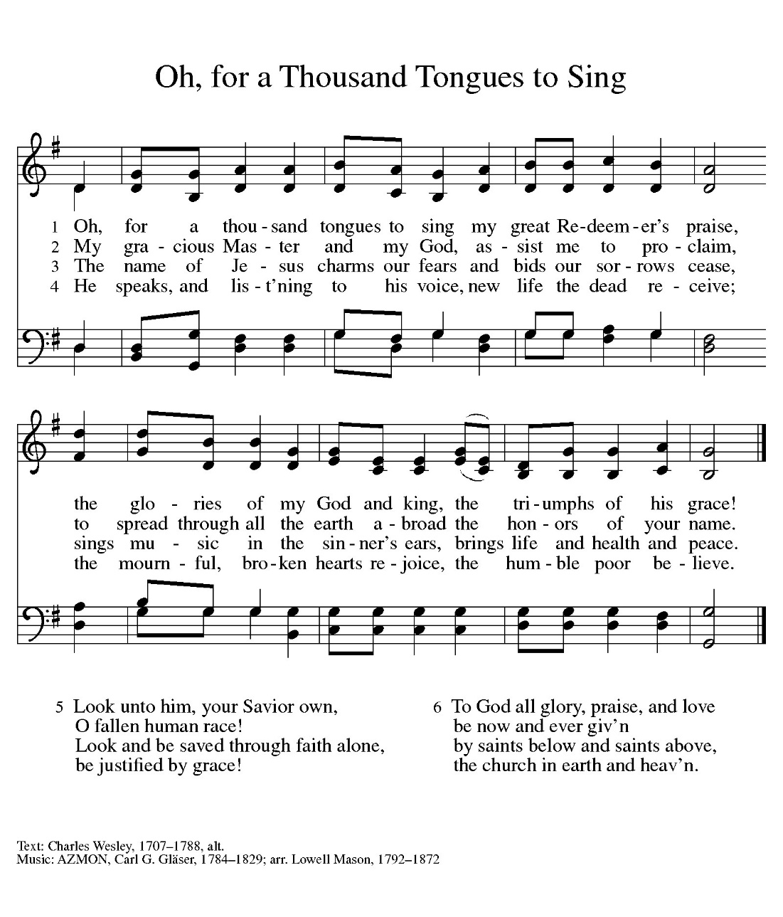

Confession and Forgiveness

Loving God,
While we were sinners, you sent Christ to die for us
that we might be justified by grace through faith and
have peace with you.
Yet, we continue to live in sin. We know what is good and right, but we do what is hateful and evil.
We live according to the flesh and resist the work of the Spirit.
We reject and deny your calling to the other children of Abraham.
We fail to love our neighbors and thereby fail to fulfill your law.
We do not contribute to those in need or extend hospitality to strangers.
We ignore the groaning of creation and forget the hope of the gospel.

Forgive us, loving God.
Pour out your Spirit into our hearts, that we may learn to live as those who are dead to sin and alive in you;
Through Jesus Christ our Lord.

In the name of Jesus Christ, we are forgiven.
Thanks be to God!

Prayer of the Day

Holy God,
by your providence you have preserved your people through many times of trouble.
Bless and keep us in these days, that we may know your abundant love and proclaim your saving work;
through Jesus Christ our Lord, Amen.
Amen.

WORD

First Reading: Isaiah 56:1, 6-8

¹ Thus says the Lord:
Maintain justice, and do what is right, for soon my salvation will come and my deliverance be revealed.
⁶ And the foreigners who join themselves to the Lord,
to minister to him, to love the name of the Lord and to be his servants, all who keep the Sabbath and do not profane it
and hold fast my covenant—⁷ these I will bring to my holy mountain and make them joyful in my house of prayer; their burnt offerings and their sacrifices will be accepted on my altar,
for my house shall be called a house of prayer for all peoples.
⁸ Thus says the Lord God, who gathers the outcasts of Israel:
I will gather others to them besides those already gathered.

Word of God, word of life.
Thanks be to God!

Psalm: Psalm 67

¹ May God be merciful to us and bless us; may the light of God’s face shine upon us.
² Let your way be known upon earth, your saving health among all nations.
³ Let the peoples praise you, O God; let all the peoples praise you.
⁴ Let the nations be glad and sing for joy, for you judge the peoples with equity and guide all the nations on earth.
⁵ Let the peoples praise you, O God; let all the peoples praise you.
⁶ The earth has brought forth its increase; God, our own God, has blessed us.
⁷ May God give us blessing and may all the ends of the earth stand in awe.

Second Reading: Romans 11:1-2a, 29-32

[Paul writes:] ¹ I ask, then, has God rejected his people? By no means! I myself am an Israelite, a descendant of Abraham, a member of the tribe of Benjamin. ^{2a} God has not rejected his people whom he foreknew.
²⁹ For the gifts and the calling of God are irrevocable. ³⁰ Just as you were once disobedient to God but have now received mercy because of their disobedience, ³¹ so also they have now been disobedient in order that, by the mercy shown to you, they also may now receive mercy. ³² For God has imprisoned all in disobedience so that he may be merciful to all.

Word of God, word of life.
Thanks be to God!’
Gospel Acclamation Celtic Alleluia ELW pg. 174
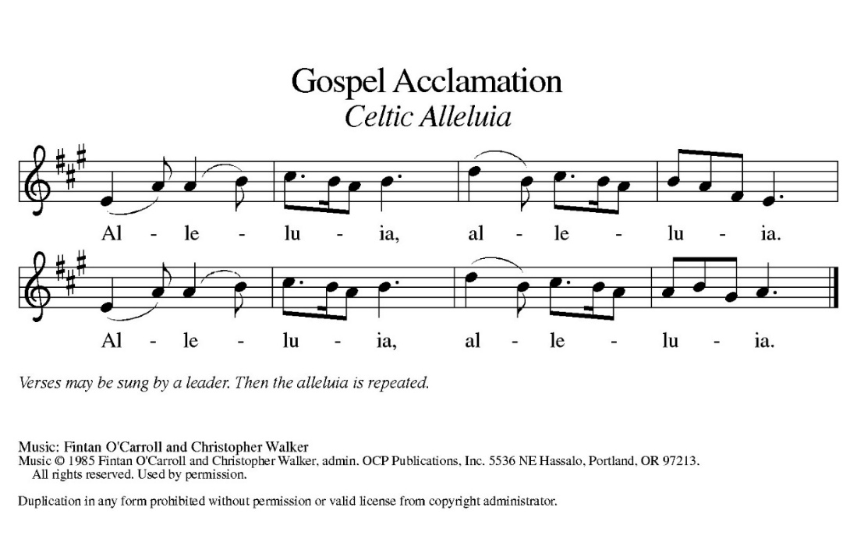
The Holy Gospel according to Matthew, the 15th Chapter.
Glory to you, O Lord.

Gospel: Matthew 15: [10-20] 21-28

¹⁰ [Jesus] called the crowd to him and said to them, “Listen and understand:¹¹ it is not what goes into the mouth that defiles a person, but it is what comes out of the mouth that defiles.” ¹² Then the disciples approached and said to him, “Do you know that the Pharisees took offense when they heard what you said?” ¹³ He answered, “Every plant that my heavenly Father has not planted will be uprooted. ¹⁴ Let them alone; they are blind guides of the blind. And if one blind person guides another, both will fall into a pit.” ¹⁵ But Peter said to him, “Explain this parable to us.” ¹⁶ Then he said, “Are you also still without understanding? ¹⁷ Do you not see that whatever goes into the mouth enters the stomach and goes out into the sewer? ¹⁸ But what comes out of the mouth proceeds from the heart, and this is what defiles. ¹⁹ For out of the heart come evil intentions, murder, adultery, sexual immorality, theft, false witness, slander. ²⁰ These are what defile a person, but to eat with unwashed hands does not defile.”]
²¹ Jesus left that place and went away to the district of Tyre and Sidon. ²² Just then a Canaanite woman from that region came out and started shouting, “Have mercy on me, Lord, Son of David; my daughter is tormented by a demon.” ²³ But he did not answer her at all. And his disciples came and urged him, saying, “Send her away, for she keeps shouting after us.” ²⁴ He answered, “I was sent only to the lost sheep of the house of Israel.” ²⁵ But she came and knelt before him, saying, “Lord, help me.” ²⁶ He answered, “It is not fair to take the children’s food and throw it to the dogs.” ²⁷ She said, “Yes, Lord, yet even the dogs eat the crumbs that fall from their masters’ table.” ²⁸ Then Jesus answered her, “Woman, great is your faith! Let it be done for you as you wish.” And her daughter was healed from that moment.

The gospel of the Lord. Praise to you, O Christ.

Sermon Pastor Melissa Pagel

Hymn of the Day Build a Longer Table ACS 1062
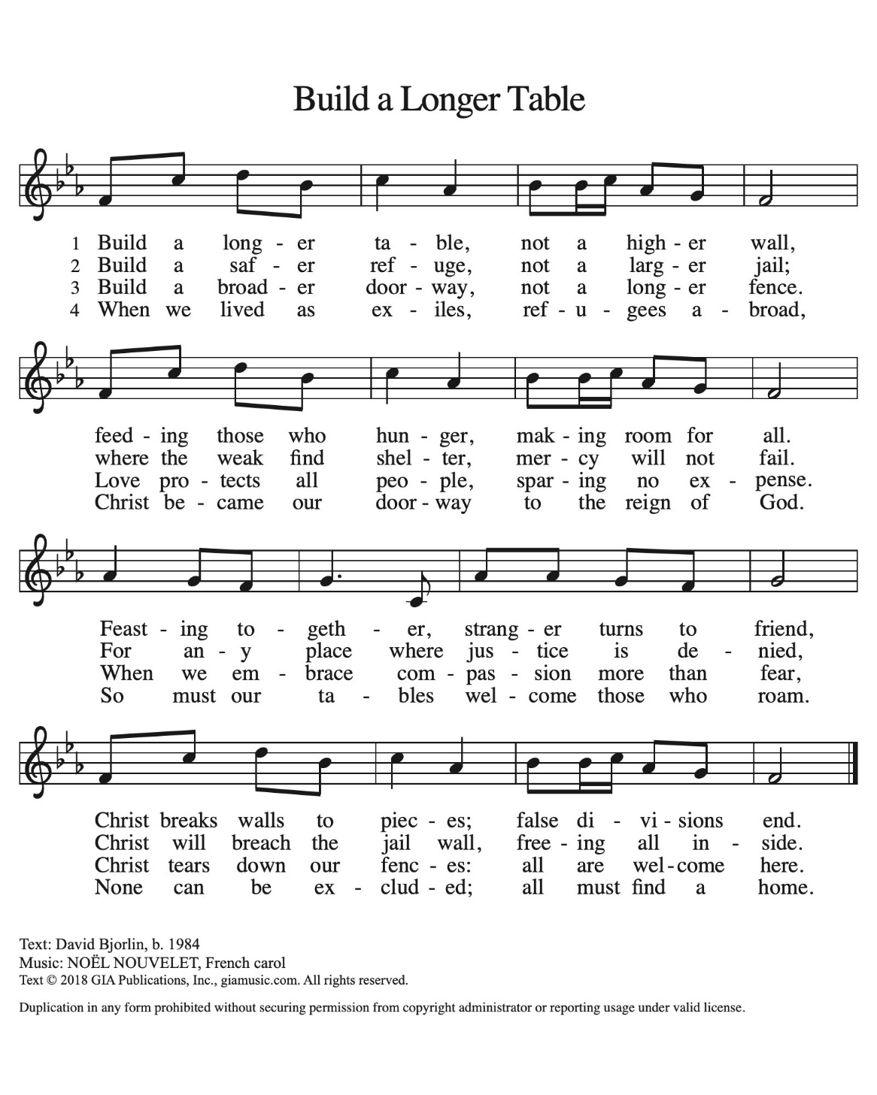
Apostles’ Creed

I believe in God, the Father almighty,
creator of heaven and earth.
I believe in Jesus Christ, God’s only Son, our Lord,
who was conceived by the Holy Spirit,
born of the virgin Mary,
suffered under Pontius Pilate,
was crucified, died, and was buried;
he descended to the dead.*
On the third day he rose again;
he ascended into heaven,
he is seated at the right hand of the Father,
and he will come to judge the living and the dead.
I believe in the Holy Spirit,
the holy catholic church,
the communion of saints,
the forgiveness of sins,
the resurrection of the body,
and the life everlasting. Amen

Prayers of the People

With bold trust in God’s unfailing provision, we pray for the church, those in need and all of God’s creation.
For believers around the world who stream to your holy mountain, that all be united in faith and harmony in the body of Christ. Let your church on earth be a witness to the beloved community of your heavenly kingdom. Merciful God,

Response: Hear our prayer.
Receive our prayers and answer, O God, as you have promised. All this we ask in the name of your Son, Jesus Christ our Lord. Amen.

The peace of Christ be with you always.
And also with you.

Offering

Offering Prayer

Loving God,
we offer at your table the gifts of our hearts.
Help us take heart in you and share freely of your love,
so that all creation can taste your abundance.
We ask this in the name of Jesus,
through the Spirit abiding with us now and forever.
Amen.

Thanksgiving at the Table

The Lord be with you. And also with you.
Lift up your hearts. We lift them to the Lord.
Let us give thanks to the Lord, Our God.
It is right to give God thanks and praise.

It is indeed, our right, our duty, and our joy…and join their unending hymn.

Holy, Holy W & P Pg 60, Verse #1 Only
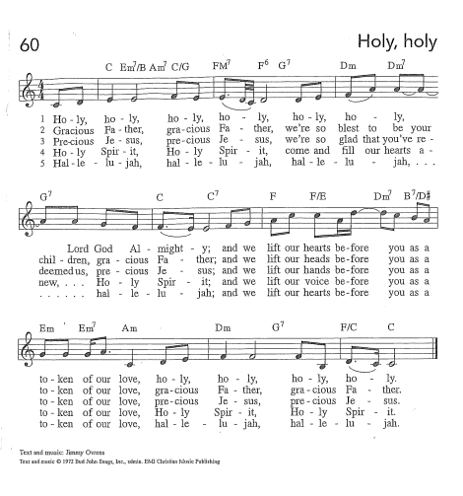
On the night…let us pray as Jesus taught us.

The Lord’s Prayer
Our Father, who art in heaven, hallowed be thy name, thy kingdom come, thy will be done, on earth as it is in heaven. Give us this day our daily bread; and forgive us our trespasses, as we forgive those who trespass against us; and lead us not into temptation but deliver us from evil.
For thine is the kingdom, and the power, and the glory, forever and ever. Amen.

Invitation to the Table

Even in time of famine, God provides a table for us, feeding us with mercy.

Come to this table—where strangers become siblings and foes become friends;
where wanderers are welcome and humble ones are honored;
where the sick find salvation and the outcast find open arms.

Table Blessing

The body and blood of our Lord Jesus Christ strengthen you and keep you in his grace. Amen.

Prayer after Communion

Compassionate God,
through the gifts of bread and wine
our hearts are filled with the abundance of your love.
Strengthen us that we, through this holy meal,
may share your love freely, as you have shared with us.
We ask this in the name of Jesus,
through the Spirit nourishing us now and forever.
Amen.

Benediction

Creator, Redeemer, Sustainer, ☩ one God, bless, heal, and hold you today and always. Amen.

Sending Hymn My Faith Looks Up to Thee ELW 759
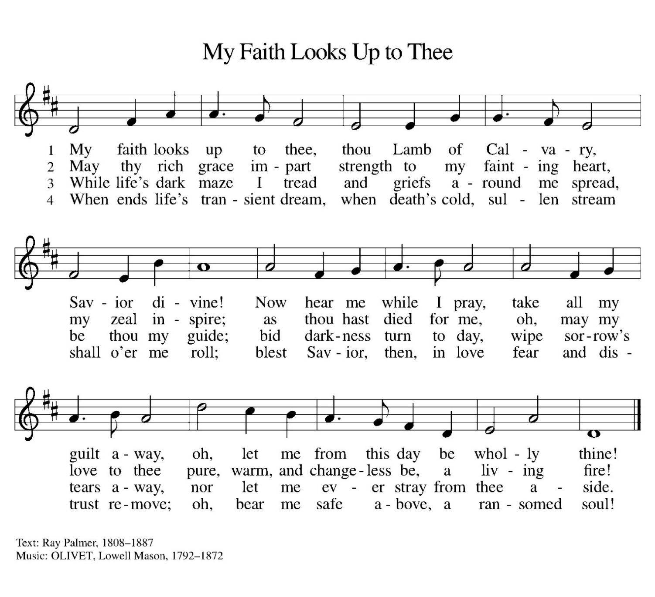
The Blessing

Go in peace, to live and share the love of Christ.
Thanks be to God.

This Week at a Glance

Office Hours: Mon-Wed, 9 am-2 pm
Monday
Meth Anonymous 6:00 pm
Tuesday
Quilters 9:00 am
Thursday
Food Pantry 9:00-11:00 am
Friday
Alcoholics Anonymous 9:00-10:30 am
Cocaine Anonymous 7:00-9:00 pm
Sunday
Worship Service 10:00 am

Please note:
Pastor Melissa will be out of the office Thursday-Saturday. Pastor Rachel will be covering. Please contact the Church Council President, Carol Borremans if you need to reach Pastor Rachel.

Upcoming Events

Assisting with Worship | Serving us today | 8/23/26
Musician | Greg Pagel | Greg Pagel
Usher | Open | Open
Communion Deacon | Carol Borremans | Cathy Morgans
Counters | Jim & Judy Gatske | Jim & Judy Gatske
Lector | Carol Borremans | Jim Gatske
Altar Guild | Val Nelson | Val Nelson
Fellowship | Pie Social | Jim & Judy Gatske

Meal Prep Workshops
Are you looking for healthy, tasty meals? There will be a series of workshops held in the church kitchen. This workshop has you walking away with three different dinners, each giving you 4-6 servings, along with a dozen delicious muffins or some sort of dessert.
All the planning and grocery shopping are done for you! You’ll go home with one meal ready to eat and two prepped for whenever you need them.
If the meal isn’t to your liking, give it as a gift!
All meat is sourced from local farmers and ranchers
Come prep three amazing meals with a fun group!
Upcoming Menus:

- Monday, August 17th:
Great Northern Enchiladas with Cilantro Lime Corn
Baked Ziti
Cilantro Lime Chicken
Fresh Berry Dessert Salad
- Time is 6-8 PM

- Saturday, September 5th:
Stuffed Bell Peppers
Beef & Broccoli Teriyaki (Local Beef)
Quinoa Pizza Bites
Lazy Day Oatmeal Cake
- Time is 1-3 PM
Flyers are in the Narthex and the cost is $60. You can call, email or text Emily Cowles to register: Please sign up by the Wednesday prior to the workshop.
Call 605-515-3910 or RDEmily@emskitchentable.com
Or Purchase Online:
https://emskitchentable.com/productdetails/product/mealprep

Bethel/Resurrection Newsletter
The newsletter deadline is monthly on the 22nd. Please email any articles or information to Ashley at Bethel at:
bethelonbond@yahoo.com
Culver’s Share Night for Bethel
Please join us on August 25th from 5-8 PM at the Culver’s De Pere location. Make your meal matter!

The Chosen Bible Study
Please bring your own lunch and join us for episodes of The Chosen followed by a discussion in the Gathering Room at church on the following Wednesdays from 11:30-1:00 pm.
- August 26

School Supply Drive
The giving tree will be collecting new, unused school supplies soon and will be distributed to three area elementary schools.
Thank you so much for your donations to this very important outreach project!

Supplies needed:
Pens/Pencils/Markers/Colored pencils/Erasers/Folders/Glue sticks/Wide ruled notebooks/Crayons/Rulers/Scissors /Index cards/Sticky notes/Rubber bands.

