
Resurrection Lutheran Church
To Live & Share the Love of Christ
Pastor Melissa Pagel

Sunday, February 15th, 2026
Transfiguration of Our Lord

Congregational responses are printed in Bold Type. To Live & Share the Love of Christ

Sundays and Seasons.com. Copyright 2022 Augsburg Fortress. All rights reserved. Reprinted by permission under Augsburg Fortress Liturgies Annual License #SB173453. Duplication in any form is prohibited without permission or valid license from copyright administrator. CCLI License 1366153 One license A#712525 All rights reserved.

Introduction

Today’s festival is a bridge between the Advent-Christmas-Epiphany cycle that comes to a close today and the Lent-Easter cycle that begins in several days. On a high mountain Jesus is revealed as God’s beloved Son, echoing the words at his baptism. This vision of glory sustains us as Jesus faces his impending death in Jerusalem. We turn this week to Ash Wednesday and our yearly baptismal journey from Lent to Easter. Some churches put aside the alleluia at the conclusion of today’s liturgy. This word of joy will be omitted during the penitential season of Lent and will be sung again at Easter.

Gathering Hymn Immortal, Invisible God Only Wise ELW 834

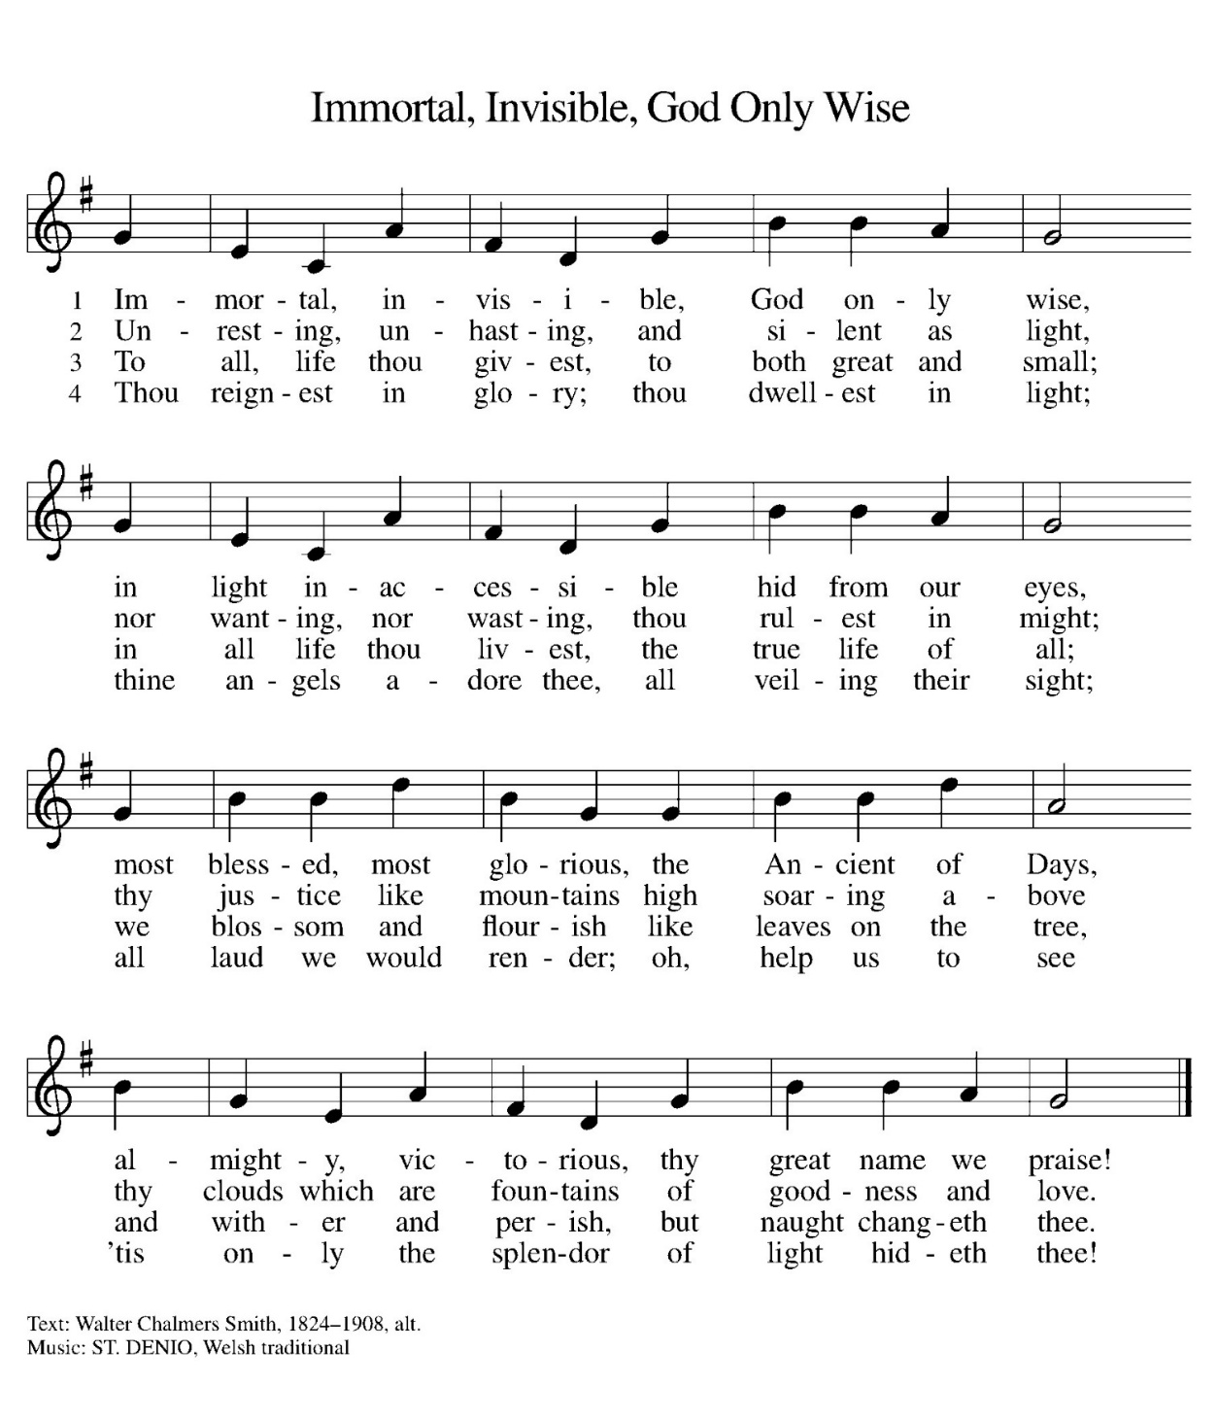
The grace of our Lord Jesus Christ, the love of God, and the communion of the Holy Spirit be with you all.
And also with you.

Confession and Forgiveness

Blessed be the holy Trinity, ☩ one God,
the Creator of heaven and earth,
the Word who spoke life into being,
the Wind stirring the waters. Amen.

Let us turn in confession to the one who knows us completely.

Prayer of Confession

Mighty God, lover of justice,
you call us to life in community,
but we have served our own interests
at the expense of our neighbors.
We have sown deceit where honesty was needed.
We say the right words,
but our hearts are far from you.
Turn us to seek your face.
Knit us together and give us the mind of Christ,
that we may do justice, love mercy,
and walk humbly with you, our God. Amen.

The former things have passed away,
and new things God now declares:
Like a spring of water that never fails,
God covers you in the righteousness of Christ,
and forgives your sin in ☩ Jesus’ name.
May the Spirit give you strength to live for others,
and bless you with the gift of peace. Amen.

Prayer of the Day

O God, in the transfiguration of your Son you confirmed the mysteries of the faith by the witness of Moses and Elijah, and in the voice from the bright cloud declaring Jesus your beloved Son, you foreshadowed our adoption as your children. Make us heirs with Christ of your glory, and bring us to enjoy its fullness, through Jesus Christ, our Savior and Lord, who lives and reigns with you and the Holy Spirit, one God, now and forever. Amen.

Word

First Reading: Exodus 24:12-18
¹² The Lord said to Moses, “Come up to me on the mountain and wait there; I will give you the tablets of stone, with the law and the commandment, which I have written for their instruction.” ¹³ So Moses set out with his assistant Joshua, and Moses went up onto the mountain of God. ¹⁴ To the elders he had said, “Wait here for us, until we come back to you. Look, Aaron and Hur are with you; whoever has a dispute may go to them.”
¹⁵ Then Moses went up on the mountain, and the cloud covered the mountain. ¹⁶ The glory of the Lord settled on Mount Sinai, and the cloud covered it for six days; on the seventh day he called to Moses out of the cloud. ¹⁷
Now the appearance of the glory of the Lord was like a devouring fire on the top of the mountain in the sight of the Israelites. ¹⁸
Moses entered the cloud and went up on the mountain. Moses was on the mountain for forty days and forty nights.
Word of God, word of life.
Thanks be to God!

Psalm: Psalm 2
¹ Why are the nations in an uproar?
Why do the peoples mutter empty threats?
² Why do the kings of the earth rise up in revolt, and the princes plot together,
against the Lord and against the Lord’s anointed?
³ “Let us break their yoke,” they say;
“let us cast off their bonds from us.”
⁴ God whose throne is in heaven is laughing;
the Lord holds them in derision.
⁵ Then in wrath God speaks to them,
and in rage fills them with terror.
⁶ “As for me, I have anointed my king
upon Zion, my holy mountain.”
⁷ Let me announce the decree of the Lord,
who said to me, “You are my son; this day have I
begotten you.
⁸ Ask of me, and I will give you the nations for your
inheritance and the ends of the earth for your possession.
⁹ You shall crush them with an iron rod
and shatter them like a piece of pottery.”
¹⁰ And now, you kings, be wise;
be warned, you rulers of the earth.
¹¹ Submit to the Lord with fear,
and with trembling bow in worship;
¹² lest the Lord be angry, and you perish in a sudden | blaze of wrath. Happy are all who take refuge in God

Second Reading: 2 Peter 1:16-21
¹⁶ We did not follow cleverly devised myths when we made known to you the power and coming of our Lord Jesus Christ, but we had been eyewitnesses of his majesty. ¹⁷ For he received honor and glory from God the Father when that voice was conveyed to him by the Majestic Glory, saying, “This is my Son, my Beloved, with whom I am well pleased.” ¹⁸ We ourselves heard this voice come from heaven, while we were with him on the holy mountain.
¹⁹ So we have the prophetic message more fully confirmed. You will do well to be attentive to this as to a lamp shining in a dark place, until the day dawns and the morning star rises in your hearts. ²⁰ First of all you must understand this, that no prophecy of scripture is a matter of one’s own interpretation, ²¹ because no prophecy ever came by human will, but men and women moved by the Holy Spirit spoke from God.
Word of God, word of life.
Thanks be to God!

Gospel Acclamation p. 151

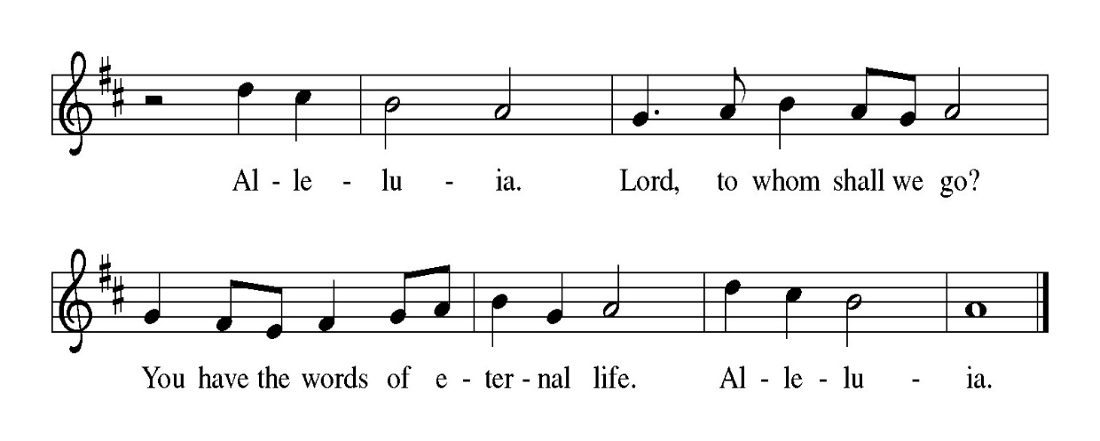

The Holy Gospel according to Matthew, the 17th Chapter.
Glory to you O’ God.

Gospel: Matthew 17:1-9
¹ Six days later, Jesus took with him Peter and James and his brother John and led them up a high mountain, by themselves. ² And he was transfigured before them, and his face shone like the sun, and his clothes became bright as light. ³ Suddenly there appeared to them Moses and Elijah, talking with him. ⁴ Then Peter said to Jesus, “Lord, it is good for us to be here; if you wish, I will set up three tents here, one for you, one for Moses, and one for Elijah.” ⁵ While he was still speaking, suddenly a bright cloud overshadowed them, and a voice from the cloud said, “This is my Son, the Beloved; with him I am well pleased; listen to him!” ⁶ When the disciples heard this, they fell to the ground and were overcome by fear. ⁷ But Jesus came and touched them, saying, “Get up and do not be afraid.” ⁸ And when they raised their eyes, they saw no one except Jesus himself alone.
⁹ As they were coming down the mountain, Jesus ordered them, “Tell no one about the vision until after the Son of Man has been raised from the dead.”
The gospel of the Lord. Praise to you, O Christ.

Sermon Pastor Melissa Pagel

Hymn of the Day How Good, Lord, to Be Here! ELW 315
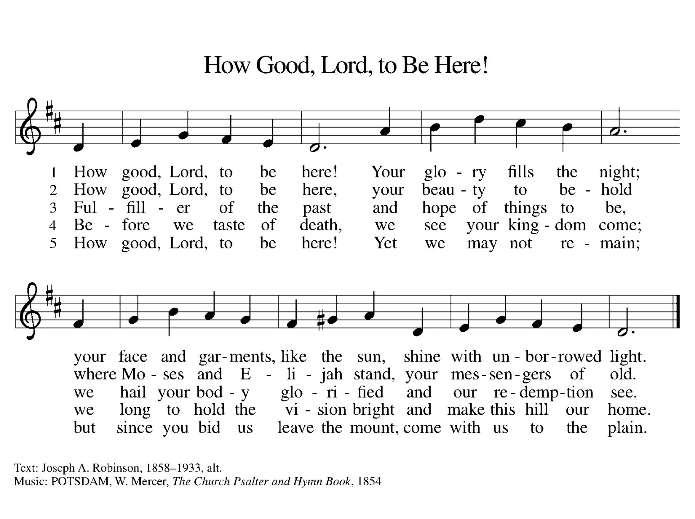
Apostles’ Creed
I believe in God, the Father almighty,
creator of heaven and earth.
I believe in Jesus Christ, God’s only Son, our Lord,
who was conceived by the Holy Spirit,
born of the virgin Mary,
suffered under Pontius Pilate,
was crucified, died, and was buried;
he descended to the dead.*
On the third day he rose again;
he ascended into heaven,
he is seated at the right hand of the Father,
and he will come to judge the living and the dead.
I believe in the Holy Spirit,
the holy catholic church,
the communion of saints,
the forgiveness of sins,
the resurrection of the body,
and the life everlasting. Amen

Prayers of the People

As God’s beloved children united in Christ, let us pray for the church, the whole human community, and the well-being of the earth, our home.
Response: Merciful God, receive our prayer.
Confident that the Holy Spirit receives our prayers and answers us, we commend all for whom we pray to God’s loving-kindness made known to us in Christ Jesus our Savior. Amen.

The peace of Christ be with you always.
And also with you.

Offering

Offering Prayer

God of majesty,
no eye has seen, no ear has heard
what you have prepared for those who love you,
yet in this meal you reveal the wideness of your mercy.
Use what we have gathered
to feed us with the reign of God come near,
Jesus Christ, our Savior and Lord. Amen.

Thanksgiving at the Table

The Lord be with you. And also with you.
Lift up your hearts. We lift them to the Lord.
Let us give thanks to the Lord, Our God. It is right to give God thanks and praise.

It is indeed, our right, our duty, and our joy…and join their unending hymn.

Holy, Holy p. 153
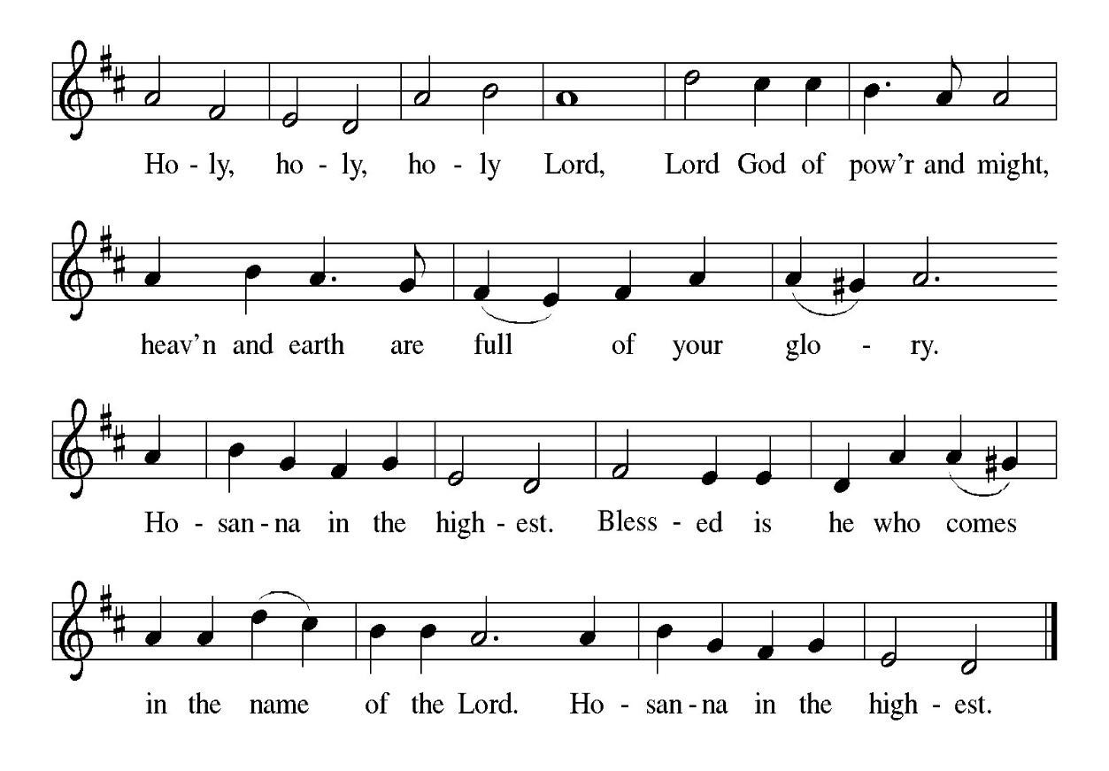

On the night…let us pray as Jesus taught us.

The Lord’s Prayer

Our Father, who art in heaven, hallowed be thy name, thy kingdom come, thy will be done, on earth as it is in heaven. Give us this day our daily bread; and forgive us our trespasses, as we forgive those who trespass against us; and lead us not into temptation but deliver us from evil.
For thine is the kingdom, and the power, and the glory, forever and ever. Amen.

Welcome to the Table

Here is the Lamb of God who takes away the sin of the world!
Come to the table; taste and see.
Table Blessing

The body and blood of our Lord Jesus Christ strengthen you and keep you in his grace. Amen.

Thanksgiving Prayer

Radiant God,
we have seen your glory in the face of Jesus Christ.
In the sacrament of his body and blood
you have drawn us to your heart.
Send us from this table with delight,
that our lives may reflect the beauty of your love,
and bear witness to all we have seen and heard,
through Jesus Christ, our Savior and Lord. Amen.

Benediction
May the triune God,
who has put a new song in your mouth
and tuned your heart for praise
☩ bless you now and forever. Amen.

Sending Hymn O’ Master, Let Me Walk with You ELW 818

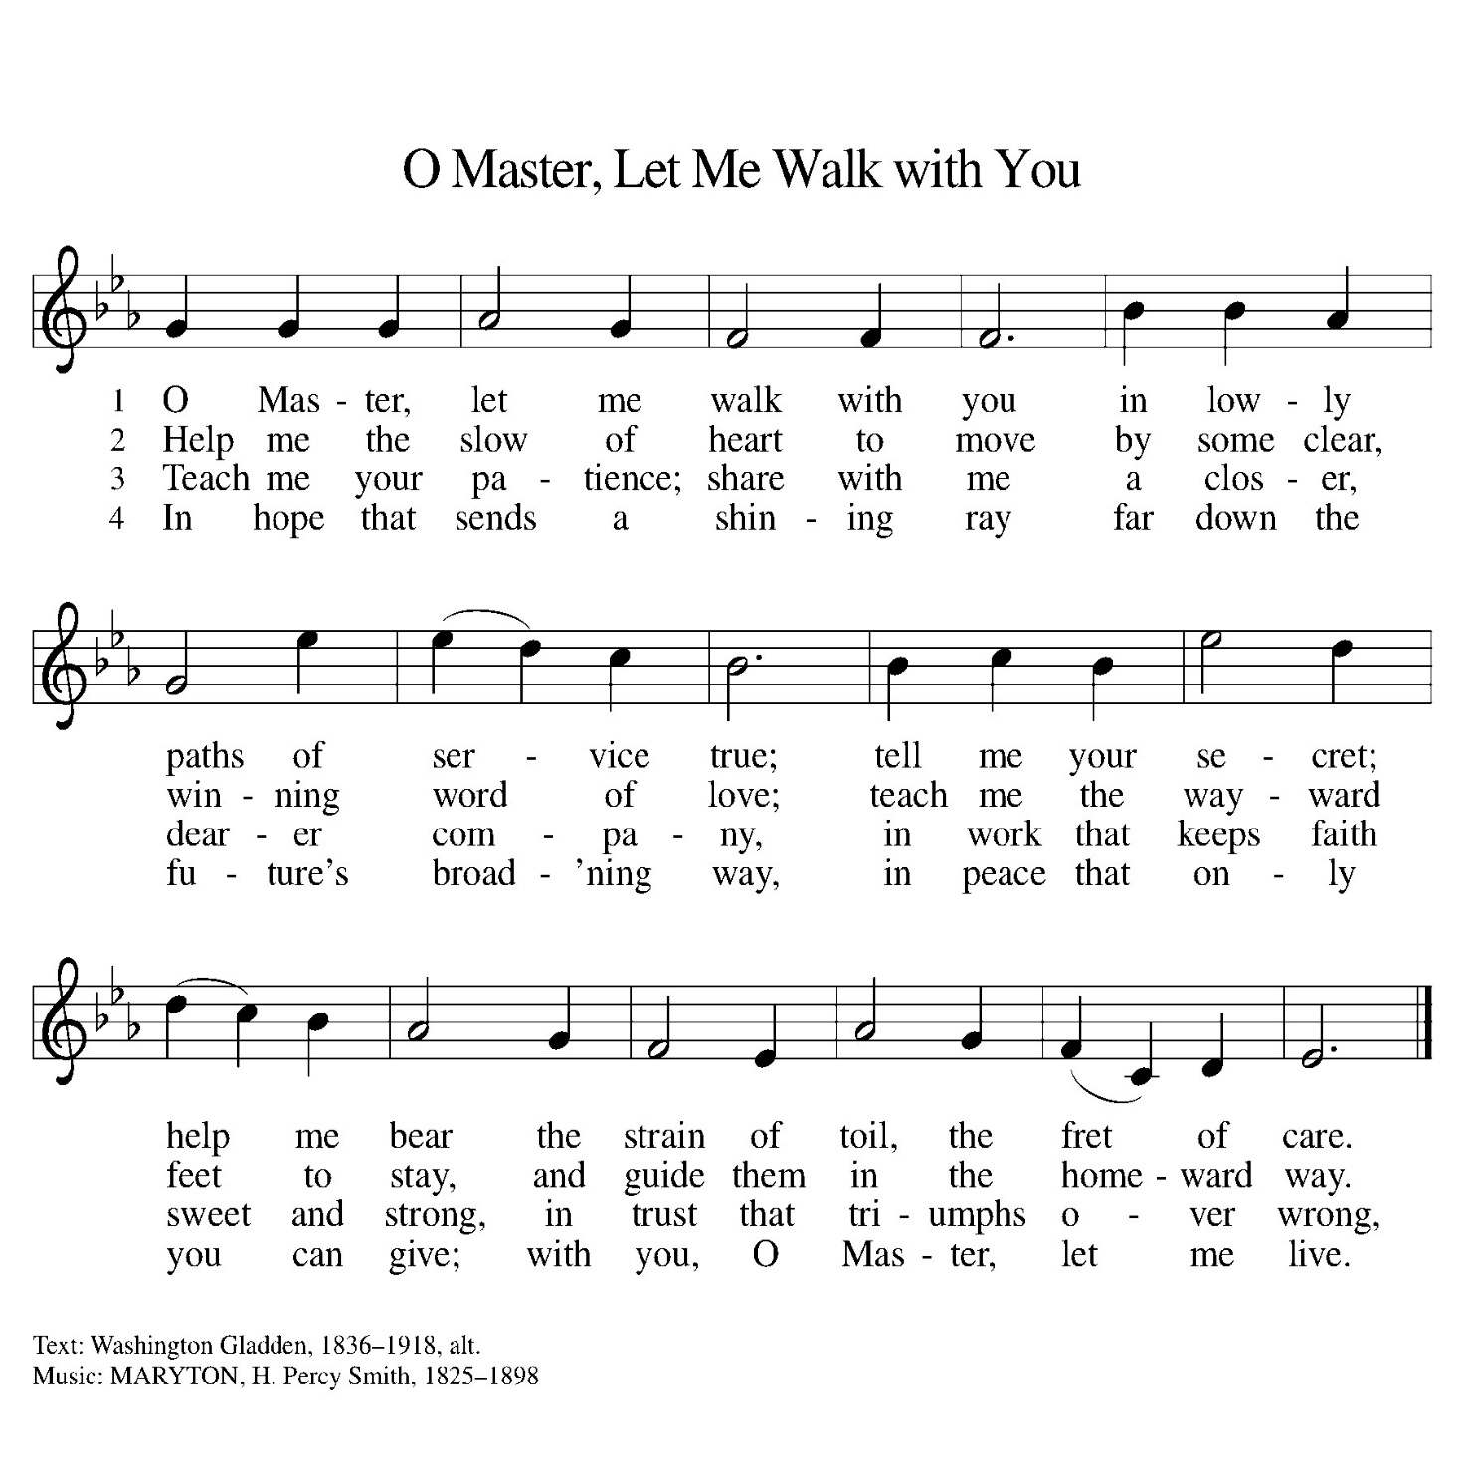
Go in peace. Do justice. Love Mercy.
Thanks be to God!

This Week at a Glance

Monday & Wednesday Office Hours
9:00 am-1:00 pm
Monday
Food Pantry Board
Meeting 11:00 am
Resource &
Finance Meeting 2:00 pm
Tuesday
Quilters 9:00 am
Church Council 6:00 pm
Wednesday
Soup Supper 5:00 pm
Ash Wednesday Lenten
Worship Service 6:30 pm
Sunday Worship Service 9:30 am

Upcoming Events

Assisting with Worship | 2/15/2026 | 2/22/2026
Usher | Bob Bishoff | Bob Bishoff
Communion Deacon | John Koch | OPEN
Counters | Jim & Judy Gatske | Jim & Judy Gatske
Lector | Jodi Koch | OPEN
Altar Guild | Carol Borremans | Carol Borremans
Fellowship | The Pagels | Hartungs/Kochs/Gatskes

Wedding Celebrations:
Congratulations go out to Jim & Judy Gatske, Bill & Kris Hartung and John & Jodi Koch who are all celebrating wedding anniversaries in the month of February! Jim & Judy celebrate 58 years, Bill & Kris celebrate 55 years and John & Jodi celebrate 31 years. All 3 couples are hosting fellowship on Sunday, February 22nd with cake and refreshments. In addition, Jim & Judy will be providing the altar flowers on that day.

Continuing Bible Study Series:
Please join us for an ongoing bible study every other Tuesday, based on the book, “Life Together” by Dietrich Bonhoeffer on Tuesday, February 24 at 6 PM. The book is FREE so please contact the church office if you plan on attending. Mark your calendars for the remaining dates: March 10, March 24 and April 7.

New Offering Envelopes:
The following is clarification from Financial Secretary, Chris Peterson:
The categories will be distributed in the following manner:
- Tithes/General = Current
- Missions = Food Pantry
- Building = Capital Fund

If you would like your offering to go to another fund (such as flowers, hunger, etc.) please write the donation category and amount on your envelope.

Food Pantry Gratitude:
Please join us after worship in the Narthex in celebration and thanksgiving for all of the work and dedication provided by volunteers of the food pantry!

Final Vote for the House:
The final vote for the house will take place on March 1st. Please mark your calendars to attend. It will take place immediately after worship. Please feel free to add any comments to the pros and cons sheets.

