
Resurrection Lutheran Church
To Live & Share the Love of Christ
Pastor Melissa Pagel

Sunday, August 23rd 2026

Lectionary 21 (Pentecost 13)

Congregational responses are printed in Bold Type.

To Live & Share the Love of Christ
Welcome to Resurrection Lutheran Church where different people come together for the shared purpose of worshiping God and encouraging each other through the inclusive love of Jesus. Whether you are our guest, looking for a church home, or already a member, we want you to feel welcomed by our congregation and inspired by our worship service.
Contact Us
Address: 1024 Shawano Ave.
Email: rlutheranchurch1024@gmail.com
Website: rlutherangb.com
Office phone: 920-497-7052

Sundays and Seasons.com. Copyright 2026 Augsburg Fortress. All rights reserved. Reprinted by permission under Augsburg Fortress Liturgies Annual License #SB173453. Duplication in any form is prohibited without permission or valid license from copyright administrator. CCLI License 1366153 One license A#712525 All rights reserved. Westminster John Knox Press from Connections Worship Companion. Copyright 2023.
Worship & Praise copyright 1999 Augsburg Fortress. All rights reserved.

Introduction

In Isaiah the people are advised to look to their spiritual ancestors as the rock from which they were hewn. Jesus declares that the church will be built on the rock of Peter’s bold confession of faith. God’s word of reconciliation and God’s mercy are keys to the church’s mission. Paul urges us to not be conformed to this world but to offer our bodies as a living sacrifice, using our individual gifts to build up the body of Christ. From the table we go forth to offer our spiritual worship through word and deed.
How good and pleasant it is when the people of God live in unity!

If the Lord had not been with us,
our enemies would have destroyed us and the floods would have swept us away.

Blessed be the Lord,
who has not forsaken us.

Our help is in the name of the Lord,
maker of heaven and earth.

Invitation To Discipleship

The people of God are called not to be conformed to this world,
but to be transformed—
by seeking the will of God for our lives and for the world.
Through our common life and witness, God is working to
transform the world.

Will you join us in this calling?
Will you come and be transformed?

Gathering Hymn My Hope is Built on Nothing Less
ELW 597

Confession and Forgiveness

Loving God,
While we were sinners, you sent Christ to die for us
that we might be justified by grace through faith and
have peace with you.
Yet, we continue to live in sin. We know what is good and right, but we do what is hateful and evil.
We live according to the flesh and resist the work of the Spirit.
We reject and deny your calling to the other children of Abraham.
We fail to love our neighbors and thereby fail to fulfill your law.
We do not contribute to those in need or extend hospitality to strangers.
We ignore the groaning of creation and forget the hope of the gospel.

Forgive us, loving God.
Pour out your Spirit into our hearts, that we may learn to live as those who are dead to sin and alive in you;
Through Jesus Christ our Lord.

In the name of Jesus Christ, we are forgiven.
Thanks be to God!

Prayer of the Day

Holy God,
Through baptism you save us from sin and evil and deliver us from sin and evil and deliver us from death.
Nourish us at your table and train us for your service, that we may help to set others free; through Jesus Christ our Lord. Amen.

WORD

First Reading: Isaiah 51:1-6

¹ Listen to me, you who pursue righteousness, you who seek the Lord. Look to the rock from which you were hewn and to the quarry from which you were dug.
² Look to Abraham your father and to Sarah, who bore you,
for he was but one when I called him, but I blessed him and made him many.

³ For the Lord will comfort Zion; he will comfort all her waste places and will make her wilderness like Eden, her desert like the garden of the Lord; joy and gladness will be found in her, thanksgiving and the voice of song.
⁴ Listen to me, my people and give heed to me, my nation,
for a teaching will go out from me and my justice for a light to the peoples.
⁵ I will bring near my deliverance swiftly; my salvation has gone out and my arms will rule the peoples;
the coastlands wait for me and for my arm they hope.
⁶ Lift up your eyes to the heavens and look at the earth beneath,
for the heavens will vanish like smoke, the earth will wear out like a garment and those who live on it will die like gnats,
but my salvation will be forever and my deliverance will never be ended.

Word of God, word of life.
Thanks be to God!

Psalm: Psalm 138

¹ I will give thanks to you, O Lord, with my whole heart; before the gods I will sing your praise.
² I will bow down toward your holy temple and praise your name, because of your steadfast love and faithfulness; for you have glorified your name and your word above all things.
³ When I called, you answered me; you increased my strength within me.
⁴ All the rulers of the earth will praise you, O Lord,
when they have heard the words of your mouth.
⁵ They will sing of the ways of the Lord, that great is the glory of the Lord.
⁶ The Lord is high, yet cares for the lowly, perceiving the haughty from afar.
⁷ Though I walk in the midst of trouble, you keep me safe;
you stretch forth your hand against the fury of my enemies; your right hand shall save me.
⁸ You will make good your purpose for me; O Lord, your steadfast love endures forever; do not abandon the works of your hands.

Second Reading: Romans 12:1-8

¹ I appeal to you therefore, brothers and sisters, on the basis of God’s mercy, to present your bodies as a living sacrifice, holy and acceptable to God, which is your reasonable act of worship. ² Do not be conformed to this age, but be transformed by the renewing of the mind, so that you may discern what is the will of God—what is good and acceptable and perfect.
³ For by the grace given to me I say to everyone among you not to think of yourself more highly than you ought to think but to think with sober judgment, each according to the measure of faith that God has assigned. ⁴ For as in one body we have many members and not all the members have the same function, ⁵ so we, who are many, are one body in Christ, and individually we are members one of another. ⁶ We have gifts that differ according to the grace given to us: prophecy, in proportion to faith; ⁷ ministry, in ministering; the teacher, in teaching; ⁸ the encourager, in encouragement; the giver, in sincerity; the leader, in diligence; the compassionate, in cheerfulness.

Word of God, word of life.
Thanks be to God!’

Gospel Acclamation Celtic Alleluia ELW pg. 174
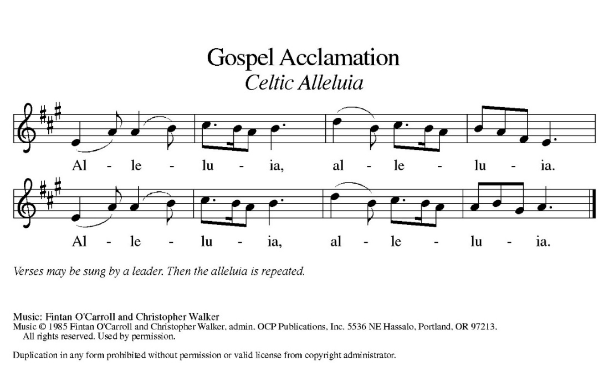

The Holy Gospel according to Matthew, the 16th Chapter.
Glory to you O Lord.

Gospel: Matthew 16: 13-20

¹³ Now when Jesus came into the district of Caesarea Philippi, he asked his disciples, “Who do people say that the Son of Man is?” ¹⁴ And they said, “Some say John the Baptist but others Elijah and still others Jeremiah or one of the prophets.” ¹⁵ He said to them, “But who do you say that I am?” ¹⁶ Simon Peter answered, “You are the Messiah, the Son of the living God.” ¹⁷ And Jesus answered him, “Blessed are you, Simon son of Jonah! For flesh and blood has not revealed this to you but my Father in heaven. ¹⁸ And I tell you, you are Peter, and on this rock I will build my church, and the gates of Hades will not prevail against it. ¹⁹ I will give you the keys of the kingdom of heaven, and whatever you bind on earth will be bound in heaven, and whatever you loose on earth will be loosed in heaven.” ²⁰ Then he sternly ordered the disciples not to tell anyone that he was the Messiah.

The gospel of the Lord. Praise to you, O Christ.

Sermon Pastor Melissa Pagel

Hymn of the Day The Church’s One Foundation ELW 654

Apostles’ Creed

I believe in God, the Father almighty,
creator of heaven and earth.
I believe in Jesus Christ, God’s only Son, our Lord,
who was conceived by the Holy Spirit,
born of the virgin Mary,
suffered under Pontius Pilate,
was crucified, died, and was buried;
he descended to the dead.*
On the third day he rose again;
he ascended into heaven,
he is seated at the right hand of the Father,
and he will come to judge the living and the dead.
I believe in the Holy Spirit,
the holy catholic church,
the communion of saints,
the forgiveness of sins,
the resurrection of the body,
and the life everlasting. Amen

Prayers of the People

With bold trust in God’s unfailing provision, we pray for the church, those in need and all of God’s creation.

God, our rock, you are the foundation on which the church is built. Strengthen and encourage your faithful people everywhere they gather, that they boldly proclaim your word of life to all the world. Merciful God,

Response: Hear our prayer.

Receive our prayers and answer, O God, as you have promised. All this we ask in the name of your Son, Jesus Christ our Lord. Amen.

The peace of Christ be with you always.
And also with you.

Offering

Offering Prayer

Loving God,
we offer at your table the gifts of our hearts.
Help us take heart in you and share freely of your love,
so that all creation can taste your abundance.
We ask this in the name of Jesus,
through the Spirit abiding with us now and forever.
Amen.

Thanksgiving at the Table

The Lord be with you. And also with you.
Lift up your hearts. We lift them to the Lord.
Let us give thanks to the Lord, Our God.
It is right to give God thanks and praise.

It is indeed, our right, our duty, and our joy…and join their unending hymn.

Holy, Holy W & P Pg 60, Verse #1 Only
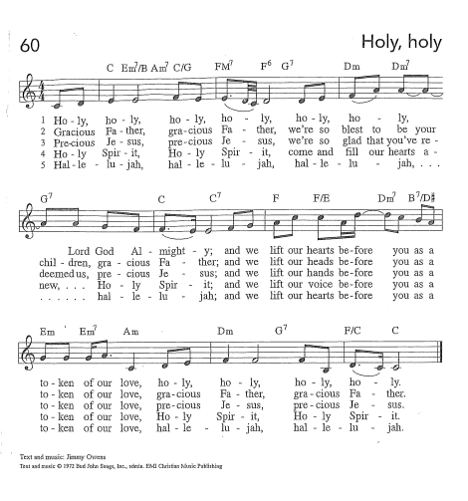
On the night…let us pray as Jesus taught us.

The Lord’s Prayer
Our Father, who art in heaven, hallowed be thy name, thy kingdom come, thy will be done, on earth as it is in heaven. Give us this day our daily bread; and forgive us our trespasses, as we forgive those who trespass against us; and lead us not into temptation but deliver us from evil.
For thine is the kingdom, and the power, and the glory, forever and ever. Amen.

Invitation to the Table

We who are many are one body in Christ and individually we are members of one another,
When we gather at the Lord’s table, we are united with God and one another, as members of the one body of Christ.

You are invited to share in this feast.
Come, Christ prepares a place for you here.

Table Blessing

The body and blood of our Lord Jesus Christ strengthen you and keep you in his grace. Amen.

Prayer after Communion

Compassionate God,
through the gifts of bread and wine
our hearts are filled with the abundance of your love.
Strengthen us that we, through this holy meal,
may share your love freely, as you have shared with us.
We ask this in the name of Jesus, through the Spirit nourishing us now and forever. Amen.

Benediction

Creator, Redeemer, Sustainer, ☩ one God, bless, heal, and hold you today and always. Amen.

Sending Hymn We All Are One in Mission ELW 576

The Blessing

Go in peace, to live and share the love of Christ.
Thanks be to God.

This Week at a Glance

Office Hours: Tuesday-Thursday, 9 am-2 pm
Monday
Meth Anonymous 6:00 pm
Tuesday
Quilters 9:00 am
Thursday
Food Pantry 5:30-7:30 pm
Friday
Alcoholics Anonymous 9:00-10:30 am
Cocaine Anonymous 7:00-9:00 pm
Sunday
Worship Service 10:00 am

Upcoming Events

Assisting with Worship | Serving us today | 8/30/26
Musician | Greg Pagel | Greg Pagel
Usher | Open | Open
Communion Deacon | Cathy Morgans | Kevin Wood
Counters | Jim & Judy Gatske | Jim & Judy Gatske
Lector | Jim Gatkske | Cathy Morgans

Assisting with Worship | Serving us today | 8/30/26
Altar Guild | Val Nelson &  Melissa Smith | Val Nelson &  Melissa Smith
Fellowship | Jim & Judy Gatske | Open

Meal Prep Workshops
Are you looking for healthy, tasty meals? There will be a series of workshops held in the church kitchen. This workshop has you walking away with three different dinners, each giving you 4-6 servings, along with a dozen delicious muffins or some sort of dessert.
Upcoming Menus:
- Saturday, September 5th:
Stuffed Bell Peppers
Beef & Broccoli Teriyaki (Local Beef)
Quinoa Pizza Bites
Lazy Day Oatmeal Cake
- Time is 1-3 PM
- Saturday, October 3rd:
Spinach Gnocchi Alfredo
Tempting Taco Pasta Shell Casserole
Turkey Chili
Chocolate Chip Cookies
- Time is 1-3 PM
- Saturday, November 7th:
Beef Barley Stew (local beef)
Deep Dish Cheesy Broccoli & Brown Rice
Easy Tuna Casserole
Brown Butter Pecan Pie
- Time is 1-3 PM
- Saturday, December 5th:
White Bean Chicken Chili
Amazing Macaroni and Cheese
Smashed Bean and Red Pepper Quesadillas
Molten Hot Fudge Lava Cakes
- Time is 1-3 PM
The cost is $70. You can call, email or text Emily Cowles to register: Please sign up by the Wednesday prior to the workshop.
Call or text 605-515-3910 or email at: RDEmily@emskitchentable.com

The Chosen Bible Study
Please bring your own lunch and join us for episodes of The Chosen followed by a discussion in the Gathering Room at church on the following Wednesdays from 11:30-1:00 pm.
- August 26
- September 15
- October 13
- October 27
Breaking Bread
Join us the second Tuesday of each month with Bethel for Breaking Bread at The Rite Place Restaurant at 5:30 pm. Food and drink will be available for purchase. The restaurant is located at 1580 Bellevue Street in Green Bay.

School Supply Drive
The giving tree will be collecting new, unused school supplies soon and will be distributed to three area elementary schools.
Thank you so much for your donations to this very important outreach project!

Supplies needed:
Pens/Pencils/Markers/Colored pencils/Erasers/Folders/Glue sticks/Wide ruled notebooks/Crayons/Rulers/Scissors /Index cards/Sticky notes/Rubber bands.

The deadline to donate supplies is today, Sunday, August 23rd and will be distributed to Fort Howard and Lincoln schools the week of August 24th. If you have any questions, please contact Sandy Krakow at 920-606-9385 or sandylr54@gmail.com.

End of Life Planning Workshop
Please join us on September 19 from 1-3 PM in the fellowship hall at Bethel for an End of Life Planning Workshop. We will be joined by the staff of Fort Howard Mausoleum for service and funeral planning, as well honoring your final wishes.

Confirmation for All Ages
Never confirmed? Don't remember a thing from confirmation class as a kid? This one's for you. Starting September 23rd from 6-7:30 PM in the Gathering Room at Resurrection, we're offering an 8-month course exploring what it means to be Lutheran — the Creed, the Ten Commandments, the Lord's Prayer, and Baptism and Communion — built for adults, not teenagers. We'll meet twice monthly for 1.5 hours in a discussion-based setting that welcomes real questions. The course concludes with an optional opportunity to affirm your baptism in worship — no pressure, just an open door.
October dates:
- October 13
- October 27
Trunk or Treat Support
Outreach is looking for 4-5 individuals to apply for Thrivent Action Teams to help support Trunk or Treat on Oct. 10 so that the community can enjoy a free family event! There will be a sign up for teams for the following categories:
- Printing/advertising
- Food
- Candy/s'mores
- Food pantry games

Please see Melissa Smith if you’re willing to apply for Thrivent Action Teams on Resurrection’s behalf.

