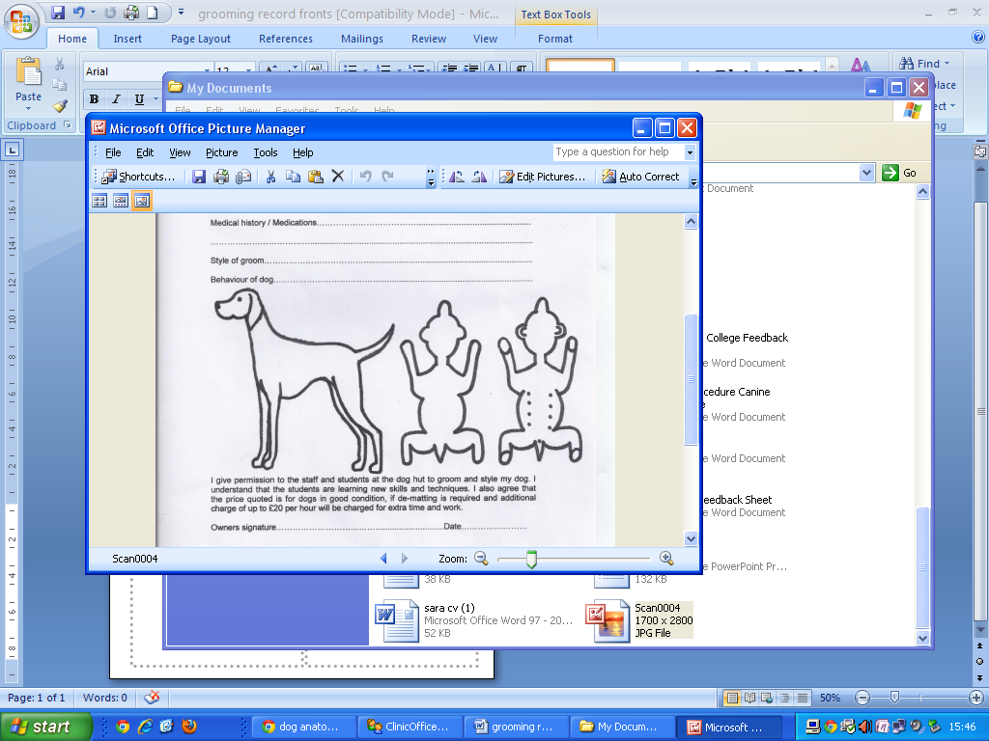

**Lump, Bump and Wart Chart** If there are any changes in the health,

welfare and condition of your dog since signing this agreement, then it

is your responsibility to notify Harvey Barkers Dog Groomers at time of

appointment.

Owner signature……………………………………. Date……………….....

**Owners Details**

Owners Name..................................................

Address...........................................................

......................................................................

......................................................................

.......................................................................

Home Telephone:..............................................

Mobile Number:..............................................

Alternative Contact Number: ...........................

Email Address:..................................................

Best or Preferred Method of Contact: (please circle)

Home Phone Mobile Email

**Dogs Details**

Dogs Name.......................................................

Dogs Breed.......................................................

Date of Birth..................... Sex: Male / Female

Microchipped: Yes / No Neutered: Yes / No

Vaccination Date:............................................

Vet Details..............................

Vet Phone Number: ..........................

Medical Conditions or Allergies:.......................

..........................................................................

Behaviour of Dog:.............................................

Microchip Number if known:...........................................

**Terms and Conditions**

I _____________________________ give permission to the staff at Harvey Barkers Dog Groomers at 1 Stone Cottages, Lewes Road, Forest Row to groom and style my dog. All Staff have appropriate pet grooming business insurance cover.

**Late fee and cancellation charges**

You will be given an appointment time at the time of booking. If you are more than 10 minutes late for an appointment your dog may not be able to be groomed and the cancellation charge will apply.

At time of drop off an approximate collection time will be given to you to collect your dog (As standard we will message you 10 minutes before the collection time to confirm the groom will be completed). If you arrive more than 10 minutes late for collection then a £5 late collection fee will apply. This will be multiplied every further 10 minutes you are late to collect your dog. If we are unable to contact you on the number supplied and you are more than 30 minutes late collecting your dog, we may contact a local vet or dog warden to take your dog. The grooming charge and late fee will still apply as well as a possible additional fee from when the vet/warden takes responsibility for your dog.

**Any appointments cancelled with less than 48hours notice will be charged at the full quoted grooming rate.**

**Coat Maintenance and Welfare**

I agree that the price quoted is based on my dogs’ behaviour and coat being in good condition. If any additional grooming or assistance is required, such as de-matting or an additional handler needed, whilst we will endeavour to complete your dog’s groom in the allotted time as discussed with you upon your arrival, if additional time/resources is needed to complete the groom, up to £35 an hour extra will be charged for the extra time required.

The provision of the additional time is in line with our animal welfare policy and is too ensure that the welfare of your dog is maintained throughout the grooming process.

If the groomer at Harvey Barkers is unable to be completed in the allotted time due to coat condition or behaviour, we may send the dog home partially groomed and will offer alternative appointment to complete the groom (however it cannot be guaranteed as to the time scale of the next appointment and there will be an additional grooming appointment charge.)

In the case of large areas of matting where we are able to complete the groom in the allotted appointment time then a £10 matting fee will be charged in addition to the grooming appointment fee.

**Dogs in season**

As a standard rule, we are unable to groom a dog that is in season. If your dog is found to be in season during the groom we reserve the right to send dog home partially groomed and there may be an additional £20 charge on top of the groom for the additional salon cleaning required. There may be exceptional circumstances where we can complete a groom for your dog. however this would be by prior agreement by the owner only.

**Fleas**

If you suspect your dog has fleas, please contact us as early as possible to rearrange your appointment. If it is within 24 hours the cancellation charge will still apply. If your dog arrives for the appointment and we discover it has fleas, then there will be a £20 additional charge for treating the salon. If we are able to, we shall wash your dog in an anti-flea shampoo at an additional charge of £5. It may not be possible to complete your dog’s groom but we shall endeavour to do so if possible. The full grooming fee will still apply.

**Tics**

If we discover a Tic on your dog during the grooming process we shall remove if possible at no additional charge. You will be informed if this has happened.

**Medical Conditions/injuries**

It is your responsibility to inform the groomer at the drop off time of any medical conditions, wounds, injuries. Whilst we always treat the dogs with welfare as our main priority we cannot be held responsible if you dog suffers a medical episode due to a health condition.

If such an incident should occur, then we would ring you immediately as well as contacting the local vet for advise/assistance. If your dog should need veterinary care we are not liable for the charges associated with this. In the rare event that an injury should occur during the appointment then we would inform you immediately and discuss if we thought veterinary care was needed. We are not liable for any veterinary costs associate with the injury unless a vet report is obtained specifically deeming the cause to be a direct fault of the groomer and not associated with the dogs behaviour towards grooming.

Owner signature……………………………………. Date……………….....

***Please note****: photographs may be taken of your dog during the groom for our profiles. We may wish to use some of these for photos for advertising and on our social media. If you do not consent to this please inform us in writing.*