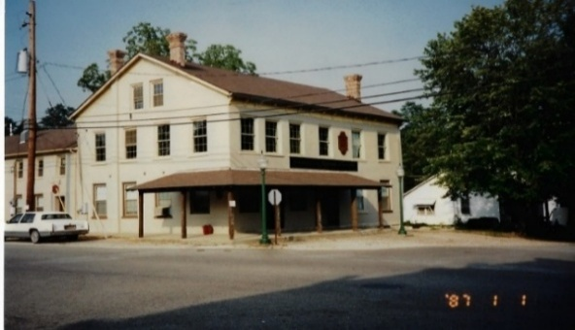
North American House Museum
Jennings County Historical Society
P.O. Box 335, 134 E Brown St., Vernon, IN 47282 812-346-8989
Email: jenninghistoricalsociety@gmail.com

Calendar of Events

Repeating Events:
- April - October 10 Working Blacksmith Shop Open 9a.m. to 2p.m. Second Saturday Monthly
- Monthly Meeting 4th Friday of every month (except July and December) at Noon, Historical Society in Vernon, IN

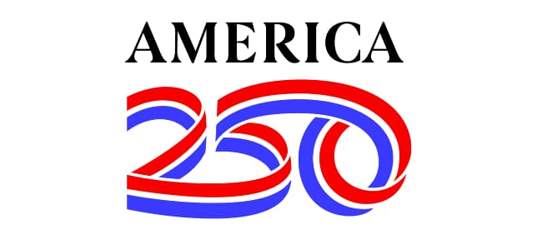
250th Celebration – July 6th, 2026
In partner with North Vernon Main Street and The Woodshop Boys. North Vernon
and Jennings County Historical Society celebrate 250 years of the United States of
America!

(Program 2) August 16th – 3:30 pm Jennings County Historical Society
Join Us for Indiana Black History with award winning Sue Livers, historian and first-person interpreter! This is a three-part series by Sue Livers, Black History Historian and first-person interpreter. This program is sponsored by Indiana Humanities.

October 16 & 17, 2026 Friday / Saturday – Ghost Walk and Mystery Dinner at North American House
Join us for fun of exploring local folklore, ghost stories, and mysteries presented by Jennings County youth around the town of Vernon. The Mystery Dinner serves a full course dinner with mysterious fun! Reservations required for the Mystery Dinner but not required for the Ghost Walk, which runs tours about every 20 minutes from 6:30 pm to 9:30 pm.

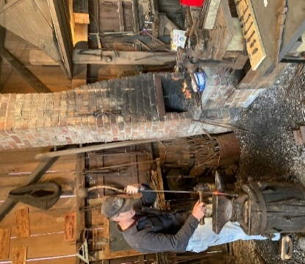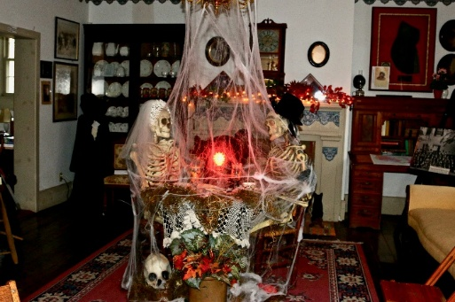

(Program 3) November 15th – 3:30 pm, Jennings County Historical Society followed by a free chili supper.
Join Us for Indiana Black History with award winning Sue Livers, historian and first-person interpreter! This is a three-part series by Sue Livers. This program is sponsored by Indiana Humanities.

November 28, 2026 – January 24, 2027 Voices Over Votes – Smithsonian Exhibit in Historic Vernon, Indiana

Sponsored by Indiana Humanities and the Jennings County Historical Society. "Voices and Votes" is a Smithsonian traveling exhibition exploring the history, challenges, and ongoing story of democracy in the United States.

Overview
"Voices and Votes: Democracy in America" examines the evolution of American democracy from the Revolution to the present, highlighting who has had the right to vote, the responsibilities of citizenship, and how citizens make their voices heard Smithsonian Institution+1. The exhibition is based on the Smithsonian’s National Museum of American History exhibition American Democracy: A Great Leap of Faith and is presented through the Museum on Main Street (MoMS) program, which brings high-quality Smithsonian content to small and rural communities across the U.S.

Sassafras and Civil War Living History Festival - April 24 and 25, 2027 Saturday and Sunday
9a.m. to 4p.m.

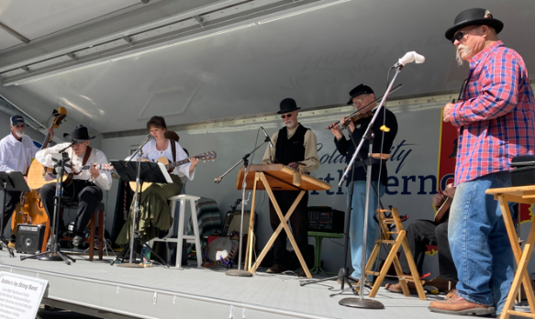
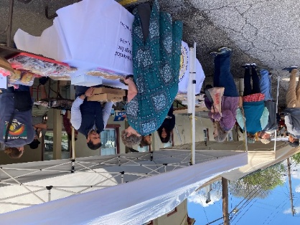

Come relive the 1860’s as Jennings County lived through the Civil War, learn about the Underground Railroad, and daily life in pioneer America. Re-enactments of battles, first person interpreters such as Lew Wallace, Hagerman Tripp, Oliver Morton and others, making pottery from mud (with Karen Chilman), weaving and other crafts, Music on the square, the Blue-Grey Ball, working blacksmith shop, wood carving, broom making and much more. Famous for its Sassafras and Tea and homemade pies, this annual event has something for the entire family.

Events from the Jennings County Historical Society are presented to you in part by local businesses, donations, and mini grants through the Jennings County Community Foundation, Indiana Humanities and in part from the Columbus Area Arts Council, the Indiana Arts Commission, a state agency and the National Endowment for the Arts.
Vernon Indiana is located in Jennings County Indiana, approximately midway between Louisville, Indianapolis and Cincinnati. From Interstate 65 take the North Vernon Exit East on U.S. Highway 50. At the junction of U.S. 50 and Indiana 3/7 travel south approximately 2 miles to Vernon. Vernon was settled in the early 1800’s and the entire town is listed in the National Register of Historic Places. The Jennings County Historical Society is a not-for-profit 501C3 organization incorporated in 1961 and headquartered in the North American House, open W, Th, F from 11a.m. to 4p.m. It was built in 1838 and restored in the 1980’s. It houses artifacts and documents illustrating the history of Jennings County with an emphasis on traditional arts and local history. The working Blacksmith Shop and a Victorian Pattern House are also located on the museum grounds. All proceeds from donations and events are used for the operation of the museum, programs and projects. Other events and programs will be scheduled throughout the year and posted on the Society’s website: http://www.jenningscounty.org

