Brown’s Landing RV Park Map
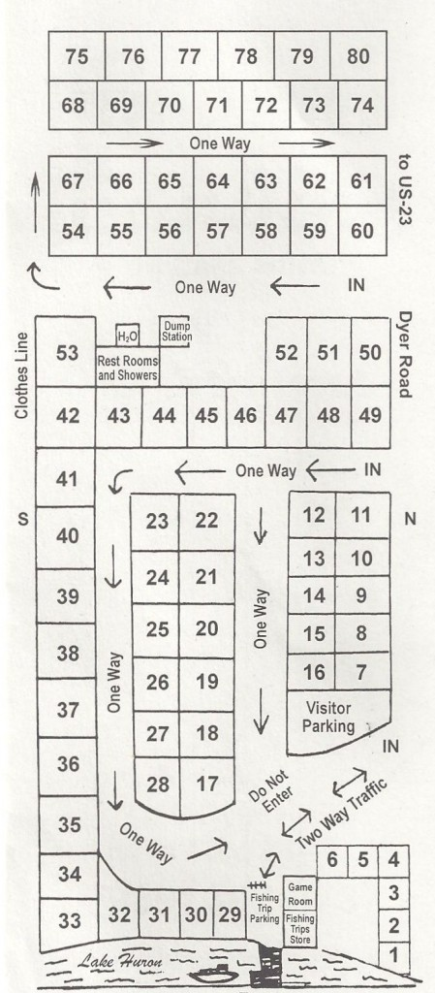

Brown’s Landing RV Park Map

Brown’s Landing RV Park Map

Brown’s Landing RV Park
2016 Prices

Overnight Non-Holiday Holiday

Site #1- full hook up $40 $45
All other full hook up $35 $40
Includes: Sewer, Electric, Cable, Cement Patio, Picnic Table and Fire Pit. WIFI available.

Seasonal Rates May - October

Full Hook Up………$2250.00 + electric
Sewer, Electric, Cable, WIFI, Cement Patio

Basic Hook Up……..$2100.00 + electric
Electric, cable, WIFI, cement patio

Mobile pump-out…$10
Or Dump it yourself @ the dump station

www.brownslandingrvpark.com
contact@brownslandingrvpark.com
989-362-3737
Follow us on Facebook

****A Dining Adventure****
Sunset Cruise to Charity Island
Aboard “Miss Charity Isle”
$94/person
Reservations: 989-254-7710

Brown’s Landing RV Park
2016 Prices

Overnight Non-Holiday Holiday

Site #1- full hook up $40 $45
All other full hook up $35 $40
Includes: Sewer, Electric, Cable, Cement Patio, Picnic Table and Fire Pit. WIFI available.

Seasonal Rates May - October

Full Hook Up………$2250.00 + electric
Sewer, Electric, Cable, WIFI, Cement Patio

Basic Hook Up……..$2100.00 + electric
Electric, cable, WIFI, cement patio

Mobile pump-out …$10
Or Dump it yourself at the dump station

www.brownslandingrvpark.com
contact@brownslandingrvpark.com
989-362-3737
Follow us on Facebook

****A Dining Adventure****
Sunset Cruise to Charity Island
Aboard “Miss Charity Isle”
$94/person
Reservations: 989-254-7710

Brown’s Landing RV Park
2016 Prices

Overnight Non-Holiday Holiday

Site #1- full hook up $40 $45
All other full hook up $35 $40
Includes: Sewer, Electric, Cable, Cement Patio, Picnic Table and Fire Pit. WIFI available.

Seasonal Rates May - October

Full Hook Up………$2250.00 + electric
Sewer, Electric, Cable, WIFI, Cement Patio

Basic Hook Up……..$2100.00 + electric
Electric, cable, WIFI, cement patio

Mobile pump-out …$10
Or Dump it yourself at the dump station

www.brownslandingrvpark.com
contact@brownslandingrvpark.com
989-362-3737
Follow us on Facebook

****A Dining Adventure****
Sunset Cruise to Charity Island
Aboard “Miss Charity Isle”
$94/person
Reservations: 989-254-7710
