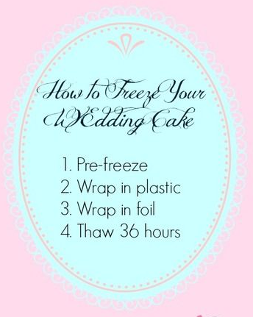
How to Freeze Your Wedding Cake in 4 Simple Steps

1. Pre-freeze. If you want to preserve all that delicate frosting decoration, you'll need to harden it a little, first. This sounds counter-intuitive, but as soon as possible (same day, for best results), put your tier in the freezer uncovered. Leave it there for a couple hours or overnight.
2. Wrap in plastic. Now that the frosting is frozen in place you can wrap the cake in about 5 or 6 layers of cling wrap. You'll want to cover as much of every surface as possible, but not handle the cake so much that the frosting starts to melt.
3. Wrap in foil. Next you can wrap your cake in a protective layer of heavy aluminum foil. It's ready for the deep freeze. Make sure it's in a location that won't get bumped a lot.
4. Thaw before eating. About 36 hours before your first anniversary (congratulations!) take the cake out of the freezer and unwrap it completely, first. Then let the cake thaw on a plate in the refrigerator. About an hour before you want to eat it, move the cake to a counter and let it reach room temperature. Enjoy!

