**HOW TO CUT THE CAKE**

|  |
| --- |
| http://4.bp.blogspot.com/_OMeEqNjZRio/S_Obp0ifilI/AAAAAAAAAEU/F7pHEgAXM-Q/s1600/Cake+Cutting+2a.jpg |
| http://2.bp.blogspot.com/_OMeEqNjZRio/S_Ockp0OyFI/AAAAAAAAAEc/J6f_LqUVtGY/s200/Cake+cutting+3a.jpg |
| http://4.bp.blogspot.com/_OMeEqNjZRio/S_OdEkusDiI/AAAAAAAAAEk/qm52nxTTs2s/s200/cake+cutting+6a.jpg |
| http://4.bp.blogspot.com/_OMeEqNjZRio/S_OiOLh2iLI/AAAAAAAAAE0/iz8I6TmTW9g/s200/cake+cutting+7a.jpg |

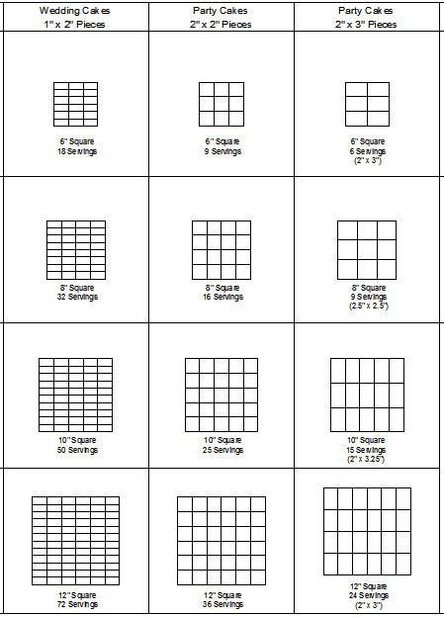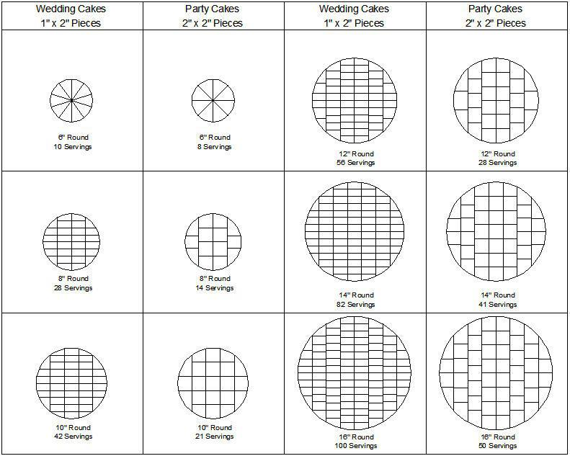

|  |  |
| --- | --- |
| |  | | --- | | * When cutting a cake 2 people are always better than 1 especially for larger and more complex cakes. As one distributes the cut slices the other can concentrate exclusively on the cutting. * You need a clean damp towel to wipe the knife clean every few slices. If the knife gets too sticky the cake slices will become ragged and untidy on the edges, in some cases the cake slice will end up on the plate in a shapeless mound of crumbles. * For larger cakes with tiers and separators you need to have enough room to rest all the inedible equipment as you go along. * A tiered cake (generally a wedding cake) needs to be cut starting from the top. The smallest top tier is usually removed and set aside as this is traditionally the bride and groom keepsake tier. | |

|  |
| --- |
|  |