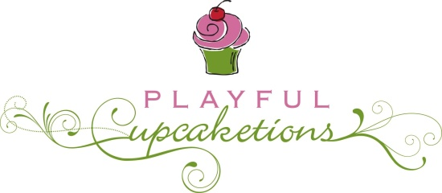
Playful Cupcaketions
712-301-9867
1101 Gary Ave, Spirit Lake, IA 51360
okoboji123@msn.com

Cake Tasting & Consultation Form

The cake consultation is a personalized cake tasting which allows you address all questions and concerns regarding cake design, pricing, payment, delivery and all other details.

At the cake consultation, you will pick up you requested flavors for a fee of $25. The cake tasting fee is complimentary, should you decide on my services and the total is over $150. The amount would be deducted from your final cake price estimate. Please bring your cake tasting payment in the form of cash or check payable to Playful Cupcaketions.

Please select up to 4 flavors of your choice for your cake tasting. The flavors must be provided no later than 1 week prior to your scheduled cake consultation date. If you want to try more flavors and additional samplers can be purchased for $25 each. The cost of the additional samplers will not be deducted from your final cake price.

A non-refundable deposit of $50.00 is required when booking a wedding cake, this reserves my services for your date and time of your wedding cake order. The cake estimate is to be provided shortly after your cake consultation. Along with the deposit, the wedding cake order is confirmed when the Cake Contract and final estimate are signed and agreed upon by the bridal couple. Thank you.

Name of Bride: ___________________________ Name of Groom: _______________________________
Home Address: ________________________________________________________________________
_____________________________________________________________________________________
Bride Phone: ____________________________ Groom Phone: ___________________________________
Email: ________________________________________________________________________________
Additional Contact Information: ___________________________________________________________

Wedding Day & Date: _________________________________
Reception Time: _____________________________________
Reception/Location: _____________________________________________________________
Estimated Guest Count:_______________________________

Cake Design: # of Tiers ________________# of servings________________
What will be the guests dessert:______________________________________
Flowers: Fresh, silk, or sugar paste________________________________________________
Cake topper:__________________________________________________________________
Stand rental___________________________________________________________________
Wedding Colors/Theme:_________________________________________________________

Will you be saving cake for your anniversary_________________________________________?
Will you need someone to cut the cake at the reception_________________________________?
If no, will you need instructions on cutting the cake______________________________?

Date receiving Samples:__________________

Cake Tasting Flavors (select up to 4):
1 ________________________________
2 ________________________________
3 ________________________________
4 ________________________________

Please remember to bring to your consultation:
- pictures of cakes
- ribbons/color swatches
- memorabilia you want incorporate in to your cake design

Cake Details:
___________________________________________________________________
_____________________________________________________________________________________________________________________________________________________________________________________________________________________________________________________________________________________________________________________________________________________________________________________________________________________________________________________________________________________
___________________________________________________________________

