U. S. Coast Guard
Chief Petty Officer Association
Grand Haven Chapter
October 20, 2022
1830 HRS

In Attendance: HSC Girvin, MSTC O’Neil, ETC Peterson, BMC Karpin, BMCM Moore, BMCS Stepien, BMC Fiore,
BMC Cucovatz, ETC Locklear

Minutes
- Call to Order & Pledge of allegiance MSTC O’Neil
  - 1838
- Welcome new members & guests MSTC O’Neil
  - Guest: AUX Kumpf
- Review and acceptance of September minutes MSTC O’Neil
  - Motion to approve BMC Karpin, Second BMCM Moore
- Review and acceptance of Treasurer Report HSC Girvin
  - See attachment figure 1
  - Motion to approve BMCS Stepien, Second BMCM Moore
- Communications MSTC O’Neil
  - Thank you letter from Madison Beatty for scholarship

- Committee Reports
  - Community Service BMC Fiore
    - Burger Night HCPO Niemiec
      - Next one December 9th
    - Adopt a Highway BMC Lauters
      - Completed Sept 20th
    - CG41448 CWO Yoder
      - Nothing to report
    - Escanaba Park BMC Fiore
      - Nothing to report
  - Membership BMCM Beatty
    - HSC Olthof listed in The Chief
  - Finance, Budget & Investments HSC Girvin
    - Property ETC Locklear
      - Nothing to report
    - Budget Submissions for Nov HCPO Niemiec
      - Hot Spot?
        - Either a phone with add on hotspot or activated phone.
          - BMCM Moore will go to Verizon and look at options.
        - BMC Fiore: GVSUhas a Lenovo Think Pad
          - He will submit the hotspot and ThinkPad for the budget
          - The IT Tech from GVSU provided the following about the laptop. The cost will be $70-$80. They’ll reimage it with Windows 10. We can use 1 of his licenses for Microsoft Office 365.
            - Lenovo Thinkpad Ultrabook
            - 2014 I5 400 1.6 GHZ
            - Ram 4 or 6 GB he was checking into it
            - Touch Screen & Stylus
            - 2in1 tablet
            - 2 USBs
            - Head Phone jack
            - SD Card Slot
            - Micro HD Microphone Jack
            - Camera
            - Wifi
      - Money for National Convention?
        - Should chapter fund an amount to attend?
          - MSTC O’Neil will submit amount for budget.
      - Fundraising Option for next year
        - Charity Mania as possibility (BMCM Moore)
          - He will head this up.
            - 200 tickets will make us 2800 dollars with about 55 in overhead. He will submit for budget.
  - Publication & Public Relations BMC Reed
i. Facebook page & Website BMC Fiore
a. Renewal was approved in last year’s budget. BMC Fiore will handle it.
  - Standing Rules and Regulations BMC Cucovatz
    - Nothing to pass
  - Fundraising Vacant
    - CG Festival Water Tent ETC Locklear
      - ETC Locklear relieved MKCS Light.
      - Will look at what we have for water going into next year.
    - Golf Outing BMC Lauters
      - See Attached figure 2
      - Made $200 this year with most recent check.
      - Will be back at Spring Lake next year.
      - Further discussion needs to occur as to whether this is a fundraiser or morale event.
    - Merchandise BMC Fiore
      - 10 Coins left
        - Submitted info for budget.
  - Activities BMC Karpin
    - Visiting Chiefs Picnic BMCM Beatty
      - Nothing to report
    - Chapter Scholarship Program BMCS Stepien
      - Nothing to report
    - Flag Football Tournament
      - Will be at Norton Shores indoor field
      - October 27th
      - Looking at food option. There is $250 in the budget.
- Old Business Membership
a. Bylaws non-budget item voting BMC Cucovatz
i. See Attached figure 3.
ii. Looking at way to change how we vote.
iii. Board of directors to re-write rule 5 in its entirety at next BOD meeting.
b. Fundraising for next year/Need Chair MSTC O’Neil
i. Need to have someone take charge of fundraising as the Chair.
1. BMCM Moore will help as temp fund-raising chair.
c. $364.79 from CPOA funds used for recruiting event. 27 recruits attended with around 40 adults. Believe there will be several sign-ups as a result of it.
d. Quick books online meeting with National was a no-show and cancelled. No new date is scheduled.
e. Next Chief Dinner in January.
f. Turkey Time checks go out October/November.
- New Business Membership
  - FN at Station MI City had his sister and niece involved in a home explosion at his home of record in Puerto Rico. Both are critical injured. BMCM Moore is asking for $500 to send to the member to assist with travel back to Puerto Rico to be with family. MSTC O’Neil will send out text for BOD vote.
a. Good of the Order Membership
- Moment of Silence for those who have gone before us Membership
- Next Meeting 08 November 2022, 1830hrs
  - Changed due to lack of availability of members.
  - Location to be determined.
- Meeting Adjourned 1944
- 50/50 Drawing

FIGURE 1

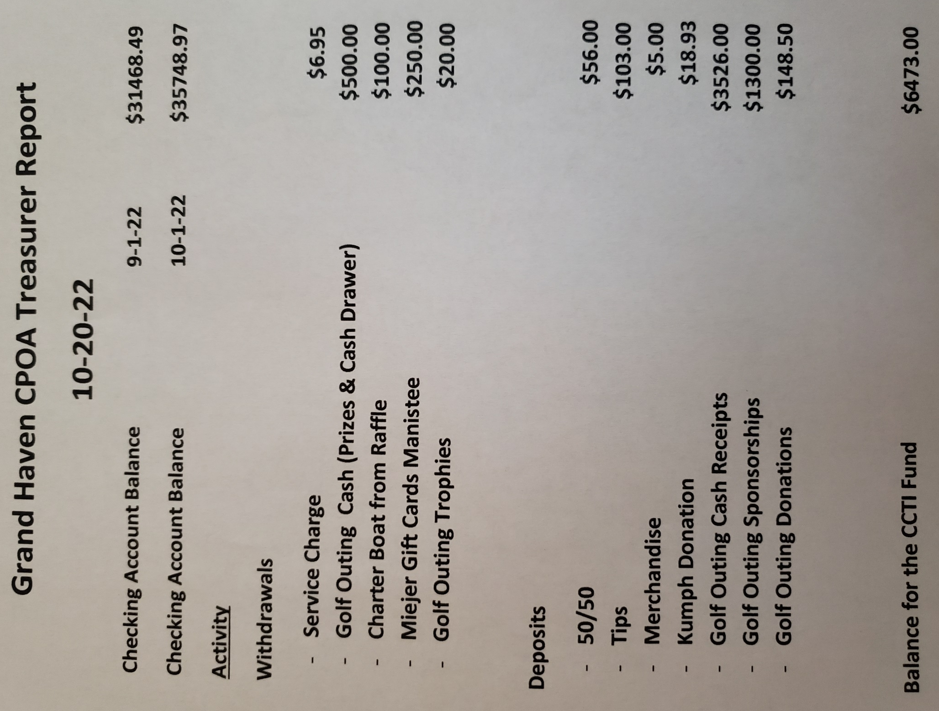
FIGURE 2

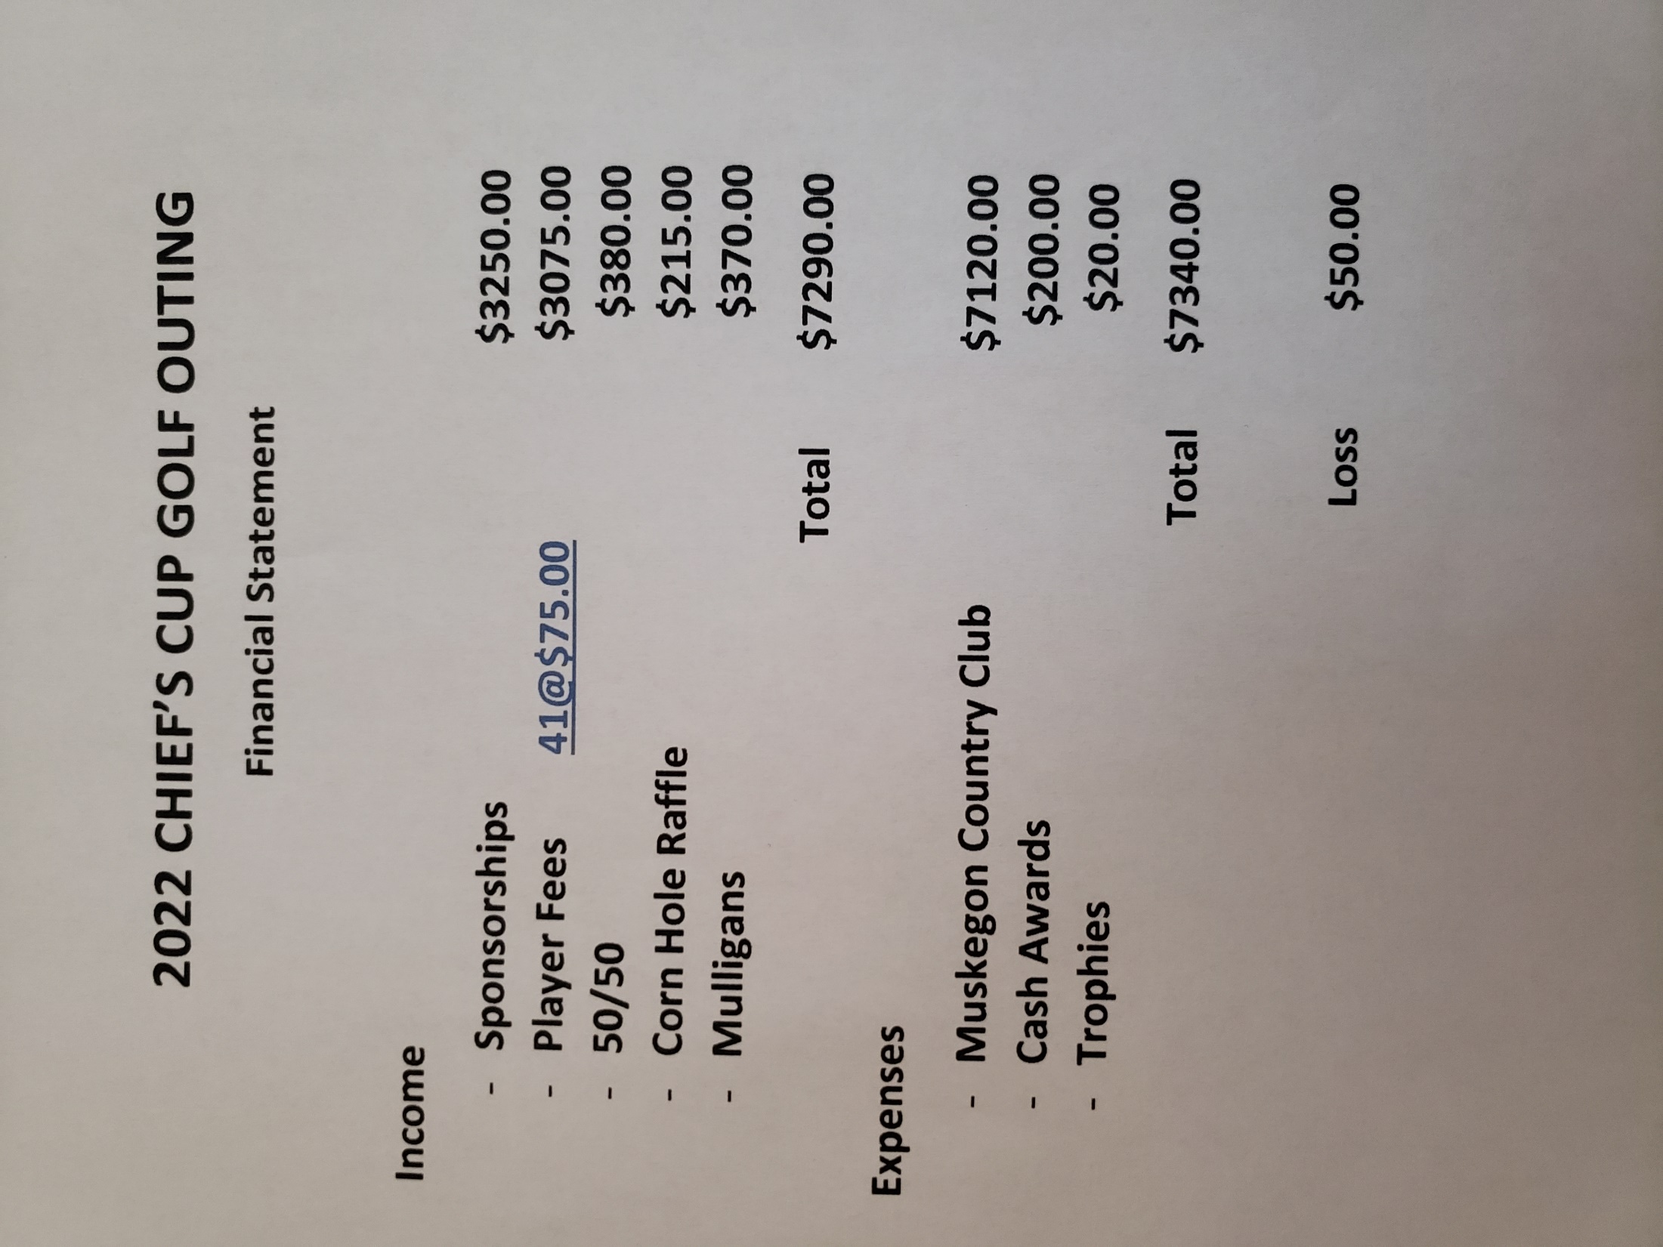
FIGURE 3

