Themed Food Nights

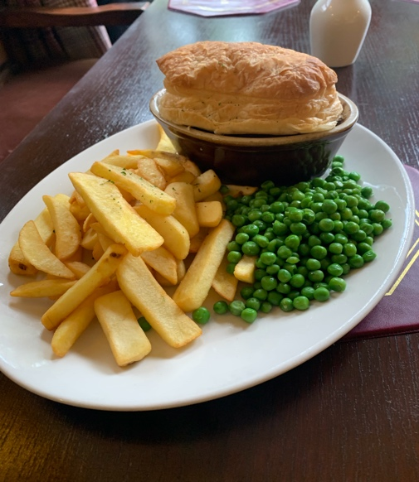
Tuesday – Pie Night New
Choose from one of our homemade pie’s
- Steak & Ale £13.50
- Chicken & Mushroom £13.50
- Steak & Kidney £13.50
- Cottage Pie £13.50
All served with chips & Peas

Thursday – Steak Night
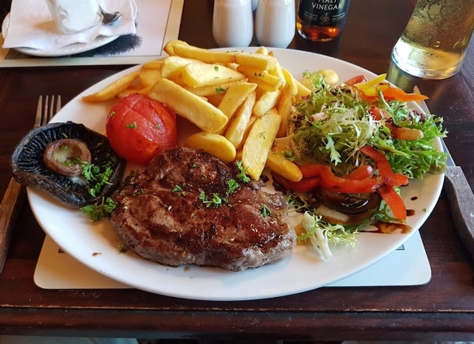
Choose from a selection of locally sourced steaks:
- Sirloin £14.95
- Fillet £16.95
- Ribeye £17.95
All served with chips, mushroom & grilled tomato

