SVS
S
Academic Catalog

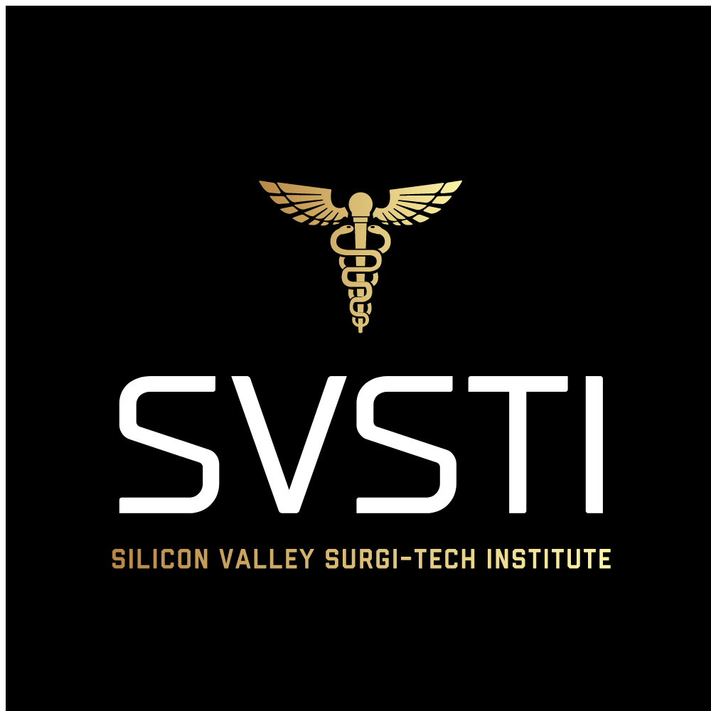

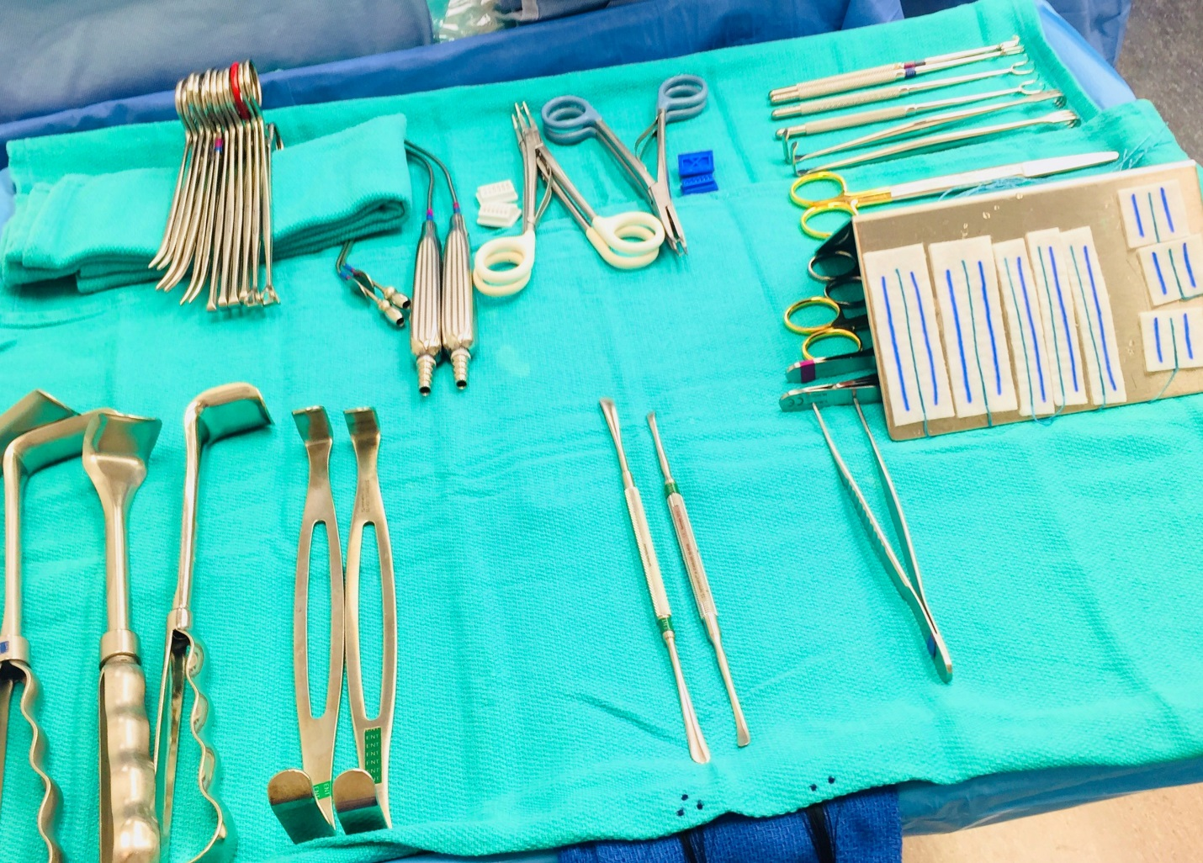

Welcome to SVSTI. We are delighted you have chosen our facility and programs as you begin your journey into the fascinating field of medicine.
Our certified educators specialize in helping students master communication skills, critical thinking, respect, accountability and personal responsibility. We are committed to skills training and core competencies for personal and professional growth in the medical field.
We encourage each and every student to reach their highest potential. We strive for quality in every endeavor, and commit to the success of our students, staff and the professional community.
We are excited that you have chosen to join our professional family.

Table of Contents

Mission Statement…………..……………….…
Location and Hours of Operations……………....
Education Delivery ………………………...……
Programs of Study & and course descriptions…..
Admissions Requirements…………………..…
Graduation Requirements………………………
Tuition & Fees………………………………….
Cancellations & Refunds……………………….
Externship Policy………………………………
Student Lab Safety & Maintenance Policy…………
Needle Stick Protocols…………………………..
Sign off Sheet ……………………………..

Mission Statement

SVSTI is committed to the success of our students by providing the curriculum and skills and education to pursue their goals of becoming active, sought after participants in the medical community.
We are dedicated to helping students master communication skills, critical thinking, respect, accountability and personal responsibility.
We support our students, educators, and our community by providing a safe environment, qualified graduates, and financially viable programs in the evolving field of medicine.

Location

1040 Park Ave. #C
San Jose, CA 95126
(408) 883-9171

Hours

Monday & either Wednesday or Thursday 4pm-9pm (Sterile Processing classes 5-8pm twice a week).
Facility tours and admissions are available by appointment
Friday & Saturday: By appointment only
Sunday: Closed

Education Delivery
SVSTI offers blended programs for Sterile Processing. In a blended program students will be face to face on campus and utilize hands on learning for core competencies in combination with our online course platform. Campus-based instruction includes applications, laboratories, and externships. Online courses require a commitment to substantial independent study along with the access and participation of the platform.
The online learning platform is accessible 24 hours per day, seven days per week. The course syllabus, material, assignments, participation post, and email will be through this online platform.
The Student Success/ library is available onsite during regular business hours. The virtual library and other web-based resources will provide students with a comprehensive learning experience that enables them to master the course content outlined on the syllabi.
Students are required to have sufficient technology and internet skills & access to complete online coursework successfully.
Refresher courses, CST prep classes, and BLS may be on site at facilities seeking this course for current employees or on campus for current students.
Programs
- Sterile Processing/ Central Service Technician Program – 4 week program in the lab with hands on training and hybrid learning. Following is a 6 weeks rotation as an externship in a SPD facility. This is a certificate of completion program and will allow for students to sit for the CBSPD certification. We will also have a Certification prep class before taking the national certification.
Courses
- CPR for Healthcare Providers is a 4 hour class to certify or recertify. This class provides skills and a test at the end of class designed to result in a certification card.
- Refresher Course/ CST preparation will vary in length. This is for anyone who might have been out of the field for some time, had on job training, needs to freshen up on aseptic technique or wants to sit for certification and needs some prep classes.
- Aseptic Technique training for L&D techs that want to learn standards & best practices.

Admissions Requirements

- Candidates must have a high school diploma or equivalent and are required to provide their diploma and valid transcripts.
- Candidates will have a preliminary interview with Program Director *
- Candidates must have 2 professional references *
- Candidates are required to complete a written essay *
- If an applicant has had medical experience, an email or letter, with a verified letterhead, from employer to verify experience *

* Candidate selection is based upon a point system from the requirements above (Surgical Technology only).

Basic Essay Format
(10 Points Total)

Essay Topic: Why are you interested in pursuing a career in Surgical Technology?

The Introduction (2 Points)
The introduction will contain a thesis statement. A thesis statement or essay hook is usually one sentence that summarizes the main point of the essay.

The Body (6 Points)
The majority of the content will be contained in the body. In the 5 paragraph essay (total including intro and conclusion), the body should be three paragraphs. Each paragraph includes one supporting point that provides more information or proof to support your thesis statement. Transition each paragraph in the body into the next. (Transition words work well for this and entry essays are the perfect place for students to practice using their transitions and making sure the essay is easily read.)

The Conclusion (2 Points)

Graduation Requirements
- Must receive a minimum of 70% throughout program
- Must complete all requirements with student success
- Must pay tuition on time in order to be placed on externship and graduate on time.
- All required cases/hours at the appointed facilities for externship must be completed successfully
- Must complete all required coursework on the online platform by fourth week.
- Must complete and pass the final exam with a score of 70% or higher.

Tuition & Fees
- Sterile Processing Program is $2500.
- SVSTI does not guarantee job placement however, we do provide clinical placement as part of the curriculum which may lead to professional placement. The tuition includes externship placement, online platform for coursework, and BLS certification.

- There might be additional fees associated with immunizations as per request from clinical sites.
- Students will be required to purchase their own black scrubs to wear on campus.
- The online platform for material needed for coursework is provided, and book rental is available at no additional charge.
- SVSTI pays for back ground & drug testing pre request from clinical sites.

Cancellations & Refunds
- Tuition may be refunded (minus the non-refundable registration fee of $400) up to 48 hours before first day of class. Cancellation less than 48 hours before the 1st scheduled class will result in $0 refund for tuition as well as $0 refund for registration fee.

EXTERNSHIP POLICY

The following are basic rules for your upcoming externships. These policies are no different than any employer would require of a paid employee. This means that you are expected to perform externship site with the same level of maturity and professionalism that is expected of any commitment, and professionalism. Keep in mind, your behavior level of professionalism reflects not only upon you or staff member but on SVSTI as well.

These rules include, but are not limited to:

- You will be assigned a clinical site, if you refuse the assigned site it could significantly delay the start of your externship or even the possibility of being removed from the program.
- If you are removed from a site for any reason it will result in expulsion from the program.
- First and foremost, you MUST conform to the rules, regulations and policies of the facility. These include use of P.P.E. (personal protective equipment), rules of patient confidentiality (HIPAA), wearing of I.D badges, and any other facility-specific policies and procedures including but not limited to the cell phone use & attendance.
- Adhere to SVSTI’s dress codes. This includes, but is not limited to, policies regarding the wearing of jewelry (including facial), cologne or perfume, no artificial/gel nails, & fingernail length/polish, etc. This means you must present a professional appearance and conduct at all times.
- Tardiness is unacceptable. Leave home early enough to allow yourself time to change into scrubs and be ready to start before your shift begins. This will not go unnoticed when it comes time to make the decision whether to hire you or not. Understand that some sites require you to pay for parking.
- Absences are unacceptable except in cases of illness. If you are ill, you are required to: 1) notify your preceptor two hours prior to the start of shift, and 2) notify the clinical coordinator at school prior to start of shift. You are only allowed a total of 2 absences during your rotation. If absences are in excess
of 2 days, this could impact your clinical site assignment, including being removed from site and therefore leading to either failure of that term or expulsion.
- Every effort will be made to keep externship sites within a 2 hour commute of campus; however this may not always be possible. Students are expected to go where assigned.
- ATTITUDE IS EVERYTHING, You are a student. You are there to learn. Keep this in mind.

STUDENT LAB SAFETY & MAINTENANCE POLICY

Safety of self and others is the primary concern in the laboratory setting. To ensure the safety of students and faculty in the laboratory, students are expected to follow the policies and procedures for Lab Safety & Maintenance in the SVSTI Academic Handbook. Students are encouraged to expand their skills through safe practice. Demonstration of critical safety elements by ST faculty is required prior to any student being allowed to use ST related equipment. Students will be required to demonstrate appropriate safety with all equipment, techniques and procedures in the laboratory prior to practicing as patients or clinicians.
General Lab Safety Rules and Policies:
- No long sleeves are allowed under grey scrub tops
- No bulky/large/chunky jewelry. Simple necklaces and post earrings are allowed.
- No rings or bracelets of any kind.
- No hats of any kind are allowed in lecture or lab.
- Minimal makeup is allowed.
- No fake (Gel or Acrylic) nails. Nails should be short, natural color without polish.
- Beards must be kept trimmed and good personal hygiene is must at all times.
- Students will be responsible for sterilizing items.
- Students will be responsible for all laundry.
- Students will be responsible for letting their Program Director know when an item needs to be reordered.
- Any accidents, injuries, or unexpected responses to intervention or skills being practices must be immediately reported to the Program Director.
- Students must report any unsafe situations to staff or faculty immediately.
- Though every effort is made to ensure that all equipment is functioning properly, students must notify the instructor of any broken or malfunctioning equipment.
- Absolutely no cell phone use allowed to during instruction time, this includes but not limited to texting. If you use your instructor has the right to send you home for the day.
- You are considered tardy at 1 min past the start of class time. You will also be considered tardy if you leave class early.
Weekly lab evaluations cannot be made up.
- Students are only allowed in Lab when an instructor is present.
- No open toed shoes are allowed in lab or lecture.
- Teamwork is expected.

Lab Maintenance:
- Students are responsible for cleaning the lab after every class
- All equipment and treatment areas shall be cleaned following each use with an approved antimicrobial cleanser.

- All counter tops/flat surfaces will be cleared off and cleaned.
Timers will be put back on the whiteboard
- Floors will be swept
- All equipment will be wiped down with disinfectant wipes
- All equipment & supplies should be returned to their storage areas at the end of each lab session.
- Students should adhere to the Hazardous Materials safety precautions while using chemical cleansers.
No lab equipment or supplies may be removed without prior written consent of the lab Instructor.

NEEDLE STICK PROTOCOLS
Always Observe Standard/Universal Precautions
Should you suffer a needle stick or any blood/body fluid exposure, immediately notify your preceptor. Do not be embarrassed, and do not wait. Drug prophylaxis following a high risk exposure is time sensitive. Seek immediate help.

Scrub out, and immediately clean the wound/exposure site with liberal amounts of soap and water.

Exposed oral and nasal mucosa should be decontaminated by vigorous flushing with water.

Exposed eyes should be irrigated with copious amounts of clean water or sterile saline.

Follow all facility protocols, including reporting of the incident to the facility’s Employee Health Service.

If the facility has not already drawn patient blood, then they will need to do so before the patient is released from the facility. Once the patient has been released from the facility, he/she is under no obligation to return to have their blood drawn.
Once facility protocols have been met, you must contact the Program Director, Julie Hamrick, and immediately return to the campus in order to fill out the Student Accident paperwork. This paperwork is time sensitive and must be filled out the same day with no exceptions.

SVSTI ORIENTATION PACKET
SIGN-OFF SHEET
I have received my copy of the SVSTI’s Orientation Packet. I understand that it is my responsibility to read and familiarize myself with the policies and procedures contained in this Academic handbook.
I further agree to abide by the standards and accept full responsibility for my behavior both on and off campus at all times.
I pledge to adopt the professional philosophy of SVSTI, perform my duties to the best of my ability and, upon graduation, will demonstrate pride in my career as a medical professional.

Signed: ________________________________ Date: ________________
Print Name: ________________________________________________
Program/Time of Day: __________________________________________
SVSTI Representative: ___________________________________________

