*SVS*

*S*

Academic Catalog



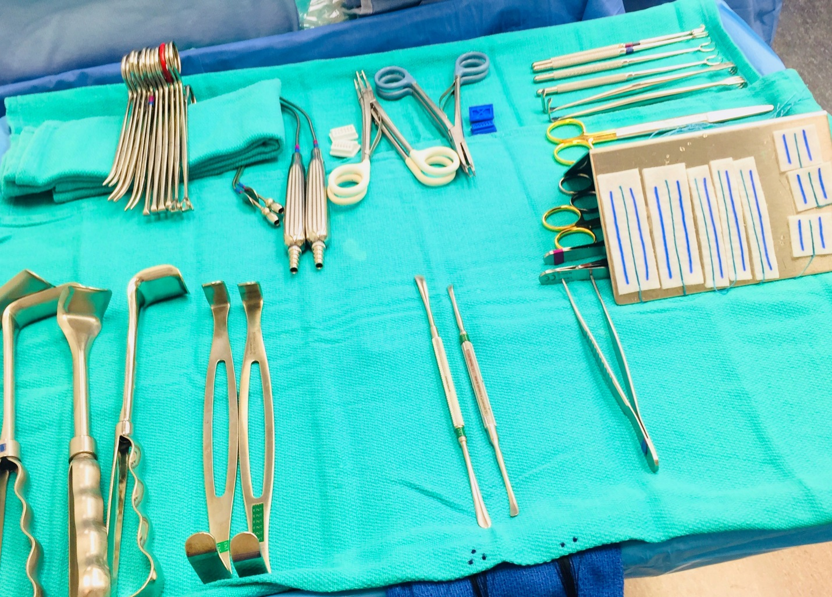

Welcome to SVSTI. We are delighted you have chosen our facility and programs as you begin your journey into the fascinating field of medicine.

Our certified educators specialize in helping students master communication skills, critical thinking, respect, accountability and personal responsibility. We are committed to skills training and core competencies for personal and professional growth in the medical field.

We encourage each and every student to reach their highest potential. We strive for quality in every endeavor, and commit to the success of our students, staff and the professional community.

We are excited that you have chosen to join our professional family.



*Table of Contents*

Mission Statement…………..……………….…

Location and Hours of Operations……………....

Education Delivery ………………………...……

Programs of Study & and course descriptions…..

Admissions Requirements…………………..…

Graduation Requirements………………………

Tuition & Fees………………………………….

Cancellations & Refunds……………………….

Externship Policy………………………………

Sign off Sheet ……………………………..

**Mission Statement**

SVSTI is committed to the success of our students by providing the curriculum and skills and education to pursue their goals of becoming active, sought after participants in the medical community.

We are dedicated to helping students master communication skills, critical thinking, respect, accountability and personal responsibility.

We support our students, educators, and our community by providing a safe environment, qualified graduates, and financially viable programs in the evolving field of medicine.

**Location**

1040 Park Ave. #C

San Jose, CA 95126

(408) 883-9171

**Hours**

Monday & either Wednesday or Thursday 4pm-9pm (Sterile Processing classes 5-8pm twice a week).

Facility tours and admissions are available by appointment

Friday & Saturday: By appointment only

Sunday: Closed

**Education Delivery**

SVSTI offers blended programs for Sterile Processing. In a blended program students will be face to face on campus and utilize hands on learning for core competencies in combination with our online course platform. Campus-based instruction includes applications, laboratories, and externships. Online courses require a commitment to substantial independent study along with the access and participation of the platform.

The online learning platform is accessible 24 hours per day, seven days per week. The course syllabus, material, assignments, participation post, and email will be through this online platform.

The Student Success/ library is available onsite during regular business hours. The virtual library and other web-based resources will provide students with a comprehensive learning experience that enables them to master the course content outlined on the syllabi.

Students are required to have sufficient technology and internet skills & access to complete online coursework successfully.

Refresher courses, CST prep classes, and BLS may be on site at facilities seeking this course for current employees or on campus for current students.

**Programs**

* Sterile Processing/ Central Service Technician Program – 4 week program in the lab with hands on training and hybrid learning. Following is a 6 weeks rotation as an externship in a SPD facility. This is a certificate of completion program and will allow for students to sit for the CBSPD certification. We will also have a Certification prep class before taking the national certification.

**Courses**

* CPR for Healthcare Providers is a 4 hour class to certify or recertify. This class provides skills and a test at the end of class designed to result in a certification card.
* Refresher Course/ CST preparation will vary in length. This is for anyone who might have been out of the field for some time, had on job training, needs to freshen up on aseptic technique or wants to sit for certification and needs some prep classes.
* Aseptic Technique training for L&D techs that want to learn standards & best practices.

**Admissions Requirements**

* Candidates must have a high school diploma or equivalent and are required to provide their diploma and/or valid transcripts.
* Copy of immunizations (need to have numerical values showing immunity).
* Copy of State ID or Driver’s License

**Graduation Requirements**

* Must receive a minimum of 70% in final grade
* Must complete all requirements with student success
* Must pay tuition on time in order to be placed on externship and graduate on time.
* All required cases/hours at the appointed facilities for externship must be completed successfully
* Must complete all required coursework on the online platform by fourth week.

**Tuition & Fees**

* Sterile Processing Program is $**2500**.
* SVSTI does not guarantee job placement however, we do provide clinical placement as part of the curriculum which may lead to professional placement. The tuition includes externship placement, online platform for coursework, and BLS certification.
* There might be additional fees associated with immunizations as per request from clinical sites.
* Students will be required to purchase their own black scrubs to wear on campus.
* The online platform for material needed for coursework is provided, and book rental is available at no additional charge.
* SVSTI pays for back ground & drug testing pre-request from clinical sites.

**Cancellations & Refunds**

* Tuition may be refunded (minus the non-refundable registration fee of $400) up to 48 hours before first day of class. Cancellation less than 48 hours before the 1st scheduled class will result in $0 refund for tuition as well as $0 refund for registration fee.

**EXTERNSHIP POLICY**

The following are basic rules for your upcoming externships. These policies are no different than any employer would require of a paid employee. This means that you are expected to perform externship site with the same level of maturity and professionalism that is expected of any commitment, and professionalism. Keep in mind, your behavior level of professionalism reflects not only upon you or staff member but on SVSTI as well.

These rules include, but are not limited to:

* You will be assigned a clinical site, if you refuse the assigned site it could significantly delay the start of your externship or even the possibility of being removed from the program.
* If you are removed from a site for any reason it will result in expulsion from the program.
* First and foremost, you MUST conform to the rules, regulations and policies of the facility. These include use of P.P.E. (personal protective equipment), rules of patient confidentiality (HIPAA), wearing of I.D badges, and any other facility-specific policies and procedures including but not limited to the cell phone use & attendance.
* Adhere to SVSTI’s dress codes. This includes, but is not limited to, policies regarding the wearing of jewelry (including facial), cologne or perfume, no artificial/gel nails, & fingernail length/polish, etc. This means you must present a professional appearance and conduct at all times.
* Tardiness is unacceptable. Leave home early enough to allow yourself time to change into scrubs and be ready to start before your shift begins. This will not go unnoticed when it comes time to make the decision whether to hire you or not. Understand that some sites require you to pay for parking.
* Absences are unacceptable except in cases of illness. If you are ill, you are required to: 1) notify your preceptor two hours prior to the start of shift, and 2) notify the clinical coordinator at school prior to start of shift. You are only allowed a total of 2 absences during your rotation. If absences are in excess

of 2 days, this could impact your clinical site assignment, including being removed from site and therefore leading to either failure of that term or expulsion.

* Every effort will be made to keep externship sites within a 2 hour commute of campus; however this may not always be possible. Students are expected to go where assigned.
* ATTITUDE IS EVERYTHING, You are a student. You are there to learn. Keep this in mind.

Signed: ________________________________ Date: ________________

Print Name: ________________________________________________

Program/Time of Day: __________________________________________

SVSTI Representative: ___________________________________________

**No lab equipment or supplies may be removed without prior written consent of the lab** **Instructor.**

**SVSTI ORIENTATION PACKET**

**SIGN-OFF SHEET**

I have received my copy of the SVSTI’s Orientation Packet. I understand that it is my responsibility to read and familiarize myself with the policies and procedures contained in this Academic handbook.

I further agree to abide by the standards and accept full responsibility for my behavior both on and off campus at all times.

I pledge to adopt the professional philosophy of SVSTI, perform my duties to the best of my ability and, upon graduation, will demonstrate pride in my career as a medical professional.

Signed: ________________________________ Date: ________________

Print Name: ________________________________________________

Program/Time of Day: __________________________________________

SVSTI Representative: ___________________________________________