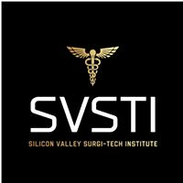

Attendance Policy for Surgical Technology Lab

It is very crucial for every student to attend every class as SVSTI’s Surgical Technology Program is an advanced fast paced course. You are allowed only 3 absences of lab each 16-week term with the exception of Clinical rotation where you are only allowed 2 absences for emergencies. Please save these absences for true emergencies as life happens and we never know when we might need them.
Please note that all 48 days each term are a part of the overall grade. It counts for 10% of your grade as it is important to be present to learn the skills needed to be successful.

If a student has more than 3 absences in a term, they will be subject to a letter grade drop. 5 absences will get you dropped from the Program.
If a student obtains 3 tardies in a term that will count as 1 absence.
By signing this form, you acknowledge the seriousness of your attendance in the lab and the policies.

Print Student Name: _________________________________Date: ___________

Student Signature: ___________________________________Date: ___________

SVSTI Representative: _______________________________Date: ____________

