SVS
S

Academic Catalog

Dec. 31,2018 – Dec. 31, 2019

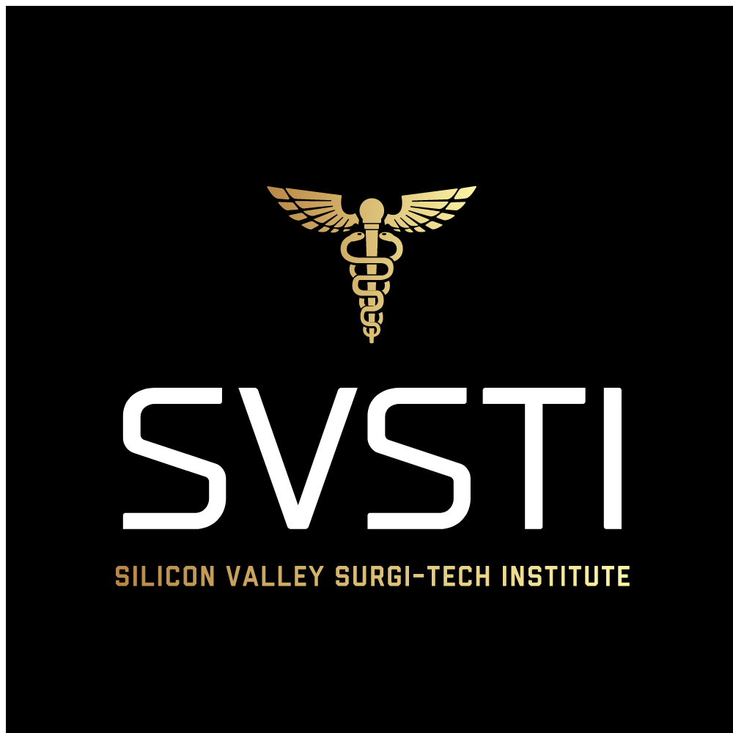

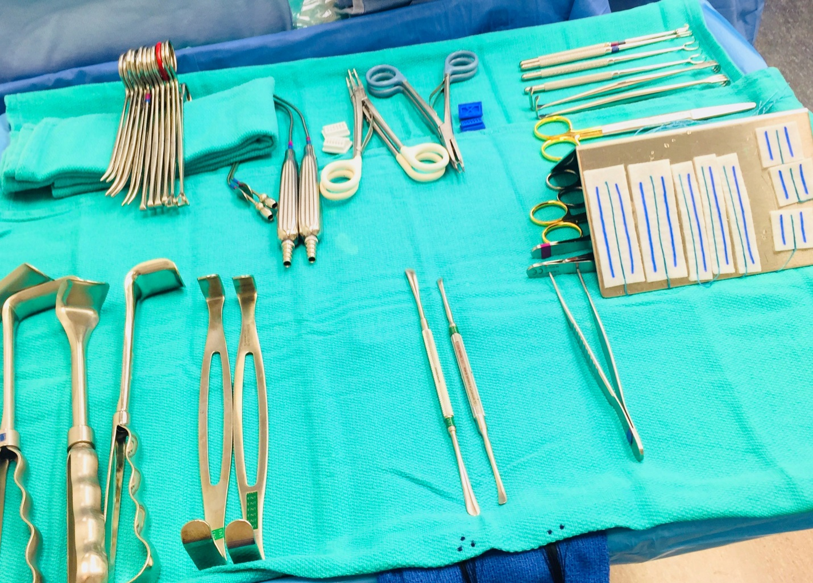

Welcome to SVSTI. We are delighted you have chosen our facility and programs as you begin your journey into the fascinating field of medicine.
Our certified educators specialize in helping students master communication skills, critical thinking, respect, accountability and personal responsibility. We are committed to skills training and core competencies for personal and professional growth in the medical field.
We encourage each and every student to reach their highest potential. We strive for quality in every endeavor, and commit to the success of our students, staff and the professional community.
We are excited that you have chosen to join our professional family.
As a perspective student, you are encouraged to review this catalog prior to signing an enrollment agreement. You are also encouraged to review the School Performance Fact Sheet, which must be provided to you prior to signing an enrollment agreement.

Table of Contents

Mission Statement………….………...….………. Page 4
Location and Hours of Operations………………. Page 5
Education Delivery …………….………….……Page 6-7
Programs of Study & Course Descriptions…...…. Page 8
Management & Faculty……………………….…. Page 9
Equipment List………………………….………. Page 10
Admissions & Attendance Requirements…………Page 11
Graduation Requirements…………………….……Page 11
Student Services…………………………………...Page 12
Probation & Dismissal Policy……...………………Page 12
Tuition & Fees…………………………...…………Page 13
Cancellations & Refunds…………...………………Page 14
Externship Policy……………………………... Page 15-16
Student Lab Safety & Maintenance Policy…… Page 17-18
Needle Stick Protocols……………………...….…Page 19
Sign off Sheet ……………………………………. Page 20
Additional Information…………………………. Page 21-31

Mission Statement

SVSTI is committed to the success of our students by providing the curriculum and skills and education to pursue their goals of becoming active, sought after participants in the medical community.
We are dedicated to helping students master communication skills, critical thinking, respect, accountability and personal responsibility.
We support our students, educators, and our community by providing a safe environment, qualified graduates, and a financially viable program in the evolving field of medicine.

Location
SVSTI

1040 Park Ave. #C
San Jose, CA 95126
(408) 883-9171
Web Address: www.Svsti.com

Hours

Monday, Wednesday, Friday 9am-9pm
Tuesday & Thursday 10am- 5pm
Facility tours and admissions are available by appointment
Saturday: By appointment only
Sunday: Closed

Education Delivery
SVSTI is a private Institution that offers the Sterile Processing Program. Classes will be held on campus at 1040 Park Ave #C San Jose, CA 95126. SVSTI has been approved to operate by BPPE for a non-accredited operational license for Sterile Processing. The approval to operate indicates that the institution meets or exceeds minimum state standards as set forth in this chapter.
SVSTI is an approved Sterile Processing Program through CBSPD. We are also BBB (Better Business Bureau) Accredited as of 2019.
SVSTI offers a blended Sterile Processing Program where students will use an LMS platform for assignments in combination with face to face on campus to utilize hands on learning for core competencies. Campus-based instruction includes applications, laboratories, and externships. Online courses require a commitment to substantial independent study along with the access and participation of the platform.
The online learning platform is accessible twenty-four hours per day, seven days per week. The course syllabus, material, assignments, participation post, and email will be through Canvas (online platform).
The Student Success/ library is available onsite during regular business hours. The virtual library and other web-based resources will provide students with a comprehensive learning experience that enables them to master the course content outlined on the syllabi.
SVSTI will assist students in resume building, mock interviews, and will allow students and graduates to use the student success computers in the aid of building a resume.
SVSTI standards of student achievement are the following;
SVSTI’s Institutional Student Learning Outcomes illustrate the entire institution’s commitment to ensuring that all graduates demonstrate proficiency in the following:
- Critical thinking. 2. Information management. 3. Personal and professional development. 4. Communication skills, and, 5. Respect and responsibility
Programmatic Student Learning Outcomes are listed below:
1. Demonstrate the skills and knowledge required to be a competent Sterile Processing Technician in a variety of settings, including hospitals, outpatient surgical facilities, and other appropriate sites.
2. Demonstrate critical thinking, information management, personal and professional development, communication skills, and respect and responsibility.
SVSTI course content is developed in alignment with specific Student Learning Outcomes (SLO).
1. | Apply basic principles of sterile processing and infection prevention.

The online learning platform is accessible 24 hours per day, seven days a week. The course syllabus, material, assignments, participation post, and email will be through this online platform. The Student Success/Library is available during regular business hours. The virtual library and other web-based resources will provide students with a comprehensive learning experience that enable them to master the course content outlined on the syllabus. Students are required to have sufficient technology and internet skills & access to complete online coursework successfully.
We have a student success room with a variety of books and other resources such as flash cards, diagram posters, and workbooks. We also have two student computers along with iPad for students to use during regular business hours or by appointment. Students may borrow any of the resources to use at home to study and complete assignments such as instrument books etc. Students sign a Book loan form when borrowing a book and are to return to campus in a timely fashion. We also have tutor hours posted and will take them as a need basis as well. They have 24-hour access to the LMS platform (Canvas) until the completion of the certification test. There are many resources available to them on the platform and the curriculum recommended by the CBSPD via their materials such as book, workbook and study guide. Also have a printer station for students.

Assignments on Canvas will be graded automatically, and students will know how they did immediately. The final will be taken on campus and students will know within 24 hours if they passed with a 70% or higher.
BLS may be on site at facilities seeking this course for current employees or on campus for current students.
SVSTI offers the Academic Catalog on our website at https://svsti.com/ in English but offers Google translate in other languages to ensure that all procedures & policies are understood when English isn’t the primary language.

Programs
- Sterile Processing/ Central Service Technician Program – 4-week program in the lab with hands on training and hybrid learning. Following is a 6 weeks rotation as an externship in an SPD facility. There is approximately 300 instructional hours. This is a certificate of completion program and will allow for students to sit for the CBSPD certification. We will also have a Certification prep class before taking the national certification.

SVSTI’s Sterile Processing Program is an approved school through CBSPD and you can find us on their website at http://www.sterileprocessing.org/courses/courses1.htm

Currently we are not accredited by any accrediting agency recognized by United States Department of Education and therefore are not eligible for any federal or state financial aid programs.

Courses
- BLS for Healthcare Providers is a 4-hour class to certify or recertify. This class provides skills and a test at the end of class designed to result in a certification card. This course is for our current students in either Sterile Processing and/or Surgical Technology Programs at no extra cost.

We only offer classes in English and do not offer any Visa services. Students must be able to communicate and understand directions in English to be successful in this program.

Management & Faculty
Chief Executive Officer- Julie Hamrick BBA CST CRCST
Chief Operating Officer- Julie Hamrick BBA CST CRCST
Chief Academic Officer- Julie Hamrick BBA CST CRCST
Julie Hamrick has her degree in business consideration in healthcare management. She has experience as a Program Director, Clinical Coordinator, Preceptor, and Operational manager. She is certified in Sterile Processing & Surgical Technology and has over 20 years in the medical field. She is also BLS certified and a BLS instructor.
Julie Hamrick will provide all responsibilities for the administration of SVSTI’S academic affairs including supervision of the faculty, development of the educational programs, the curriculum, and implantation of the institution’s mission, purposes and objectives.
Julie Hamrick is also responsible for SVSTI’s business operations, finances, management, and contracting of goods, services, and property.
Julie Hamrick is the Institution Director.
Ferdinand Castro CHL, CRCST is the Instructor & faculty member for the Sterile Processing course. He is certified as a Technician and a leader by IACSHMM with over 30 years’ experience along with management experience. He is certified in Sterile Processing and as a healthcare leader. He is also BLS certified.
Latrice Gonzalez is the administration that will oversee the student files, enrollment, financial services, and student success. She has many years of experience in Student Finances and admin.

Equipment
Laparoscopic Tower (monitor, camera box, light source, lap instruments, scopes), Cautery Machine x 2, Suction Device x 3, OR Bed x2, OR Light x2, Autoclave, A Variety of Instrument Sets in all Specialties, Back Table x 4, Mayo Stand x 7, Ring Stand x 4, OR Scrub Sink, Hand Wash Sink, Computers & iPad in Student Success, Instrument and Supply Racks, Library of Resources/Books, IV Poles x 4, Kick Bucket, Step Stool, Prep Stands x 2, First Aid Kit, Suture Cart, Printer/Laminator Station, Tables, Chairs, Hampers x 5, Head Light Source, Blood Pressure Cuff Machine, Case Cart, Projector and Screen, Sharps Container x 2, Flat Wrap Rack with a variety of wraps, Whiteboards, Mannequins x 2, Variety of Instrument set rigid containers, Scrub Brush Holder x 2, Scrub Brushes, Instrument Brushes, Cleaning Materials, Infection Control Materials, Sterile Processing equipment/supplies, A Variety of OR, Supplies/Drapes/Suction/Bovie/Gloves etc., A Variety of Disposables for OR, Anesthesia, Cart with Anesthesia Supplies, Core Power, Arthroscopy Shaver, Cooling, Rack, A variety of Internal and external indicators, A variety of Peel pouches, Workflow Tables x 4.

SVSTI’s facilities consist of a huge lab that has 2 mock Operating Rooms, Central Service area that contains supplies, and a Sterile Processing Department. We have an office for the Program Director, admissions area, Student success area with break room, two bathrooms, and a classroom. We have a printer station along with computers that students can use during business hours. We also have a vast amount of resources in the Student Success area available to students for learning purposes.

Admissions Requirements
- Candidates must have a high school diploma or equivalent and are required to provide their diploma and valid transcripts.
- International students providing a high school diploma must have document translated to English.
- Candidates will have a preliminary interview with Program Director
- Need a copy of State ID or Driver’s license
(At this time SVSTI does not accept Entering credits for the Sterile Processing Program. No leave of absence from the Sterile Processing Program is allowed since the program is only 10 weeks long. If student has a grievance, they will have to take a leave and be rescheduled to next course start date. SVSTI has not entered into an articulation or transfer agreement with any other college at this time. We do not accept credits earned through challenge examinations, achievement test or ability to benefit at this time.)

Attendance Policy

- Sterile Processing 101 Infection Control -Candidate will only be allowed a total of 2 absences during the duration of the program. If absences are in excess of 2 days, they will be dropped from the program. Students must complete a minimum of 240 hours of clinical rotation.
- Surgical Technology Program -Candidate will only be allowed 3 absences each 16-week term and 2 absences during clinical rotation. If a student has 5 or more absences in a term, they will be subject to a letter grade drop. 5 tardies equal 1 absence. Students must complete a minimum of 120 specific cases on clinical rotation to meet requirements of the program.
- Attendance is a portion of your grade and it is very important to attend class.

Graduation Requirements
- Must receive a minimum of 70% or higher for final grade.
- Must complete timesheets and evaluations.
- Must pay tuition on time in order to be placed on externship and graduate on time.
- All required hours at the appointed facilities for externship must be completed successfully.
- Must complete all required coursework on the online platform by fourth week.
- Must complete the final with a 70% or higher grade.
- All requirements must be met to receive Certification of Completion.
- All documents need to be signed and turned in to get credit.

Student Services
- Resume Building/Assistance
- Mock Interviews
- Access to computers for assistance even after graduation
- Resume template
- While placement in a job is not guaranteed or promised to persons who complete the program, every effort will be made to assist you in securing employment.
- SVSTI does not participate in the Student and Exchange Visitor Program to provide Visa services or vouch for student status.

Probation & Dismissal Policy

- Students that fail a course will be put on probation and are required to repeat the course (additional fees may apply). They must pass the following course with a 70% of higher or will be dismissed from the program with no fundable fees.
- Students must complete all hours at clinical site. If student is asked to leave the site due to behavior or attendance issues, they will be dismissed from SVSTI with no refund of fees.
- No leave of absence is allowed however if student needs to leave for personal reasons, they may do so by withdrawing and then reenrolling. (additional fees may be required).
- W (Withdrawal) A grade of W (Withdrawal) is issued when a student withdraws or is administratively withdrawn from a course. The course counts as credit hours attempted but is not calculated in the CGPA. If student needs to withdraw, they will have to re-enroll to repeat the course. (additional fees may be required).
- Students who are re-entering or re-applying to a program that involves skills and competencies in both written and hands-on format must meet all requirements specific to that program in addition to obtaining approvals before enrolling.

Tuition & Fees
- Sterile Processing 101 Infection Control total charge is $2500. (SVSTI does not currently participate in any Federal and State financial aid programs).
- Surgical Technology Program total charge is $18.000. (SVSTI does not currently participate in any Federal and State financial aid programs).
- SVSTI has a $250 registration fee that is nonrefundable that will be used towards tuition.
- SVSTI does not guarantee job placement however, we do provide clinical placement as part of the Curriculum which may lead to professional placement. The tuition includes externship placement, online platform for coursework, and BLS certification.
- There might be additional fees associated with immunizations as per request from clinical sites.
- Students will be required to purchase their own black scrubs to wear on campus and to clinical sites if site doesn’t provide their own scrubs.
- The LMS online platform (Canvas) needed for coursework is provided to students at no additional cost.
- The “Basic of Sterile Processing Sixth Edition” book will be loaned to student for no additional charge. If book is damaged or not returned student will have to purchase book. Students can also purchase on their own.
- SVSTI pays for background & drug testing pre-request from clinical sites.
- The STRF as of March 2019 is $0 for every $1000 paid. (nonrefundable). There are no additional institutional charges or fees.
- TOTAL STERILE PROCESSING 101 INFECTION CONTROL TUITION= $2500.00 + $125 for Certification Exam (noninstitutional charge) = $2625 for 10-12-week program
- TOTAL SURGICAL TECHNOLOGY PROGRAM TUITION= $18,000.00 + $247 for certification exam= $18,247 for 52-week program
- The tuition charges and total charges for your program are estimated and may change for the following reasons: (a) you may have to repeat a course(s) required for graduation; (b) the courses in your program, and number of credit hours for such courses, are subject to change; and (c) course materials (e.g., books, course packets, etc.) and associated costs are subject to change.

Cancellations & Refunds
- SVSTI shall refund 100 percent of the amount paid for tuition, less a $250 registration fee if cancellation is made through attendance at the first-class session, or the seventh day after enrollment, whichever is later. Cancelation must be made in a letter in person, email or a certified letter sent to SVSTI.
- STUDENT’S RIGHT TO CANCEL: You have the right to cancel the enrollment agreement and obtain a refund of charges minus registration fee paid through attendance at the first-class session____/____/____ (date), or the seventh day after enrollment, whichever is later. The $250 nonrefundable registration fee will not be refunded if canceled.
- Cancellation occurs when you give written notice of cancellation. You can do this by mail, in person, by fax or email.
- SVSTI shall pay a refund within 45 days of a student’s written cancellation or withdrawal.

EXTERNSHIP POLICY

The following are basic rules for your upcoming externships. These policies are no different than any employer would require of a paid employee. This means that you are expected to perform externship site with the same level of maturity and professionalism that is expected of any commitment, and professionalism. Keep in mind, your behavior level of professionalism reflects not only upon you or staff member but on SVSTI as well.

These rules include, but are not limited to:

- You will be assigned a clinical site, if you refuse the assigned site it could significantly delay the start of your externship or even the possibility of being removed from the program.
- If you are removed from a site for any reason it will result in expulsion from the program.
- First and foremost, you MUST conform to the rules, regulations and policies of the facility. These include use of P.P.E. (personal protective equipment), rules of patient confidentiality (HIPAA), wearing of I.D badges, and any other facility-specific policies and procedures including but not limited to the cell phone use & attendance.
- Adhere to SVSTI’s dress codes. This includes, but is not limited to, policies regarding the wearing of jewelry (including facial), cologne or perfume, no artificial/gel nails, & fingernail length/polish, etc. This means you must present a professional appearance and conduct at all times.
- Tardiness is unacceptable. Leave home early enough to allow yourself time to change into scrubs and be ready to start before your shift begins. This will not go unnoticed when it comes time to make the decision whether to hire you or not. Understand that some sites require you to pay for parking.
- Absences are unacceptable except in cases of illness. If you are ill, you are required to: 1) notify your preceptor two hours prior to the start of shift, and 2) notify the clinical coordinator at school prior to start of shift. You are only allowed a total of 2 absences during your rotation. If absences are in excess
of 2 days, this could impact your clinical site assignment, including being removed from site and therefore leading to either failure of that term or expulsion.
- Every effort will be made to keep externship sites within a 2-hour commute of campus; however, this may not always be possible. Students are expected to go where assigned.
- ATTITUDE IS EVERYTHING, you are a student. You are there to learn. Keep this in mind.

Signed: ________________________________ Date: ________________
Print Name: ________________________________________________
Program/Time of Day: __________________________________________
SVSTI Representative: ___________________________________________

STUDENT LAB SAFETY & MAINTENANCE POLICY

Safety of self and others is the primary concern in the laboratory setting. To ensure the safety of students and faculty in the laboratory, students are expected to follow the policies and procedures for Lab Safety & Maintenance in the SVSTI Academic Catalog. Students are encouraged to expand their skills through safe practice. Demonstration of critical safety elements by faculty is required prior to any student being allowed to use related equipment. Students will be required to demonstrate appropriate safety with all equipment, techniques and procedures in the laboratory prior to practicing as patients or clinicians.

General Lab Safety Rules and Policies:
- No long sleeves are allowed under black scrub tops
- No bulky/large/chunky jewelry. Simple necklaces and post earrings are allowed
- No rings or bracelets of any kind
- No fake (Gel or Acrylic) nails. Nails should be short, natural color without polish
- Beards must be kept trimmed and good personal hygiene is always a must
- Students will be responsible for sterilizing items
- Students will be responsible for letting their Program Director know when an item needs to be reordered.
- Any accidents, injuries, or unexpected responses to intervention or skills being practices must be immediately reported to the Program Director.
- Students must report any unsafe situations to staff or faculty immediately
- Though every effort is made to ensure that all equipment is functioning properly, students must notify the instructor of any broken or malfunctioning equipment
- Absolutely no cell phone use allowed to during instruction time, this includes but not limited to texting. If you use your instructor has the right to send you home for the day.
- You are considered tardy at 1 min past the start of class time. You will also be considered tardy if you leave class early.
- No open toed shoes are allowed in lab or lecture.
- Teamwork is expected.

Lab Maintenance:
- Students are responsible for cleaning the lab after every class
- All equipment and treatment areas shall be cleaned following each use with an approved antimicrobial cleanser.

- All counter tops/flat surfaces will be cleared off and cleaned.
- Floors will be swept & mopped
- All equipment will be wiped down with disinfectant wipes
- All equipment & supplies should be returned to their storage areas at the end of each lab session
- Students should adhere to the Hazardous Materials safety precautions while using chemical cleansers.
No lab equipment or supplies may be removed without prior written consent of the lab Instructor.

NEEDLE STICK PROTOCOLS

Always Observe Standard/Universal Precautions
Should you suffer a needle stick or any blood/body fluid exposure, immediately notify your preceptor. Do not be embarrassed, and do not wait. Drug prophylaxis following a high-risk exposure is time sensitive. Seek immediate help.
Scrub out, and immediately clean the wound/exposure site with liberal amounts of soap and water.
Exposed oral and nasal mucosa should be decontaminated by vigorous flushing with water.
Exposed eyes should be irrigated with copious amounts of clean water or sterile saline.
Follow all facility protocols, including reporting of the incident to the facility’s Employee Health Service.
If the facility has not already drawn patient blood, then they will need to do so before the patient is released from the facility. Once the patient has been released from the facility, he/she is under no obligation to return to have their blood drawn.
Once facility protocols have been met, you must contact the Program Director, Julie Hamrick, and immediately return to the campus in order to fill out the Student Accident paperwork. This paperwork is time sensitive and must be filled out the same day with no exceptions.

SVSTI ORIENTATION PACKET
SIGN-OFF SHEET

I have received my copy of the SVSTI’s Orientation Packet. I understand that it is my responsibility to read and familiarize myself with the policies and procedures contained in this Academic Catalog.
I further always agree to abide by the standards and accept full responsibility for my behavior both on and off campus.
I pledge to adopt the professional philosophy of SVSTI, perform my duties to the best of my ability and, upon graduation, will demonstrate pride in my career as a medical professional.

Signed: ________________________________ Date: ________________
Print Name: ________________________________________________
Program/Time of Day: __________________________________________
SVSTI Representative: __________________________________________

Additional Information
The State of California established the Student Tuition Recovery Fund (STRF) to relieve or mitigate economic loss suffered by a student in an educational program at a qualifying institution, who is or was a California resident while enrolled, or was enrolled in a residency program, if the student enrolled in the institution, prepaid tuition, and suffered an economic loss. Unless relieved of the obligation to do so, you must pay the state-imposed assessment for the STRF, or it must be paid on your behalf, if you are a student in an educational program, who is a California resident, or are enrolled in a residency program, and prepay all or part of your tuition.
You are not eligible for protection from the STRF and you are not required to pay the STRF assessment, if you are not a California resident, or are not enrolled in a residency program.
It is important that you keep copies of your enrollment agreement, financial aid documents, receipts, or any other information that documents the amount paid to the school. Questions regarding the STRF may be directed to the Bureau for Private Postsecondary Education, 2535 Capitol Oaks Drive, Suite 400, Sacramento, CA 95833, P.O. Box 980918, West Sacramento, CA 95798-0818 Telephone and Fax #’s: (888) 370-7589 or by fax (916) 263-1897 (916) 431-6959 or by fax (916) 263-1897.To be eligible for STRF, you must be a California resident or enrolled in a residency program, prepaid tuition, paid or deemed to have paid the STRF assessment, and suffered an economic loss as a result of any of the following:
1. The institution, a location of the institution, or an educational program offered by the institution was closed or discontinued, and you did not choose to participate in a teach-out plan approved by the Bureau or did not complete a chosen teach-out plan approved by the Bureau.
2. You were enrolled at an institution or a location of the institution within the 120-day period before the closure of the institution or location of the institution or were enrolled in an educational program within the 120-day period before the program was discontinued.
3. You were enrolled at an institution or a location of the institution more than 120 days before the closure of the institution or location of the institution, in an educational program offered by the institution as to which the Bureau determined there was a significant decline in the quality or value of the program more than 120 days before closure.
4. The institution has been ordered to pay a refund by the Bureau but has failed to do so.
5. The institution has failed to pay or reimburse loan proceeds under a federal student loan program as required by law or has failed to pay or reimburse proceeds received by the institution in excess of tuition and other costs.
6. You have been awarded restitution, a refund, or other monetary award by an arbitrator or court, based on a violation of this chapter by an institution or representative of an institution, but have been unable to collect the award from the institution.
7. You sought legal counsel that resulted in the cancellation of one or more of your student loans and have an invoice for services rendered and evidence of the cancellation of the student loan or loans.
To qualify for STRF reimbursement, the application must be received within four (4) years from the date of the action or event that made the student eligible for recovery from STRF.
A student whose loan is revived by a loan holder or debt collector after a period of noncollection may, at any time, file a written application for recovery from STRF for the debt that would have otherwise been eligible for recovery. If it has been more than four (4) years since the action or event that made the student eligible, the student must have filed a written application for recovery within the original four (4) year period, unless the period has been extended by another act of law.
However, no claim can be paid to any student without a social security number or a taxpayer identification number.
NOTICE CONCERNING TRANSFERABILTY OF CREDITS AND CREDTIALS EARNED AT OUR INSITUTION
The Transferability of credits you earn at SVSTI is at the complete discretion of an institution to which you may seek to transfer. Acceptance of the Certificate you earn in SVSTI’s Sterile Processing 101 Infection Control and/or Surgical Technology Program is also at the complete discretion of the institution to which you may seek to transfer. If the Certificate that you earn at this institution are not accepted at the institution to which you seek to transfer, you may be required to repeat some or all your coursework at that institution. For this reason, you should make certain that your attendance at this institution will meet your educational goals. This may include contacting an institution to which you make seek to transfer after attending SVSTI to determine if your Certificate will transfer. SVSTI currently does not award credit for prior experiential learning. Currently SVSTI does not award of credit for prior experiential learning. We do not offer transfer of credits at this time.
As a prospective student, you are encouraged to review this catalog prior to signing an enrollment agreement. You are also encouraged to review the School Performance Fact Sheet, which must be provided to you prior to signing an enrollment agreement.
SVSTI has no pending petition in bankruptcy, is not operating as a debtor in possession, has not filed a petition or have had a petition filed against the institution within the past five years that resulted in reorganization under Chapter 11 of the United States Bankruptcy Code (11 U.S.C. Sec. 1101 et seq.).
SVSTI stores all academic and financial student files here on campus at 1040 Park Ave in a locked file room. Academic files contain all academic records, BLS, grade print out, Transcript, immunizations and externship records. Financial files contain high school diploma, copy of driver’s license, enrollment agreement, performance fact sheet, invoice/payments, and catalog sign off sheet. Retention of student records will be for 5 calendar years via paper form and indefinitely for any electronic records.
SVSTI does not offer housing nor is responsible in finding or assisting students in searching for housing. We do not have dormitory facilities however there are plenty of apartments and housing available near the campus at 1040 Park Ave. San Jose, CA. The average rent is $2,730 according to https://www.rentcafe.com/average-rent-market-trends/us/ca/santa-clara-county/san-jose/
We are located near 280, 87, 101, and 880 Highways and Caltrain, VTA and Bus Lines are nearby.
The online learning platform is accessible 24 hours per day, seven days a week. The course syllabus, material, assignments, participation post, and email will be through this online platform. The Student Success/Library is available during regular business hours. The virtual library and other web-based resources will provide students with a comprehensive learning experience that enable them to master the course content outlined on the syllabus. Students are required to have sufficient technology and internet skills & access to complete online coursework successfully.
SVSTI has a Student Success Room with a variety of books and other resources such as flash cards, diagram posters, and workbooks. We also have two student computers along with iPad for students to use during regular business hours or by appointment. Students may borrow any of the resources to use at home to study and complete assignments such as instrument books etc. Students sign a Book loan form when borrowing a book and are to return to campus in a timely fashion. SVSTI has tutor hours posted in the Student Success Room and is available during regular business hours and will take student on as a need basis as well.
SVSTI currently has 2 educational programs; Sterile Processing 101 Infection Control & Surgical Technology Program. Both are blended programs that offer 24-hour access to the LMS platform for student learning. Students have 24-hour access to the LMS platform (Canvas) until the completion of the class and the certification test. There are many resources available to Students on the platform and the curriculum recommended by the CBSPD for Sterile Processing 101 Infection Control via their materials such as book, workbook and study guide. Also have a printer station available for students http://www.sterileprocessing.org/cbspd.htm. The required curriculum for Surgical Technology by ARC/STSA & CAAHEP http://www.arcstsa.org/ https://www.caahep.org/ is on a LMS platform called Cengage & MindTap https://www.cengage.com/ https://www.cengage.com/mindtap/ and is available to students 24-hours a day. Sterile Processing 101 Infection Control has a final in class. Surgical Technology Program has lab evaluations weekly along with a midterm & final.
If a student obtains a loan to pay for an educational program, the student will have to repay the full amount of the loan plus interest, less the amount of any refund, and that, if the student receives federal student financial aid funds, the student is entitled to a refund of the moneys not paid from federal financial aid funds.
SVSTI admits high school graduates and applicants beyond the age of compulsory school attendance who have a General Educational Development GED®- (GED® is a registered trademark of the American Council on Education (ACE).) credential or Certificate of Proficiency equivalent to a high school diploma. SVSTI does not participate in the ability-to-benefit program. SVSTI does not participate in the Student and Exchange Visitor Program to provide Visa services or vouch for student status. There are no associated charges. SVSTI does not offer English as a Second Language (ESL) coursework. All instruction and services are provided in English only. English language proficiency equivalent to a High School Diploma or high school equivalency diploma is required. The age requirement varies by state. The minimum age requirement for attending SVSTI, 17 in California Those who are under the age of 18 at
enrollment are required to have a parent guardian sign the Enrollment Agreement. Some programs have additional age or program-specific requirements that are found in program overviews.
Any questions a student may have regarding this catalog that have not been satisfactorily answered by the institution may be directed to the Bureau for Private Postsecondary Education at 2535 Capital Oaks Drive, Suite 400, Sacramento, CA 95833
P.O. Box 980818, West Sacramento, CA 95798-0818
Web Site Address: www.bppe.ca.gov
Telephone and Fax #’s: (888)370-7589 or by fax (916)263-1897
(916)431-6959 or by fax (916)263-1897
A student or any member of the public may file a complaint about this institution with the Bureau for Private Postsecondary Education by Calling (888)370-7589 or by completing a complaint form, which can be obtained on the bureau’s internet Web Site www.bppe.ca.gov .
While placement in a job is not guaranteed or promised to persons who complete the program, every effort will be made to assist you in securing employment.

Occupational Employment and Wages, May 2017

31-9093 Medical Equipment Preparers
Prepare, sterilize, install, or clean laboratory or healthcare equipment. May perform routine laboratory tasks and operate or inspect equipment.

National estimates for this occupation:
Employment estimate and mean wage estimates for this occupation:
Employment (1) | Employment  RSE (3) | Mean hourly  wage | Mean annual  wage (2) | Wage RSE (3)
53,920 | 1.5 % | $17.82 | $37,060 | 0.4 %
Percentile wage estimates for this occupation:
Percentile | 10% | 25% | 50%  (Median) | 75% | 90%
Hourly Wage | $11.83 | $13.86 | $17.00 | $20.95 | $25.11
Annual Wage (2) | $24,600 | $28,830 | $35,370 | $43,570 | $52,240
State | Employment (1) | Employment per thousand jobs | Location quotient (9) | Hourly mean wage | Annual mean wage (2)
California | 6,210 | 0.37 | 0.98 | $22.66 | $47,140
https://www.bls.gov/oes/2017/may/oes319093.htm
Employment numbers
1. There are 50,550 instrument specialist technicians in the U.S., according to the U.S. Bureau of Labor Statistics.
2. The size and type of facility, hospital, physician office, surgery center, etc., dictates the amount of people that work in the sterile processing department. Many facilities hire people based on surgical hours performed, according to Mr. Bilal. There could be one person in a sterile processing department or as many as 100 people.
3. The constant technological advancements in medical supplies/devices and instrumentation has led to a growing demand for highly trained central service technicians. According to the BLS, the job growth for instrument specialist technicians between 2012 and 2022 is at 20 percent.
Industries with the highest levels of employment of instrument specialist technicians:
- General medical and surgical hospitals — 35,100
- Outpatient care centers — 3,660
- Physician offices — 2,890
- Dentist offices — 2,380
States with the highest employment level of instrument specialist technicians:
- California — 6,540
- Florida — 4,580
- Texas — 3,100
- Ohio — 2,260
- New York — 2,230
Salary
The mean hourly wage for instrument specialist technicians is $16.28.
The mean annual wage for instrument specialist technicians is $33,850.
Duties
Tech Is likely perform basic duties such as delivering supplies and carts, while a Tech IV might have to put together more sets, handle biologicals or perform sterilization duties.
Sterile processing department staff play a large role in helping prevent healthcare-associated infections. Without proper decontamination, preparing and packaging and sterile instrumentation, patients could be at risk for HAIs. According to the Centers for Disease Control and Prevention, HAIs occurred in an estimated 722,000 patients in acute care hospitals, and caused 75,000 deaths in 2011.
Medical Equipment Preparers in California
May also be called: Central Processing Technicians (CPT); Central Service Technicians (CST); Central Sterile Supply (CSS) Technicians; Certified Registered Central Service Technicians (CRCST); Sterile Preparation Technicians; Sterile Processing and Distribution (SPD) Technicians; and Sterile Processing Technicians
Medical Equipment Preparers are essential to the medical field. They are responsible for sterilizing, stocking, and preparing various medical tools, supplies, and equipment in health care facilities, such as hospitals, dental offices, and outpatient care centers. They may prepare operating areas with the proper supplies and equipment. Since there are contagious infections and diseases present in health care facilities where Medical Equipment Preparers work, it is important that potential spreading of these be minimized. Preparers are crucial in preventing the spread of viruses and contamination of germs and bacteria.
Annual Wages for 2018 | Low  (25th percentile) | Median  (50th percentile) | High  (75th percentile)
California | $36,434 | $47,080 | $59,547

Task |  |  |  | Skill Used in this Task
Operate and maintain steam autoclaves, keeping records of loads completed, items in loads, and maintenance procedures performed. |  |  |  | Critical Thinking
Organize and assemble routine or specialty surgical instrument trays or other sterilized supplies, filling special requests as needed. |  |  |  | Information Ordering
Examine equipment to detect leaks, worn or loose parts, or other indications of disrepair. |  |  |  | Quality Control Analysis
Record sterilizer test results. |  |  |  | Written Expression
Start equipment and observe gauges and equipment operation to detect malfunctions and to ensure equipment is operating to prescribed standards. |  |  |  | Operation Monitoring
Report defective equipment to appropriate supervisors or staff. |  |  |  | Problem Sensitivity
Stock crash carts or other medical supplies. |  |  |  | Customer and Personal Service
Purge wastes from equipment by connecting equipment to water sources and flushing water through systems. |  |  |  | Arm-Hand Steadiness
Check sterile supplies to ensure that they are not outdated. |  |  |  | Near Vision
Disinfect and sterilize equipment such as respirators, hospital beds, or oxygen or dialysis equipment, using sterilizers, aerators, or washers. |  |  |  | Manual Dexterity
Clean instruments to prepare them for sterilization. |  |  |  | Finger Dexterity
Estimated Employment and Projected Growth
Medical Equipment Preparers
Geographic Area  (Estimated Year-Projected Year) | Estimated  Employment | Projected  Employment | Numeric  Change | Percent  Change | Job  Openings
California  (2016-2026) | 6,900 | 7,800 | 900 | 13.0 | 10,000

Certification is not required by all employers; however, many employers may prefer to hire prospective Medical Equipment Preparers who are certified as a sterile processing technician. In order to take the exam, individuals must provide verification of 6-12 months of employment in a sterile processing and distribution (SPD) related field, depending on the specific occupation and duties performed. One may also qualify for the exam by completing a Central Service/SPD training course with a passing grade. For more information, go to the U.S. Department of Labor's Career InfoNet Web site and scroll down to "Career Tools." Click on "Certification Finder" and follow the instructions to locate certification programs.
https://www.labormarketinfo.edd.ca.gov/OccGuides/detail.aspx?Soccode=319093&Geography=0601000000

This Academic Catalog is available on our website at http://svsti.com and can also be emailed to students that request it. The Catalog is updated annually. An addendum will be inserted if any changes made before then.
HOLIDAY CALENDAR Academic Catalog 2018-2019
Winter Holiday Dec. 24- Jan. 1, Good Friday April 19, Memorial Day May 27, Independence Day July 4, Labor Day September 2, Veteran’s Day November 11, Thanksgiving November 28-29

Students are protected against capricious, arbitrary, unreasonable, unlawful, false, malicious, or professionally inappropriate evaluations or behavior by an instructor, an employee, an administrator, an official of the College or another student. Student complaints may be classified as grievances and fall into four categories: Academic, Non-Academic, Discrimination, and Financial Aid Challenge.
  - Academic Grievances: When grades are given for any course of instruction taught in a community college district, the grade given to each student shall be the grade determined by the instructor of the course and the determination of the student’s grade by the instructor, in the absence of mistake, fraud, bad faith, or incompetency shall be final (Education Code Section 76224(a). If a student files a grievance relative to a grade, he/she must prove that “mistake, fraud, bad faith, or incompetency” as the reason for the grade assignment. The student must follow the Student Complaint and Grievance Procedures and complete the form located on the College’s website, http://svsti.com
  - Non-academic Grievances: As used in this section, grounds for a non-academic grievance include, but are not limited to, the following: • any act or threat of intimidation; • any act or threat of physical aggression; • arbitrary action, violation of student rights, or imposition of sanctions without proper regard to College policy as specified in the Education Code, Board Policies, and/or Administrative Procedures; • Course Repetition, Withdrawals, and Enrollment Fees: Students may file complaints related to course repetition, withdrawals or enrollment fees based on evidence of extenuating circumstances. Students should file a Petition and provide supporting documentation. Action will be taken by the appropriate administrator. Petitions may be submitted to the Chief Academic Director within 30 calendar days.
  - Discrimination Complaints: Students wishing to file discrimination complaints on the basis of ethnic group identification, national origin, religion, age, sex or gender, gender identity, sexual orientation, race, color, ancestry, physical or mental disability, or on the basis of these perceived characteristics or based on association with a person or group with one or more of these perceived characteristics, and any other category of unlawful discrimination should contact the College’s Chief Academic Director • OCR (Office of Civil Rights) http://www2.ed.gov/about/offices/list/ocr/complaintintro.html • DFEH (Department of Fair Employment and Housing) http://www.dfeh.ca.gov/
  - We do not offer Financial Aid currently.
Grievances must be filed no later than 30 instructional days, Monday through Friday, when classes are in session, after the beginning of the primary term following the alleged violation, or 30 instructional days from the time that the student learns of the basis for the grievance. Students are required to meet with the Director, regarding the grievance prior to starting the process to establish deadline dates. The following is the College’s approved process to pursue a grievance:
INFORMAL PROCESS A. Statement of Grievance – Level I Any student who believes an injustice or a violation of State, Federal, or College policies, laws, or regulations has occurred should try to resolve the problem through informal consultation with each of the individuals indicated below, in order, before filing a formal grievance (Level II). The Statement of Grievance form (Level I) must be completed in order to document that the student followed the informal resolution process. Within three days of initiating the grievance with the Chief Academic Director, the student must submit the Statement of Grievance form (Level I) to the employee. The student will have 20 instructional days to meet with the employee, and the Chief Academic Director.
FORMAL PROCESS GRIEVANCE REVIEW - LEVEL II If the student believes the issue has not been resolved satisfactorily at Level I, the student must meet with the Director, to establish deadline dates for Level II. The subsequent procedures are to be followed: 1. The student shall file a Formal Grievance form with the Student Life Office within 10 instructional days after completing Level I. Additional documentation substantiating the grievance must be attached to the form. 2. The Director, is responsible for informing the aggrieved student of his/her rights, responsibilities, and procedures. 3. The employee against whom the grievance is filed will be sent a copy of the student grievance (Levels I and II) by the Chief Academic Director within 10 instructional days. A notification of the grievance will be sent to the employee’s supervisor. The employee will have 15 instructional days to submit a response. 4. Both the student and employee involved may solicit documentation from other persons to support their position. 6. The written grievance and written response by the employee shall be forwarded to the Director. APPEAL PROCESS College President 1. If either party is dissatisfied with the decision of the Grievance Hearing Panel, an appeal may be submitted to the College President. 2. Such an appeal must be submitted to the College President by certified mail within 10 instructional days after notification of the decision. 3. The College President has 10 instructional days to respond to the appeal. The College President can uphold and support the original requested outcome or the decision. The President’s decision shall be final.

- Federal Education Rights and Privacy Act (FERPA) SVSTI respects the rights and privacy of its students and acknowledges the responsibility to maintain confidentiality of personally identifiable information. FERPA is a federal law that affords students’ rights with respect to their education records. An education record is a record which contains information that is personally identifiable to a student and which is maintained by SVSTI. Under FERPA, certain types of records (for example, confidential reference letters, certain security records, and records kept by school officials for their own personal reference) are exempted from the definition of an education record and are not made available to students. FERPA affords students the following rights with respect to their education records: The right to inspect and review one’s own education records Students have the right to review their education records within 45 days of the day that SVSTI receives their request. Students should submit written requests to the Director that identify the record(s) they wish to inspect. SVSTI will make arrangements for access and notify the student of the time and place where the records can be inspected. SVSTI refunds tuition if student cancels an enrollment agreement or withdraws during a period of less than 60% of attendance and shall be a pro rata refund.

