**SVSTI Surgical Technology**

**Student Handbook**

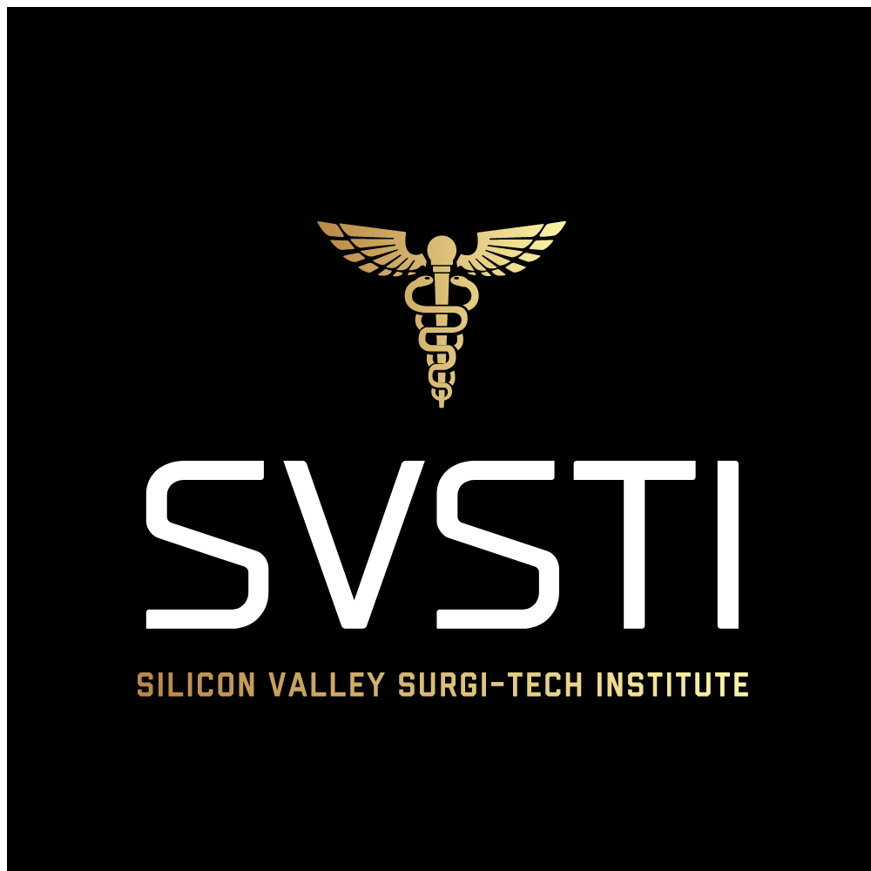

Volume I

Effective October 31, 2020

Updated Feb. 20, 2021

Updated July 10, 2021

**Table of Contents:**

Welcome…Pg. 3

Credits Required for Program Completion… Pg. 4

Externship Rotation Minimum Requirements…Pg. 5-6

Attendance Policy …Pg. 6

Graduation Requirements…Pg. 7

Pre-Enrollment Criteria…Pg. 7-8

Tuition & Additional Charges …Pg. 7-8

Program Certification Prep & Externship…Pg. 9

Student Work Policy…Pg. 9

Immunization / Medical Screening Requirements…Pg. 10

Needle Stick Protocols…Pg. 11

Lab Rules…Pg. 12

Lab Safety and Maintenance Policy…Pg. 13

Technology Attestation Requirements … Pg. 14

**WELCOME!!!**

Welcome to the Silicon Valley Surgi-Tech Institute Surgical Technology Program. You have chosen a program in which you will stretch your abilities to reach your fullest potential as a Surgical Technologist. We know the effort that went into your decision and the work that will be required to complete this program. The faculty is ready and willing to assist you in achieving your goals. We recognize that individuals may have unique and varying needs, capabilities, and experiences. The key to success lies in the recognition by each individual of any learning areas that may need improvement, and in assuming responsibility for strengthening any deficiency. SVSTI has numerous resources to assist you including help with study habits, test-taking skills, increasing reading skills, and time management.

#### Number of credits required for program completion

#### Surgical Technology Certificate Program

You will need to pass each Surgical Tech course with a 70% or higher to continue to the next course. Please see the following:

**Surgical Technology Certificate Program**

**Credit Hours**

**ST1/ST111 27 Credit Hours**

352 Lecture Hours

144 Lab Hours

Total Hours= 496 Hours

**ST2/ST222 26 Credit Hours**

336 Lecture Hours

144 Lab Hours

Total= 480 Hours

**ST3/ST333 20 Credit Hours**

140 Lecture Hours (including CST Prep which is required)

500 Clinical Hours

Total= 640 Hours

**Total Credit Hours for Certificate Program = 1616 Hours**

**73 Credit Hours**

**Externship Rotation minimum Requirements**

**The distribution of the 120 procedures is as follows**:

General Surgery cases (minimum of 30 cases)

A. Students must complete a minimum on 30 cases in General Surgery, 20 which must be performed in the First Scrub Role. The remaining 10 cases may be performed in either First or Second Scrub Role.

Specialty Cases (minimum of 90 cases)

B Students must complete a minimum of 90 cases in various surgical specialties excluding General Surgery; 60 which must be performed in the First Scrub Role. The additional 30 cases may be performed in either the First or Second Scrub Role.

a. A minimum of 60 surgical specialty cases must be performed in the First Scrub Role and distributed amongst a minimum of four surgical specialties.

(1) A minimum of 10 cases in the First Scrub Role must be completed in each of the required minimum of four surgical specialties (40 cases total required).

(2) The additional 20 cases in the First Scrub Role may be distributed amongst any one surgical specialty or multiple surgical specialties.

b. The remaining 30 surgical specialty case may be performed in surgical specialty either in the First or Second Role.

Optional Surgical Specialties

1. Diagnostic endoscopy cases and vaginal delivery cases are not mandatory. However, up to 10 diagnostic endoscopic cases ad 5 vaginal delivery cases can be counted toward the maximum number of Second Scrub Role cases.

a. Diagnostic Endoscopy cases must be documented in the category of “Diagnostic Endoscopy”, rather than by specialty.

b. Vaginal delivery cases must be documented in the category of: “Labor & Delivery” rather than in the OB/GYN specialty.

Case Experience in the Second Scrub Role is not mandatory.

Observation cases must be documented, but do not count towards the 120 required cases.

Cases will be counted and documented according to surgical specialty (exception being diagnostic endoscopic cases.

All student activities associated with the curriculum, especially while students are completing clinical rotations, will be educational in nature. Students will not be substituted for hired staff personnel within the clinical institution, in the capacity of a surgical technologist.

**Certification Exam**

SVSTI requires each and every student to participate in the Certification Prep class during the program and after externship to graduate from the program. We want to ensure every student is successful in passing their certification exam and require this as part of the curriculum.

**Attendance Policy for Surgical Technology Lab**

It is very crucial for every student to attend every class as SVSTI’s Surgical Technology Program is an advanced fast paced course. You are allowed only 3 absences of lab each 16-week term with the exception of Clinical rotation where you are only allowed 2 absences for emergencies. Please save these absences for true emergencies as life happens and we never know when we might need them.

Please note that all 48 days each term are a part of the overall grade. It counts for 10% of your grade as it is important to be present to learn the skills needed to be successful.

If a student has more than 3 absences in a term, they will be subject to a letter grade drop. 5 absences will get you dropped from the Program.

If a student obtains 3 tardies in a term that will count as 1 absence.

***Graduation Requirements***

· Must receive a minimum of 70% or higher for program.

· Must complete all requirements with student success.

· Must pay tuition on time in order to be placed on externship and graduate on time.

· All required cases/hours at the appointed facilities for externship must be completed successfully and documents turned in signed.

· Must complete all required coursework on the online platform.

· Must complete and pass the final exam with a score of 70% or higher.

Must obtain to the Attendance Policy, Externship Policy and any other policy signed

**SVSTI**

Surgical Technology Program

Pre-Enrollment Criteria

To enroll in the SVSTI Surgical Technologist program, **the following steps are required:**

**STEP 1**

1. Timed Entrance Exam - this is given on campus
2. Written Essay (found on our website)
3. TWO professional Reference Letters (found on our website)
4. Interview with SVSTI Program Director

**STEP 2 - Bring the following:**

1. COMPLETED Surg-Tech enrollment packet (found on our website)
2. Your high school transcript OR diploma OR GED certificate
3. A driver's license OR California State ID
4. Request for a Payment Plan OR (notification of payment in accordance with the following)

**Once your documents have been received, and you are formally accepted into the Surg-Tech program, you will receive an acceptance letter (email) from our Program Director.  At that time, you will have THREE business days to make your payment in full OR pay your $3400.00 deposit in accordance with your PRE-APPROVED payment plan.**

**Tuition and Fees:**

The tuition charges and total charges for your program are estimated and may change for the following reasons:

(a) you may have to repeat a course(s) required for graduation.

(b) the courses in your program, and number of credit hours for such courses, are subject to change; and

(c) course materials (e.g., books, course packets, etc.) and associated costs are subject to change.

No other fees are required to any other entity to participate in the educational program.

|  |  |
| --- | --- |
| **SURGICAL TECHNOLOGY CERTIFICATE PROGRAM - COST BREAKDOWN** | |
| Institutional **Tuition Cost** (48-Weeks) 73 Semester Credits | $18,800 |
| Certification Examination (noninstitutional charge) | $247¹ |
| Cengage- eBooks (1-year unlimited) | $179.99+ |
| **TOTAL COST** | **$19,226.99**\* |

¹*Cost covers AST membership, Examination book and Certification examination to be paid in Term 2 by student.*

\**Only $18,800 goes to SVSTI - additional supplies, immunizations, scrubs, books, etc. not included.*

*+Students can elect to purchase the longer membership if they want early access to eBooks or want* *them accessible for two years. The cost is $239.99. These are the current prices which are subject to change.* *Length of Program does not include any breaks or holidays.*

**Registration Fee (Non-Refundable) $100.00**

**Tuition $18,800.00 ($100.00 registration fee will go towards the tuition, leaving a remainder of $18,700.00)**

**TOTAL SURGICAL TECHNOLOGY CERTIFICATE TUITION= $18800.00+ $247 NBSTSA certification exam + eBooks $179.99 = $19,226.99 (only $18,800 will be paid to SVSTI).**

The STRF as of Feb. 8, 2021, is $0.50 for every $1000 paid. (nonrefundable). There are no additional institutional charges or fees.

**Cancelation Policy & Refunds**

**STUDENT’S RIGHT TO CANCEL**: You have the right to cancel the enrollment agreement and obtain a refund of charges minus registration fee paid through attendance at the 14th calendar day of first-class session____/____/____ (date).  The $100 nonrefundable registration fee will not be refunded if canceled.

Cancellation occurs when you give written notice of cancellation. You can do this by mail, in person, by fax or email.

SVSTI shall pay a refund within 45 days of a student’s written cancellation or withdrawal. SVSTI shall refund 100 percent of the amount paid for tuition for Surgical Technology Program, less a $100 registration fee if cancellation is made through attendance at the end of the business day of the 14th calendar day of the start date. Cancelation must be made in a letter in person, email or a certified letter sent to SVSTI.

If the student wishes to cancel, Cengage eBook is nonrefundable the fee is $180 paid by student prior to orientation for the Surgical Technology Program is nonrefundable. Refunds for items of extra expense to the student, such as books, tools or other supplies should be handled separately from refund of tuition and other academic fees.

**Additional Charges for the Surgical Technology Program**

• $179.00 (for 1-year unlimited for Certificate Program) for Cengage eBooks & MindTap (so be sure to not purchase too early) This will be bought a day before or the day of orientation by the student.

OR

• $239.00 (for 2-year unlimited for Degree Program) for Cengage eBooks & MindTap.

AND

• $247.00 for AST Membership, Study Guide, and Exam (This will need to be paid during 2nd term)

• Immunizations or any other requirements required per clinical site such as Drug testing and/or background.

• Student is responsible for black scrubs (can purchase OR hat if prefer over disposable)

• Student is responsible for own supplies, laptop/tablet/desktop

**STUDENT ID BADGE**

**The student photo identification badge and lanyard provided by SVSTI should be worn during all times on campus and at clinical sites. Replacement badges can be obtained by contacting SVSTI administrative staff.  The replacement cost of the Badge and Lanyard is $20.00.**

**Certification Prep & Externship for Surgical Technology**

1. Every student will be required to come to campus for four weeks (days and times TBD) for Certification Prep class either at the end of 3rd term or after externship rotation (depending on the entire class’s status of required cases) If a student does not participate in prep, they will receive a zero for the term and need to repeat term 3.
2. All students are required to take the Certification exam on a scheduled date and if you do not participate you will receive an F for the Program and not graduate.
3. All externship paperwork will be sent via screen shot or email of the weekly required paperwork by Friday at 5pm. If they are not sent you will be pulled from the site until further notice.
4. If payments are not made during term 3 the student will be pulled from the site and will not be returning until payments are made or until 2 absences have been taken (If the site does not allow you to return you will be dropped from the program).
5. Refer the Externship Policy & Payment Plan Policy for externship attendance and details on notifying Program Director for any absences and/or leaving early.

**Student Work Policy**

 All student activities associated with clinical externship must be educational in nature. Students cannot substitute for paid personnel and will not receive any monetary benefits while at the clinical site.

SVSTI

**EXTERNSHIP – Immunization /Medical Screening Requirements**

These requirements are based on the California State Department of Health Services recommendations and clinical facility requirements.  You MUST complete the following immunizations and provide documentation to the Enrollment Coordinator OR the Program Director. Titers MUST be drawn (#3, #4, #5) and report submitted to SVSTI BEFORE your program start date. If your TITER report indicates that you are no longer immune, you must receive a booster or the immunization series to begin your Externship on time.

***Proof of all titers, titer results / report, and proof of immunizations must be submitted BEFORE classes begin.***

1. **Tetanus/Diphtheria/whooping cough (TDaP)** –Must show proof of vaccination (dated within 10 years). If no proof is available - a booster is required
2. **Mantoux Test (PPD**)- Two-step ppd test is required **OR Gold Interferon** test **(*best option – 1 step*)**
3. PPD antigen is injected; student must have area read **3 days after injection**.

If positive, a chest x-ray will be taken

1. If negative, a second PPD antigen is injected under the skin 4 days later

The 2nd test must be read **3 days after injection**

1. If positive, a chest x-ray must be taken (**Do not have x-ray until 1 month before externship**) - If negative, testing is complete

**3.  Measles/Mumps/Rubella**- **TITER is required**, with numerical lab values

* Titer results must be turned in to the Enrollment Coordinator or Program Director
* If no immunity, immunization is required

**4.**  **Hepatitis B** - **TITER is required**, with numerical lab values.

* Titer results must be turned in to the Enrollment Coordinator or Program Director
* If no immunity, immunization is required - *Students must complete the required series (3 immunizations) and show proof of an additional Titer before start of externship –* ***THIS CAN TAKE UP TO 6 MOS***

**5.  Varicella (chicken pox) -** **TITER is required**, with numerical lab values

* Ttiter results must be turned in to the Enrollment Coordinator or Program Director
* If no immunity, immunization is required

1. **Physical -** a physical may done - Or a simple note from your physician releasing you to be in good health for Externship

**7. BLS -** Submit proof of current BLS (**B**asic **L**ife **S**upport) **BEFORE** Sterile Processing classes begin

**8. Influenza** – Proof of Vaccination is required during flu season (Sept – April) or per site request

**9. Passport Photo** – Required in Term 2 of Surgical Technology **ONLY**

**10.**  Effective 9/2021 All Students will be required to present proof of a valid COVID vaccination.

**NEEDLE STICK PROTOCOLS**

Always Observe Standard/Universal Precautions

However,

Should you suffer a needle stick or any blood/body fluid exposure, immediately notify your preceptor. Do not be embarrassed, and do not wait. Drug prophylaxis following a high-risk exposure is time sensitive. Seek immediate help.

Scrub out, and immediately cleans the wound/exposure site with liberal amounts of soap and water.

Exposed oral and nasal mucosa should be decontaminated by vigorous flushing with water.

Exposed eyes should be irrigated with copious amounts of clean water or sterile saline.

Follow all facility protocols, including reporting of the incident to the facility's Employee Health Service.

If the facility has not already drawn patient blood, then they will need to do so before the patient is released from the facility. Once the patient has been released from the facility, he/she is under no obligation to return to have their blood drawn.

Once facility protocols have been met, you must contact the Program Director, Julie Hamrick, and immediately return to the campus in order to fill out the Student Accident paperwork. This paperwork is time sensitive and must be filled out the same day with no exceptions.

Julie Hamrick, Program Director

408-640-2991 (cell).

**LAB RULES**

* **NO PHONES**- Phones remain at table on vibrate, unless otherwise arranged with instructor(s). **NO** pictures or video taken unless approved by instructor(s).
* Besides our morning or evening “huddle”, **no one** is at the tables or LEAVES lab until the instructor has dismissed you from class.
* If you come in with improper attire, e.g., no scrubs, wearing nail polish, false lashes, unnatural hair color etc. You **WILL** leave for the day, and it will count against your absences.
* Instructor(s) always oversee music.
* Instructor(s) oversee the Patient info on white boards.
* **NO** smoking or vaping on premises.
* Students may **not** be under the influence of **ANY** illegal substance **OR** alcohol during class, externship, certification prep etc.
* You are tardy **1 minute** after the start of the class, the door will be locked at **5 minutes**, and if you aren’t here, you are absent.
* If you leave **EARLY**, it is a tardy under 45 minutes, over 45 minutes it will be an absence.
* No side talk in your native language.
* **No foul language!** If you cuss, you will owe the class treats.
* **NO,** the test days cannot be changed, nor will there be make ups.
* All papers must have your name, the date, AND be legible! If I can’t read it, I can’t correct it, and it **WILL** be marked wrong.
* Questions are welcomed **BUT** arguing **will not** be tolerated. You **will** be asked to leave and will take an absence for the day.
* If you do not participate in **TEAMWORK** and pulling your own weight you will be assigned an SSP (Student Success Plan). Once you receive three (3) SSP’s you can be dropped from the program or put on probation. Once a student is on probation there is no more warnings!!

**STUDENT LAB SAFETY & MAINTENANCE POLICY**

**Safety** of self and others is the primary concern in the laboratory setting. To ensure thesafety of students and faculty in the laboratory, students are expected to follow the policies and procedures for Lab Safety & Maintenance in the SVSTI Academic Catalog. Students are encouraged to expand their skills through safe practice. Demonstration of critical safety elements by faculty is required prior to any student being allowed to use any equipment. Students will be required to demonstrate appropriate safety with all equipment, techniques, and procedures in the laboratory prior to practicing as patients or clinicians.

**STUDENT LAB SAFETY & MAINTENANCE POLICY**

**Safety** of self and others is the primary concern in the laboratory setting.  To ensure the safety of students and faculty in the laboratory, students are expected to follow the policies and procedures for Lab Safety & Maintenance in the SVSTI Academic Catalog. Students are encouraged to expand their skills through safe practice. Demonstration of critical safety elements by faculty is required prior to any student being allowed to use any equipment. Students will be required to demonstrate appropriate safety with all equipment, techniques and procedures in the laboratory prior to practicing as patients or clinicians.

**General Lab Safety Rules and Policies:**

1. No long sleeves are allowed under scrub tops (Surgical Technology only).
2. No bulky/large/chunky jewelry. Simple necklaces and post earrings are allowed.
3. No rings or bracelets of any kind (No facial jewelry).
4. No hats of any kind are allowed in lab.
5. Minimal makeup is allowed (no false eyelashes)
6. No fake nails. Nails should be short, natural color without polish.
7. No unnatural hair colors
8. Beards must be kept trimmed
9. Good personal hygiene must always be kept.
10. Students will be responsible for sterilizing items.
11. Students will be responsible for keeping towels in hampers and folding clean ones.
12. Students will be responsible for informing their instructor or Program Director when an item needs to be reordered.
13. Any accidents, injuries, or unexpected responses to intervention or skills being practiced should be immediately reported to the lab instructor.
14. Students must report any unsafe situations to staff or faculty immediately.
15. Though every effort is made to ensure that all equipment is functioning properly, students must notify the instructor of any broken or malfunctioning equipment.
16. Absolutely no cell phones may be used during instruction time. If you are seen using your phone during class your instructor will instruct you to put it away. A second offense may result in dismissal from the class for the day.
17. You are considered tardy at 1 min past the start of class time. You will also be considered tardy if you leave class early. Weekly lab evaluations cannot be made up. The door will be locked 5 minutes after the start of class.
18. Students are only allowed in Lab when an instructor is present.
19. No open toed shoes are allowed in lab.
20. Teamwork is expected

**Technology Attestation Requirements**

By signing this document, I am agreeing that I have the required access to a computer and the minimum recommended system requirements to successfully complete the distance educational program.

Canvas recommended requirements:

* Smart device, PC, laptop, iPad etc. that is 5 years old or newer with at least 1 GB of RAM.
* Web browser success
* Internet speed of 512 Kbps or faster

Cengage (Surgical Technology only) recommended requirements:

* Download bandwidth 5 Mbps or faster
* 2 GB of RAM or more
* Sound
* Graphics 64 MB or higher
* CPU 1.8 GHz or more

**Equal Employment Opportunity**

**EEO Policy Statement**

It is the policy of Silicon Valley Surgi-Tech Institute to promote equal employment opportunities through a positive continuing program. This means that Silicon Valley Surgi-Tech Institute will not discriminate, nor tolerate discrimination, against any applicant or employee because of race, color, religion, gender, pregnancy, sexual orientation, gender identity, national origin, citizenship status (including document abuse), age, disability, veteran status, or genetic information. Additionally, it is the policy of Silicon Valley Surgi-Tech Institute to provide an environment for each Silicon Valley Surgi-Tech Institute job applicant and employee that is free from sexual harassment, as well as harassment and intimidation on account of an individual’s race, color, religion, gender, pregnancy, sex, sexual orientation, gender identity, or national origin, citizenship status, age, disability, veteran status, or genetic information.

Silicon Valley Surgi-Tech Institute is an equal opportunity employer of protected veterans, and individuals with disabilities. All qualified applicants will receive consideration for employment without regard to race, color, religion, sex, sexual orientation, gender identity, or national origin.

Silicon Valley Surgi -Tech is an Equal Opportunity Employer/Program Auxiliary Aids and Services are available upon request to individuals with disabilities.

This policy shall be posted in places conspicuous to all members of the faculty, staff, and student body; it shall be communicated to all applicants for employment and admission; and it shall be given such external dissemination as is necessary to inform and secure the cooperation of individuals and organizations constituting sources of employment and student referrals to Silicon Valley Surgi-Tech Institute. The “Equal Opportunity is the Law” poster is posted in the faculty/staff/student breakroom.  Copies of this document in other languages is available at <https://www.dol.gov/agencies/ofccp/posters>

For more information about Silicon Valley Surgi-Tech Institute’s EEO program, including procedures for filing a complaint of discrimination and its commitment to affirmative action in hiring minorities, women, persons with disabilities and veterans please see the administrative office.

**SVSTI SIGN OFF SHEET**

**INITIAL ALL**

____ I understand that it is my responsibility to read and familiarize myself with the

policies and procedures contained in the Academic Catalog & Student Handbook which may be found on the website at [www.svsti.com](http://www.svsti.com)

____ I agree to always abide by the standards and accept full responsibility for my behavior on and off campus.

____ I pledge to adopt the professional philosophy of SVSTI, perform my duties to the

to the best of my ability and, upon graduation will demonstrate pride in my career as a medical professional.

____ I have read the externship policy and understand that if I decline an externship and/or get expelled from a site, I will be withdrawn from the Program without a completion grade.

____ I accept that placement is based on availability and understand that most sites require a full-time schedule.

____ I have read and understand the lab safety & Maintenance Policy.

____ I have read and understand the Academic Policies.

____ I have read & signed the Technology Attestation form.

____ I have read and understand the Emergency Preparedness & Response Plan.

____ I accept that during COVID, Flu Season, Natural Disasters, etc. there could be a

delay in my externship placement.

Student Signature: ____________________________________Date: _____________

Student Printed Name: ___________________________________________________

Program: _____________________________________

SVSTI Signature: _____________________________________Date: ___________