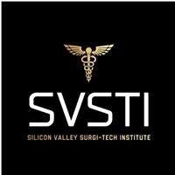
Sterile Processing Additional Charges Policy

- Students are responsible for paying for their textbook ($155+): The Basics of Sterile Processing Textbook, 8th edition, Sterile Processing University LLC, and the workbook ($40+): The Basics of Sterile Processing Workbook, 8th edition, Sterile Processing University LLC. Students will need to buy BOTH the 8th edition textbook and workbook. 8th edition ONLY.
- Students are responsible for paying for their CBSPD: CSPDT certification exam ($135+), payable to the Certification Board for Sterile Processing and Distribution.
- Students are responsible for their own Drug Testing ($55+), and Background Checks ($55+), for a total of ($110+).
- Students are responsible for paying for their BLS class ($70.00) if they decide to sign up for the class offered at SVSTI. ONLY AMERICAN HEART ASSOCIATION BLS PROVIDER.
- Immunizations or any other requirements required by the clinical site are the student’s responsibility.
- Students are responsible for wearing black scrubs, scrub caps (which can be purchased if preferred over disposable caps), and wipeable, closed-toe shoes.
- Students are responsible for their own supplies, including laptops, tablets, and desktops.
- Students are responsible for replacing the SVSTI Diploma ($20.00) and/or Identification Badge ($20.00).

Student Name:_____________________________________________ Date:_____________________

Student Signature:___________________________________________ Date:____________________

SVSTI Official Signature:_______________________________________ Date:____________________

