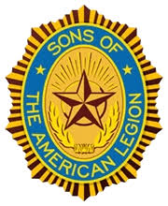
Detachment of Oklahoma
37th Midwinter
January 17th, 2026
Agenda

Opening at 0900
- Salute the Colors
- Prayer
- POW-MIA
- Pledge of Allegiance
- Preamble
- Roll Call

Minutes of the previous meeting

Guest Speakers

Unfinished Business
- Website
- Drawing for National Convention 2026 Louisville, KY
- 501-C-3

New Business
- Summer Convention 2026

Reports
- Senior Vice Commander
- Vice Commander East
- Vice Commander West
- National Executive Committee
- Alternate National Executive Committee
- Sargent-at-Arms
- District Commander
- Treasurer
- Judge Advocate
- Legion Liaison
- Advisor PNC Cook
- Chairman of Committee/Commission
- Squadron Reports
- Detachment Commander

