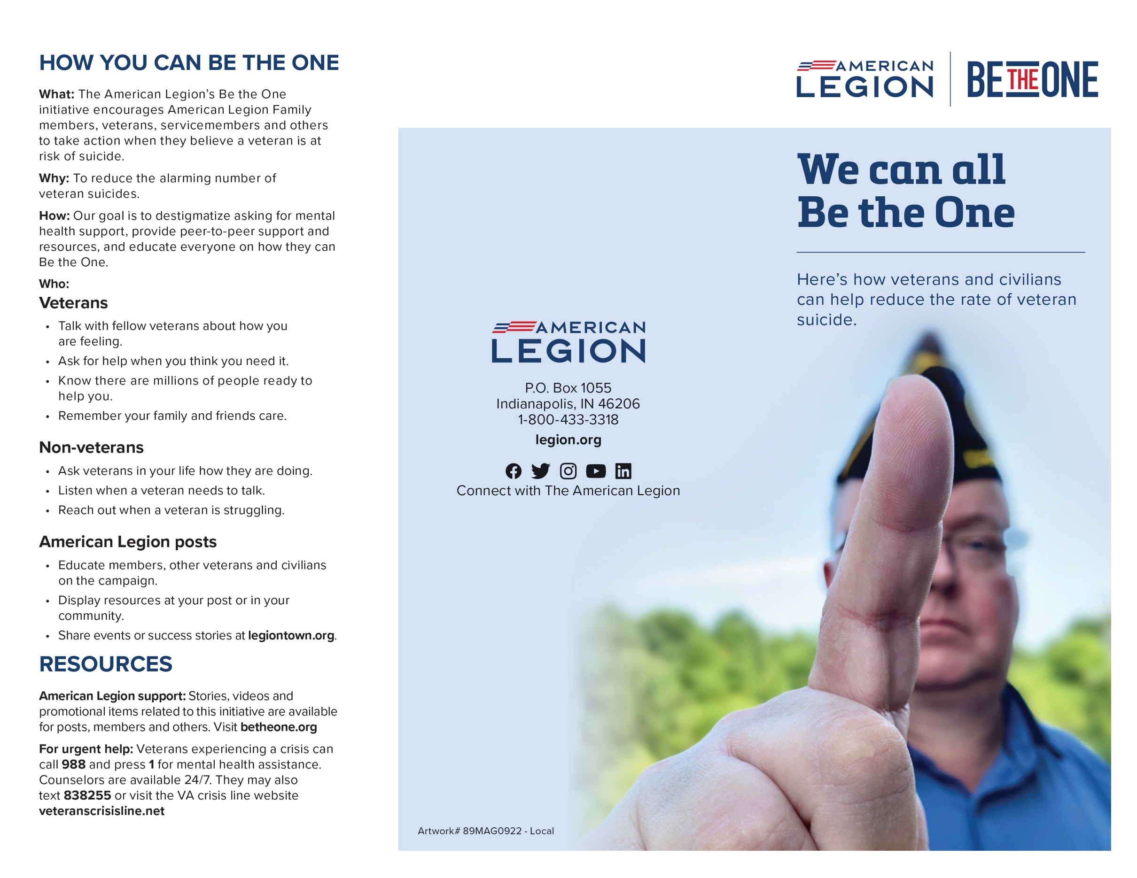

**USE THIS BE THE ONE BROCHURE TO HIGHLIGHT RESOURCES IN YOUR COMMUNITY**

The American Legion national HQ staff has made this customizable brochure available for American Legion posts to use with local information in their communities.

You can use this side of the brochure as a resource page for veterans who need assistance with issues related to PTSD, TBI, mental health and other issues.

Here's how to use the brochure:

1. Open this file in Microsoft Word and save a copy to your computer.
2. Fill in this side of the document with a collection of your local resources that would be useful to veterans. Include information such as the service provider's name, phone number, email address, physical address, services provided, website and any other relevant information.
3. After completing the page of local resources, take both front and back to a printer who can print as one trifold brochure for you.
4. Once you have the finished product, you can hand it out at post events, distribute it to veterans in your area, and publish it on your post Facebook page, newsletter or website.
5. Share how you are using this brochure and other resources to help community members in your area learn how they can "Be the One." Visit Legiontown.org to share your story.