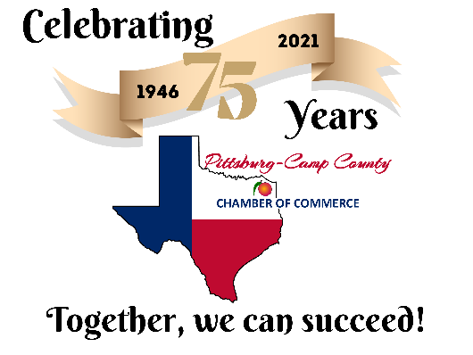

Pittsburg-Camp County Chamber of Commerce
202 Jefferson Street, Pittsburg, TX 75686
903-856-3442
Info@pittsburgcampcountychamber.com

Dear Potential Fireworks Sponsor:

Plans are already well underway for our 2021 Tri-County Independence Day Spectacular. The Pittsburg-Camp County Chamber of Commerce is once again honored to serve as the sponsoring organization of this event which draws thousands to our community. It’s an evening enjoyed by children of all ages - from preschool age to grandparents. Generations come together to celebrate our freedom and our country with a spectacular fireworks show.

Not only are we celebrating our countries freedom, the Pittsburg-Camp County Chamber of Commerce is celebrating its 75th Anniversary. And we are excited to be carrying on this wonderful, family-friendly, Independence Day tradition with our community and surrounding areas.

Last year’s fireworks show was absolutely spectacular and this year’s show will be just as elaborate. However, we have committed to the City of Pittsburg that we will not have food vendors and games once again this year before the fireworks show. But, we are already planning on next year’s show being a blowout party. You will be able to bring your picnic and enjoy the show from your vehicle or lawn chair.

Every year we invite you, our Chamber Members and the community, to help us fund our July 4th Celebration. A minimum of $15,000 is needed to fund our July 4th Celebration. Can we count on you and/or your business to support this event? See page two for an overview of sponsor benefits. Please indicate your chosen sponsorship level and send your donation to the Pittsburg-Camp County Chamber of Commerce (202 Jefferson, Pittsburg, TX 75686).

Thank you again for supporting the 2021 Tri-County Independence Day Blast. If you should have any questions, please call the Chamber at 903-856-3442 or info@pittsburgcampcountychamber.com.

Sincerely,

Sandy Thompson & the Chamber Board of Directors
Pittsburg-Camp County Chamber of Commerce

