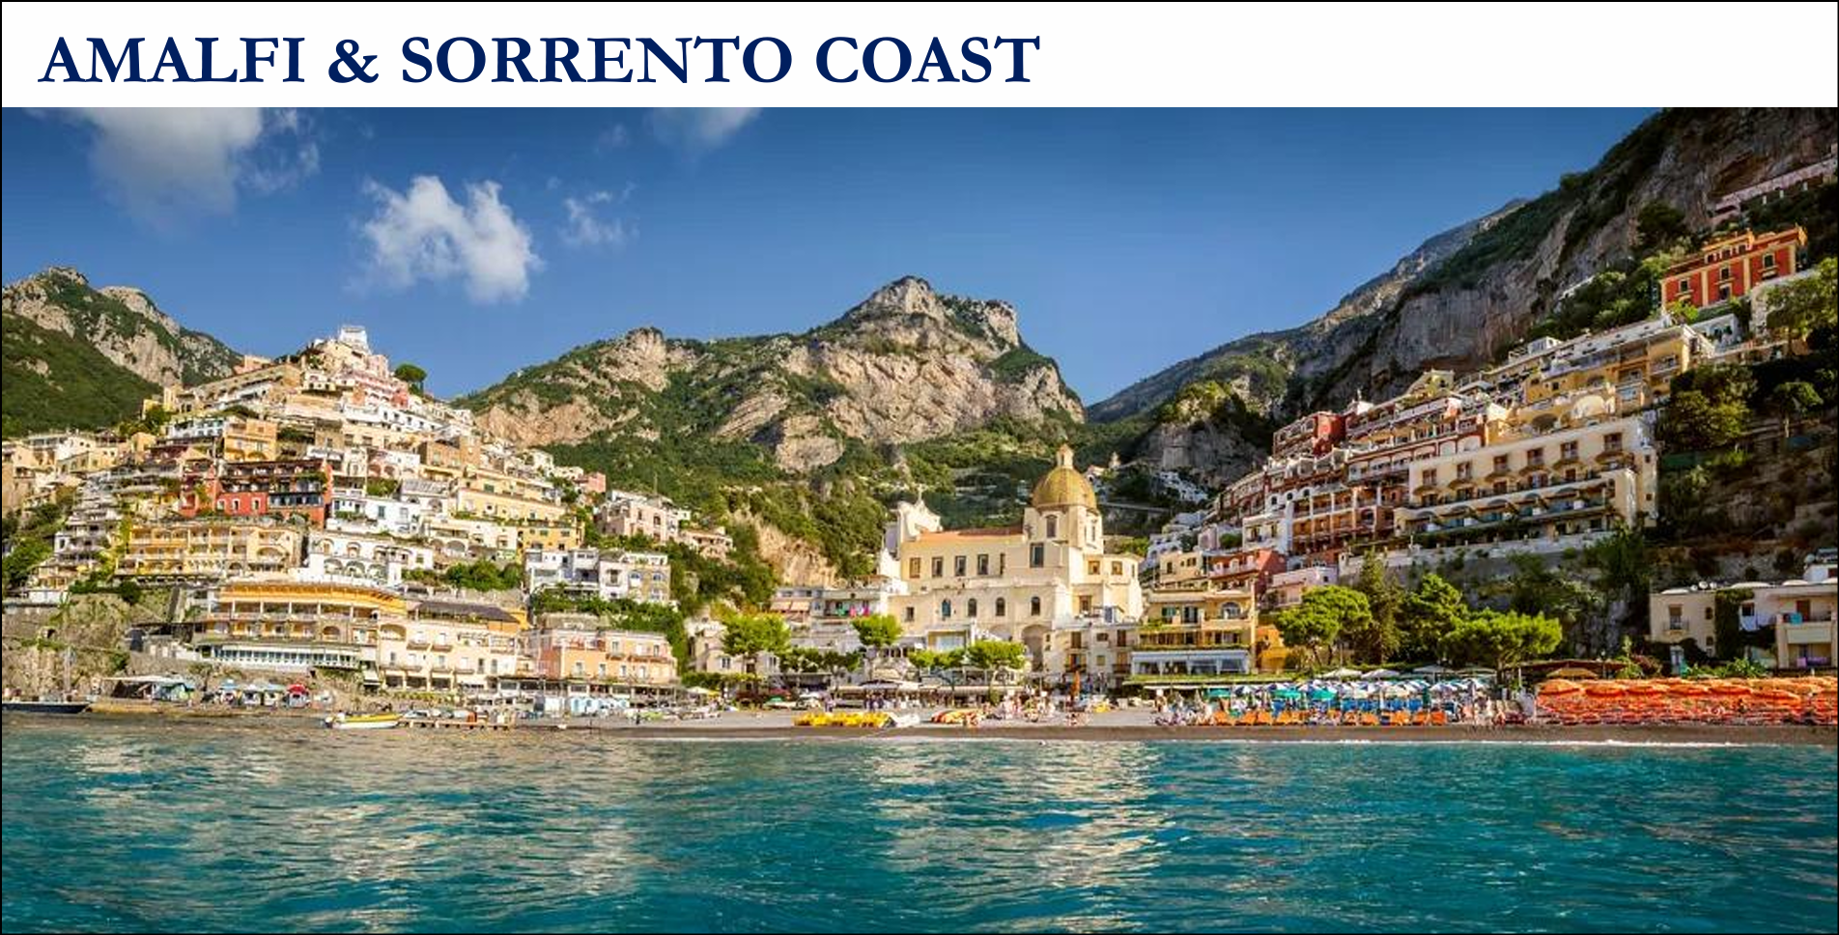

Rossellinis - ROSSELLINIS RESTAURANT, Ravello - Restaurant Reviews and Photos
Zass- ZASS RESTAURANT, Positano - Restaurant Reviews and Photos
Circolo dei Forestieri - CIRCOLO DEI FORESTIERI - Restaurant Review and Photos
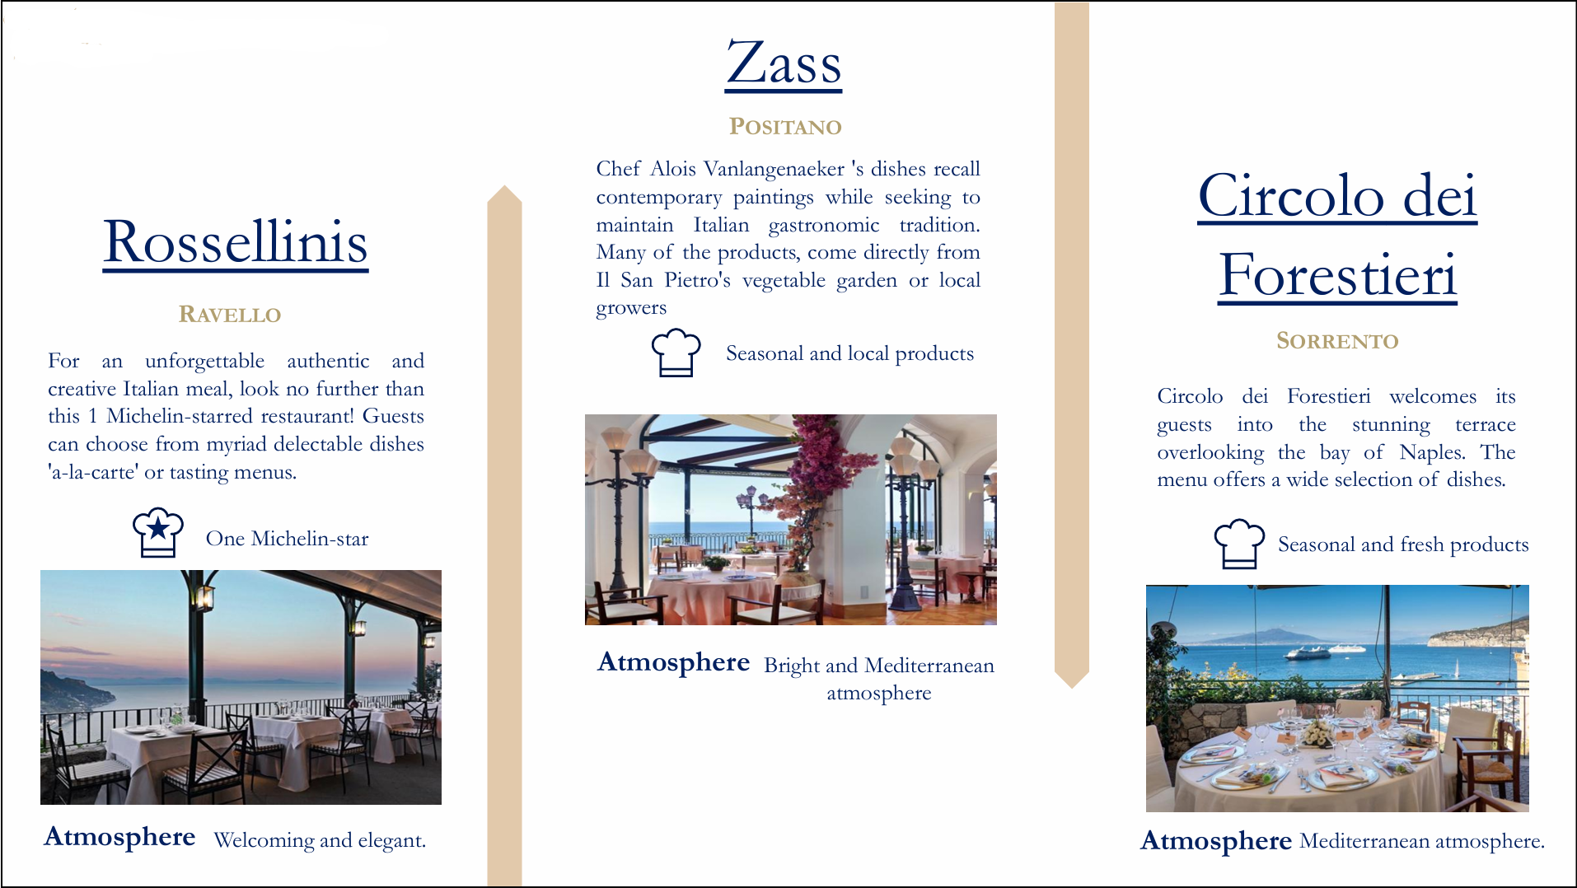
La taverna del Duca - LA TAVERNA DEL DUCA, Amalfi - Restaurant Reviews and Photos
Lo Smeraldino- LO SMERALDINO, Amalfi - Restaurant Reviews and Photos
Ristorente Bruno- BRUNO, Positano - Restaurant Reviews and Photos
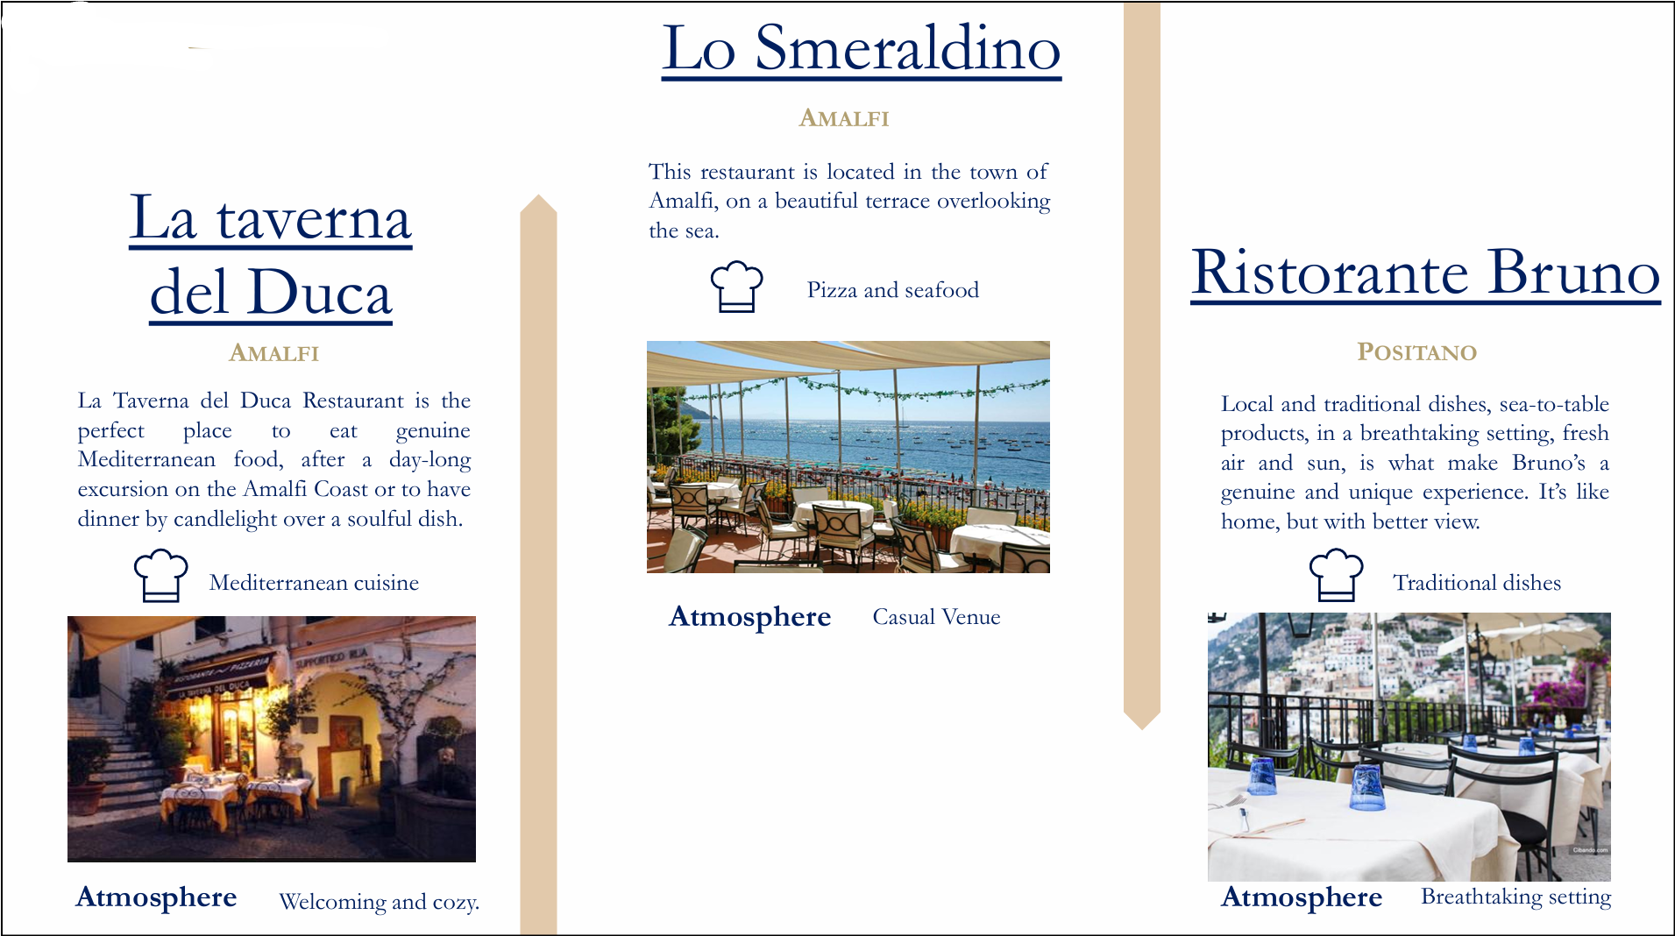

O’Parrucchiano – O'PARRUCCHIANO, Sorrento - Restaurant Reviews, and Photos
Bistrot 86 - 86BISTRÓ - Restaurant Reviews and Photos
Ristorante Tasso - RISTORANTE PIZZERIA TASSO, Sorrento - Restaurant Reviews and Photos
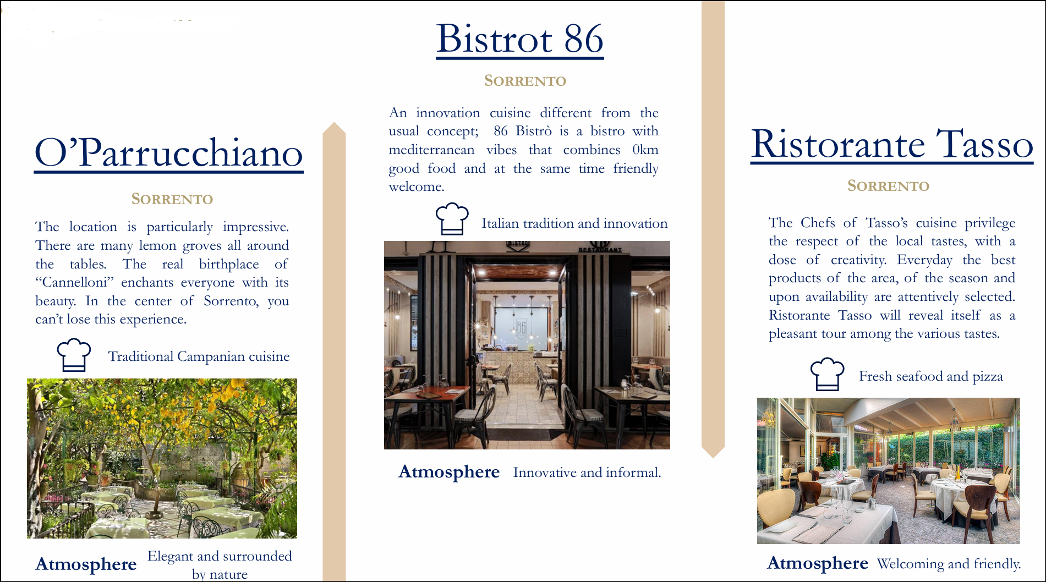

Il Faro di Capo d’Orso- IL FARO DI CAPO D’ORSO, Maiori - Restaurant Reviews and Photos
L’Antica Trattoria 1930- L'ANTICA TRATTORIA, Sorrento - Restaurant Reviews and Photos
LaSponda - RISTORANTE LA SPONDA, Positano - Restaurant Reviews and Photos
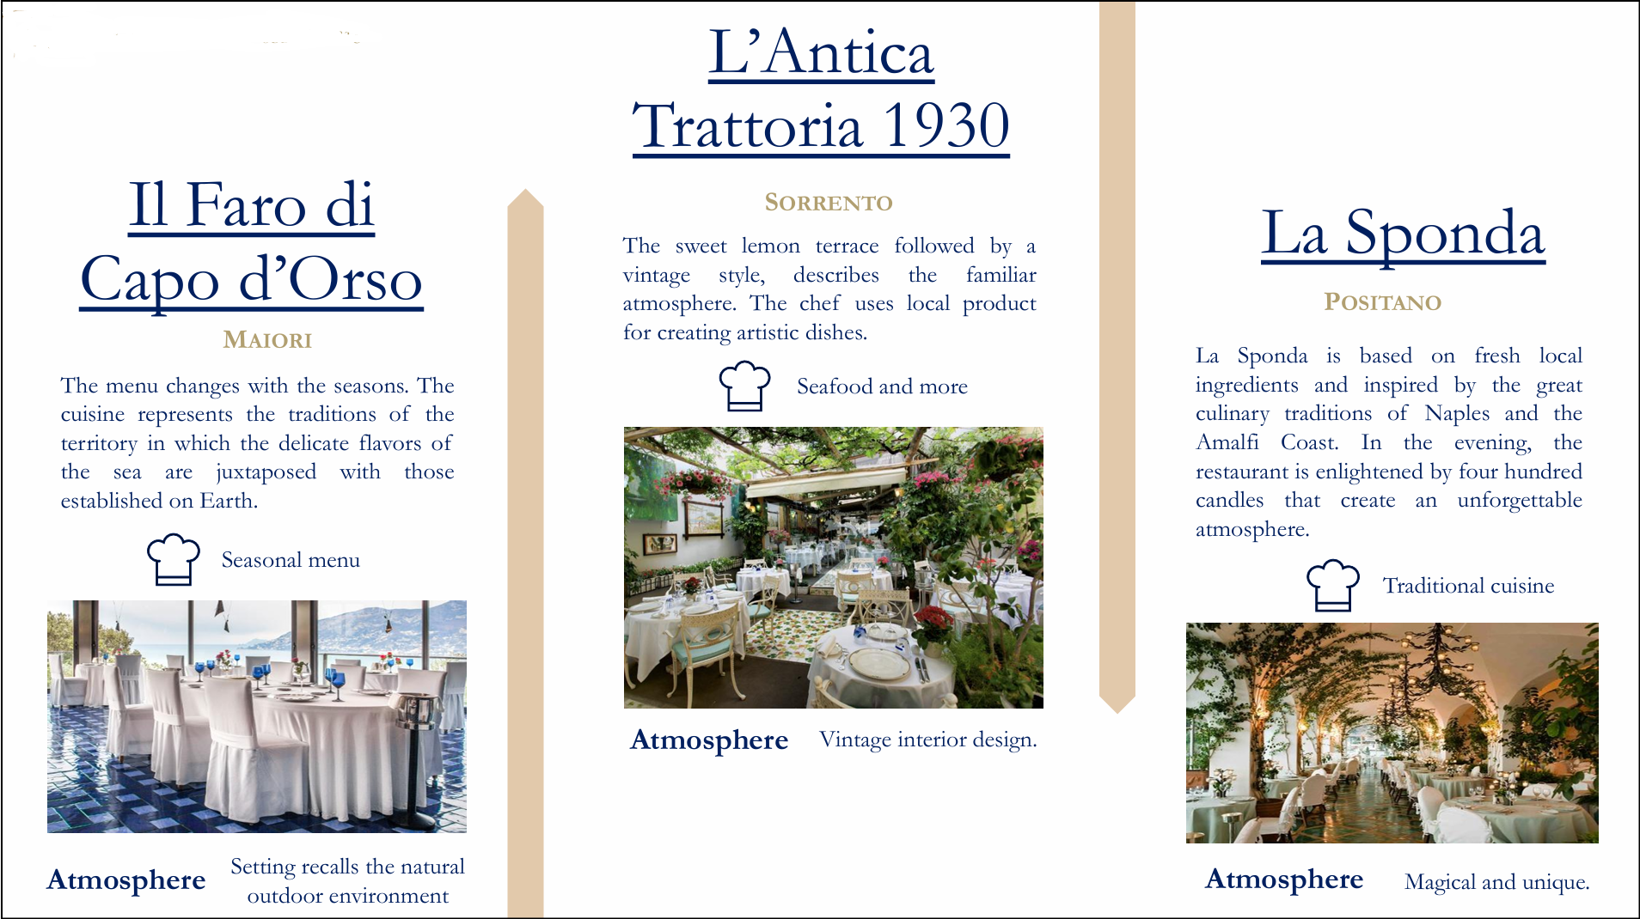
LaTagliata – RISTORANTE LA TAGLIATA, Montepertuso - Restaurant Reviews and Photos
DaVincenzo – Da Vincenzo, Postino - Restaurant Reviews and Photos
Lo Gurrancino - LO GUARRACINO, Positano - Restaurant Reviews and Photos
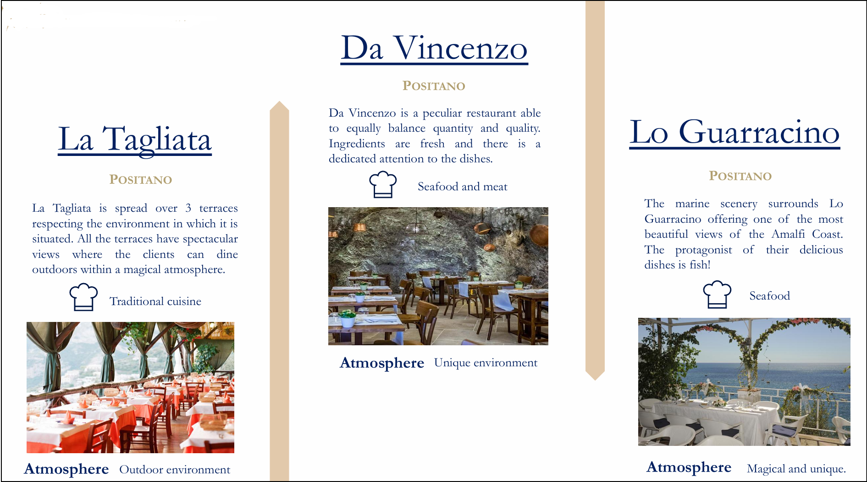
Don Alfonso - DON ALFONSO , Sorrento - Restaurant Reviews and Photos
Ristorente Max - RISTORANTE MAX, Positano - Restaurant Reviews and Photos
Franco’s Bar - Franco's Bar, Positano - Contemporary Bar with Quality Drinks and Stunning Views 