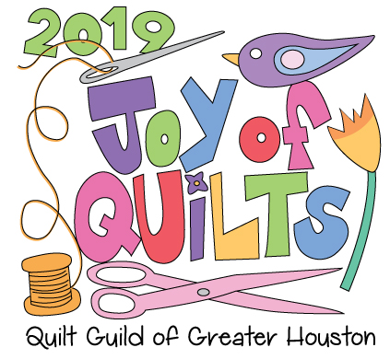

May 3 – 4, 2019

ENTRY INFORMATION & RULES

PLEASE READ CAREFULLY

* Entries may not have been displayed in any quilt show in the State of Texas within the 13 months prior to May 1, 2019.
* Each entry shall consist of:

1. Completed Entry Form
2. Fees – Fees and a self-addressed envelope must be turned in at a QGGH Meeting or mailed via post office beginning in January.
3. Self-Addressed Stamped envelope
4. Clearly Printed Photo of the Entry – Print entrant’s name, entry title and size dimensions of entry on the back of the photo.

In-person acceptance of entry forms will begin being accepted at the January evening (1/15/19) and daytime (1/18/19) meetings. All entry forms, photos and applicable fees must be received by March 22, 2019 at either a daytime or evening meeting or through the mail.

Number of entries will be limited based on space considerations. Confirmation of acceptance and Check-in information will be mailed to entrants by April 12, 2019.

QGGH members have no limit in the number items entered: non-QGGH members may enter three (3). Entry fee for QGGH members is $10 per item. For non QGGH entries, the entry fee is $20 per item. Entry fees are non-refundable after April 5, 2019.

If entry is to be mailed/shipped back to entrant, a $20 fee must be included with entry form.

Each entry may have only ONE entrant. The name on the “Entrant” line must match the release signature on the form. Entrant must either be the owner of the item entered or must have been involved in the making of the item.

Each Entrant will be given a receipt for items that are checked in. Receipt MUST be presented to claim items at the end of the show. No entry will be released without a receipt. All entries must remain on display for the entire show. If someone other than the Entrant is picking up the entries after the show, that person must have the receipt and permission in writing by the Entrant to retrieve the show entries.

*By entering a quilt, permission is granted to the quilt Guild of Greater Houston (QGGH) for the right to photograph the entry for its files, publicity or promotional purposes in all media types. This permission remains in effect and on file until revoked IN WRITING. I understand that I am responsible of insuring my own entry (entries). I and all those claiming through me, hereby release QGGH and its members from all liability in connection with the display and use of the described entry. I understand that no responsibility for loss or damage to my entry (entries will be assumed by QGGH, its officers, agents or volunteers.*