ENTRY PREPARATIONS:
LABELS: Each entry must have a label.
The label must include your name, title of the entry, and address. Please SEW labels securely to quilts on the lower left corner in the back. SEW labels securely to garments on the inside of the garment and attach securely to dolls or 3-D items under the base of the items. For judging, labels must be covered with fabric (please baste in place - do not use pins) so that maker(s) of items will remain anonymous during judging. | Example of label placement.

SLEEVES: No quilts will be accepted at check-in without a hanging sleeve! All quilts must have a sleeve stitched to the top of the quilt on the back for hanging the quilt.

Wall-hangings and large quilts need a 4” or larger sleeve placed just under the binding at the top of the quilt.
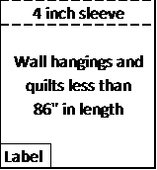

Quilts longer than 86” must have a sleeve attached no more than 86” from the bottom of the quilt.
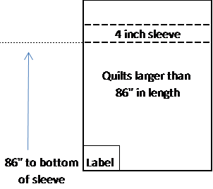

Miniature quilts must have a 2” or larger sleeve for hanging.
