SUPPLY LIST PORTRAITS FACE FORWARD! KAROL KUSMAUL

Wednesday, November 20, 2019 9 AM to 4 PM
Location: Trini Mendenhall Community Center, 1414 Wirt Road, Houston, TX 77055

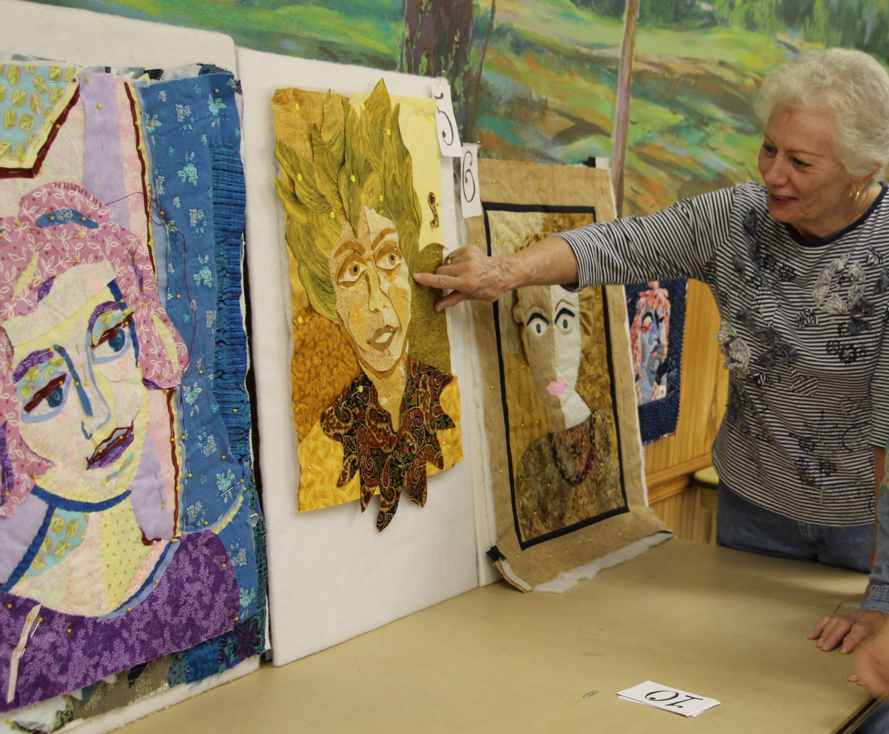

Instructor will bring samples of her freestyle portrait work, and discuss and demonstrate her processes. Students will lay out a background and a portrait, using (and sharing) recycled fabrics. Critique and discussion of facial features, proportions, and light and shadow will follow. Finally, students will be shown the ladder stitch for appliquéing the shapes to the batting with embroidery thread.

Each participant will need to bring the following:

Batting approximately 30” x 30”
Three or more pieces of thrift store clothing – one dark print, one light print, one medium print (shirt, skirt, dress - any color) **** Note: no T-shirt or stretchy material, please. Cottons or rayons are best. We will be sharing these. Please pre-wash!!
Glue stick, Scissors, Straight pins
Long, thin needle ( #7 darner) and a thimble
Embroidery floss in various colors
Portable design board (large piece of cardboard or foam core would work, 20” x 30”)
Iron and ironing boards to share – no fusibles will be use
A willing attitude and a smile

